ATMO 170 Name__________________________________
In-class Optional Assignment
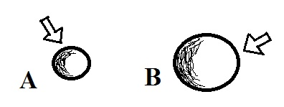
1. Object A in the picture at right has a smaller mass than Object B. When equal amounts of energy are added to each object, both objects experience the same temperature change, ΔT. This means that Object A must have a HIGHER, LOWER, the SAME specific heat as Object B ΔT = ______ΔE________
mass x specific heat

2. Energy transport by convection can take place in _______ and _______.
a. empty space b. gases c. liquids d. solids

3. If you place a cup of liquid nitrogen in a room it will slowly CONDENSE EVAPORATE FREEZE SUBLIMATE. Does this phase change TAKE energy from the surrounding air or RELEASE energy into the surrounding air?

4. Rank the following temperatures in order from _______
coldest (bottom step) to warmest (top step) ________
0º C 0º F 0º K ________
100º C 200º F 300º K ________
________
________

5. Microwave radiation is a LONGER SHORTER wavelength and HIGHER LOWER energy form of electromagnetic radiation than ultraviolet light. Infrared light is a LONGER SHORTER wavelength and HIGHER LOWER energy form of EM radiation than visible light.

6. Room temperature is approximately 300º CELSIUS FAHRENHEIT KELVIN.

7. The formation of frost on a cold morning is an example of _______. A bathroom mirror that fogs up during a hot shower illustrates _______. A piece of dry ice left in a room will slowly disappear because of _______.
a. condensation b. deposition c. evaporation
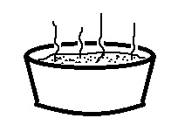
d. freezing e. melting f. sublimation

8. People often blow on a steaming hot bowl of soup to cool it
off so that they can eat it. What two energy transport processes
do you think cause the most cooling?

