ATMO 170 Name________________________________________
A fairly challenging Humidity Variables Optional Assignment
1. Determine the following for Point A on the graph below (try to include the units)

air temperature__________ mixing ratio__________ dew point __________

relative humidity__________ saturation mixing ratio__________
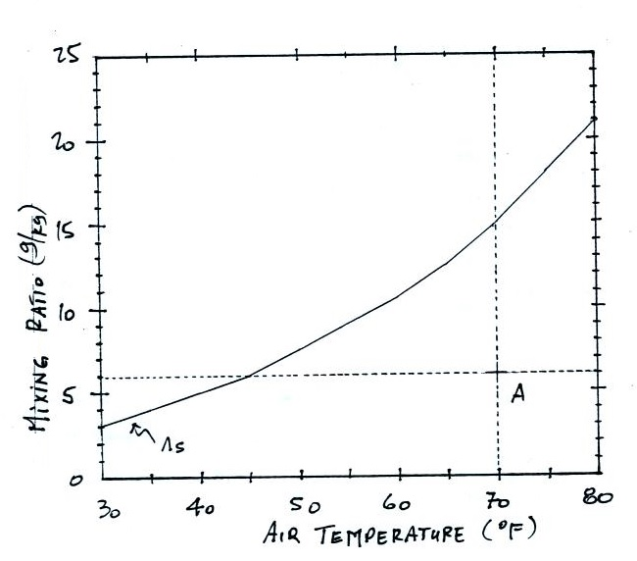

Use the table of saturation mixing ratio values at right below for Questions #2 and #3.
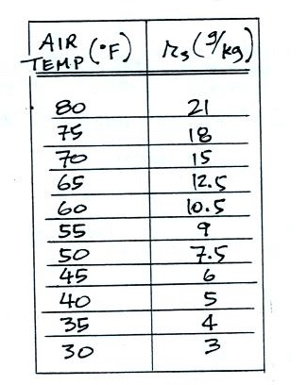
2a. If the air temperature is 70º F and the mixing ratio is 5 g/kg, what is the relative humidity? What is the dew point temperature?

2b. Calculate the relative humidity and the mixing ratio when the air temperature is 65º F and the dew point temperature is 50º F.

3. How many grams of water vapor are in 1 kg of saturated 70º F air? If you could somehow turn all that water vapor into water and then collect it, how many teaspoons of water would you end up with (1 tsp of water has a mass of 5 grams).

4. Assume that the actual amount of water vapor in the air remains constant during the day. Then __________ and __________ will remain the same during the day, __________ and __________ will probably be higher in the afternoon than in the morning, and __________ will be higher in the morning than in the afternoon. (fill in each blank with T for air temperature, r_{s}, for saturation mixing ratio, r for mixing ratio, RH for relative humidity and Td for dew point temperature; each answer should be used once)

5. Based on the information at right would CITY A or CITY B City A City B
have the highest relative humidity, would CITY A or CITY B Tair = 80º F Tair = 70º F
have the highest actual amount of water vapor in the air? Td = 40º F Td = 50º F
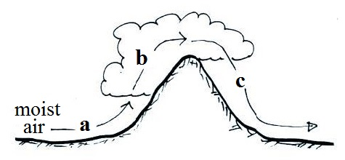
6. The mixing ratio, r, is increasing along Path _______ in the
figure at right. The relative humidity, RH, is increasing along
Path _______. Along Path _______ the mixing ratio is
decreasing and the relative humidity is decreasing along
Path _______. (fill in each blank with a, b, c as shown in the
figure or use d for nowhere; each answer should be used once)

7. Indicate whether the humidity variables r, r_{s}, RH, and Td will Increase, Decrease, or remain the Same
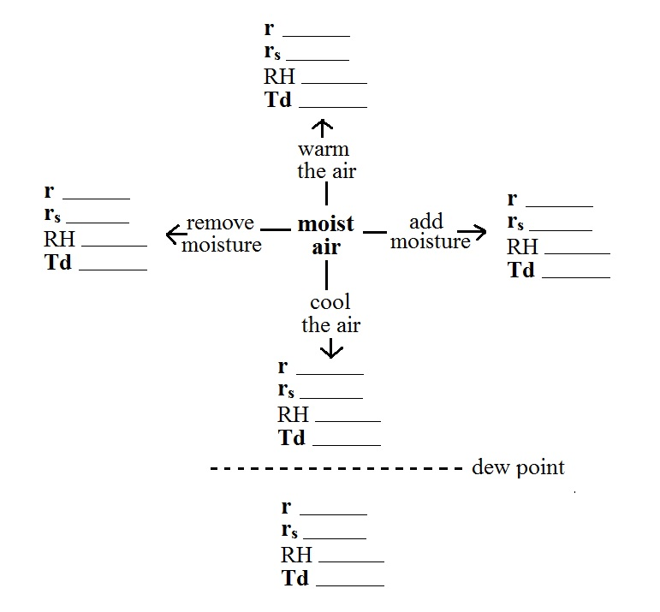
when moist air is warmed or cooled (consider both cooling and staying warmer than the dew point and cooling enough to drop below the dew point), and when moisture is added to or removed from the air.

