ATMO/ECE 489/589 Spring 2017
Homework #2 due Tuesday Feb. 7

Everyone should do Problem #1 (undergraduates may skip part (d) if they want to or include it for extra credit). Graduate students should do the remaining three problems. Undergraduate students need to only do two of the three remaining problems.

1. (15 pts) A point charge, Q, is located at an altitude, H, above a grounded conducting plane of infinite extent.

(a) Is there an attractive or repulsive force between Q and the conducting plane?
(b) Derive an expression for the electric field at the ground as a function of horizontal distance, D. (hint: this is a method of images (aka method of image charges or method of mirror charges) problem. You will need to find an equivalent situation for which it is easier to determine E.)
(c) Determine the surface charge density, σ, as a function of D.
(d) Integrate the surface charge density over the entire conducting plane.

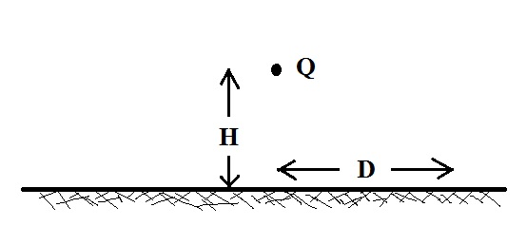

Note: if you choose the right coordinate system this is really just a 1-dimensional problem. We are only determining E and σ at the surface on the conducting plane (z=0). The problem has azimuthal symmetry so E and σ both are both functions of D only.
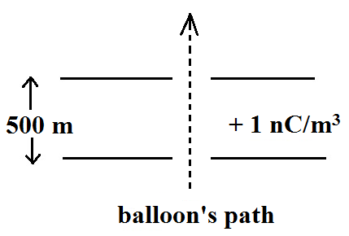
2. (10 pts) Assume a balloon borne electric field sensor is
approaching a 500 m thick layer of charge from below.
Compute and plot the electric field, E(z), that would be measured by the sensor as it approaches the layer
from below, passes through the layer, and then exits and moves away from the top of the layer. You can assume the layer has infinite horizontal extent and a uniform volume space charge density of + 1 nC/m³.
3. (10 pts) Actual measurements of fair weather electric field between the ground and about 30 km altitude are shown in the two figures below. The following two equations seem to provide a pretty good fit to the measured data:

E(z) = -200 V/m e^{- ( z / 2.8 km)} for z between 0 and 10 km altitude
E(z) = - 20 V/m e^{- ( z / 8.3 km)} for z between 10 and 30 km altitude

The negative sign in both equations indicates that the E field points downward. Use these two equations for electric field to determine the potential difference (in volts) between the ground and 30 km altitude.
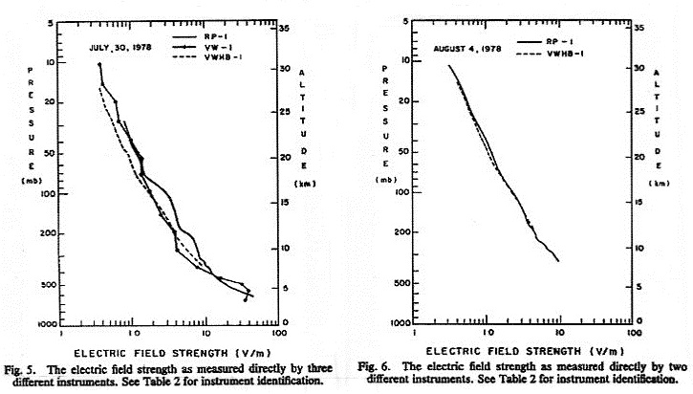

Note that electric field is shown on a logarithmic scale at the bottom of each figure. As you move from left to right the labeled values of E field are 0.1, 1.0, 10, and 100 V/m (I'm just pointing that out, it is not something you need to worry about in the problem).

The figures are from: Rosen, J.M., D.J. Hofmann, W. Gringel, J. Berlinski, S. Michnowski, Y. Morita, T. Ogawa, and D. Olson, "Results of an International Workshop of Atmospheric Electrical Measurements," J. Geophys. Res., 87, 1219-1227, 1982.

4. (10 pts) Two parallel plates are positioned a distance d apart. A voltage V is applied to the upper plate, the lower plate is grounded.

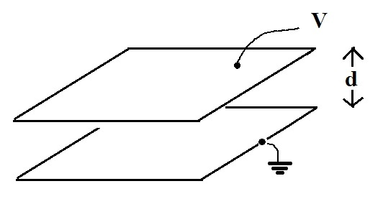

(a) Solve Laplace's equation and determine the potential φ and the electric field, E, as a function of z in between the two plates. For this problem you can assume that has just a vertical (z) component in the space between the two plates and can neglect any bending of the field lines that would occur near the edges of the plates. Effectively you can imagine that the plates have infinite horizontal extent.

(b) Determine the direction of ∇φ.

