ATMO/ECE 489/589 Spring 2017
Homework #7 due Thu., Apr. 20

1. (10 pts)The sketch below illustrates some of the paths that signals from a distant lightning return stroke could follow between the source and a receiving antenna located 100s (1000s) of kilometers away. Radiation can propagate directly to the antenna along the ground (this is the "ground wave"). Radiation initially directed upward can also arrive at the antenna after undergoing one or more reflections between the ground and a conducting layer in the lower ionosphere.

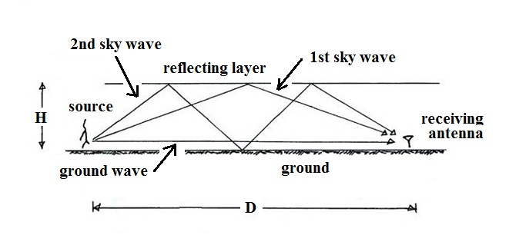

An actual recording of a distant return stroke electric field waveform is shown below. This signal was recorded at Gainesville, Florida, and was produced by a return stroke that occurred approximately 900 km to the ENE. The ground wave signal as well as the first and second "sky wave" signals (from the 1- and 3-reflection paths in the sketch above) are identified. Use the differences in the times of arrival between the ground wave and the 1st sky wave and between the ground wave and the 2nd sky waves to make two estimates of, H, the effective height of the reflecting layer in the ionosphere (you may assume that the signal source is at ground level, that the ground is flat, and that the radio waves propagate at the speed of light).
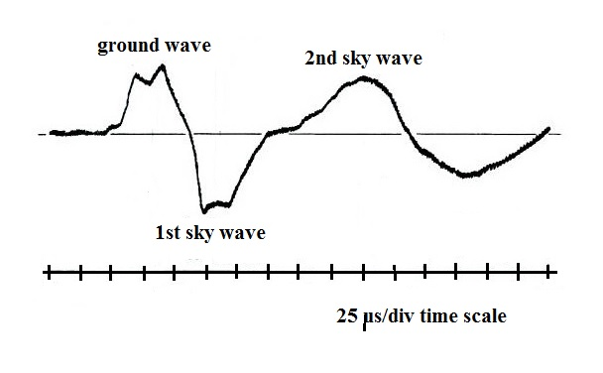

2. (10 pts) Intersections of bearing vectors from a network of magnetic direction finding sensors has produced multiple lightning strike locations, (X_{i}, Y_{i}). What would the optimal location,(X,Y), be in a case like this?
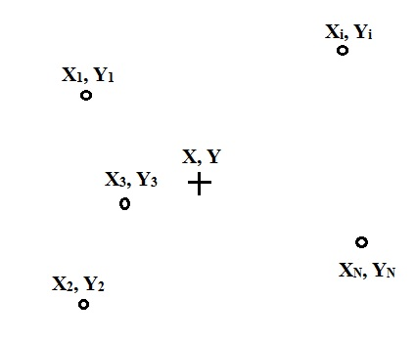

Often in problems of this kind we try to find a solution that minimizes R², the sum of the squares of the differences between the optimal location and the measured locations:

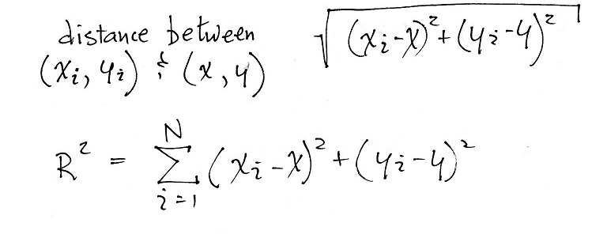

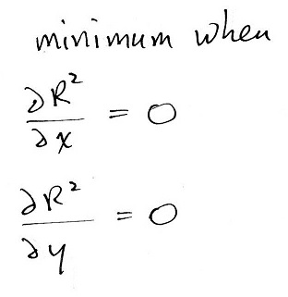
We can differentiate R² with respect to X and Y and set each equation equal to zero to find the minimum:

3. (15 pts) The definition of a hyperbola is "the set of points in a plane whose distance to fixed points in the plane have a constant difference." The object of this problem is to demonstrate the validity of that statement.
Two fixed points 1 & 2 are located at (-c, 0) and (+c, 0). A hyperbola crosses the x-axis at x = a. Point (x, y) is an arbitrary point on the hyperbola and is a distance d₁ from Point 1 and a distance d₂ from Point 2. The values of d₁ and d₂ will change depending on x and y but the difference d₁- d₂ will remain the same for any point on the hyperbola.
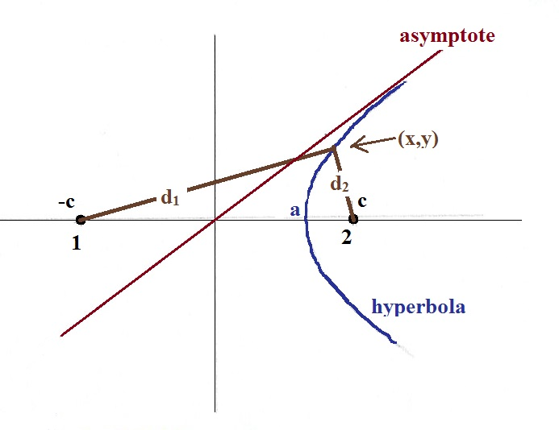

The problem has three parts:
(a) Show that d₁- d₂= 2a (hint: since d₁- d₂ remains constant, you can choose any point on the hyperbola to determine d₁- d₂ )
(b) Demonstrate that, after some manipulation, the expression above (i.e d₁ - d₂ = 2a) leads to
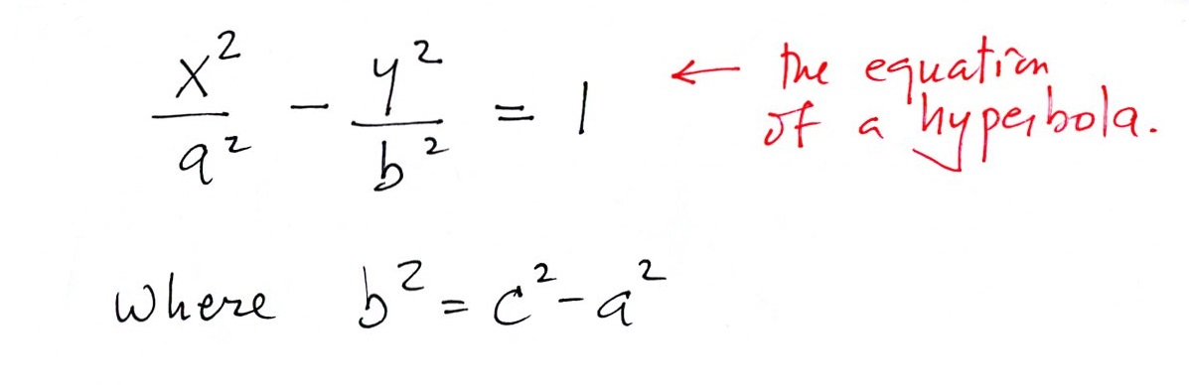

(c) Show that at large values of x and y the hyperbola becomes a straight line
