ATMO 170 In-class Optional Assignment Name_________Answers_________________
(due at the end of class)

1. Three of the following would all be located at about the same altitude. Which one is found at considerably higher altitude than the other three?
a. the flat top of a thunderstorm b. the summit of Mt. Everest
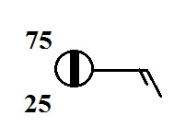
c. a commercial airliner at 30,000 ft. altitude d. the ozone layer (~25 km)
a, b, and c are all near the top of the troposphere (about 10 km)

2. According to the information plotted at right,
is MORE or LESS (1/8th) than half of the sky covered with clouds

3. The atmosphere is split into layers (troposphere, stratosphere, mesosphere, etc.) according to how _______ changes with altitude.
a. composition b. density c. pressure d. temperature
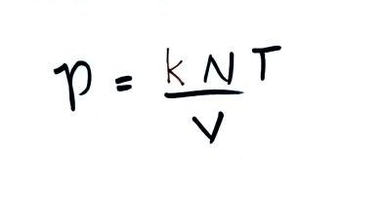
4. If you double the number (N) of air molecules in a balloon,
double the volume (V) of the balloon, and double the temperature (T),
the pressure of the air in the balloon will
a. increase by a factor of 2 b. increase by a factor of 4
c. remain constant
d. decrease by a factor of 2 e. decrease by a factor of 4
Doubling N increases P by a factor of 2. Doubling T increases P by another factor of 2, for an overall increase by a factor of 4. Doubling V decreases P by 1/2. The 4-fold increase in P caused by doubling N and T is cut in half for an overall increase of 2.

5. Warming or cooling a parcel of air in the atmosphere will cause ___V____ and ___ ρ____ to change. The ___N___ and ___P___ remain constant. (fill in the blanks with ρ (density), V (volume, N (number of air molecules), or P (pressure). Each answer should be used once.)
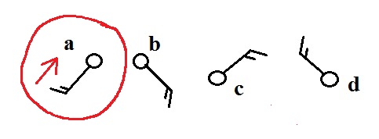
6. Circle the figure at right that shows winds
blowing from the southwest.

7. Are clouds more likely to form when moist air is WARMED or COOLED?
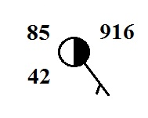
You need to cool air to its dew point.

8. Which of the following are not shown at right?
a. relative humidity b. temperature c. pressure
d. dew point e. altitude

9. Would you expect the station pressures measured in Tucson and at the summit of Mt. Lemmon to be nearly EQUAL or very DIFFERENT. Would you expect the sea level pressure estimates for Tucson and Mt. Lemmon to be nearly EQUAL or very DIFFERENT.
Pressure changes very quickly as you move vertically in the atmosphere. The station pressure measured in Tucson at 2500 ft. altitude would be very different from the station pressure measured on Mt. Lemmon at about 9000 ft. altitude. After a correction to remove the effects of altitude the two sea level pressures should be nearly the same because the Tucson valley and the summit of Mt. Lemmon aren't very far apart. Pressure changes very slowly as you move horizontally.

10. When it is 10:00 am in Tucson it is 5:00 pm in London. What time would it be in London when it is 15:00 MST in Tucson? You need to add 7 hours to the 15:00 MST. That gives you 22:00 UT or 10 pm in Greenwich (near London).

