ATMO 170 Optional Assignment Name_____________________________________

1. Find the pattern in the column of numbers at left to estimate the relative humidity for the three cases at right (Ta is air temperature, Td is dew point temperature).

Ta = 75 F, Td = 75 F, RH = 100% Ta = 55 F, Td = 35 F, RH is about__________%
Ta = 75 F, Td = 55 F, RH is about 50% Ta = 65 F, Td = 45 F, RH is about __________%
Ta = 75 F, Td = 35 F, RH is about 25% Ta = 95 F, Td = 35 F, RH is about __________%

2. Based on the information shown at right, does City A City B
CITY A or CITY B have the highest relative humidity. Ta = 90 F Ta = 70 F
Does the air in CITY A or CITY B contain the greatest Td = 60 F Td = 50 F
actual amount of water vapor?

3. The air temperature is 85 F, the pressure is 1000 mb, the mixing ratio is 10 g/kg, the dew point is 60 F, the saturation mixing ratio is 25 g/kg, the wind is blowing from the south at 15 MPH, and the time is 20:00 UT (Universal Time). What is the relative humidity?

4. To really wring the water vapor out of moist air would it be best to COOL or WARM the air?

5. Here's a solid question to test your understanding of the rain shadow effect.
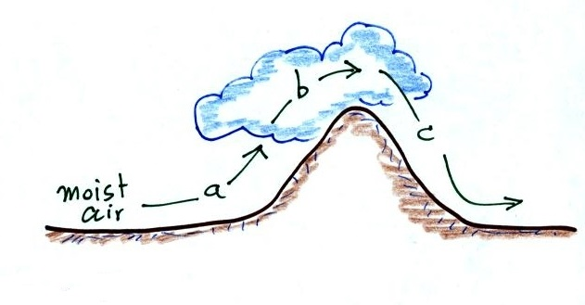
The mixing ratio, r, is increasing and RH is remaining constant _______
The RH is increasing & r is remaining constant _______
The mixing ratio, r, is decreasing and RH is remaining constant _______
The RH is decreasing & r is remaining constant _______
(fill in each blank with a, b, or c corresponding to the paths shown in the figure or
use d for nowhere; each answer should be used once)

6. Would the "drinking bird" work better on a DRY day, a HUMID day or does it
NOT MATTER?

7. A teaspoon of water has a mass of about 5 grams. How many teaspoons of water would you need to evaporate in order to saturate a kilogram of 70º F air?

8. Assume that the actual amount of water vapor in the air remains the same during the day. Then _______ and _______ won't change during the day, _______ and _______ will probably be higher in the afternoon than in the morning, and _______ will probably be higher in the morning than in the afternoon. (fill in each blank with one of the choices below, each answer should be used once)
r (mixing ratio) r_{s} (saturation mixing ratio) Ta (air temperature)
RH (relative humidity) Td (dew point temperature)

T(º F) r_{s} (g/kg)
9. Determine the mixing ratio and the relative humidity 80 21
when the air temperature is 75º F and the dew point 75 18
temperature is 55º F. (a table of saturation mixing 70 15
ratio values in included at right) 65 12
60 10
55 9
50 7.5

10. A cloud formed in a bottle in a class demonstration when sudden COMPRESSION EXPANSION caused the moist air in the bottle to WARM COOL. The "thickest" cloud formed when the air in the bottle was CLEAN SMOKY.

