ATMO 170 Optional Assignment Name_____________________________________
Thermal circulations and the 3-cell model of the earth's global scale circulation
Please select one of the following options

Option #1 Points earned on this assignment Option #2 If you make an honest attempt to
by answering the following questions correctly answer all of the questions below you will
will be added to your Final Exam score (you earn 0.25 pts of extra credit to be added to
can earn up to 8 pts) overall average prior to the Final Exam

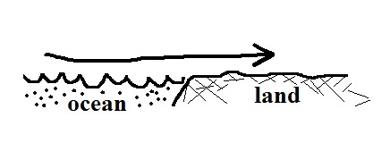
1. (2.5 pts) You can assume that the surface wind shown in
the figure is part of a thermal circulation. Would the surface winds shown be called a SEA breeze or a
LAND breeze. Would you expect the land to be WARMER
or COLDER than the ocean? Would the air over the land be RISING or SINKING? Would a surface breeze like this form during the DAY or at NIGHT? Would it be more likely to find clouds forming over the LAND or the OCEAN.

2. (2.5 pts) _______, _______, and _______ are all found at about 30º latitude in the 3-cell model of the earth's global scale circulation. _______, _______, and _______are all found at the equator. (fill in the blanks, answers can be used once, more than once, or not at all)
a. intertropical convergence zone b. doldrums c. horse latitudes
d. trade winds e. high pressure belt e. calm winds

3. (1 pts) Do the trade winds blow from the EAST or the WEST. Are the trade winds found at TROPICAL(15º) or MIDDLE(45º) latitudes.

4. (1 pt) Large cities are generally COLDER WARMER than the surrounding countryside, especially at night. This is known as the ______________________ effect.

5. (1 pt) A COLD WARM current flowing toward the NORTH SOUTH is found off the east coast of the United States.
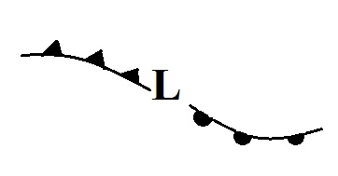
6. (1.5 pts) Are the fronts in the figure at right rotating in a CLOCKWISE or COUNTERCLOCKWISE direction around
the low pressure center. Is this a NORTHERN or SOUTHERN hemisphere middle latitude storm? Would you expect to find this storm moving from EAST to WEST or from WEST to EAST.

