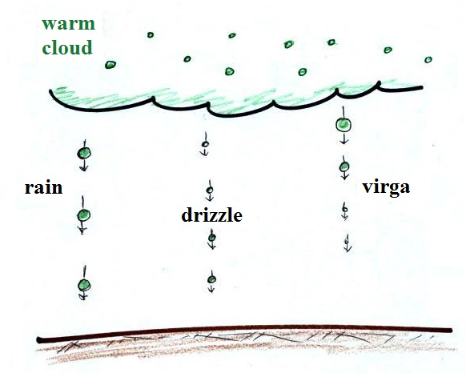
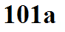
The collision coalescence (CC) process works in warm clouds, clouds that just contain water droplets. The figure below gives you some idea of the types of precipitation that the CC process can produce.

Virga is just rain that evaporates before reaching the ground.
The ice crystal (IC) process works in clouds where both ice crystals and supercooled water droplets are present. Supercooled means the droplets have been cooled to below freezing but haven't been able to freeze. The IC process is the dominant process in most locations most of the time - even Tucson in the middle of the summer. The IC process is a little harder to understand than the CC process but can produce a much larger variety of types of precipitation.
