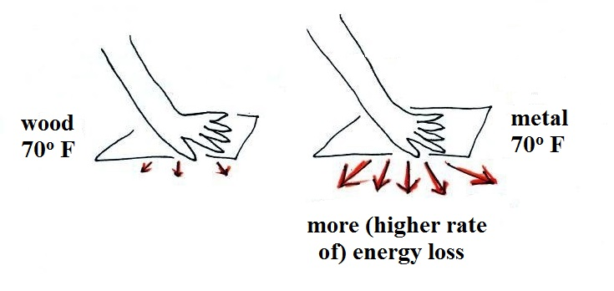

If you touch a piece of wood and a
piece of metal, the metal feels
colder even when both objects have
the same temperature. This is
because the metal is a much better
conductor than wood and will carry
energy away from your hand much
more quickly than the wood.

Our perception of cold
is more an indication of how quickly our body or hand
is losing energy
than a reliable measurement of temperature
__________________________________________________________________

