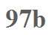
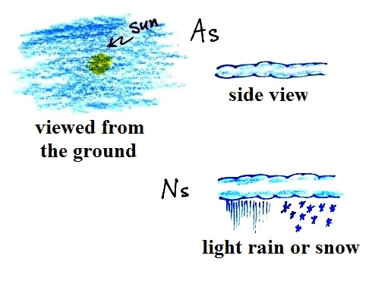
Altostratus (As) - Gray cloud layer (thicker
than Cs). The sun may be visible through thin As but
it will appear blurred or fuzzy. Mostly diffuse light
reaches the ground, not much direct sunlight so
objects on the ground do not cast shadows.

Nimbostratus (Ns) - When As thickens and begins
to produce precipitation the name changes to
Ns. Precipitation is usually fairly light, continuous,
and may cover a large area.

Fragments of cloud sometimes seen below Ns are
called stratus fractus or "scud."

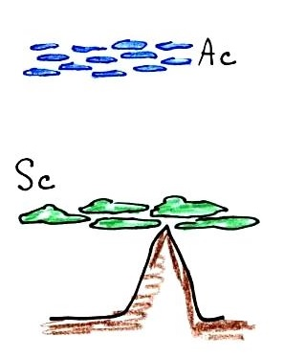

Stratocumulus (Sc) - separate "patches" of cloud that touch or are joined together. Separate cloud elements are about the size of your clenched fist.
Common low cloud type.

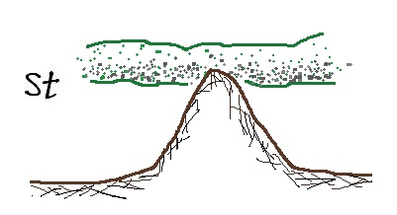

Stratus (St) - gray layer cloud. Thick enough to
completely hide the sun from view.

