ATMO 170A1 Sect. 1 Name_______________________________________
Final Exam May 9, 2016

You may refuse to answer one question on this exam. Simply write refuse next to the question of your choice and you will receive full credit for that question. Choose wisely. Each answer on this exam is worth 1 pt. A question with two parts is worth 2 pts, a question with 3 parts is worth 3 pts., etc.

1. "Oxygenated" fuels are used in Tucson to "complete" the combustion process in automobile engines.
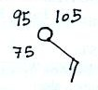
Are they used during the SUMMER or the WINTER? Do they reduce emissions of
OZONE(O₃) or CARBON MONOXIDE(CO) .

2. A temperature of 75 95 105 degrees Fahrenheit is plotted at right.
The wind is blowing from the NE NW SW SE

3. Because the earth is fairly cool it emits LONG SHORT wavelength INFRARED
ULTRAVIOLET MICROWAVE radiation.

4. The ___Fujita___________ scale is used to rate tornado intensity. (1 pt if you get the first letter of the name right, 2 pts if you spell the entire name correctly)

5. The ice crystal process produces precipitation in clouds that
a. just contain ice crystals and are colder than freezing
b. just contain water droplets and are warmer than freezing
c. contain ice crystals and water droplets and are warmer than freezing
d. contain ice crystals and water droplets and are colder than freezing

6. Widely spaced contours on a weather map would indicate a STRONG WEAK pressure gradient and would produce FAST SLOW winds.

7. The ___b___ is always inward when wind blows in a circular path. The ___c___ is always perpendicular to the height or pressure contours on a weather map. The direction of the ___a___ force is always perpendicular to the wind. (fill in the blanks)
a. Coriolis force b. net force c. pressure gradient force d. frictional force

8. Greenhouse gases absorb and emit ___IR___ light. Ozone and oxygen make the atmosphere pretty nearly completely opaque to ___UV___ light. The atmosphere is pretty much completely transparent to ___VIS___ light.[fill in each blank with VIS(visible), UV(ultraviolet), or IR(infrared)]

9. Moving over colder water would WEAKEN STRENGTHEN a hurricane. When a hurricane moves over land the strength of the frictional force will DECREASE INCREASE and the hurricane winds will blow FASTER SLOWER.

10. Because of _______ the global average surface temperature on the earth is about 60º F instead of 0º F.
a. greenhouse gases in air b. the high specific heat of water
c. kinetic energy of air molecules d. latent heat energy released during cloud formation

11. Match each of the four processes below with a a. rain b. graupel
particle or type of precipitation from the list at right. c. virga d. sleet
evaporation___c___ melting___a____
riming___b____ freezing ___d___
12. Atoms in a hot object have a lot of ___b___. Metals such as copper have high ___d____. Cold air sinks because it has high ___a____. Water vapor contains hidden ___c____. (fill in the blanks, each answer below should be used once)
a. density b. kinetic energy c. latent heat energy d. conductivity

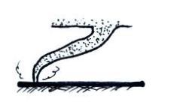
13. Judging from the sketch at right this tornado is at a relatively
STRONG WEAK and EARLY LATE stage in its
life cycle.

14. Which of the following doesn’t belong in the same group as the other three?
a. tsunami b. typhoon c. cyclone d. hurricane

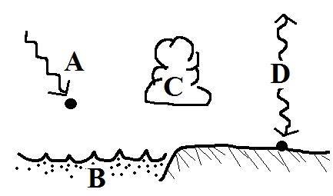
15. The atmospheric greenhouse effect is due largely to
a. the absorption & emission of infrared radiation
b. the specific heat of ocean water
c. the release of latent heat during cloud formation
d. the absorption of ultraviolet light in sunlight

16. There is less and less air left overhead when you move upward in the atmosphere.
This explains why PRESSURE TEMPERATURE always INCREASES DECREASES with increasing altitude.

17. A narrow intense thunderstorm downdraft is called a(n) ________microburst_________.

18. ___b___ below tells you a cloud is producing precipitation. ___d___ and ___e___ tell you something about a cloud's altitude. (fill in the blanks)
a. cumulo b. nimbo c. strato d. alto e. cirro

19. Let's say the skies were clear yesterday and the high temperature was 85º F and the low was 55º F. Today it is going to be cloudy. Would you expect today's high temperature to be COOLER about the SAME or WARMER than yesterday? Would tonight's low temperature be COOLER about the SAME or WARMER than it was yesterday?

20. An ordinary air mass thunderstorm lasts about _____1_____ hour(s). Lightning kills about ___100____ people every year in the United States. Thunderstorms can grow all the way to the top of the troposphere which is about ___10_____ kilometer(s) high. Sea level pressure is usually about ___1000____ millibar(s). (fill in each blank with 1, 10, 100 or 1000; each answer should be used once)

21. The strong ring of thunderstorms surrounding the eye of a hurricane is called the
a. eye wall b. wall cloud c. mesocyclone d. ring cloud

22. The _______dew point___________ is the temperature to which you must cool moist air in order to increase the relative humidity to 100%.

23. A rise in ocean levels along a coastline caused by an approaching hurricane
a. storm surge b. easterly wave c. riptide d. tsunami
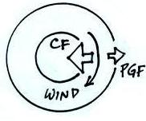
24. The figure at right shows winds blowing around HIGH LOW
pressure in the NORTHERN SOUTHERN hemisphere.

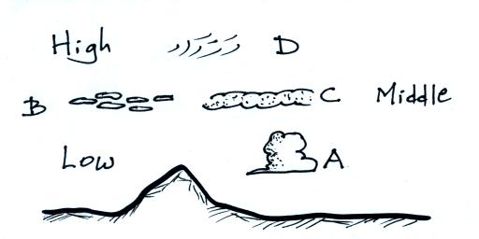
25. Correctly name any three of the clouds sketched at right

A______cumulus______ B_____altocumulus_____

C_____altostratus______ D______cirrus__________

26. An increase in the atmospheric concentration of _______ might change the color of the sky from a deep blue to a bluish-white.
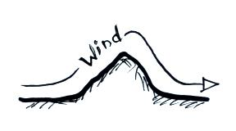
a. argon b. particulate matter c. water vapor d. ozone

27. The term rain shadow would refer to the DRY WET conditions
that would likely be found on the LEFT RIGHT side of the
mountain sketched at right.

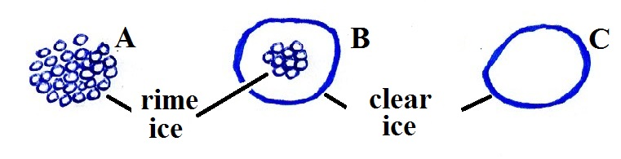
28. Everything else being equal, the coldest winter temperatures would be found at a location surrounded by OCEAN LAND. The smallest annual range of temperatures would be found at a location surrounded by LAND OCEAN.

29. Particle ___A___ at right is graupel, ___C___ is sleet
and ___B___ is hail. (fill in the blanks)

30. In an inversion layer PRESSURE TEMPERATURE increases with increasing altitude. This produces STABLE UNSTABLE atmospheric conditions that would CONCENTRATE DISPERSE any pollutants emitted into the layer.

31. Satellites are able to view clouds 24 hours a day by photographing the INFRARED ULTRAVIOLET VISIBLE light that is EMITTED REFLECTED ABSORBED by clouds.

32. A temperature of 0º C is HOTTER COLDER than 0º F. At sea level water boils at a temperature of 212º CELSIUS FAHRENHEIT KELVIN. Is 100º C HOTTER or COLDER than 300º K.

33. Most cars are made out of metal which makes them a SAFE DANGEROUS place to be during a lightning storm. It is SAFE DANGEROUS to use a cell phone during a lightning storm.

34. This instrument, invented in the 1600s by
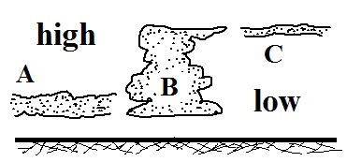
Torricelli, basically weighs the atmosphere. mercury barometer

35. (10 pts) Cloud B would appear GREY WHITE on an infrared
satellite photograph and GREY WHITE on a visible photograph.

36. Does orange light have a LONGER or SHORTER wavelength than green light. Is orange light a LESS or MORE energetic form of radiation than green light?

37. Photosynthesis is the source of most of the ___b___ in today’s atmosphere.
a. carbon dioxide b. oxygen c. water vapor d. nitrogen e. argon f. hydrogen

38. A mesocyclone is a ROTATING TILTED thunderstorm updraft and produces a(n) ANVIL WALL cloud
39. Sublimation is the opposite of deposition. Dry ice sublimates, the formation of frost is an example of deposition. What do the terms deposition and sublimation mean or refer to?
deposition = gas to solid phase change sublimation = solid to gas phase change

40. ___ SO₂___ is found in London-type smog. __ SO₂____ can react with water in clouds to form acid rain [fill in each blank with O₃ (ozone), SO₂ (sulfur dioxide) or CO (carbon monoxide)]

41. Cloud formation is more likely with surface centers of HIGH LOW pressure because they cause air to RISE SINK and COOL WARM.

42. How much an object will warm when energy is added to it depends on the object’s mass and on its
a. density b. specific heat c. latent heat d. thermal conductivity e. volume

43. Are haloes produced by THIN THICK layer clouds. Are these clouds composed of
ICE crystals or WATER droplets?

44. The release of chlorofluorocarbons (CFCs) into the atmosphere is of concern because CFCs are greenhouse gases and also because they
a. are a key ingredient in photochemical smog b. react in clouds to form acid rain
c. are heavier than air and build to hazardous levels d. react with and destroy ozone

45. "An object immersed in a fluid experiences an upward buoyant force equal to the weight of the displaced fluid" is a law postulated by
a. Newton b. Archimedes c. Galileo d. Coriolis e. Franklin

46. Which of the following creates the electricity in thunderstorms needed for lightning?
a. condensation and evaporation b. St. Elmo's fire c. expanding air
d. ultraviolet light e. collisions between precipitation particles f. wind shear
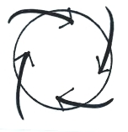
47. Does the figure at right show winds blowing around a center of HIGH or LOW pressure, in the NORTHERN or SOUTHERN hemisphere. Would these winds produce RISING or SINKING air motions?

48. The ozone layer is found in the ___S____. Cruising altitude for commercial aircraft is between 30,000 & 40,000 feet which is near the top of the ___T____. Temperature increases with increasing altitude in the ___S____. The lowest layer in the atmosphere is the ___T____. (fill in each blank with T for troposphere or S for stratosphere)

49. 95% (or more) of the air we breathe is composed of ___b____.
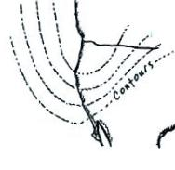
a. carbon dioxide and water vapor b. nitrogen and oxygen
c. carbon dioxide and oxygen d. oxygen and water vapor

50. The upper level weather map at right shows a RIDGE TROUGH
positioned over the west coast of the United States which means the west
is most likely experiencing COLDER WARMER than normal temperatures.

51. A parachutist is falling downward in a straight line at constant speed. The net force acting on the parachutist is DOWNWARD SIDEWAYS UPWARD ZERO. The 1st law of motion that we have been using in this course was postulated by ARCHIMEDES GALILEO CORIOLIS NEWTON.
52. If you warm moist air, the __c____ will decrease, the ___a___ and ___d___ will remain the same, and the ___b____ will increase. (fill in the blanks, each answer below should be used once)
a. r (mixing ratio) b. r_{S} (saturation mixing ratio)
c. RH (relative humidity) d. T_{D} (dew point temperature)

53. Which one of the following is produced by a thunderstorm downdraft?
a. mesocyclone b. gust front c. hook echo d. wall cloud

54. Compact fluorescent lamps (CFLs) last longer and use less energy than tungsten bulbs. There is a serious environmental concern associated with CFLs however. What is it?
CFLs contain mercury vapor which is released when/if the bulbs break.

55. If you warm a parcel of air in the atmosphere it will obey Charles' Law which means the parcel's volume will __INCR__, the density of the air in the parcel will ___DECR___, and the pressure of the air in the parcel will __SAME______. (fill in each blank with INCRease, DECRease, or remain the SAME)
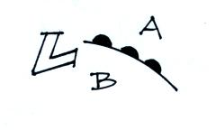
56. Does the figure at right show a COLD or WARM front?
Is the front moving toward POINT A or POINT B? Would
the warmest air be found at POINT A or POINT B?

57. A mixture of lots of red, orange, and yellow colors with lesser amounts of blue, green, and violet would produce a COOL WARM white.

58. The deadliest disaster in US history was ___a___. The costliest natural disaster in US history was ___b___. (fill in the blanks)
a. The Galveston hurricane of 1900 b. Hurricane Katrina in 2005
c. Hurricane Camille in 1969 d. The Labor Day hurricane of 1935

___________________________________________________________________________________________

Every semester there are a few students that end up just below the threshold between two grades. I find that a subset of these students didn’t complete all the required coursework. If it looks like making up the missing work would raise a student’s overall average enough for me to be able to bump them up a letter grade, I would like to be able to give them an incomplete so that they have the opportunity and extra time to make up the missing work. But I can’t really do that without checking with them first.

_______ Check here to give me permission to give you an incomplete if circumstances warrant

_______ Check here is you DO NOT WANT under any circumstances to be given an incomplete.

An incomplete means that you don’t immediately receive a grade for this class (an I appears on your transcripts). Once you’ve completed the missing work you receive a grade. You have up to one year to make up an incomplete (though I would suggest you get it done as soon as possible)

