ATMO 170 Sect. 1 Name__________________________________________
Quiz #2 Mar. 9, 2016 (please also put your name on the back)

1. (5 pts) On a day with a temperature of 40º F with 15 MPH winds, a thermometer would measure a temperature GREATER EQUAL LESS than(to) 40º F.

2. (10 pts) Boiling water and bubbling liquid nitrogen are both examples of
a. conduction b. condensation c. convection d. deposition e. evaporation

3. (5 pts) Wien's Law says that if an object warms the _______ will decrease.
a. speed of propagation b. wavelength of peak emission
c. radiative equilibrium temperature d. intensity of emitted radiation

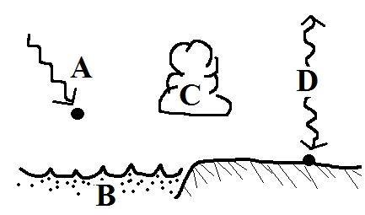
4. (5 pts) The atmospheric greenhouse effect is due largely to
a. the absorption of ultraviolet light in sunlight
b. the specific heat of ocean water
c. the release of latent heat during cloud formation
d. the absorption & emission of infrared radiation

5. (5 pts) Which of the following is visible light?
a. λmax(sun) = 0.5 µm b. λmax(tungsten bulb) = 1 µm c. λmax(earth) = 10 µm

6. (5 pts) The earth reflects about 30% of the sunlight striking it. If this increased to 40% would the earth's temperature of radiative equilibrium DECREASE remain the SAME or INCREASE
7. (10 pts) Clouds are good absorbers of FAR-INFRARED, VISIBLE, or NEAR-INFRARED light. Does this property raise the nighttime LOW temperature or lower the daytime HIGH temperature.

8. (10 pts) The coldest winter temperatures would be found at a(n) COASTAL INLAND city. A moderate climate has a SMALL LARGE annual range of temperature.

9. (10 pts) Compared to blue light, yellow light has SHORTER LONGER wavelength
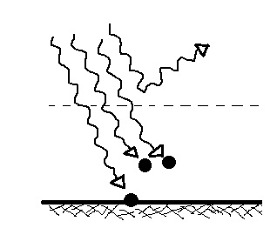
and HIGHER LOWER energy.

10. (5 pts) Four units of radiation are arriving at the top of the atmosphere in the picture at right. 1 unit passes through the atmosphere and is absorbed by the ground, 2 units are absorbed by the atmosphere, and 1 unit is reflected. To be in radiative equilibrium the atmosphere will need to emit ZERO ONE TWO THREE FOUR units of radiation.

11. (10 pts) The atoms in a hot object have an above average amount of __d___. It takes more energy to heat up water than an equal amount of soil because water has higher __c___ than soil. (fill in the blanks)
a. thermal conductivity b. latent heat c. specific heat d. kinetic energy e. density

12. (5 pts) The wavelength of peak emission for _______ falls in the visible part of the spectrum.
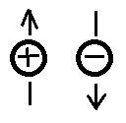
a. the sun b. the earth c. neither the earth or the sun d. both the earth and sun

13. (5 pts) The motions of the charges in the picture at right tell you the electric
field arrow points UP points DOWN is ZERO.
Name___________________________________________

14. (5 pts) An object at room temperature that feels cold to the touch probably has
a. low specific heat b. low thermal conductivity c. low latent heat
d. high specific heat e. high thermal conductivity f. high latent heat

15. (5 pts) The main benefit of the greenhouse effect is to
a. absorb harmful ultraviolet radiation b. provide nutrients needed by growing plants
c. increase global average surface temperature d. transport water from the oceans to the land

16. (15 pts) A temperature of 0º F is HOTTER COLDER than 0º C. At sea level water boils at a temperature of 212º CELSIUS FAHRENHEIT KELVIN. Is 100º C HOTTER or COLDER than 300º K.

17. (5 pts) A factor of two increase in the temperature of an object causes a _______ in the amount of radiation emitted by the object.
a. 2 times increase b. more than 2 times increase c. 2 times decrease d. more than 2 times decrease

18. (10 pts) Dry ice changes directly from a solid to a gas without melting. Is this called DEPOSITION or SUBLIMATION? Does the formation of frost ADD energy to or REMOVE energy from the surrounding air.

19. (10 pts) Which two of the following are false?
a. The earth's surface emits more radiant energy than it receives from the sun
b. The atmosphere cannot emit radiant energy into outer space
c. Over 90% of the sunlight arriving at the top of the atmosphere reaches the ground
d. Thinning of the ozone layer is not the cause of global warming

20. (5 pts) When water vapor condenses it releases
a. IR radiation b. latent heat c. specific heat d. kinetic energy

21. (15 pts) Ozone and oxygen make the atmosphere pretty nearly completely opaque to ___UV____ light. Greenhouse gases absorb and emit ___IR____ light. The atmosphere is pretty much completely transparent to ___VIS___ light.[fill in each blank with VIS(visible), UV(ultraviolet), or IR(infrared)]

22. (10 pts) A thin layer of air in contact with hot ground will warm by ___d____. Once the air becomes warm it will start to rise and transport energy upward by ___b____. (fill in the blanks)
a. convergence b. convection c. latent heat d. conduction

Extra Credit (you can earn up to 10 pts)
1. (5 pts) A black object is a good REFLECTOR TRANSMITTER ABSORBER EMITTER of visible light.

2. (5 pts) A mixture of lots of red, orange, and yellow colors with lesser amounts of blue, green, and violet would be produce a COOL WARM white.

3. (5 pts) Compact fluorescent lamps (CFLs) last longer and use less energy than tungsten bulbs. There is a serious environmental concern associated with CFLs however. What is it? They contain mercury vapor

