ATMO 170 Sect. 1 Name______________________________________
Quiz #3 Apr. 6, 2016 (please also put your name on the back)

1. (5 pts) Are the variables for mixing ratio (r) and saturation mixing ratio (r_{S}) found in the equation for RELATIVE HUMIDITY, DEW POINT, or HEAT INDEX.

2. (10 pts) ___b___ would be used to name a layer cloud. ___c____ would be used in a middle altitude cloud's name. (fill in the blanks)
a. Nimbo b. Strato c. Alto d. Cirro e. Cumulo

3. (5 pts) In the ice crystal process precipitation forms in the cloud
a. at below freezing temperatures where there are water droplets and ice crystals
b. at below freezing temperatures where there are just ice crystals
c. at warmer than freezing temperatures where there are just water droplets
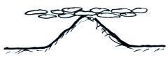
d. at warmer than freezing temperatures where there are water droplets and ice crystals

4. (10 pts) Is the cloud sketched at right a HIGH or LOW altitude cloud. Is it a STRATUS, CUMULUS or STRATOCUMULUS cloud?

5. (5 pts) Which of the following doesn't belong in the same group as the other three?
a. graupel b. rime ice c. sleet d. milky white appearance

6. (5 pts) To determine the saturation mixing ratio you need to know the air's
a. pressure b. density c. temperature d. relative humidity

7. (10 pts) Satellites are able to view clouds 24 hours a day by photographing the VISIBLE ULTRAVIOLET INFRARED light that is EMITTED REFLECTED ABSORBED by clouds.

8. (5 pts) Do particles in the air make it EASIER for clouds to form, HARDER for clouds to form, or do particles play NO ROLE in cloud formation?

9. (10 pts) If you were to warm some moist air but didn't add or remove any water vapor, the ___a___ would increase and the ___c___ would decrease. (fill in the blanks)
a. saturation mixing ratio b. dew point c. relative humidity d. mixing ratio

10. (5 pts) The maximum amount of water vapor that can be found in air depends on the
a. air temperature b. air density c. dew point d. air pressure

11. (10 pts) Are haloes produced by THIN THICK layer clouds. Are these clouds composed of
ICE crystals or WATER droplets?
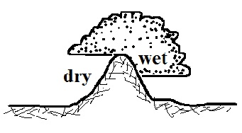
12. (10 pts The term rain shadow refers to conditions on the WET DRY
side of the mountain in the picture at right. Would rising air motions
be found on the WET or DRY side of the mountain.

Name______________________________________

13. (15 pts) Which three of the following are true? (CC = collision coalescence, IC = ice crystal,
Ns = nimbostratus, and Cb = cumulonimbus)
a. Both the IC process and the CC process can produce rain
b. In Tucson the IC process produces winter precipitation, the CC summer precipitation
c. The CC process works best when the water droplets have different sizes
d. The CC process only works in Cb clouds, the IC only in Ns clouds
e. The IC process is capable of producing larger precipitation particles than the CC process
f. The largest precipitation particles are produced by clouds with weak updrafts

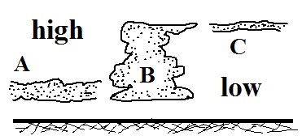
14. (5 pts) Did a cloud form in the cloud-in-a-bottle demonstration when the air EXPANDED and cooled or when the air was COMPRESSED and warmed?

15. (10 pts) Cloud B would appear WHITE GREY on an infrared
satellite photograph and WHITE GREY on a visible photograph.

16. (5 pts) If you COOL WARM air enough you can remove some of the moisture from it.

17. (20 pts) A high altitude cloud with a streaky, wispy appearance would be ___e____. Haloes are a pretty good indication that ___f____ clouds are overhead. A thunderstorm is a(n) ___a___cloud. A middle level, layer cloud producing light rain or snow would be called____c____. (fill in the blanks)
a. cumulonimbus b. altostratus c. nimbostratus
d. cumulus e. cirrus f. cirrostratus
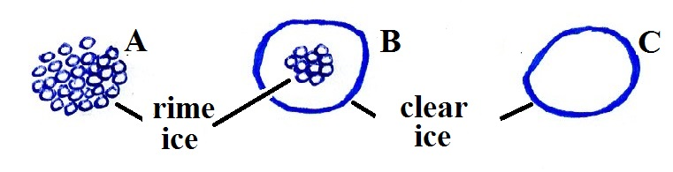
18. (15 pts) Particle ___C____ at right is sleet, ___B___ is hail
and ___A____ is graupel. (fill in the blanks)

19. (10 pts) Rain that evaporates before reaching the ground is ___e___.
An "ice storm" is caused by ___b___. (fill in the blanks)
a. hail b. freezing rain c. sleet d. snow e. virga f. graupel
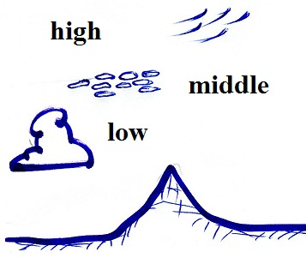
EXTRA CREDIT (you can earn up to 15 pts)
1. (6 pts) Identify any two of the clouds in the figure at right.
from top to bottom: cirrus, altocumulus, cumulus

2. (5 pts) What do meteorologists call the colored spots of light sometimes seen to the right and left of the rising or setting sun? sundogs

3. (5 pts) When the relative humidity increases and dry haze turns to wet haze, does the visibility
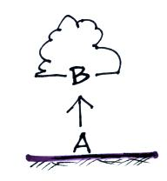
IMPROVE, stay the SAME, or WORSEN.

4. (5 pts) As air rises from the ground (Pt. A) to cloud base (Pt. B) as shown in the figure at right, the _______ will increase.
a. mixing ratio b. relative humidity c.. air temperature d. saturation mixing ratio

