ATMO 170 Sect. 1 Name_________________________________________
Quiz #4 April 27, 2016 (please also put your name on the back)

1. (10 pts) The direction of the pressure gradient force (PGF) is ___a____.
The direction of the Coriolis force is ___b____. (fill in the blanks)
a. perpendicular to the contours on a weather map b. perpendicular to the wind
c. parallel to the wind d. parallel to the contours on a weather map

2. (5 pts) The _______ associated with microbursts makes them a serious weather hazard.
a. high pressure b. cold temperatures c. strong winds d. static electricity

3. (5 pts) On average there are about 50 100 500 1000 5000 tornadoes per year in the US.

4. (10 pts) Which two of the following would indicate a thunderstorm with a rotating updraft?
a. gust front b. anvil cloud c. wall cloud d. hook echo e. lightning f. microburst

5. (10 pts) Intracloud lightning is MORE LESS common than cloud-to-ground lightning. Positive cloud-to-ground lightning is MORE LESS common than negative cloud-to-ground lightning.
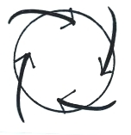
6. (15 pts) Does the figure at right show winds blowing around a center of HIGH or LOW pressure, in the NORTHERN or SOUTHERN hemisphere. Would these winds produce RISING or SINKING air motions?

7. (5 pts) Which of the following creates the electricity in thunderstorms needed for lightning?
a. ultraviolet light b. collisions between precipitation particles c. wind shear
d. condensation and evaporation e. St. Elmo's fire f. expanding air
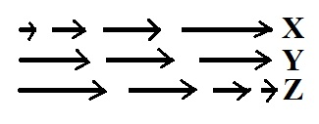
8. (10 pts) The net force is zero in ___Y___. The net force points right in __X____.
(fill in each blank with NONE of the figures., ALL of the figures,
figure X, figure Y, or figure Z )

9. (5 pts) Which one of the following is produced by a thunderstorm downdraft?
a. mesocyclone b. wall cloud c. gust front d. hook echo

10. (5 pts) Stationary air will start to move in the direction of the _______ force.
a. frictional b. inward c. pressure gradient d. Coriolis

11. (5 pts) The _______ is the first process in a negative cloud to ground lightning discharge.
a. dart leader b. upward discharge c. return stroke d. stepped leader

12. (5 pts) Increasing wind speed with increasing altitude is known as
a. wind shear b. an inversion c. an unstable layer d. acceleration

13. (15 pts) There is no ___a___ at the Equator. The strength of the ___c___ force will depend on the type of surface the wind is blowing across. The ___b___ always points inward when an object moves in a circular path. (fill in the blanks)
a. Coriolis force b. net force c. frictional force d. pressure gradient force

Name_________________________________________
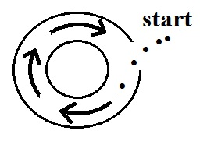
14. (10 pts) The direction of the initial motion, shown with dots in the figure at right, means this is a center of HIGH LOW pressure. The bending that occurs after the wind starts to blow
indicates that this is a NORTHERN SOUTHERN hemisphere chart

15. (5 pts) If lightning strikes 1 mile away, there would be a ONE THREE FIVE TEN second delay between the flash of light and the sound of the thunder.

16. (10 pts) Which of the following are true when there is no net force being exerted on an object.
a. a moving object could be changing speed but would need to be moving in a straight line
b. a moving object could be changing direction but would need to be moving at constant speed
c. the object could be stationary
d. a moving object could be moving in a straight line at constant speed
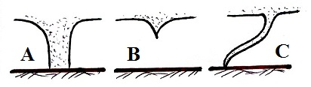
17. (10 pts) The tornado in Fig. A is probably fairly STRONG WEAK. The tornado in Fig. C is probably EARLY LATE in its life cycle.

18. (10 pts) Which two of the following are true of tornadoes?
a. tornadoes form with equal frequency in the fall and in the spring
b. tornadoes can spin clockwise or counterclockwise
c. most tornadoes have spinning winds of 100 MPH or less
d. tornadoes can spin around a core of high or low pressure

19. (5 pts) _______ blow parallel to the contours on a weather map
a. only upper level winds b. both upper level and surface winds
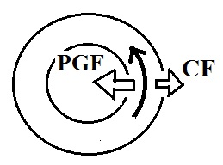
c. neither upper level or surface winds d. only surface winds

20. (10 pts) Does the figure at right show winds blowing around a center
of HIGH or LOW pressure? Is this a NORTHERN or
SOUTHERN hemisphere chart?

21. (5 pts) An air mass thunderstorm will begin to weaken and dissipate when
a. the downdraft grows horizontally b. all of the cloud and precipitation particles turn to ice
c. the cloud top reaches the stratosphere d. electrical charge begins to produce lightning

22. (5 pts) The ________Fujita___________ scale is used to rate tornado intensity.

Extra Credit (you can earn up to 10 pts)
1. (5 pts) The Coriolis force is caused by
a. temperature differences between the equator and poles b. the tilt of the earth
c. temperature differences between land and ocean d. the rotation of the earth

2. (6 pts) Would frequent LIGHTNING or large HAIL be a better indicator of a severe thunderstorm? Potentially the strongest and longest lived thunderstorm is one with a TILTED VERTICAL updraft.

3. (6 pts) Most cars are made out of metal which makes them a DANGEROUS SAFE place to be during a lightning storm. It is DANGEROUS SAFE to use a cell phone during a lightning storm.

