ATMO 170 Name_______________________________
In-class Optional Assignment
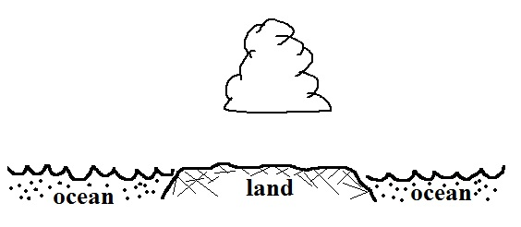
1. You can assume that winds in a thermal circulation are responsible for the cloud development shown in the figure at right. Would you expect to find RISING or SINKING air over the land. Would the land most likely be WARMER or COLDER than the ocean water. Would a cloud like this most likely develop during the DAY or at NIGHT?

2. The Coriolis force plays a(n) IMPORTANT NEGLIGIBLE role in the development of a thermal circulation.

4. The _______, _______, and _______ are all found at about 30º latitude in the 3-cell model of the earth's global scale circulation. The _______, _______, and _______are all found at the equator. (fill in the blanks, answers can be used once, more than once, or not at all)
a. intertropical convergence zone b. doldrums c. horse latitudes
d. trade winds e. high pressure belt f. calm winds

5. Low pressure belts or a center of low pressure are found at which two of the following latitudes in the 3-cell model?
a. 0º (equator) b. 30º c. 45º d. 60º e. 90º (poles)

6. Do the trade winds blow from the EAST or the WEST. Are the trade winds found at TROPICAL(15º) or MIDDLE(45º) latitudes.

7. Tucson is located at 32º latitude which is near which of the following 3-cell model features.
a. doldrums b. polar front c. subtropical high pressure belt d. ITCZ

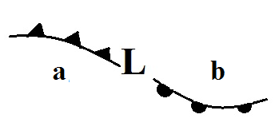
8. Would you expect the following storm system to be found in the NORTHERN or SOUTHERN hemisphere. Are the winds
spinning CLOCKWISE or OUNTERCLOCKWISE around the low pressure center. Is the air at Point a WARMER or COLDER than at Point b. Would the storm be moving from EAST to WEST or from WEST to EAST.

