ATMO 170 Name_______________________________
In-class Optional Assignment

1. Because of ______ the average surface temperature on the earth is 60º F instead of about 0º F.
a. free convection b. latent heat energy transport
c. high specific heat of water d. the greenhouse effect

2. About 44% of the radiation emitted by the sun is visible light. Most of the remaining
radiation (49%) falls in the INFRARED ULTRAVIOLET portion of the spectrum.

3. If a careful series of measurements revealed that the wavelength of peak emission from the sun (λ_{MAX}) was slowly shifting to longer wavelength, you might conclude the sun was getting
a. hotter b. bigger c. colder d. smaller e. closer

4. Micrometers (μm) are units of
a. energy b. distance c. frequency d. speed

5. Which two of the following are not found in the infrared (IR) portion of the spectrum?
a. 0.5 μm light b. peak emission from the earth
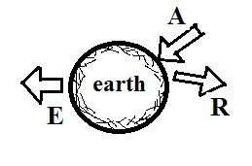
c. peak emission from a tungsten bulb d. peak emission from the sun

6. A in the figure at right represents incoming sunlight that is absorbed by the earth. R is incoming sunlight that is reflected, and E is radiation emitted by the earth. Which of the following equations would be true when the earth is in radiative equilibrium?
a. E = A + R b. A = E c. A = E + R d. E = R

7. An object that emits all the colors of visible light (violet, blue, green, yellow, orange, and red) will appear ____________________.
An object that absorbs all these colors will appear _______________________.

8. The earth’s surface emits radiant energy 24 hours per day. Does the emission peak during the DAY, at NIGHT, or is the emission about the SAME throughout the day? (hint: what does the amount of radiant energy emitted by an object depend on?)
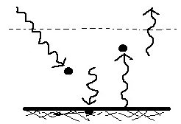
9. _______ is(are) in energy balance in the figure at right.
a. The atmosphere but not the ground
b. Both the ground and atmosphere
c. The ground but not the atmosphere
d. Neither the ground nor the atmosphere

10. About 50% of the sunlight reaching the top of the atmosphere is
a. absorbed by ozone b. reflected by air molecules & clouds
c. absorbed by the ground d. absorbed by greenhouse gases

