ATMO 170 In-class Optional Assignment Name______________________________________

1. Stratiform clouds grow HORIZONTALLY VERTICALLY and indicate STABLE UNSTABLE atmospheric conditions.

2. Days are currently GREATER LESS than 12 hours long and are getting LONGER SHORTER.
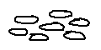
3. Pieces of cloud that are about the size of your thumbnail would
indicate a HIGH MIDDLE LOW altitude cloud.

4. Is a gust front produced by a thunderstorm UPDRAFT or DOWNDRAFT?

5. A 200 µm diameter drizzle drop has a volume that is _______ larger than a 20 µm cloud droplet.
a. 10 b. 100 c. 1000 d. 1,000,000

6. Is most of the summer rain in Tucson produced by the IC or CC process?
Is most of the winter rain in Tucson produced by the IC or CC process?
(IC stands for Ice Crystal, CC stands for Collision Coalescence)
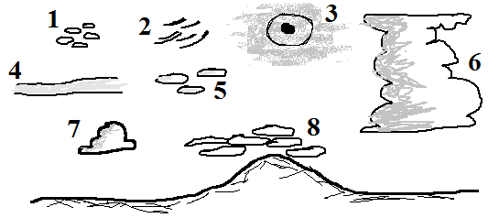
7. What two cloud types are missing
from the figure at right?

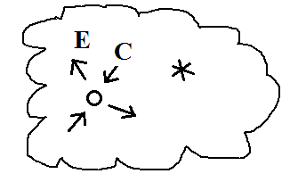
8. A supercooled water droplet and an ice crystal are shown inside
a cold cloud. The water droplet is in equilibrium with the
surroundings (equal rates of evaporation (E) and condensation (C)). Which of the following combinations of evaporation and condensation would you expect to find around the ice crystal?
a. 2 E & 2 C b. 1E & 1 C c. 2 E & 1 C d. 1 E & 2 C

9. Match each of the processes below with one of the precipitation a. graupel particles in the list at right b. rain
c. sleet
evaporation______ freezing______ melting______ riming______ d. virga

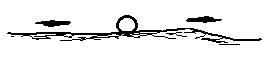
10. What do you call the bright spots of light found to the right and left
of the setting sun in the figure at right?

