ATMO 170 In-class Optional Assignment Name__________Answers____________________

1. Stratiform clouds grow HORIZONTALLY VERTICALLY and indicate STABLE UNSTABLE atmospheric conditions.

2. Days are currently GREATER LESS than 12 hours long and are getting LONGER SHORTER.
Days have been getting longer since the Dec. 21 Winter Solstice and will continue to do so until the Summer Solstice on June 21. The days were 12 hours long on the Mar. 20 Spring Equinox.
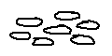
3. Pieces of cloud that are about the size of your thumbnail would
indicate a HIGH MIDDLE LOW altitude cloud.
The cloud pieces in stratocumulus, a low cloud, are about fist size.

4. Is a gust front produced by a thunderstorm UPDRAFT or DOWNDRAFT?

5. A 200 µm diameter drizzle drop has a volume that is _______ larger than a 20 µm cloud droplet.
a. 10 b. 100 c. 1000 d. 1,000,000
A 200 µm diameter drop is 10 times bigger across, 10 time bigger top to bottom and 10 times bigger from front to back than a 20 µm droplet. That's a factor os 10 x 10 x 10 = 1000

6. Is most of the summer rain in Tucson produced by the IC or CC process?
Is most of the winter rain in Tucson produced by the IC or CC process?
(IC stands for Ice Crystal, CC stands for Collision Coalescence)
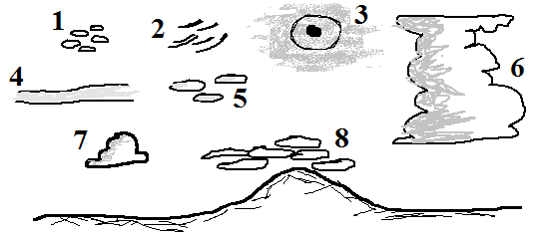
7. What two cloud types are missing
from the figure at right?
Nimbostratus (basically the same as
Cloud 4 except that it is producing
precipitation)
and Stratus

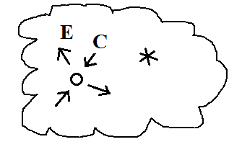
8. A supercooled water droplet and an ice crystal are shown inside
a cold cloud. The water droplet is in equilibrium with the
surroundings (equal rates of evaporation (E) and condensation (C)). Which of the following combinations of evaporation and condensation would you expect to find around the ice crystal?
a. 2 E & 2 C b. 1E & 1 C c. 2 E & 1 C d. 1 E & 2 C
The most frequently missed question on the assignment. The ice crystal will be evaporating (sublimating actually) but at a lower rate that the water droplet. It's a bigger step going from solid to gas than from liquid to gas so there won't be as many ice molecules able to do it.
The rate of condensation (deposition) depends on how much moisture is in the air. The ice crystal and the water droplets are surrounded by the same most air. So the rates of condensation to the droplets and the ice crystal are equal.

9. Match each of the processes below with one of the precipitation a. graupel particles in the list at right b. rain
c. sleet
evaporation__d__ freezing __c___ melting__b___ riming___a___ d. virga
Virga is rain that evaporates before reaching the ground, sleet is rain that freezes
before reaching the ground. Rain in Tucson is produced by the ice crystal process and
starts out with an ice particle of some kind (graupel or snow) that melts on the way
to the ground. Graupel is produced by riming.

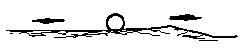
10. What do you call the bright spots of light found to the right and left
of the setting sun in the figure at right? sundogs

