ATMO 170 Spring 2019 Name_______________________________
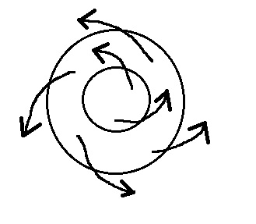
Forces & Winds Optional Assignment

1. Does the figure show SURFACE or UPPER-LEVEL
winds? Are they blowing around a center of HIGH
or LOW pressure? Are these SOUTHERN or
NORTHERN hemisphere winds?

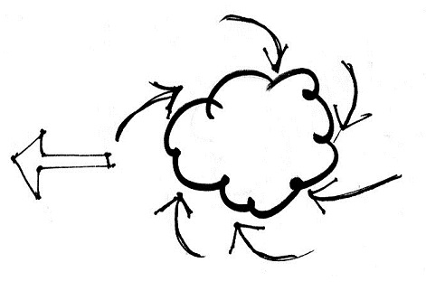
2. The clouds in the storm system at right are being produced by
surface winds that are spinning in a clockwise direction and
spiraling inward (convergence). The storm itself is moving
from the east toward the west. Based on this information you
can conclude this is a (circle three choices below, one from each
column)
Northern hemisphere middle latitude anticyclone
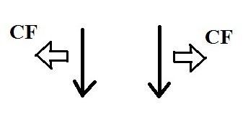
Southern hemisphere tropical cyclone

3. Circle the figure that shows winds blowing in the southern
hemisphere? (CF shows the direction of the Coriolis force)

4. Isaac Newton
a. invented calculus b. formulated a law of gravitation c. formulated laws of motion
d. discovered that when white light shines through a glass prism it is split into colors
e. all of the above
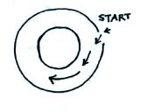
5. The direction of the initial motion in the figure at right
means this is a center of HIGH LOW pressure. Rather
than going straight toward the center of the picture the
wind turns to the left. The direction of this bending
means that this is a NORTHERN SOUTHERN
hemisphere chart.

6. The direction of the ______ force changes when you move from the northern to the southern hemisphere.
a. Coriolis b. frictional c. gravitational d. pressure gradient
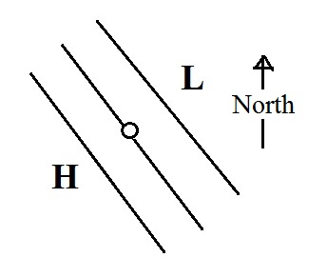

7. At the point shown in the figure at right,
the pressure gradient force (PGF) will point
toward the _______ in the northern hemisphere
and toward the _______ in the southern hemisphere.
(fill in each blank with NE, NW, SE, or SW)

8. The term ______________________________ refers to a seasonal change in the direction of the prevailing winds.

9. The term cyclone refers to winds spinning
a. around a low pressure core b. around a core of high pressure
c. spinning in a clockwise direction d. in a counterclockwise direction
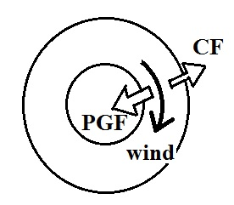

10. The direction of the PGF in the figure at right
tells you that this is a center of HIGH LOW
pressure. The direction of the CF is to the
RIGHT LEFT of the wind which indicates
this is a SOUTHERN NORTHERN hemisphere
chart. Does the fact that only two forces are shown
mean this is a SURFACE or UPPER LEVEL wind.

11. Rising air motions are produced by surface centers of HIGH LOW pressure in the northern hemisphere and centers of HIGH LOW pressure in the southern hemisphere.

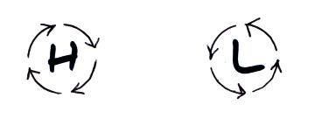
12. The wind is blowing in a circular path at constant
speed in the two figures at right. The direction
of the net force is
a. inward around L, outward around H
b. inward in both figures
c. in the direction of motion in both figures
d. zero in both figures

13. The strength of the _______ force and the _______force depend on wind speed.
a. Coriolis b. frictional c. gravitational d. pressure gradient force
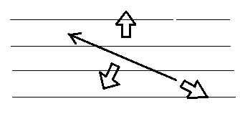
14. Identify the three forces in the figure at right.
Does this shown SURFACE or UPPER LEVEL
winds. Are these NORTHERN or SOUTHERN
hemisphere winds. Is low pressure found at the
TOP or BOTTOM edge of the figure.

15. When a hurricane moves from the ocean onto land you would expect to see a(n) DECREASE INCREASE in the strength of the frictional force and a(n) DECREASE INCREASE in the speed of the hurricane winds.

