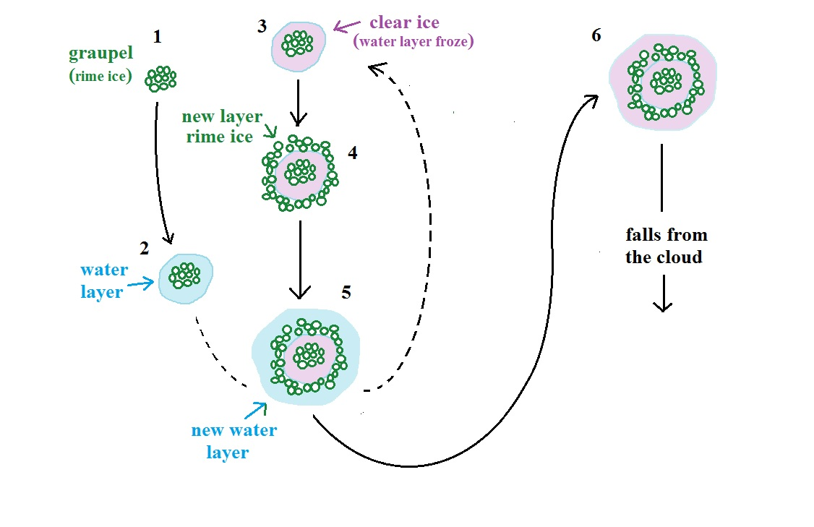
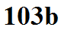
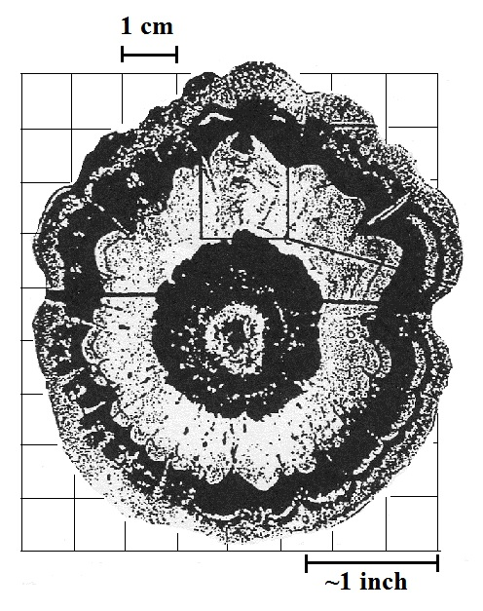
Cross section of an actual hailstone.
The image on the page is roughly
actual size.

