ATMO 170 Sect. 2 Name________________________________________
Quiz #3 April 3, 2019 (please also put your name on the back)

1. (15 pts) _______ would be used to name a cloud producing precipitation. _______ would be used in a middle altitude cloud's name. Layer clouds have _______ in the cloud's name. (fill in the blanks)
a. nimbo b. strato c. alto d. cirro e. cumulo

2. (5 pts) A thunderstorm is a _______ cloud.
a. cumulonimbus b. stratocumulus c. cirrostratus d. nimbostratus

3. (10 pts) Which two of the following are true?
a. ice crystals and water droplets at the same temperature evaporate at the same rate
b. clouds can be composed of ice crystals or water droplets but not a mixture of both
c. condensation nuclei are abundant, ice crystal nuclei are scarce
d. water droplets cooled to below freezing don't always freeze

4. (5 pts) Are sundogs and haloes produced when sunlight passes through a cloud of SMOKE particles, WATER droplets, or ICE crystals.

5. (5 pts) An ice storm is generally associated with which of the following types of precipitation?
a. hail b. sleet c. snow d. graupel e. freezing rain

6. (5 pts) Grams per kilogram are the units of
a. air density b. dew point c. mixing ratio d. relative humidity

7. (10 pts) A thick, relatively warm, low altitude layer clouds will appear WHITE GREY on a visible satellite photograph and WHITE GREY on an IR satellite photograph.

8. (5 pts) The variables mixing ratio (r) and saturation mixing ratio (r_{S}) are used to calculate the
a. relative humidity b. dew point c. heat index d. wet bulb temperature

9. (10 pts) During the cloud-in-a-bottle demonstration, the cloud formed when EXPANSION COMPRESSION caused the air in the flask to suddenly COOL WARM.

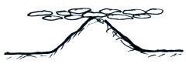
10. (10 pts) Is the cloud sketched at right a HIGH or LOW altitude cloud? Is it a STRATUS, CUMULUS, STRATOCUMULUS or NIMBUS cloud?

11. (10 pts) Satellites are able to view clouds 24 hours per day by photographing the VISIBLE ULTRAVIOLET INFRARED light that is EMITTED REFLECTED ABSORBED by the clouds
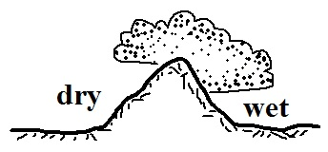
12. (10 pts) The term rain shadow refers to conditions on the WET DRY side of the mountain in the picture at right. Would rising air motions be found on the WET or DRY side of the mountain?

13. (5 pts) The maximum amount of water vapor that can be found in air depends on the _______.
a. air temperature b. air density c. dew point d. air pressure
Name_________________________________________

14. (10 pts) Rain that evaporates before reaching the ground is called _______. Rain that freezes before hitting the ground is _______. (fill in the blanks)
a. snow b. sleet c. freezing rain d. virga e. hail f. graupel

15. (10 pts) Which two of the following are true of the collision-coalescence process?
a. works best when the cloud droplets have different sizes
b. produces larger raindrops when the updrafts are strong
c. produces the electrical charge needed for lightning

d. produces most of the summer rain in Tucson

16. (5 pts) A falling snow crystal is colliding with supercooled water droplets which stick
and freeze to the crystal. This process is called _______.
a. collision coalescence b. riming c. aggregation d. deposition

17. (5 pts) A combination of cold temperatures and wind make it feel colder than it really is. A combination of hot temperatures and ____________________ make it feel hotter than it really is.

18. (10 pts) Mixing ratio and _____ provide an idea of the actual amount of water vapor in the air. If you warm the air but don't add or remove any water vapor the _______ will decrease. (fill in the blanks)
a. relative humidity b. saturation mixing ratio c. dew point d. air temperature

19. (15 pts) _______ is a high altitude cloud with a filamentary appearance. A low altitude _______ cloud will sometimes resemble a head of cauliflower. A halo is a pretty good indication that a _______ cloud
is overhead. (fill in the blanks)
a. cumulonimbus b. cirrostratus c. nimbostratus
d. cumulus e. stratocumulus f. cirrus

20. (5 pts) Foggy conditions outside would mean the _______ is high.
a. relative humidity b. dew point c. mixing ratio d. saturation mixing ratio

21. (5 pts) If you COOL WARM air enough you can remove moisture from it.
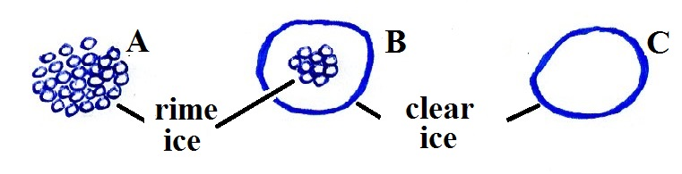
22. (10 pts) Particle _______ at right is sleet, _______ is hail
and _______ is graupel. (fill in the blanks)

Extra credit (you can earn up to 10 pts)
1. (5 pts) Which of the following would cause moisture to be removed from air with a temperature of 75º F and a dew point of 55º F?
a. cooling the air to 65º F b. cooling the air to 45º F c. warming the air to 85º F

2. (5 pts) You would never find hail falling from a NIMBOSTRATUS CUMULONIMBUS cloud.

3. (5 pts) Which of the following is not a feature found on cumulonimbus clouds?
a. shelf cloud b. lenticular cloud c. anvil cloud d. mammatus cloud

