Quiz #1 Study Guide (preliminary)
Questions on Quiz #1 will come from topics on this study guide together with material on the Practice Quiz Study Guide

*** Chap. 1 (pps 13-22), Chap. 6 (pps 142-149), Appendix C (pps 441-442) ***
Station model notation. How and where are the following weather variables plotted: cloud cover, temperature, dew point temperature (typical values for Tucson), wind direction and speed, common weather symbols (rain, snow, fog, rain shower, thunderstorm, tropical storm and hurricane), pressure. Units. After pressure is measured, what important adjustment is made before the pressure is plotted on the surface map? Why is that necessary? Average and typical range of sea-level pressure values.
Surface weather maps. A new map is prepared hourly. What time zone or time reference is used? 24-hour clock (what time is it when it is 17:30 MST in Tucson). Isobars and isotherms. Small horizontal differences in pressure cause the wind to blow. Air motions around high and low pressure centers (northern hemisphere). Strong and weak pressure gradients. Convergence and divergence. Rising and sinking air motions. How do wind motions around highs and low affect the temperature pattern? Cold fronts and warm fronts (where is the warm and cold air, what direction are the fronts moving).
Upper level charts pt 1
Ridges (warm air below) and troughs (cold air below). Winds blow parallel to contour lines and from west to east. How can upper level convergence or divergence affect surface pressure to increase or decrease? Is upper level convergence or divergence needed to cause a hurricane to intensify?
Upper level charts pt 2 (see pps 115-119 in the photocopied notes).
Pressure decreases with increasing altitude in the atmosphere. Does pressure decrease more quickly in warm or cold air, in high or low density air? Are upper level conditions normally displayed on constant altitude or constant pressure charts?
How does the pressure at point A in the crossectional figure (right figure below) compare with the pressure at Point B? Is pressure decreasing most rapidly with increasing altitude on the right or left side of the figure? Is the coldest air found on the right or left hand side of the figure?

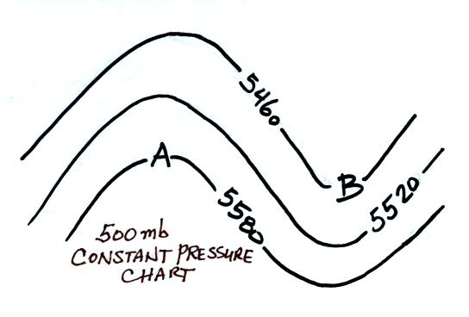 | 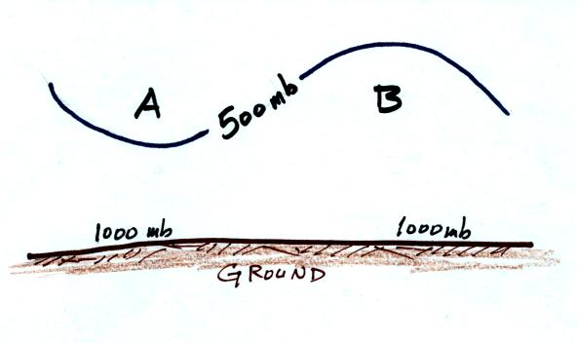
What do the numbers on the contour lines on the constant pressure (isobaric) map (left figure above) represent? Is the coldest air found in the north or south? Is the air below Point A warmer or colder than the air below Point B. Is Point A in a ridge or a trough? Is the pressure at Point A on the map higher, lower, or the same as the pressure at Point B? How do the altitudes at the two points compare?
Sample Questions (From the Fall 2000 Quiz Packet)
Practice Quiz: 2,10,11,14,19 Quiz #1: 6,7,8,9,10,11 Quiz #4: 7,14 Final Exam: 3,7,10,17,26,34,52
*** Chapter 12 (pps 334-336, 337) ***
Stratospheric ozone, ozone hole. Natural production and destruction of stratospheric ozone. Man-caused destruction of ozone. What are some of the hazards due to increased exposure to UV light caused by thinning of the ozone layer? Where does the ozone hole form? When? What unusual conditions lead to its formation?

