NATS 101 Name_______________________________
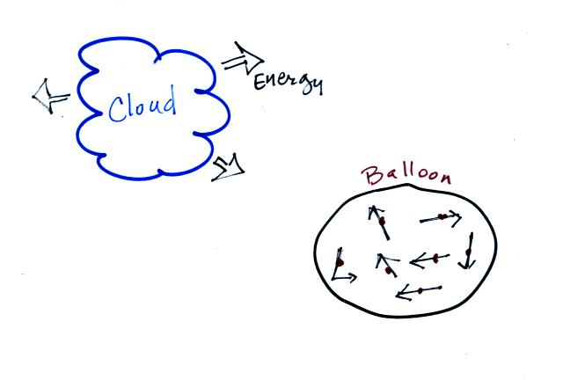
Hidden Optional Assignment
(due at the beginning of class on Thursday)
1a. When water vapor condenses and forms a cloud

______________________________ energy is
released into the atmosphere.
1b. The rapid random motions of the atoms or
molecules inside a balloon of air is an example

of _________________________ energy.

2. Room temperature is about __________ Celsius. (fill in the blank with 10, 20, 30, or 40)

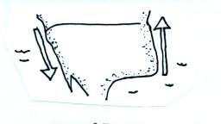
3. A warm northward flowing ocean current, the Gulf Stream is found along the east coast of the United States. A cold southward flowing current, the California current is found along the west coast. Are these ocean currents examples of energy transport by CONDUCTION or CONVECTION? Both currents
transport energy in the same direction, would that
be from NORTH TO SOUTH or SOUTH to NORTH?

4. Rising air motions are important because rising air expands, expansion causes the air to COOL WARM, and clouds might form. Fronts cause air to rise, so do winds converging into centers of low pressure. Name a 3rd way of causing rising air motions.

5. Does a combination of (a) 40º F temperature and 40 MPH winds or (b) 20º F temperature and 20 MPH winds produce the coldest wind chill temperature?
(consult Table 3.2 on p. 71 in the textbook [p. 70 in the 4th ed.] )

6.. The earth _______ electromagnetic radiation.
a. absorbs but doesn't emit b. emits but doesn't absorb
c. absorbs and emits d. doesn't absorb or emit

7. What was the curry powder used to demonstrate in Monday's class?

8. A city located on a coastline will have a more MODERATE SEVERE climate than a city located further inland.

9. When you place an ice cube tray full of water in a freezer, energy flows from the water into the colder surroundings in the freezer. When enough energy is removed from the water, the ice will freeze. To determine the amount of energy needing to be removed would you multiply the mass of water by the water's DENSITY, LATENT HEAT, or SPECIFIC HEAT?

10. Was the world cold temperature record set at the NORTH or SOUTH pole?

