NATS 101 Name_______________________________
Short Optional Assignment due at the start of the next class
(see Newton's Laws of Motion on pps 149-150 in Chapter 6 of the textbook)

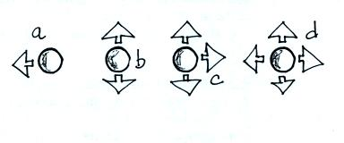
1. The 4 objects were stationary at the time the
forces shown in the diagram were applied.
The net or total force is zero in _____ and _____, those objects will remain stationary. The objects in _____ and _____ will begin
to move because the net force is not zero.
(the forces are the thick arrows in the figure)

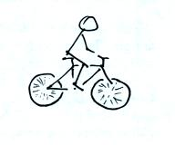
2. Isaac Newton lived during the 1600s and 700s and 1800s and 1900s. (circle two adjacent centuries.

3a. Your riding your bicycle along a flat level road and you stop pedaling. Will you continue to move in a straight line at constant speed? If not, draw an arrow on the diagram at right to show
the direction of the net force that would be exerted on the bicycle. What is the name or cause of this force?

3b. Isn't that about the best sketch of a bicycle and rider you have ever seen? (if not and if you think you could do better, I'd like to see it - use the back of this page for your sketch)

4. Isaac Newton
a. invented calculus b. formulated a law of gravitation c. formulated laws of motion
d. discovered that when white light shines through a prism it is split into colors
e. all of the above

5. What is Newton's 2nd law of motion?
(the 2nd law is often stated in equation form)

6. Acceleration can be
a. an increase in the speed of a moving object
b. a decrease in speed in the speed of a moving object
c. a change in the direction of motion of a moving object without a change in speed
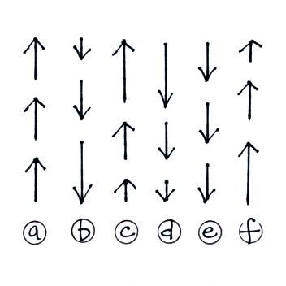
d. all of the above

6. The net force on _______ and _______
at right point upward. The net force on
_______ and _______ is zero. The net
force on _______ and _______ points
downward. (the arrows show the direction
of motion, the length gives an idea of the
speed)

