Friday, Apr. 10, 2009
Music this afternoon was "Don't die in me" by Mirah
Quiz #3 was returned in class today.
The notes below include material from Monday and what we covered on Friday.

Here's what we started in class last Monday.
We started to look at how and why surface and upper level winds blow the way they do.
Some real world examples of where this occurs are shown in the figure below. The two largest types of storm systems, middle latitude storms and hurricanes, develop around surface centers of low pressure. Winds spin counterclockwise around low in the northern hemisphere and clockwise in the southern hemisphere. Winds spin clockwise around "anticyclones" (high pressure) in the northern hemisphere and counterclockwise in the southern hemisphere.
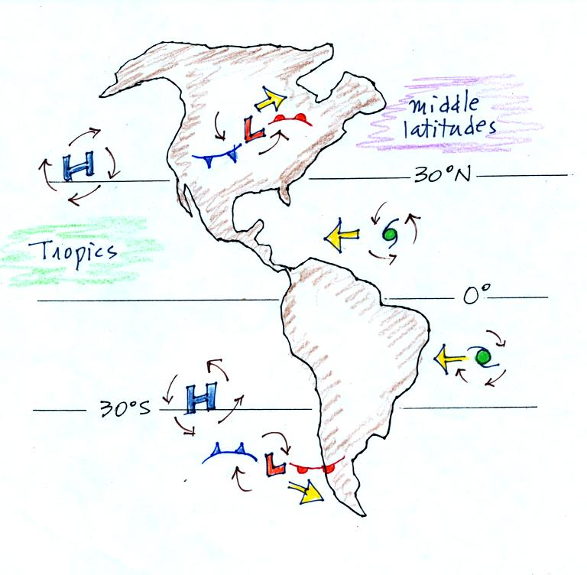
Storm systems in the tropics (0 to 30 degrees latitude) generally move from east to west. At middle latitudes (30 to 60 degrees), storm move in the other direction, from west to east. To understand why this is true we need to learn something about the earth's global scale pressure and wind patterns. This is a topic we will be getting into next week.
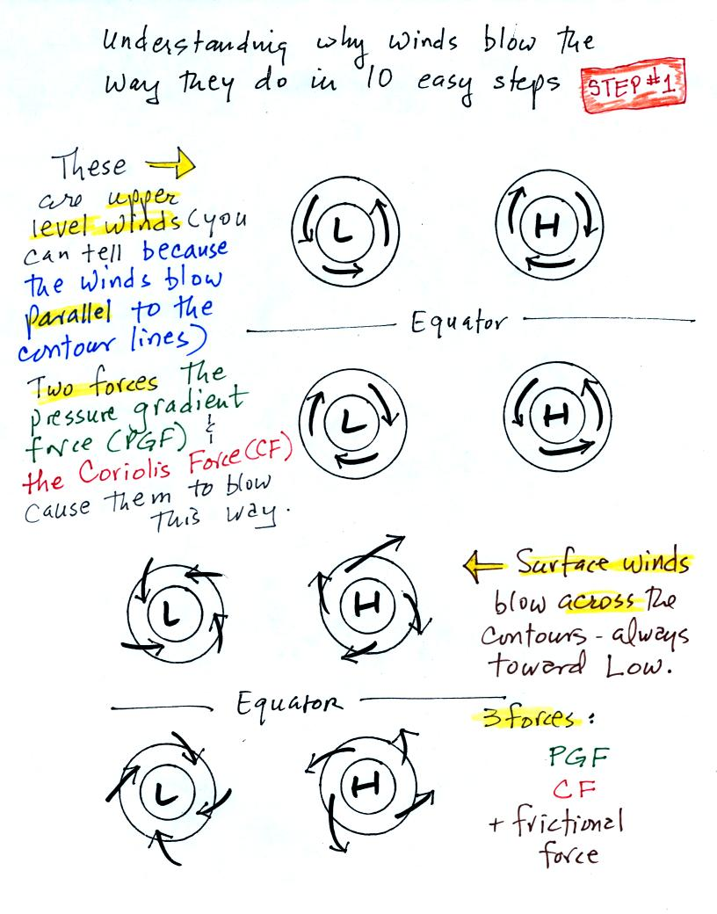
Upper level winds spinning around high and low pressure in the northern and southern hemispheres are shown in the first set of four pictures. The first thing to notice is that upper level winds blow parallel to the contours. We will see that 2 forces, the pressure gradient force (PGF) and the Coriolis force (CF), cause the winds to blow this way. Eventually you will be able to draw the directions of the forces for each of the four upper level winds examples. Here is an example of what you will be able to do.
The four drawings at the bottom of the page show surface winds blowing around high and low pressure in the southern hemisphere. These winds blow across the contour lines slightly, always toward low pressure. The frictional force is what causes this to occur. He is an example of what you will be able to say about surface winds blowing around low pressure in the southern hemisphere.
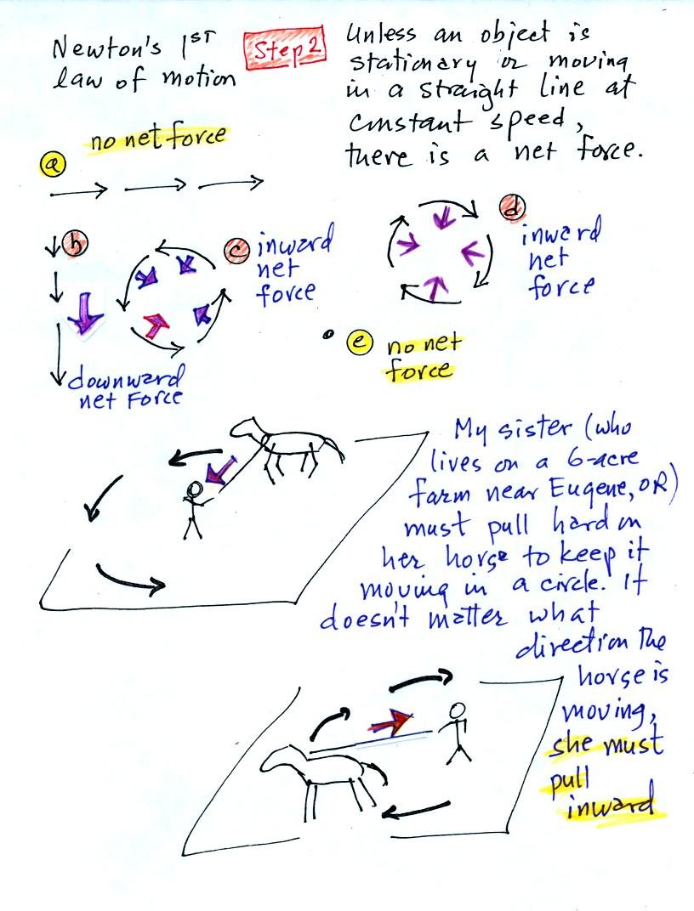
The main point to take from Step #2 is that a net inward force is needed anytime an object is moving in a circular path. It doesn't matter what direction the object is moving. The net force is inward anytime something moves in a circular path.
The force is inward in each of the cases below.
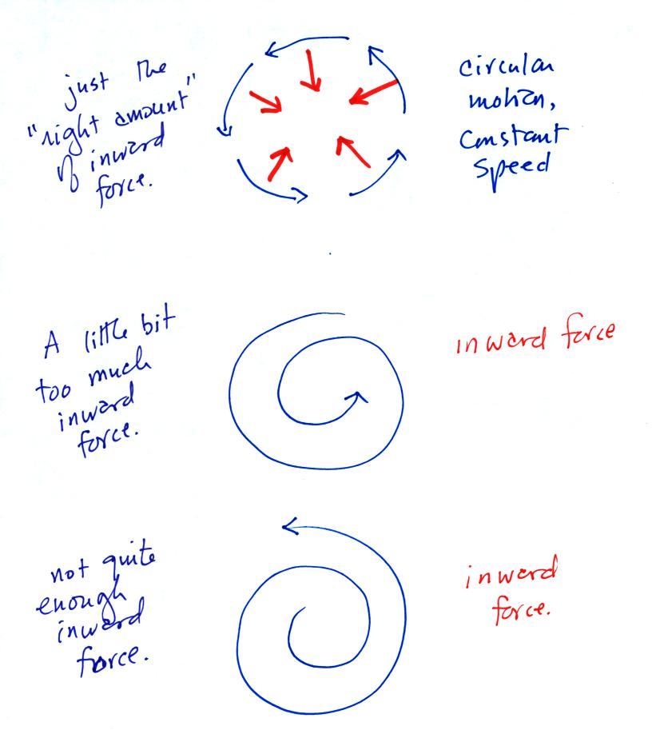
It's just not the same amount of inward force. The amount of force is just right in the top figure, a little too strong in the middle figure, and not quite strong enough in the bottom figure.

Now we'll start to look at the forces that cause the wind.
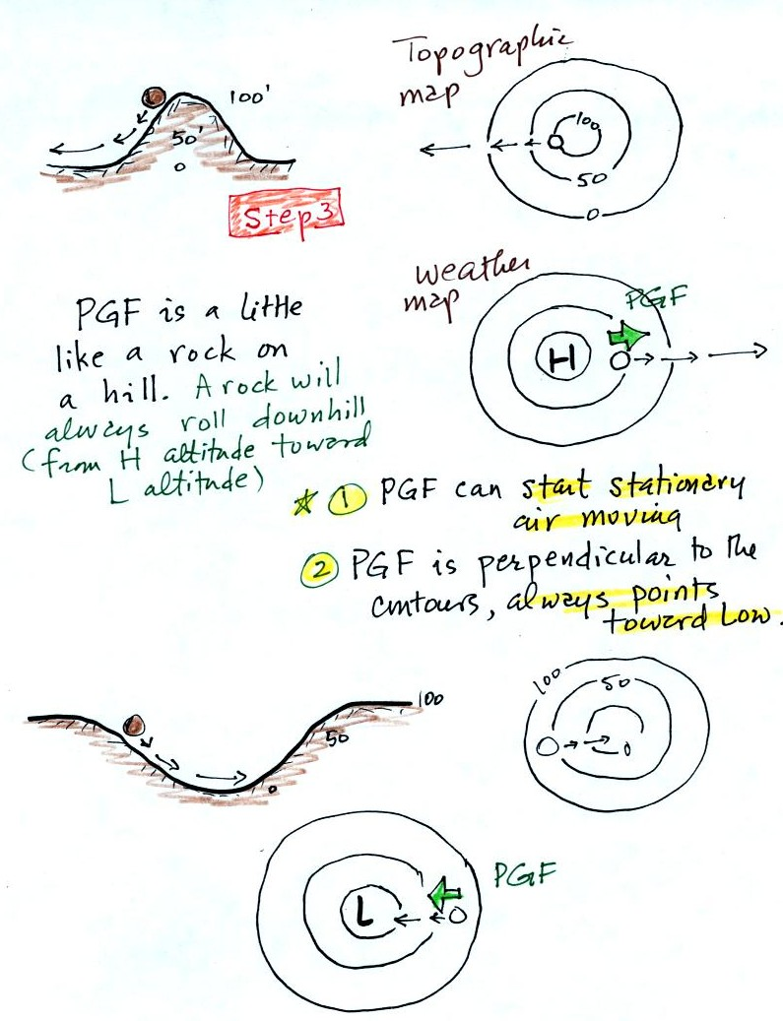
The pressure gradient force always points toward low pressure. The PGF will cause stationary air to begin to move (it will always move toward low pressure).
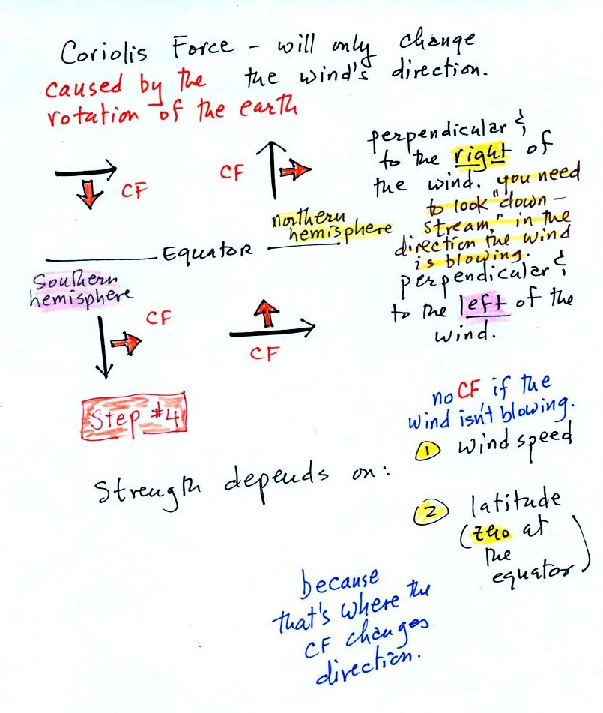
The Coriolis force is caused by the rotation of the earth and points perpendicular to the wind. It can only change the wind's direction, it can't cause the wind to speed up or slow down. The direction of the CF depends on whether you're in the northern or southern hemisphere. The next section explains the origin of the Coriolis force, we didn't cover this section in class last Monday.

Most of what follows can be found on p. 122c in the photocopied ClassNotes.
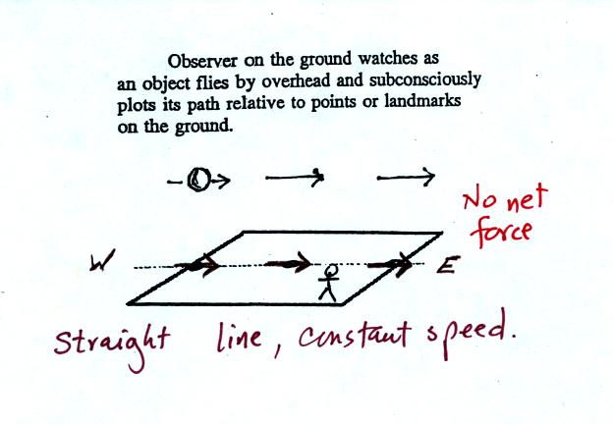
Imagine something flies over Tucson. It travels straight from west to east at constant speed. The next figure shows the path that the object followed as it passed over the city. You would, more or less subconciously, plot its path relative to reference points on the ground.
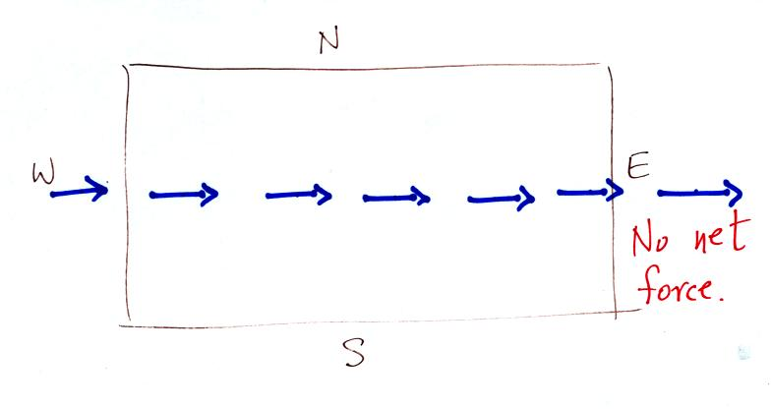
It would appear to be moving in a straight line at constant speed. You would conclude there was zero net force acting on the moving object (Newton's first law of motion).
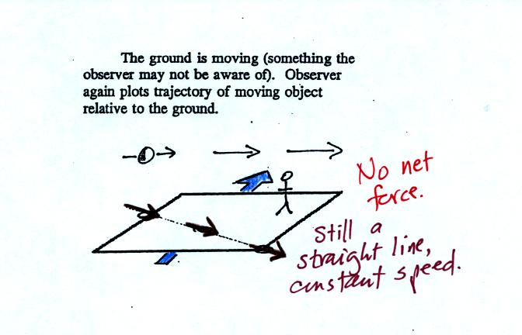
In this second picture the object flies by overhead just as it did in the previous picture. In this picture, however, the ground is moving (don't worry about what might be causing the ground to move).
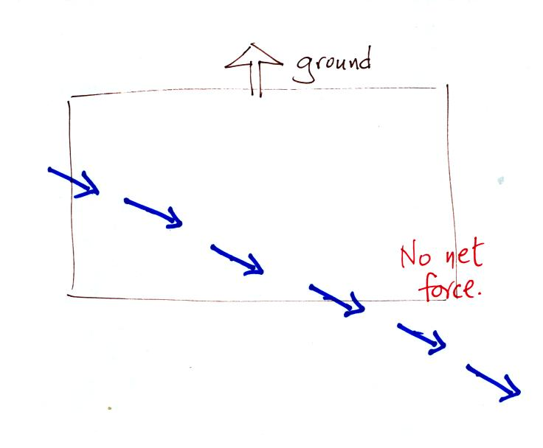
This is the path that you would see relative to the ground in this case. Even though the object flew from west to east it appears to have been traveling from the NW toward the SE because the ground was moving as the object passed overhead. Because the motion is still in a straight line at constant speed, you would conclude the net force acting on the object was zero.
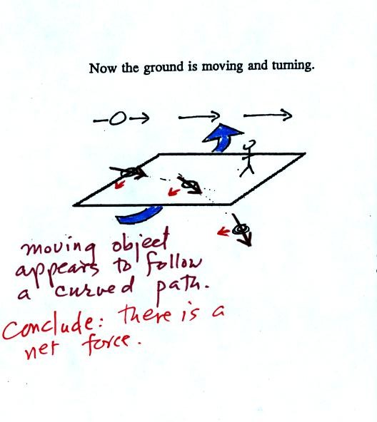
In this last figure the object flies by again from west to east. In this case however the ground is rotating.
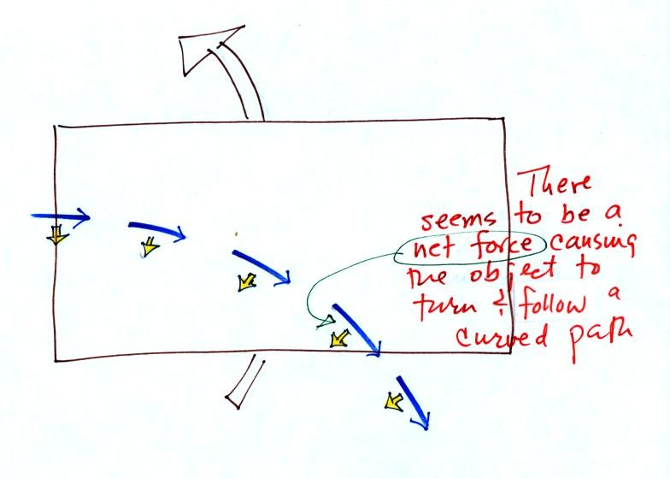
At most locations on the earth the ground IS rotating (we're just not aware of it). This is most easily seen at the poles.
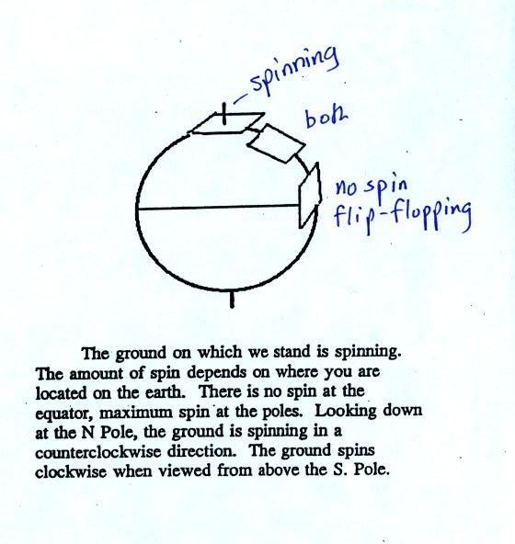
Imagine a piece of paper glued to the top of a globe. As the globe spins the piece of paper will rotate. A piece of paper glued to the globe at the equator won't spin, it will flip over. At points in between the paper would spin and flip, the motion gets complicated.
The easiest thing for us to do is to ignore the fact that the ground on which we are standing is rotating. However, if we do that we need to account for the curved paths that moving objects will take when they move relative to the earth's surface. That is what the Coriolis force does.

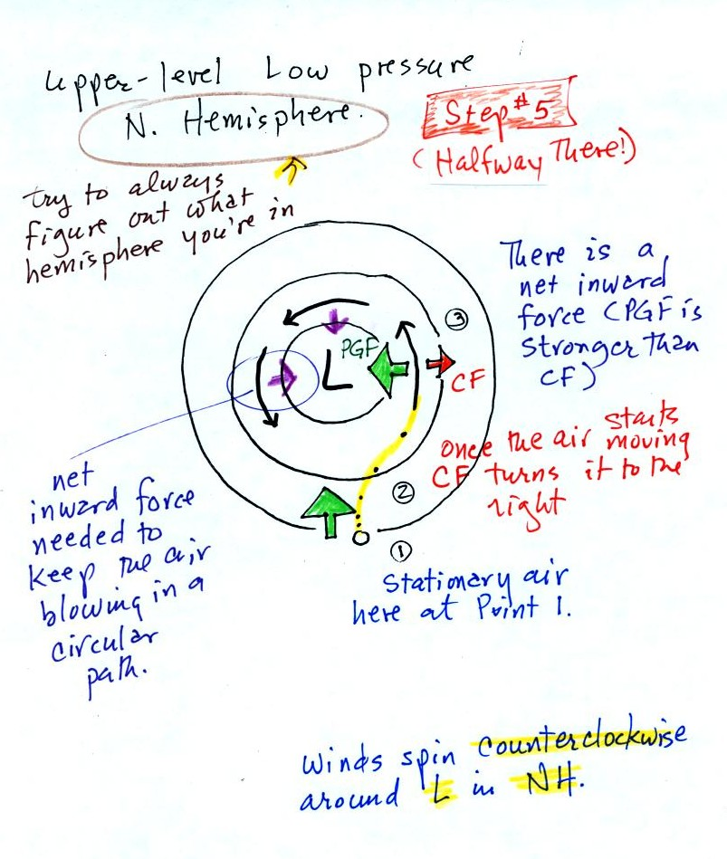
Now we start to put everything together. The PGF at Point 1 starts stationary air moving toward the center of low pressure (just like a rock would start to roll downhill). Once the air starts to move, the CF causes it to turn to the right (because this is a northern hemisphere chart). The wind eventually ends up blowing parallel to the contour lines and spin in a counterclockwise direction. Note that the inward PGF is stronger than the outward CF. This results in a net inward force, something that is needed anytime wind blows in a circular path.
That's where class ended on Monday I think.

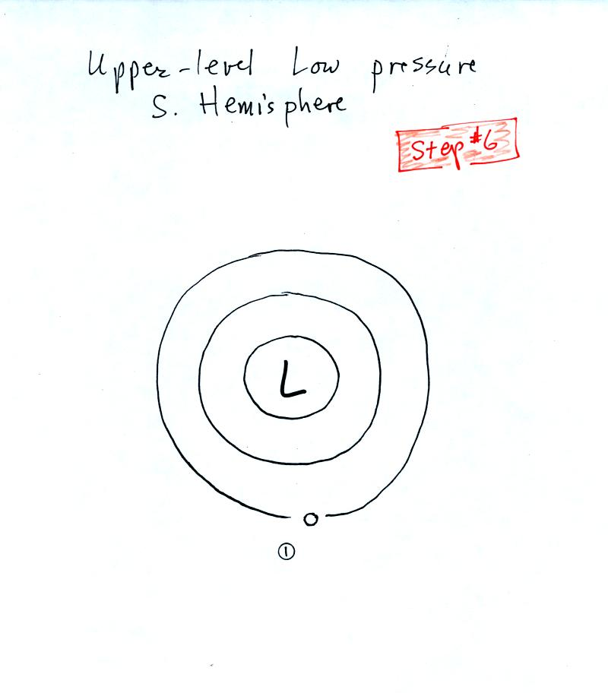

See if you can figure out what to do with this figure. The answer is on the next page.

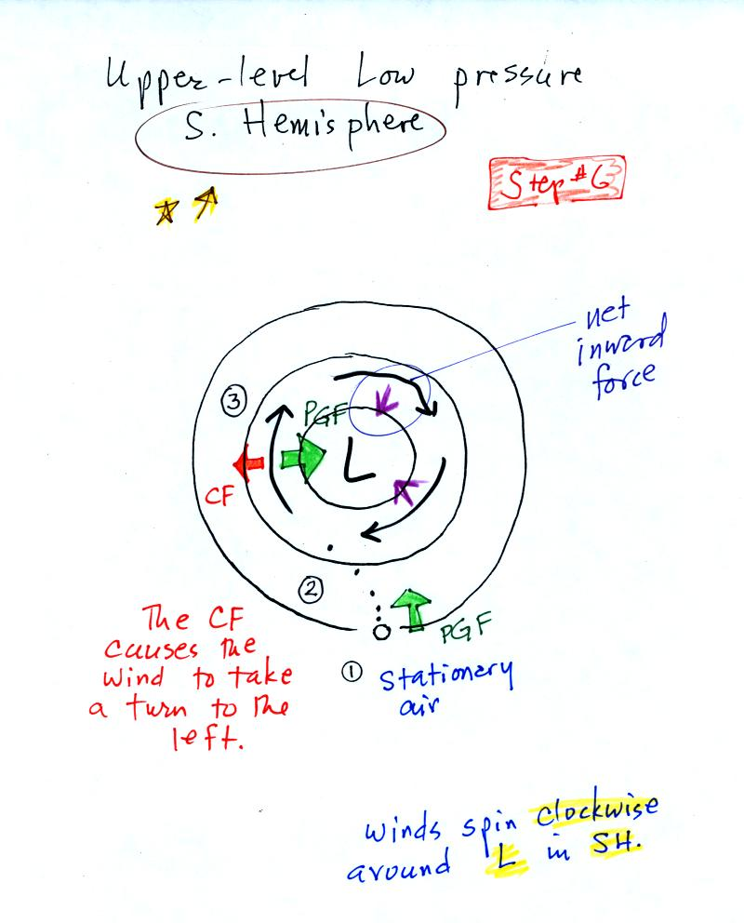
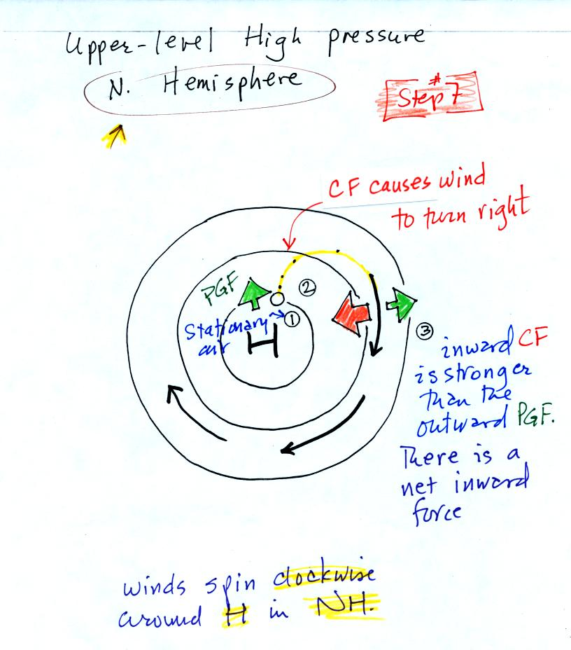

With high pressure the air starts moving outward. In this example the wind takes a right turn and ends up blowing in a clockwise direction around the high. Note there is a net inward force here just as there was with the two previous examples involving low pressure.
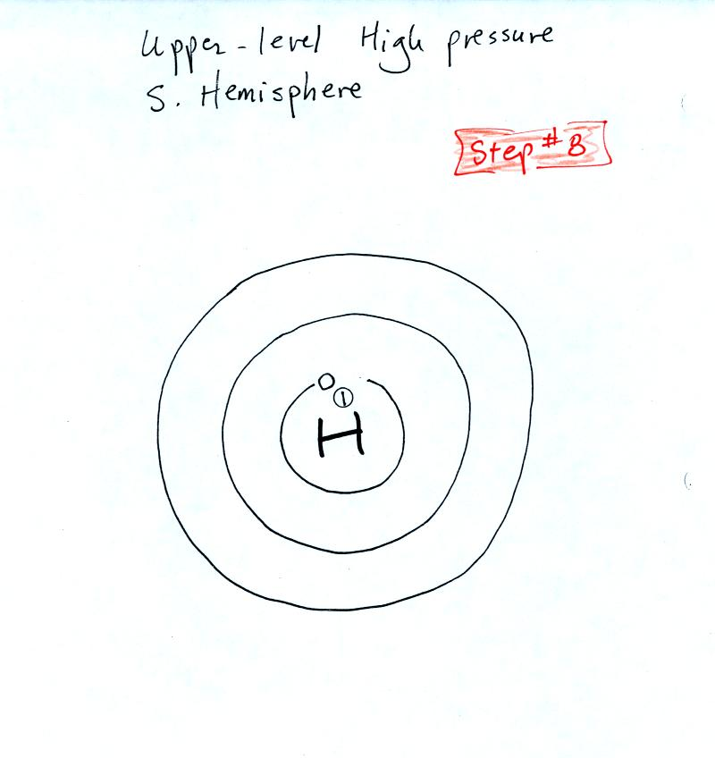
Try this one on your own. The answer is on the next page.

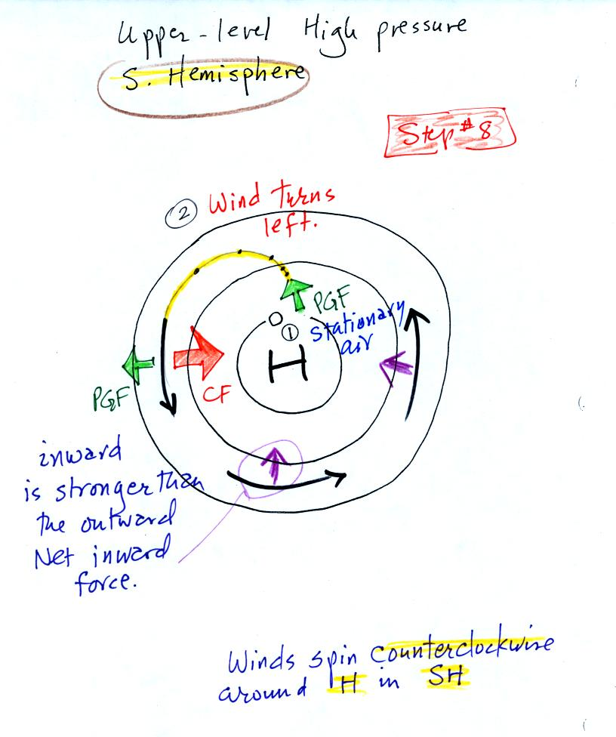

Now we're ready for surface winds.

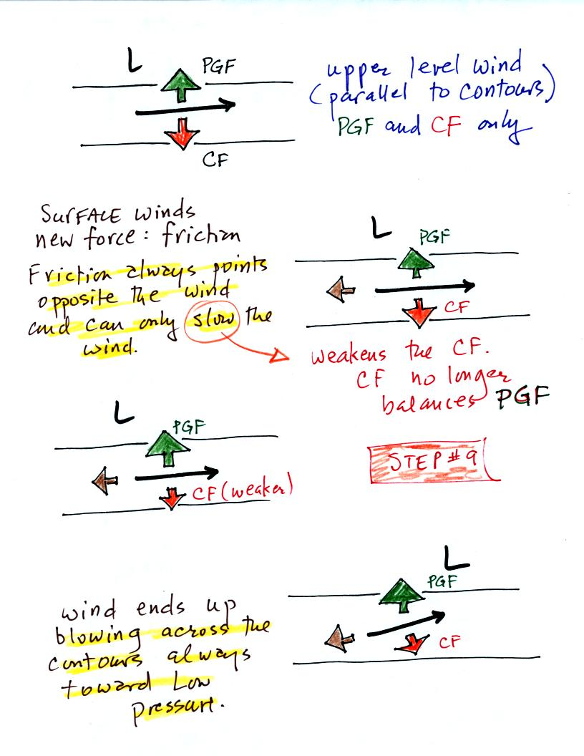
The top figure shows upper level winds blowing parallel to straight contours. The PGF and CF point in opposite directions and have the same strength. The net force is zero. The winds would blow in a straight line at constant speed.
We add friction in the second picture. It points in a direction opposite the wind and can only slow the wind down. The strength of the frictional force depends on wind speed (no frictional force if the wind is calm) and the surface the wind is blowing over (less friction over the ocean than over the land).
Slowing the wind weakens the CF and it can no longer balance the PGF. The stronger PGF causes the wind to turn and blow across the contours toward Low.
Eventually the CF and Frictional force, working together, can balance out the PGF.
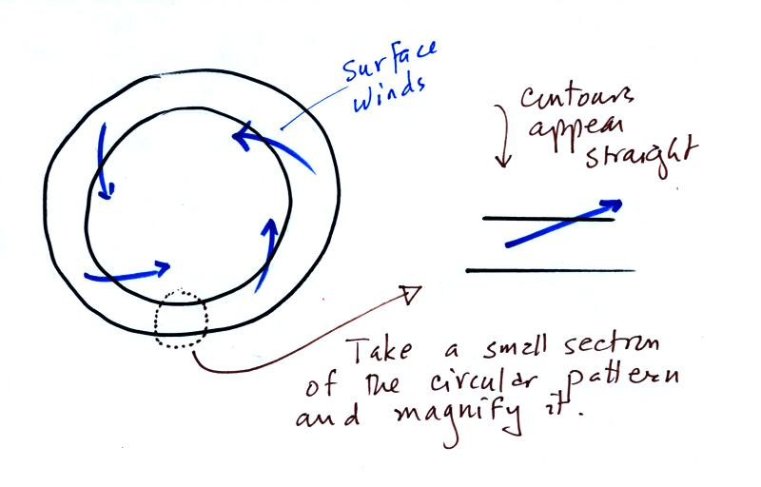
Now the transition from the straight contours above to the circular contours below might be a little abrupt. But if you zero in on a very small part of a larger circular pattern the contours look straight. The important thing to remember is that surface winds will always blow across the contours toward low.
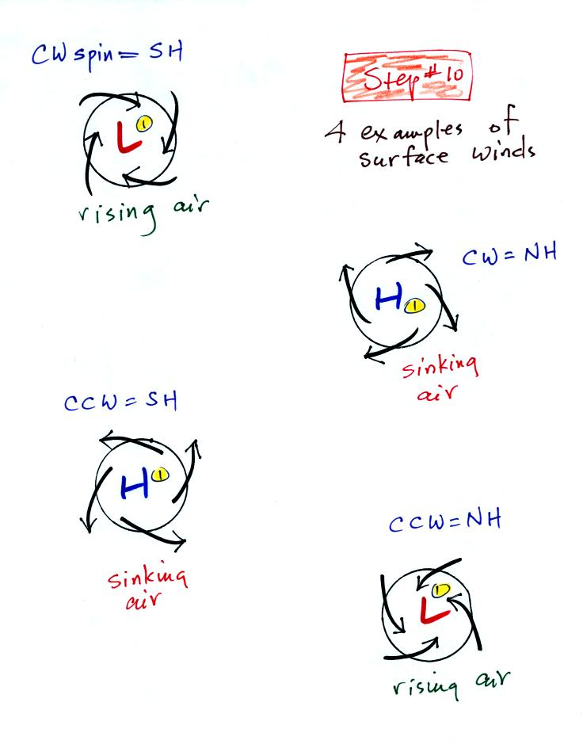
The winds are spiralling inward in the top and bottom examples. These must be surface centers of low pressure. The middle two examples are high pressure. The winds spin in the same directions around surface highs and lows as they do around upper levell highs and lows.
Converging winds cause air to rise. Rising air expands and cools and can cause clouds to form (I'll bet you're getting sick of hearing that). Diverging winds created sinking wind motions and result in clear skies.

You might already have heard that water spins in a different direction when it drains from a sink or a toilet bowl in the southern hemisphere than it does in the northern hemisphere. You might also have heard that this is due to the Coriolis force or the Coriolis effect.
The Coriolis force does cause winds to spin in opposite directions around high and low pressure centers in the northern and southern hemisphere. The PGF starts the air moving (in toward low, out and away from high pressure) then the Coriolis force bends the wind to the right (N. hemisphere) or to the left (S. hemisphere).
Here's what you end up with in the case of low pressure:
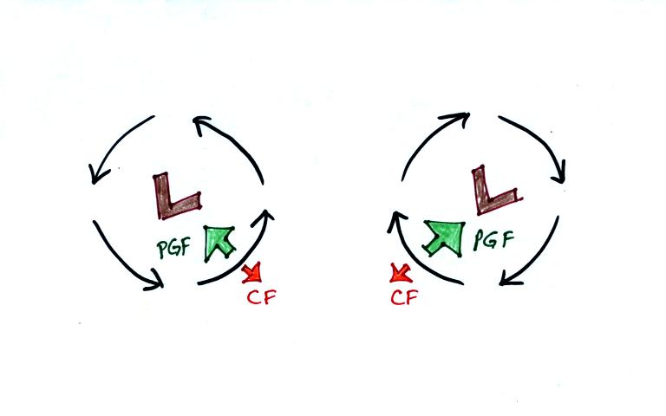
Wind motions around an upper level low. The example at left would be found in the northern (the CF is pointing to the right of the wind)? The PGF is stronger than the CF. This results in a new inward force, something that is needed for wind to blow in a circular path.
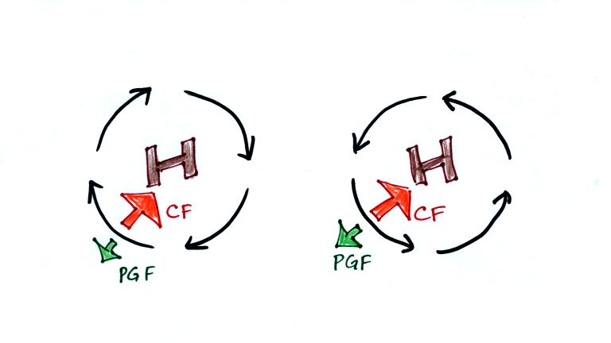
Winds also spin around high pressure. The CF is absolutely essential in this case. The CF is stronger than the PGF and the CF points inward. The CF is what provides the needed inward force needed to keep the winds blowing in a circular path.
There are situations where the PGF is much stronger than the CF; the CF can be ignored.
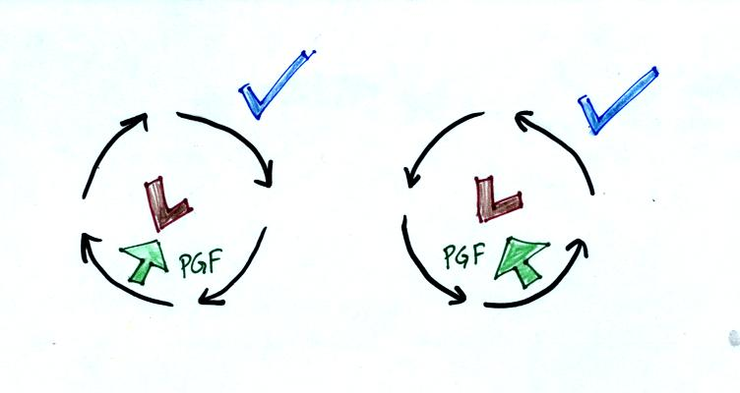

Winds can still spin around LOW. The PGF supplies the necessary net inward force. This is the case with tornadoes, for example. Tornado winds spin around a core of very low pressure.
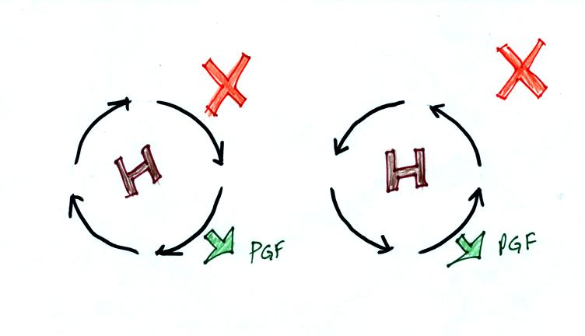
Winds can't blow around high pressure without the CF. The PGF points ouward with high pressure. Without the CF, there isn't any inward force.
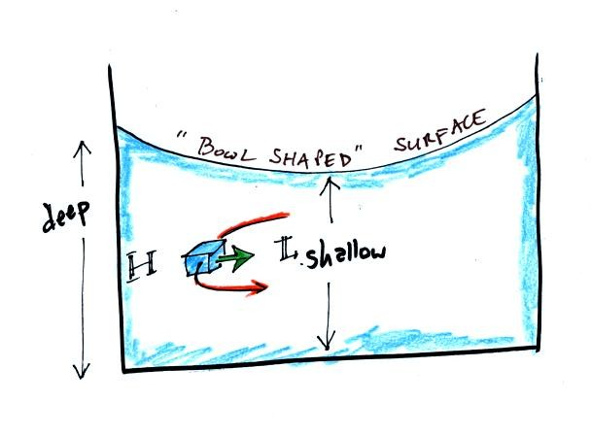
When water spins and drains from a sink or a toilet, the water is a little deeper on the outside than on the inside. This creates an inward pointing pressure difference force. There needs to be an inward force in order for the water to spin. Water can spin clockwise or counterclockwise when draining from a sink in the northern hemisphere. It can spin in either direction in the southern hemisphere also.
Now we watched a short video segment that seemed to show otherwise. Don't believe everything you see on video. The gentleman in the video was just very good at getting the draining water to spin one direction or another as he moved on opposite sides of the equator. Probably the most difficult part would be to get the water draining without spinning, which is what he was able to do when standing right on the equator.
Would you like to earn 0.1 pts (maybe 0.2 pts) of extra credit? If so click here.

