Monday Apr. 13, 2009
Music today was Dancing by Elisa.
The 1S1P Assignment #2 reports were collected today.
There is a new Bonus 1S1P Assignment. Bonus reports don't count as part of the 4 report limit allowed during the semester. So this is an additional opportunity to work your way to the 45 1S1P points limit.

The first topic covered today was thermal circulations.
Differences in temperature like you might find between a coast and the ocean or between a city and the surrounding country side can create horizontal pressure differences. The horizontal pressure gradient can then produce a wind flow pattern known as a thermal circulation.
These are generally relatively small scale circulations and the pressure gradient is so much stronger than the Coriolis force that the Coriolis force can be ignored. We will learn how thermal circulations develop and then apply to concept to the earth as a whole in order to understand large global scale pressure and wind patterns. You'll find this discussed on p. 131 in the photocopied Class Notes. The discussion in class was slightly different.
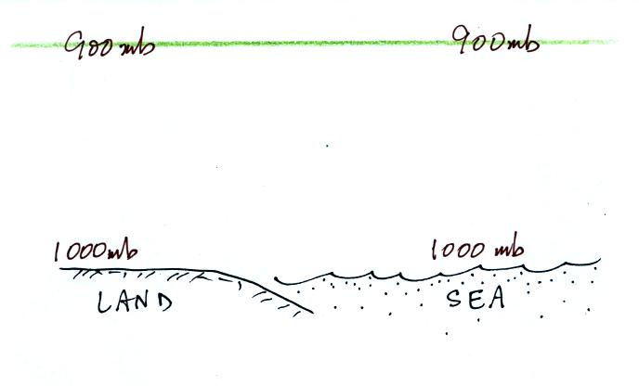
We'll start here along a sea coast. In this picture the air temperatures and pressures (at the ground and aloft) are the same over the land and over the ocean.
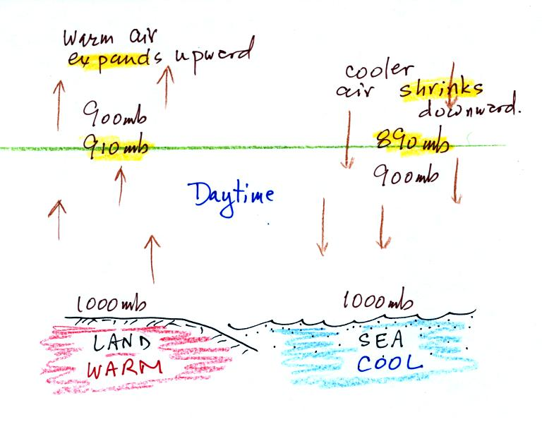
A beach will often become much warmer than the nearby ocean during the day (the sand gets hot enough that it is painful to walk across in barefeet). The warm air over the land will expand upward. Note how the 900 mb level moves above the level of the green line in the picture. The cooler air over the ocean will shrink and move downward. The 900 mb level drops below the level of the green line.
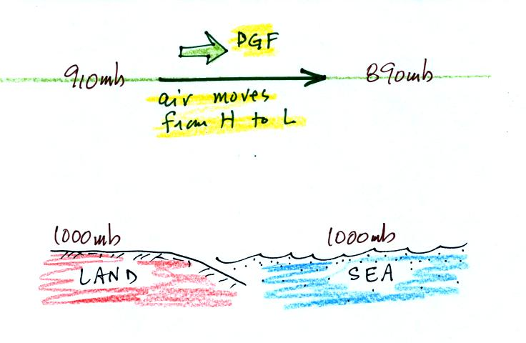
The temperature differences have created an upper level pressure gradient (pressure difference), higher pressure (910 mb) on the left and lower pressure (890 mb) on the right. The pressure difference force causes air to start to blow from left to right.
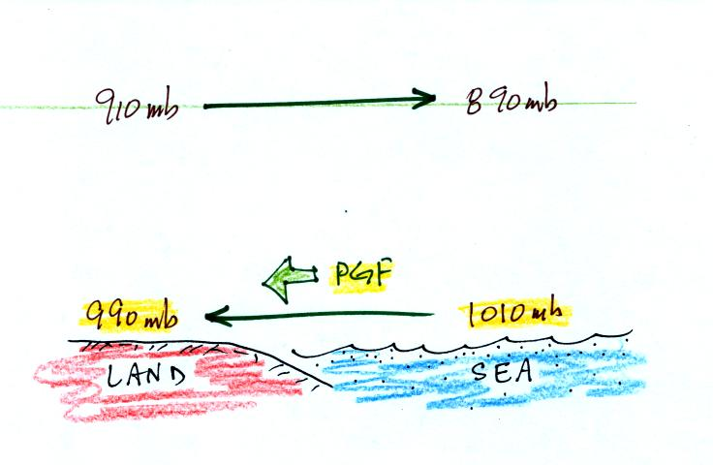
Once the air aloft begins to move it will change the surface pressure pattern. Air aloft leaving the left side of the picture will lower the surface pressure (from 1000 mb to 990 mb). Adding air aloft to the right side of the picture will increase the surface pressure (from 1000 mb to 1010 mb). Surface winds will begin to blow from right to left.
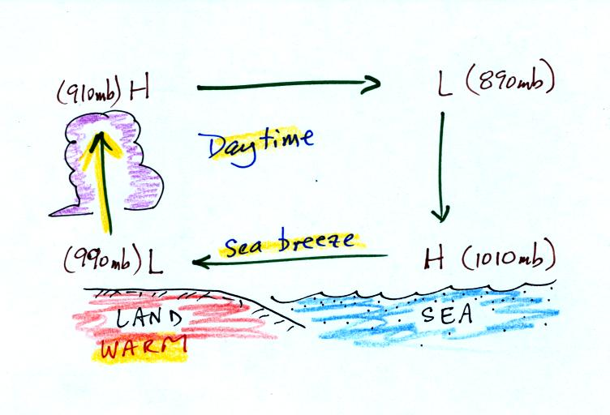
You can complete the circulation loop by adding rising air above the surface low pressure at left and sinking air above the surface high at right. The surface winds which blow from the ocean onto land are called a sea breeze (the name tells you where the winds come from). Since this air is likely to be moist, cloud formation is likely when the air rises over the warm ground.
It is pretty easy to figure the directions of the winds in a thermal circulation without going through a long-winded development like this. Just remember that warm air rises. Draw in a rising air arrow above the warm part of the picture, then complete the loop.
At night the ground cools more quickly than the ocean and becomes colder than the water. Rising air is found over the warmer ocean water (sea below). The thermal circulation pattern reverses direction. Surface winds blow from the land out over the ocean. This is referred to as a land breeze.
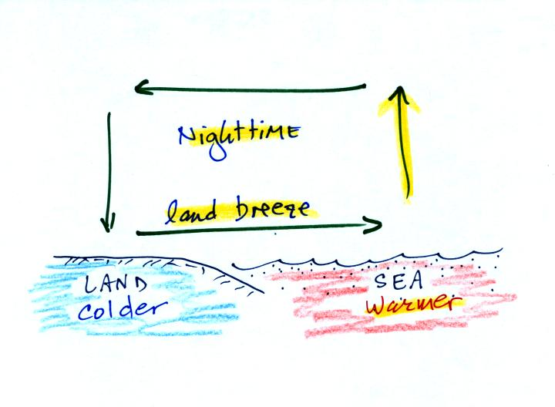

We'll use the thermal circulation idea to learn something about global scale pressure and wind patterns on the earth. Ordinarily you couldn't apply a small scale phenomena like a thermal circulation to the much larger global scale. However if we make some simplifying assumptions, particularly if we assume that the earth doesn't rotate or only rotates slowly, we can ignore the Coriolis force.
Some additional simplifications are also made and are listed below (p. 133 in the photocopied Classnotes)
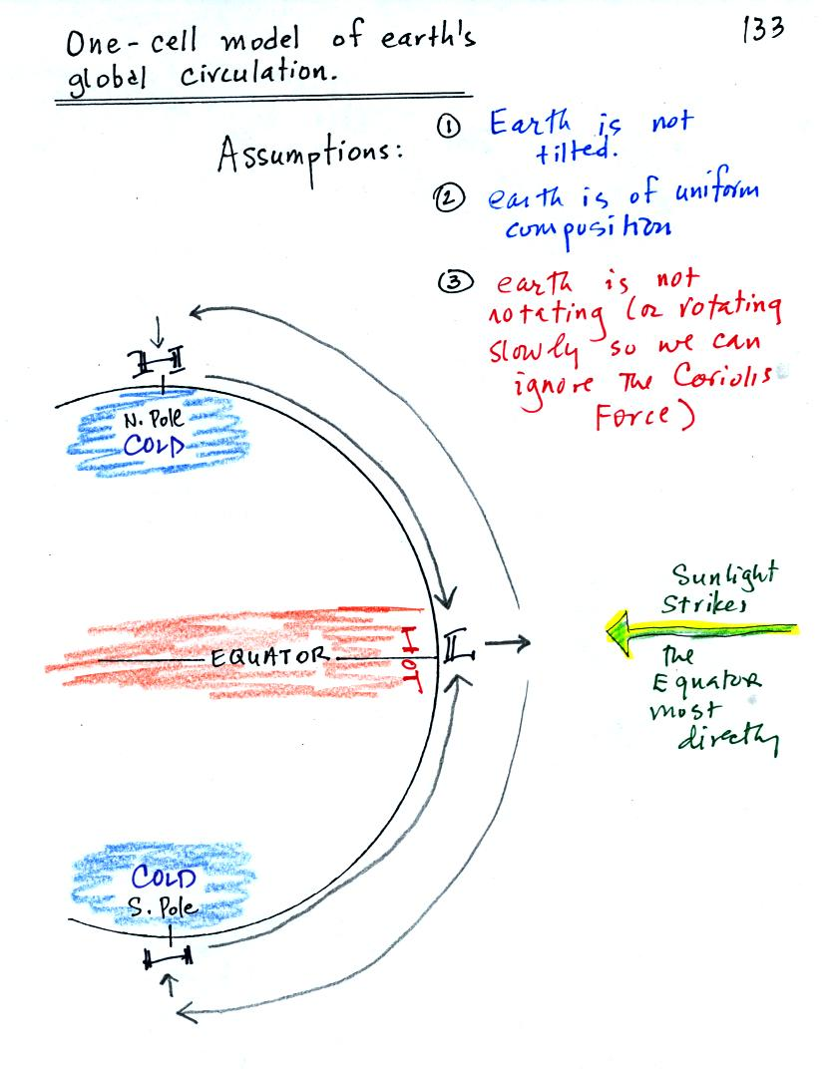
Because the earth isn't tilted, the incoming sunlight shines on the earth most directly at the equator. The equator will become hotter than the poles. By allowing the earth to rotate slowly we spread this warmth out in a belt that circles the globe at the equator rather than concentrating it in a spot on the side of the earth facing the sun. Because the earth is of uniform composition there aren't any temperature differences created between oceans and continents.
You can see the wind circulation pattern that would develop. The term one cell just means there is one complete loop in the northern hemisphere and another in the southern hemisphere.
Next we will remove the assumption concerning the rotation of the earth. We won't be able to ignore the Coriolis force now.
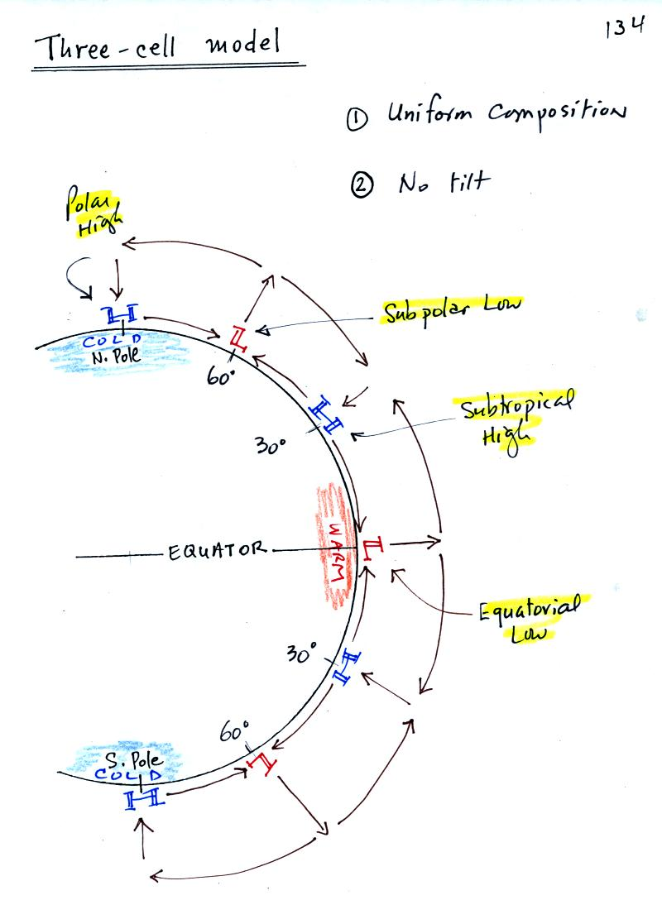

Here's what a computer would predict you would now see on the earth. Things are pretty much the same at the equator in the three cell and one cell models: surface low pressure and rising air. At upper levels the winds begin to blow from the equator toward the poles. Once headed toward the poles the upper level winds are deflected by the Coriolis force. There end up being three closed loops in the northern and in the southern hemispheres. There are surface belts of low pressure at the equator (the equatorial low) and at 60 degrees latitude (the subpolar low). There are belts of high pressure (the subtropical high) at 30 latitude and high pressure centers at the two poles (the polar highs).
We will look at the surface features in a little more detail because some of what is predicted, even with the unrealistic assumptions, is actually found on the earth.
We'll first look at surface pressures and winds on the earth from 30 S to 30 N, the tropics and subtropics. Then we'll look at the region from 30 N to 60 N, middle latitudes, where most of the US is located. The figure below was redrawn after class.
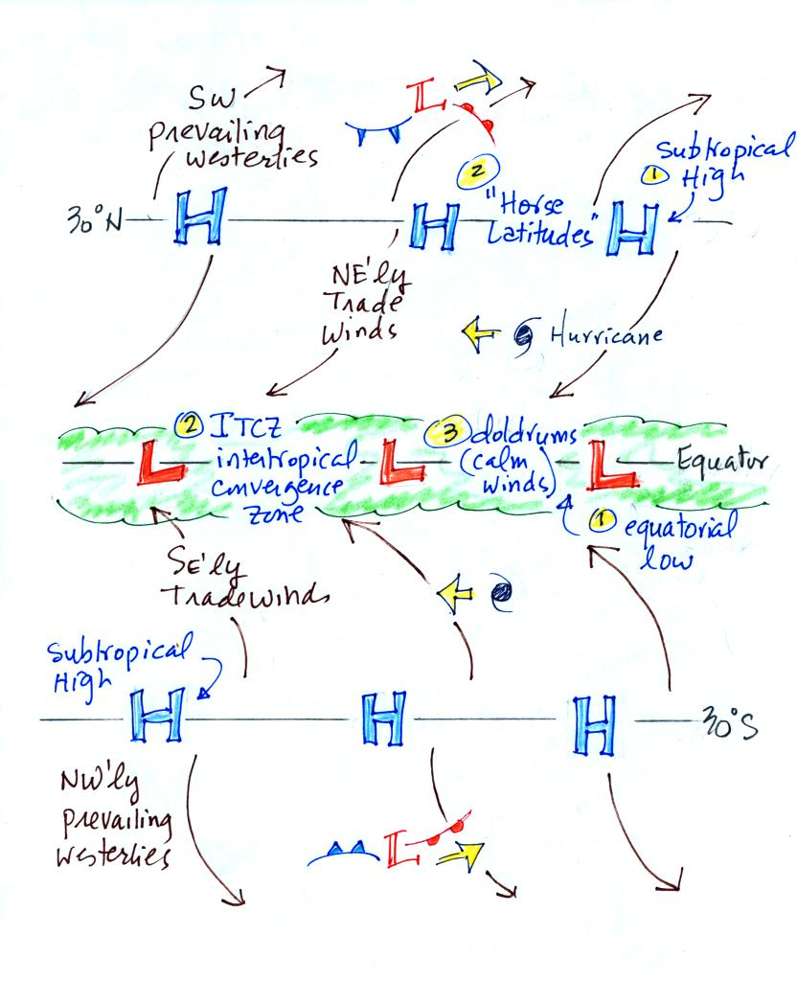
With a little study you should be able to start with a blank sheet of paper and reproduce this figure. I would suggest starting at the equator. You need to remember that there is a belt of low pressure found there. Then remember that the pressure belts alternate: there are belts of high pressure at 30 N and 30 S.
Let's start at 30 S. Winds will begin to blow from High pressure at 30 S toward Low pressure at the equator. Once the winds start to blow they will turn to the left because of the Coriolis force. Winds blow from 30 N toward the equator and turn to the right in the northern hemisphere (you need to turn the page upside down and look in the direction the winds are blowing). These are the Trade Winds (northeasterly trade winds north of the equator and southeasterly trades south of the equator). They converge at the equator and the air there rises (refer back to the crossectional view of the 3-cell model). This is the cause of the band of clouds that you can often see at or near the equator on a satellite photograph.
The Intertropical Convergence Zone or ITCZ is another name for the equatorial low pressure belt. This region is also referred to as the doldrums because it is a region where surface winds are often weak. Sailing ships would sometimes get stranded there hundreds of miles from land. Fortunately it is a cloudy and rainy region so the sailors wouldn't run out of drinking water (they might well have run out of rum though which was probably worse).
Hurricanes form over warm ocean water in the subtropics between the equator and 30 latitude. Winds at these latitudes have a strong easterly component and hurricanes, at least early in their development, move from east to west. Middle latitude storms found between 30 and 60 latitude, where the prevailing westerly wind belt is found, move from west to east.
You find sinking air, clear skies, and weak surface winds associated with the subtropical high pressure belt. This is also known as the horse latitudes. Sailing ships could become stranded there also. Horses were apparently either thrown overboard (to conserve drinking water) or eaten if food supplies were running low. Note that sinking air is associated with the subtropical high pressure belt so this is a region on the earth where skies are clear (Tucson is located at 32 N latitude, so we are strongly affected by the subtropical high pressure belt).
The winds to the north of 30 N and to the south of 30 S are called the "prevailing westerlies." They blow from the SW in the northern hemisphere and from the NW in the southern hemisphere. The 30 S to 60 S latitude belt in the southern hemisphere is mostly ocean. Because there is less friction over the oceans, the prevailing westerlies there can get strong, especially in the winter. They are sometimes referred to as the "roaring 40s" or the "ferocious 50s" (the 40s and 50s refer to the latitude belt they are found in).
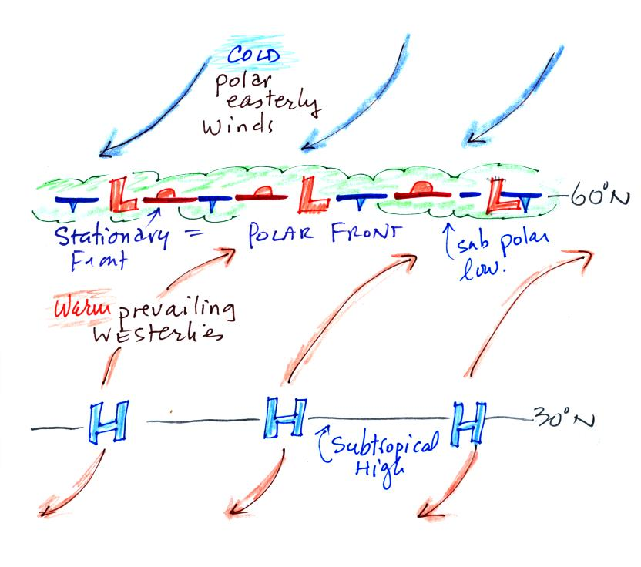
Here's the other map, it's a little simpler. Winds blowing north from H pressure at 30 N toward Low pressure at 60 N turn to the right and blow from the SW. These are the "prevailing westerlies." The polar easterlies are cold winds coming down from high pressure at the north pole. The subpolar low pressure belt is found at 60 latitude. This is also a convergence zone where the cold polar easterly winds and the warmer prevailing westerly winds meet. The boundary between these two different kinds of air is called the polar front and is often drawn as a stationary front on weather maps. A strong current of winds called the polar jet stream is found overhead. Strong middle latitude storms will often form along the polar front.

