Wednesday Apr. 15, 2009
Music today was "What's Up" from 4 Non Blondes
A new Optional Assignment was handed out in class. It is due in one week, on Wed., Apr. 22.

We'll start out with a little review. What information could you add to the figure below given just the direction of the upper level winds and knowing that the upper level winds are part of a thermal circulation.
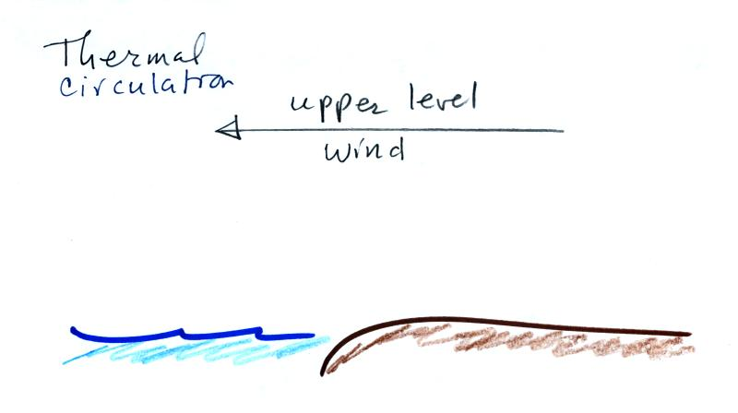
(1) The first thing to do would be to complete the circulation loop. Then if you remember that "warm air rises" you can identify the warm and cold parts of the picture that cause the thermal circulation to develop in the first place. (3) The beach is warmer than the ocean during the daytime. (4) The surface wind is blowing from the ocean toward the land and is called a "sea breeze" (the name tells you the direction the wind is coming from). The surface wind is likely to be moist since it is coming from the sea. Moist rising air could form the clouds shown at (5).
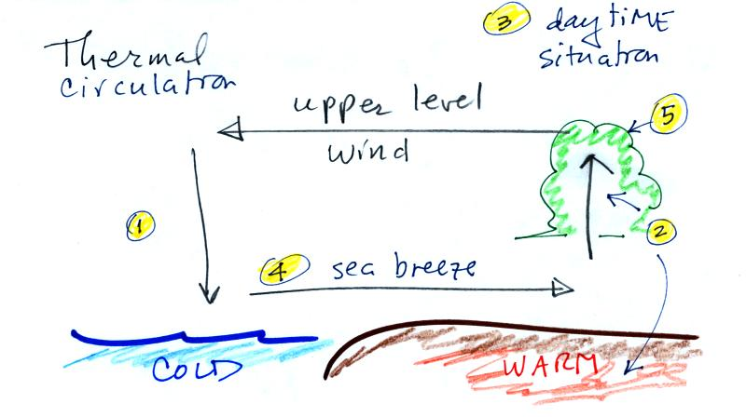
Here are some additional examples of thermal circulations or large scale circulations that resemble thermal circulations.
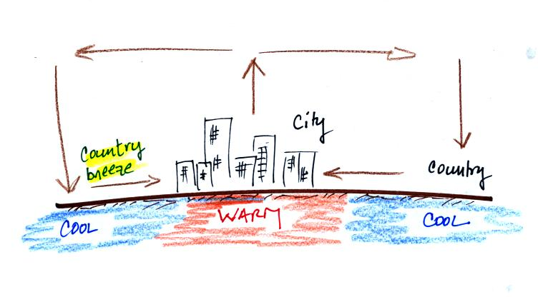
Cities are often warmer than the surrounding countryside, especially at night. This is referred to as the urban heat island effect. This difference in temperature can create a "country breeze."
The Asian monsoon (monsoon refers to a seasonal change in the direction of the prevailing winds) is a large scale circulation pattern and is much more complex than a simple thermal circulation. However you can use the thermal circulation concept to get a general understanding of what to expect at different times of the year.
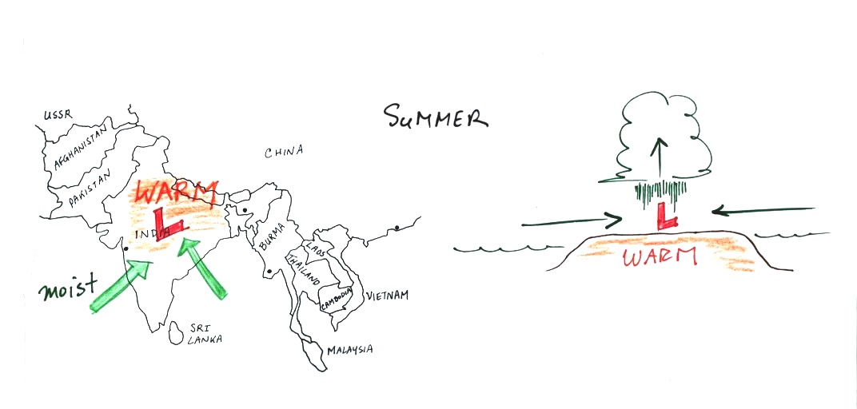
In the summer India and SE Asia become warmer than the oceans nearby. Surface low pressure forms over the land, moist winds blow from the ocean onshore, and very large amounts of rain can follow. The view above at left is from above, the view at right is from the side.
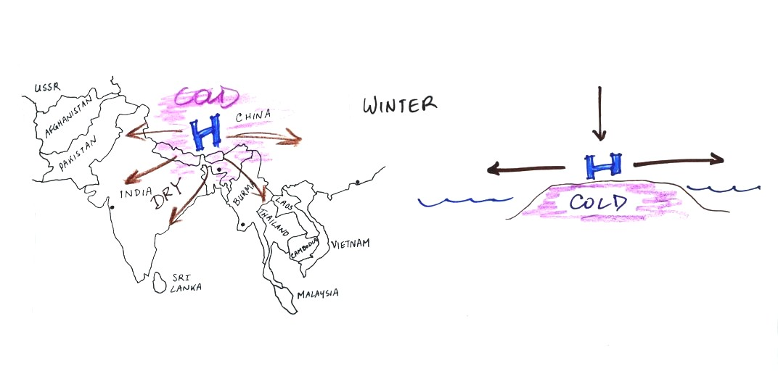

The winds change directions in the winter when the land becomes colder than the ocean.
You can also use the thermal circulation to understand some of the basic features of the El Nino phenomenon (you find a discussion of the El Nino on pps 135-139 in the photocopied Classnotes).
First here is what conditions look like in the tropical Pacific Ocean in non-El Nino years (top and side views again)
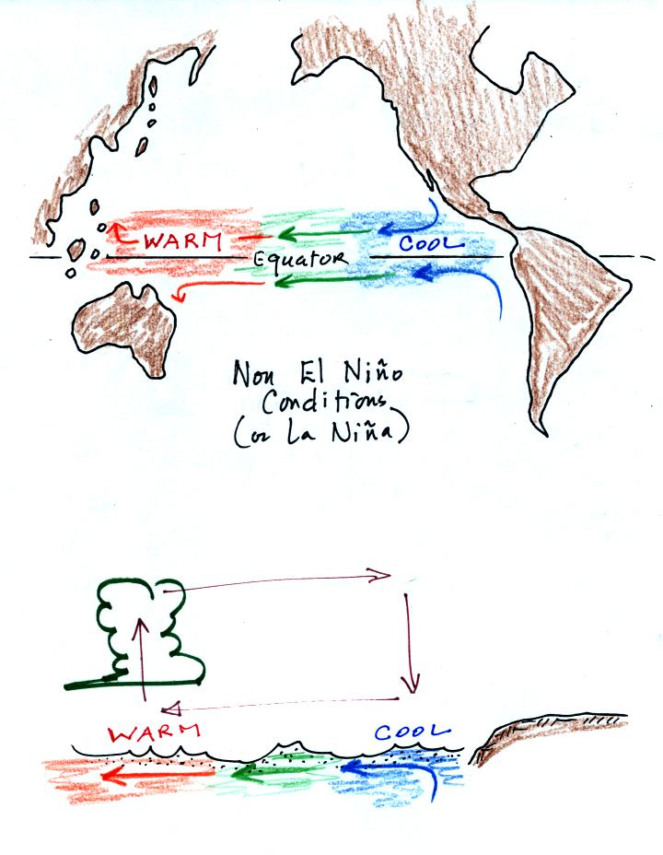
Cold ocean currents along the west coasts of N. America and S. American normally converge at the equator and begin to flow westward (see top view above). As the water travels westward it warms. Some of the warmest sea surface waters on the earth are normally found the western Tropical Pacific. A temperature gradient becomes established between the W. and E. ends of the tropical Pacific. The crossectional view above shows the normal temperature and circulation pattern found in the equatorial Pacific Ocean. You would find surface high pressure in the east and low pressure in the west. Note that the wind circulation pattern is the same as the simple thermal circulation we studied above.
Every few years El Nino conditions occur and the cold currents don't make it to the Equator. Warm water is carried from the western Pacific to the eastern Pacific
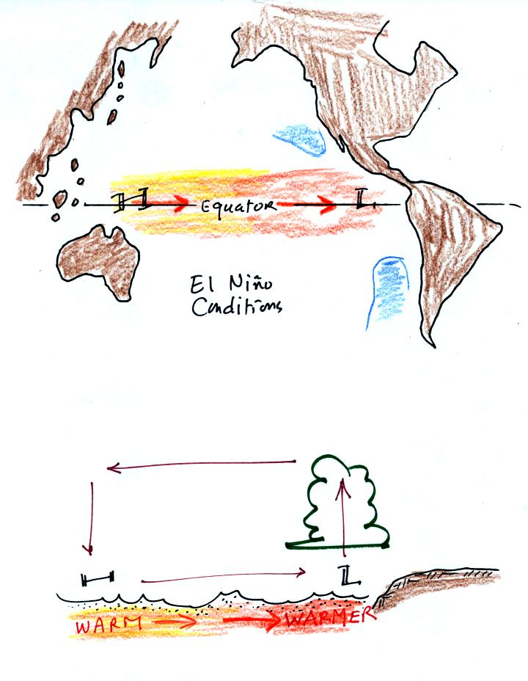
Now surface high pressure is found in the west and surface low pressure and rising air is found in the E. Pacific (the reversal in the surface pressure pattern is referred to as the southern oscillation). Indonesia and Australia often experience drought conditions during El Nino events. In the desert SW we expect slightly wetter than normal conditions (perhaps 20% wetter than normal). Wetter conditions are also found in California and in the SE US.

And here is some additional information concerning the 3-cell model of the earth's global scale circulation.
The 3-cell model predicts subtropical belts of high pressure near 30 latitude. What we really find are large circular centers of high pressure. In the northern hemisphere the Bermuda high is found off the east coast of the US, the Pacific high is positioned off the west coast. High pressure centers are found east and west of South America in the southern hemisphere.
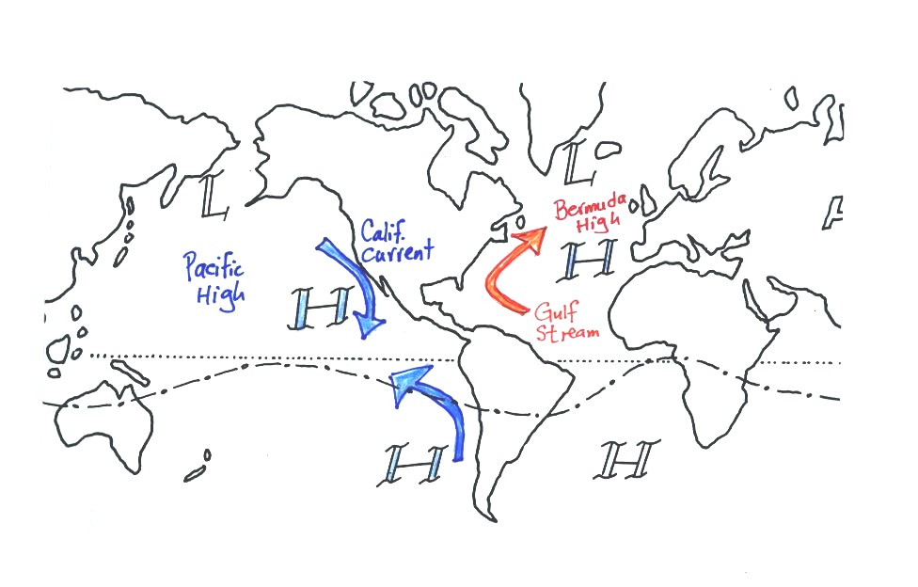
The winds that blow around these large scale high pressure centers create some of the major ocean currents of the world. If you remember that high pressure is positioned off the east and west coast of the US, and that winds blow clockwise around high in the northern hemisphere, you can determine the directions of the ocean currents flowing off the east and west coasts of the US. The Gulf Stream is a warm current that flows from south to north along the east coast, the California current flows from north to south along the west coast and is a cold current. A cold current is also found along the west coast of South America; winds blow counterclockwise around high in the southern hemisphere. These currents are shown in the picture above (not shown in class).
Circular low pressure centers, the Icelandic low (off the east coast near Iceland and Greenland in the picture below) and the Aleutian low (off the west coast near the southern tip of Alaska), are found near 60 N.

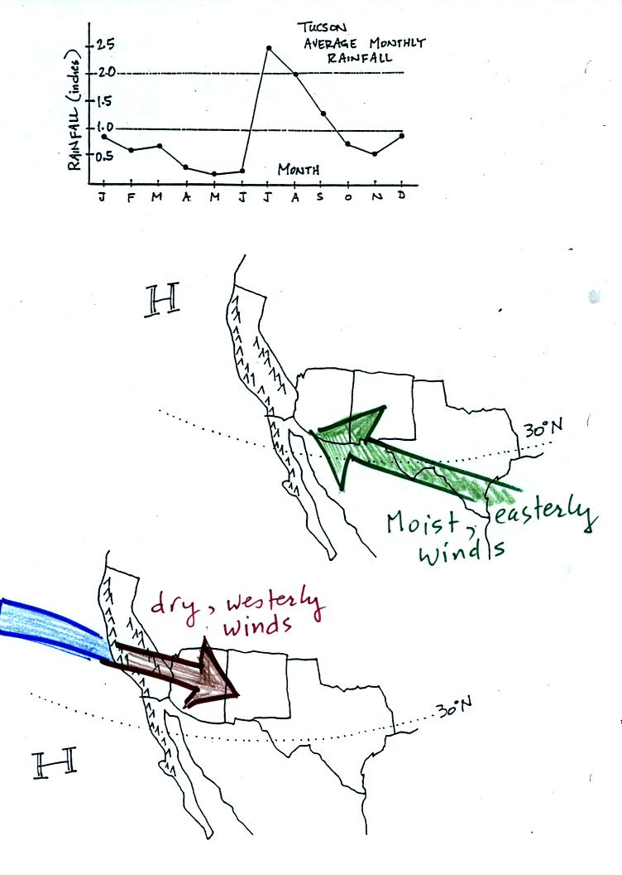
Tucson gets about 12 inches of rain in a normal year (we are well below normal this year). About half of this comes during the "summer monsoon" season. The word monsoon, again, refers to a seasonal change in wind direction. During the summer subtropical high pressure (the Pacific high) moves north of its normal position near 30 N latitude. Winds on the southhern side of the subtropical high have an easterly component. Moist air originating in Mexico and the Gulf of Mexico blows into Arizona. The sun heats the ground during the day, warm moist air in contact with the ground rises and produces convective thunderstorms.
The close proximity of the Pacific high, with its sinking air motions, is what gives California, Oregon, and Washington dry summers.
In the winter the subtropical high moves south of 30 N latitude. Winds to the north of the high blow from the west. Air originating over the Pacific Ocean loses much of its moisture as it crosses mountains in California (remember the rain shadow effect). The air is pretty dry by the time it reaches Arizona. Significant winter rains occur in Arizona when storms systems are able to draw moist subtropical air from the southwest into Arizona.

Between now and the next quiz we will be covering Thunderstorms, Tornadoes, Lightning, and maybe Hurricanes.
We just got started on thunderstorms. Here's a brief introduction.
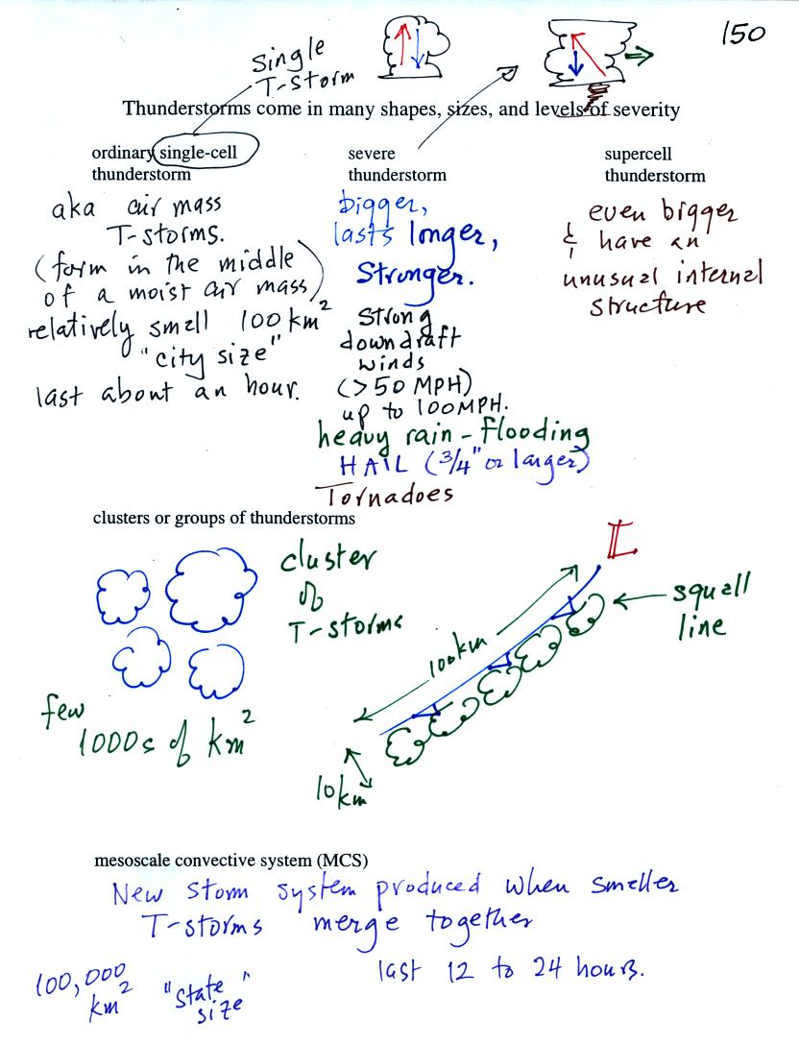
Thunderstorms come in different sizes and levels of severity. We will mostly be concerned with ordinary single-cell thunderstorms (also referred to as air mass thunderstorms). Most summer thunderstorms in Tucson are this type. At the other end of the spectrum are supercell thunderstorms. We'll watch a short video at some point that shows a computer simulation of the complex air motions inside a supercell thunderstorm.
The following somewhat tedious material was intended to prepare you to better appreciate a time lapse video movie of a thunderstorm developing over the Catalina mountains. I don't expect you to remember all of the details given below. The figures below are more carefully drawn versions of what was done in class.
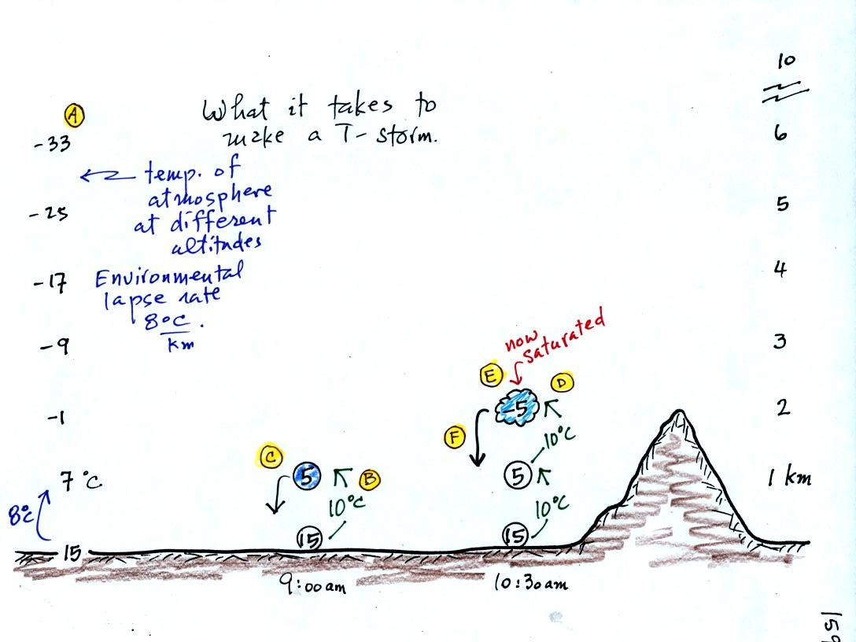
Refer back and forth between the lettered points in the figure above and the commentary below.
The numbers in Column A show the temperature of the air in the atmosphere at various altitudes above the ground (note the altitude scale on the right edge of the figure). On this particular day the air temperature was decreasing at a rate of 8 C per kilometer. This rate of decrease is referred to as the environmental lapse rate (lapse rate just means rate of decrease with altitude). Temperature could decrease more quickly than shown here or less rapidly. Temperature in the atmosphere can even increase with increasing altitude (a temperature inversion).
At Point B, some of the surface air is put into an imaginary container, a parcel. Then a meterological process of some kind lifts the air to 1 km altitude (in Arizona in the summer, sunlight heats the ground and air in contact with the ground, the warm air becomes bouyant - that's called free convection). The rising air will expand and cool as it is rising. Unsaturated (RH is less than 100%) air cools at a rate of 10 C per kilometer. So the 15 C surface air will have a temperature of 5 C once it arrives at 1 km altitude.
"Mother Nature" lifts the parcel to 1 km and "then lets go." At Point C note that the air inside the parcel is slightly colder than the air outside (5 C inside versus 7 C outside). The air inside the parcel will be denser than the air outside and the parcel will sink back to the ground.
By 10:30 am the parcel is being lifted to 2 km as shown at Point D. It is still cooling 10 C for every kilometer of altitude gain. At 2 km, at Point E the air has cooled to its dew point temperature and a cloud has formed. Notice at Point F, the air in the parcel or in the cloud (-5 C) is still colder and denser than the surrounding air (-1 C), so the air will sink back to the ground and the cloud will disappear. Still no thunderstorm at this point.
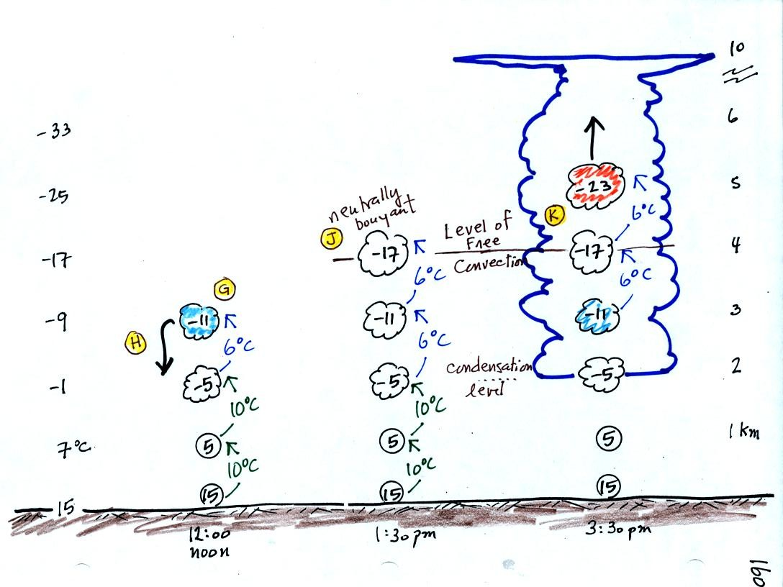
At noon, the air is lifted to 3 km. Because the air became saturated at 2 km, it will cool at a different rate between 2 and 3 km altitude. It cools at a rate of 6 C/km instead of 10 C/km. The saturated air cools more slowly because release of latent heat during condensation offsets some of the cooling due to expansion. The air that arrives at 3km, Point H, is again still colder than the surrounding air and will sink back down to the surface.
By 1:30 pm the air is getting high enough that it becomes neutrally bouyant, it has the same temperature and density as the air around it (-17 C inside and -17 C outside). This is called the level of free convection, Point J in the figure.
If you can, somehow or another, lift air above the level of free convection it will find itself warmer and less dense than the surrounding air as shown at Point K and will float upward to the top of the troposphere on its own. This is really the beginning of a thunderstorm. The thunderstorm will grow upward until it reaches very stable air at the bottom of the stratosphere.

