Friday April 17, 2009
Music today was "Punish the Monkey" sung by Mark Knopfler.
The Expt. #3 revised reports are due next Monday.
The Expt. #4 revised reports are due Monday, Apr. 27.
The revised Expt. #2 reports should all be graded by next Monday.
Most of the 1S1P Assignment #2 reports haven't been graded. The following people have earned 45 1S1P pts and don't have to write anymore reports.

We'll finish the section on thunderstorms today.
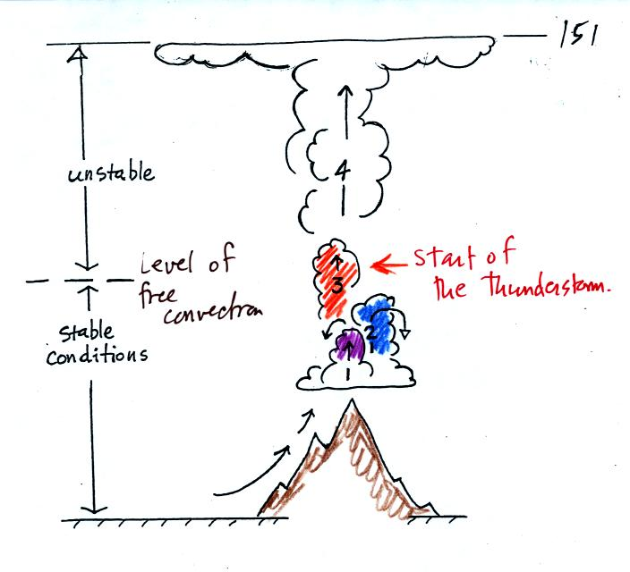
The top portion of this figure summarizes what we covered on Wednesday: it takes some effort and often a good part of the day before a thunderstorm forms. The air must be lifted to just above the level of free convection. Once air is lifted above the level of free convection it finds itself warmer and less dense that the air around it and floats upward on its own. The is the moment at which the air mass thunderstorm begins.
The thunderstorm then goes through 3 stages.
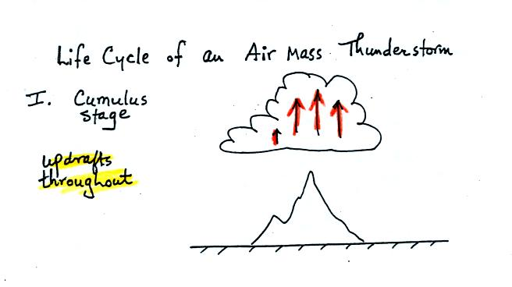
In the first stage you would only find updrafts inside the cloud.
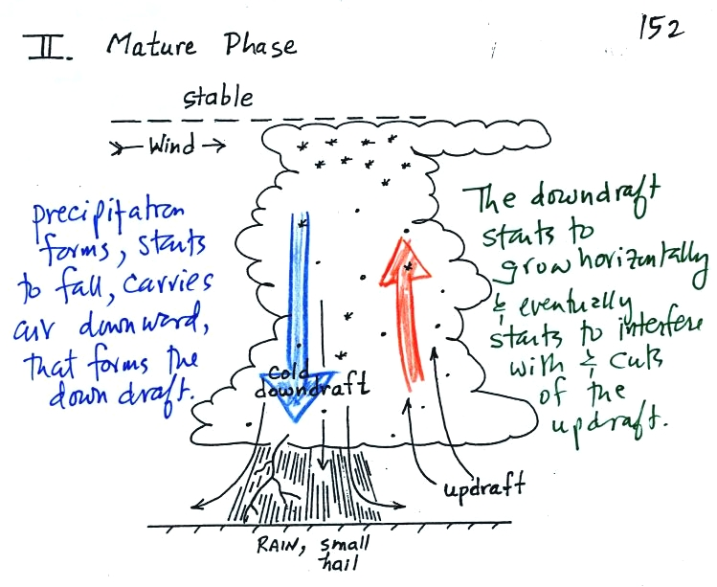
Once precipitation has formed and grown to a certain size, it will begin to fall and drag air downward with it. This is the beginning of the mature stage where you find both an updraft and a downdraft inside the cloud. The falling precipitation will also pull in dry air from outside the thunderstorm (this is called entrainment). Precipitation will mix with this drier air and evaporate. The evaporation will strengthen the downdraft (the evaporation cools the air and makes it more dense). The thunderstorm is strongest in the mature stage. This is when the heaviest rain, strongest winds, and most of the lightning occur.
Eventually the downdraft spreads horizontally throughout the inside of the cloud and interferes with or cuts off the updraft. This marks the beginning of the end for this thunderstorm.
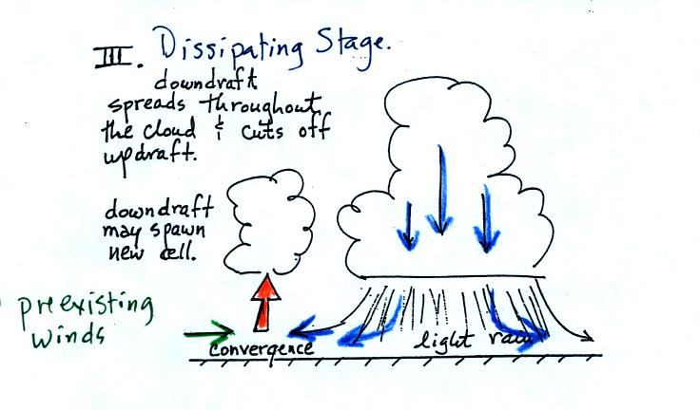
In the dissipating stage you would only find weak downodrafts throughout the interior of the cloud.
Note how the winds from one thunderstorm can cause a region of convergence on one side of the original storm and can lead to the development of new storms. Preexisting winds refers to winds that were blowing before the thunderstorm formed.

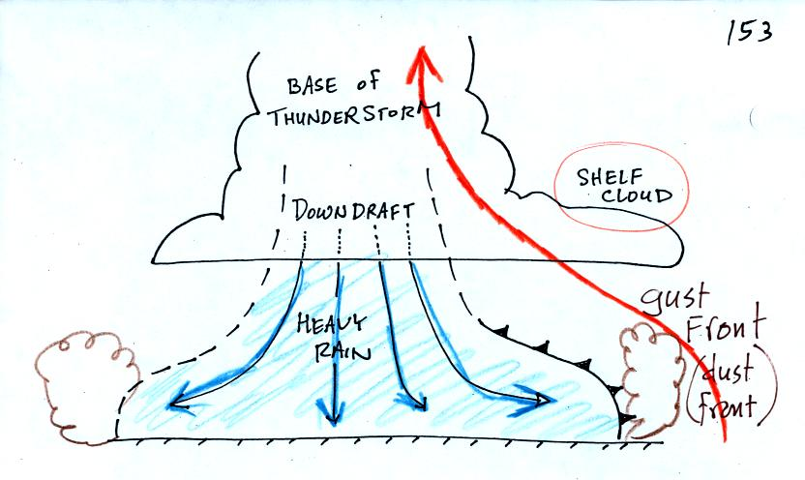
The cold downdraft air spilling out of a thunderstorm hits the ground and begins to move outward from underneather the thunderstorm. The leading edge of this outward moving air is called a gust front. You can think of it as a dust front because the gust front winds often stir up a lot of dust here in the desert southwest.
Warm moist air lifted by the gust front can form a shelf cloud.
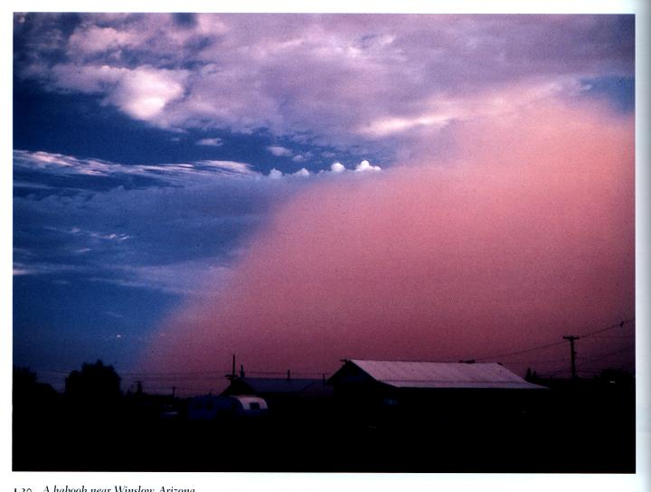

This is a picture of a dust cloud stirred up by thunderstorm gust front winds (taken near Winslow, Az). The gust front is moving from the right to the left. Visibility in the dust cloud can drop to near zero which makes this a serious hazard to automobile traffic. Dust storms like this are sometimes called haboobs.
The following picture shows a shelf cloud.
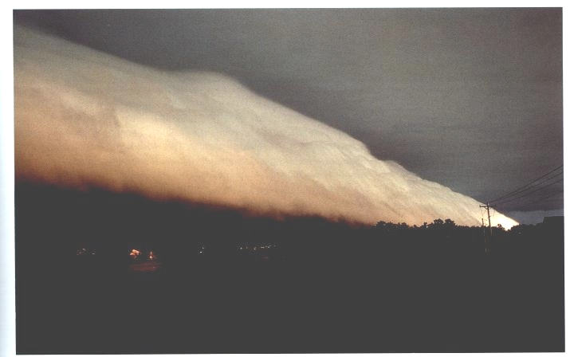
The gust front is moving from left to right in this picture. The shelf cloud is very close to the ground, so the warm air that was lifted by the gust front must have been very moist. It didn't have to rise and cool much before it became saturated and a cloud formed.

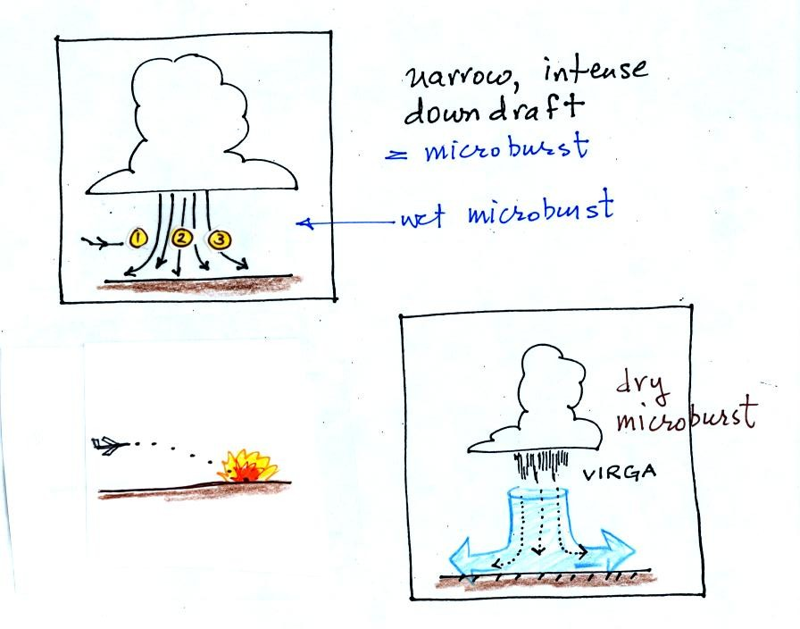
A narrow intense downdraft is called a microburst. At the ground microburst winds will sometimes reach 100 MPH (over a limited area); most tornadoes have winds of 100 MPH or less. Microburst winds can damage homes (especially mobile homes that aren't tied to the ground), uproot trees, and seem to blow over a line of electric power poles at some point every summer in Tucson.
Microbursts are a serious threat to aircraft especially when they are close to the ground during landing or takeoff. An inattentive pilot encountering headwinds at Point 1 could cut back on the power. Very quickly the plane would lose the headwinds (Point 2) and then encounter tailwinds (Point 3). The plane might lose altitude so quickly that it would crash into the ground before corrective action could be taken.
Falling rain could warn of a (wet) microburst. In other cases, dangerous dry microburst winds might be invisible (the virga, evaporating rain, will cool the air, make the air more dense, and strengthen the downdraft winds).
A simple demonstration can give you an idea of what a microburst might look like.
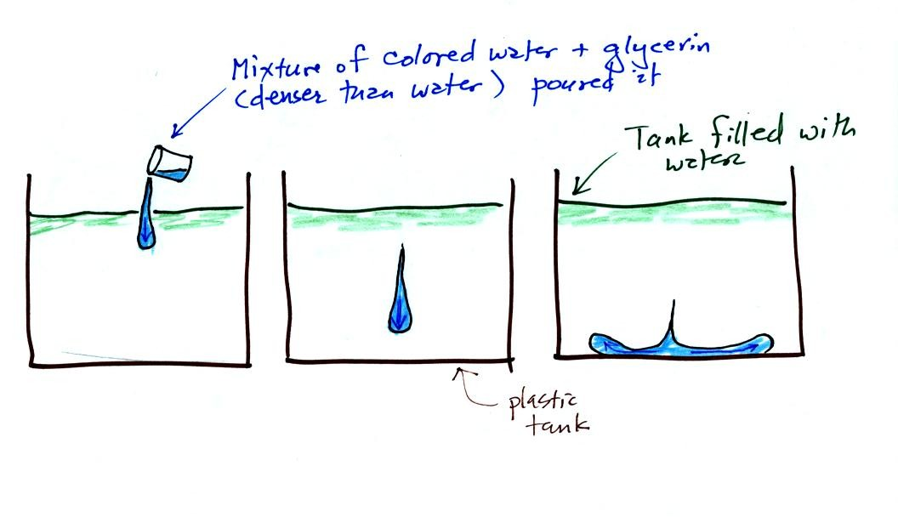

A large plastic tank was filled with water, the water represents air in the atmosphere. Then a colored mixture of water and glycerin, which is a little denser than water, is poured into the tank. This represents the cold dense air in a thunderstorm downdraft. The colored liquid sinks to the bottom of the tank and then spreads out horizontally. In the atmosphere the cold downdraft air hits the ground and spreads out horizontally. These are the strong winds that can reach 100 MPH.
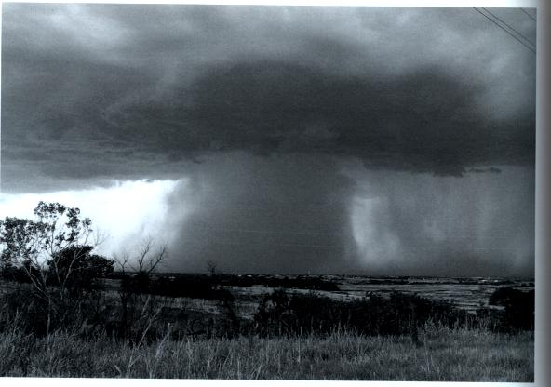
Here's a picture of a wet microburst, a narrow intense thunderstorm downdraft and rain.

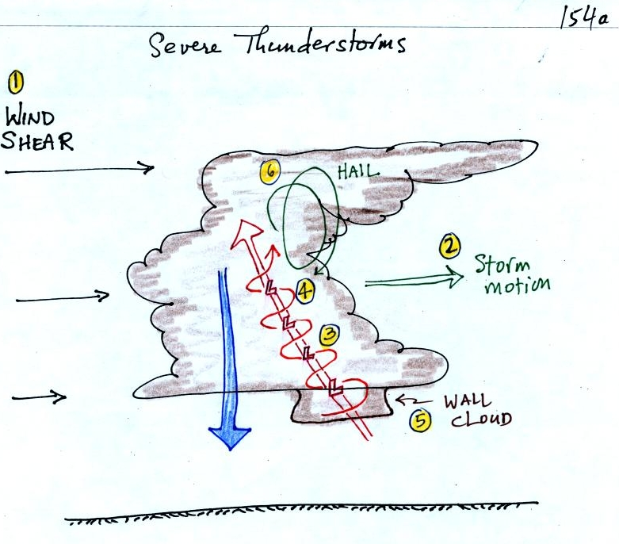

Severe storms are more likely to form when there is vertical wind shear. Wind shear (pt 1) is changing wind direction or wind speed with distance. In this case, the wind speed is increasing with increasing altitude.
The thunderstorm itself will move in this kind of an environmen, at an average of the speeds at the top and bottom of the cloud (pt. 2). The thunderstorm will move to the right more rapidly than the air at the ground which is where the updraft begins. Rising air that is situated at the front bottom edge of the thunderstorm will find itself at the back edge of the storm when it reaches the top of the cloud. This produces a tilted updraft (pt. 3). The downdraft is situated at the back of the ground. The updraft is continually moving to the right and staying away from the downdraft. The updraft and downdraft coexist and do not "get in each others way."
Sometimes the tilted updraft will begin to rotate. A rotating updraft is called a mesocyclone (pt. 4). Meso refers to medium size (thunderstorm size) and cyclone means winds spinning around low pressure. Low pressure in the core of the mesocyclone creates an inward pointing pressure gradient force needed to keep the updraft winds spinning in circular path (low pressure also keeps winds spinning in a tornado). The cloud that extends below the cloud base and surrounds the mesocyclone is called a wall cloud (pt. 5). The largest and strongest tornadoes will generally come from the wall cloud.
Note (pt. 6) that a tilted updraft provides a way of keeping growing hailstones inside the cloud. Hailstones get carried up toward the top of the cloud where they begin to fall. But they then fall back into the strong core of the updraft and get carried back up toward the top of the cloud.
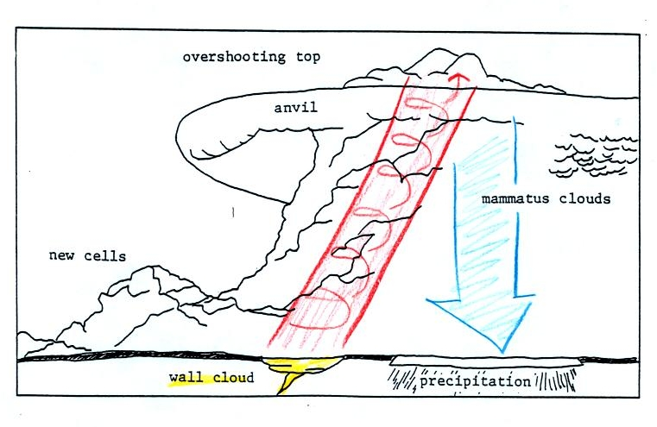

Here is a relatively simple drawing showing some of the key features on a supercell thunderstorm. In a supercell the rotating updraft (shown in orange above) is strong enough to penetrate into the stratosphere. This produces the overshooting top or dome feature above. A wall cloud and a tornado are shown at the bottom of the mesocyclone. In an ordinary thunderstorm the updraft is unable to penetrate into the very stable air in the stratosphere and the upward moving air just flattens out and forms an anvil. The flanking line is a line of new cells trying to form alongside the supercell thunderstorm.

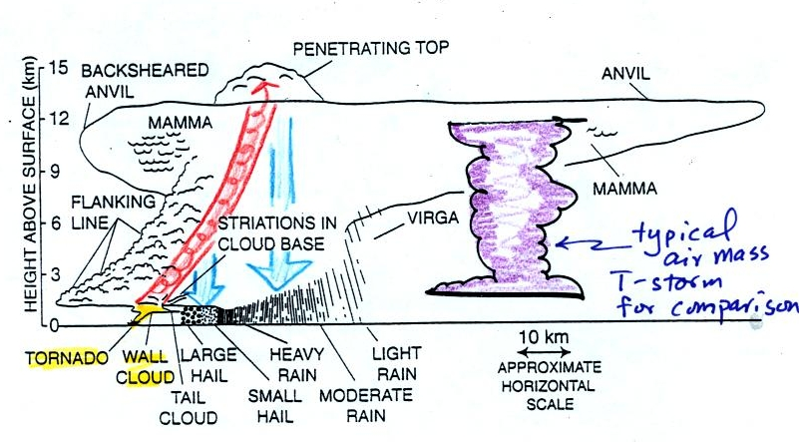
Here is a second slightly more complicated drawing of a supercell thunderstorm. A typical air mass thunderstorm (purple) has been drawn in for comparison.

We haven't discussed weather radar in this class. In some ways a radar image of a thunderstorm is like an X-ray photograph of a human body. The Xrays pass through the flesh but are partially absorbed by bone.

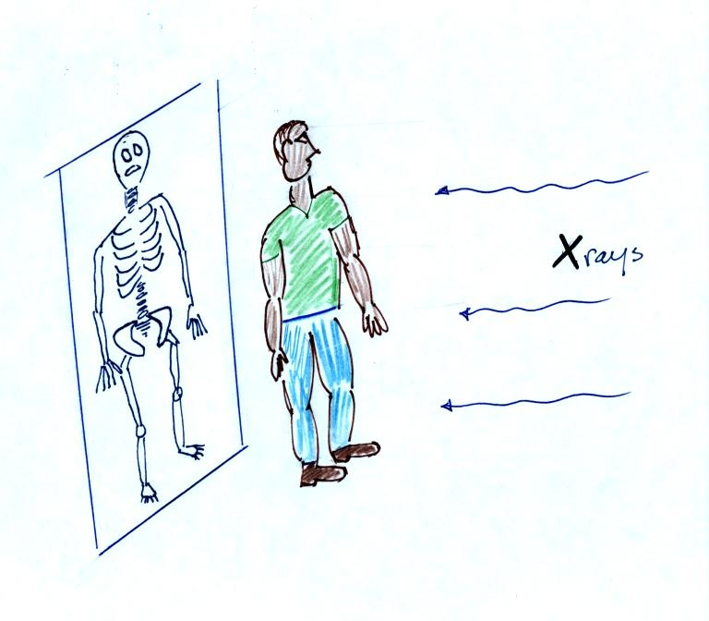

In the case of radar, microwaves emitted by the radar are reflected by precipitation particles in the cloud.
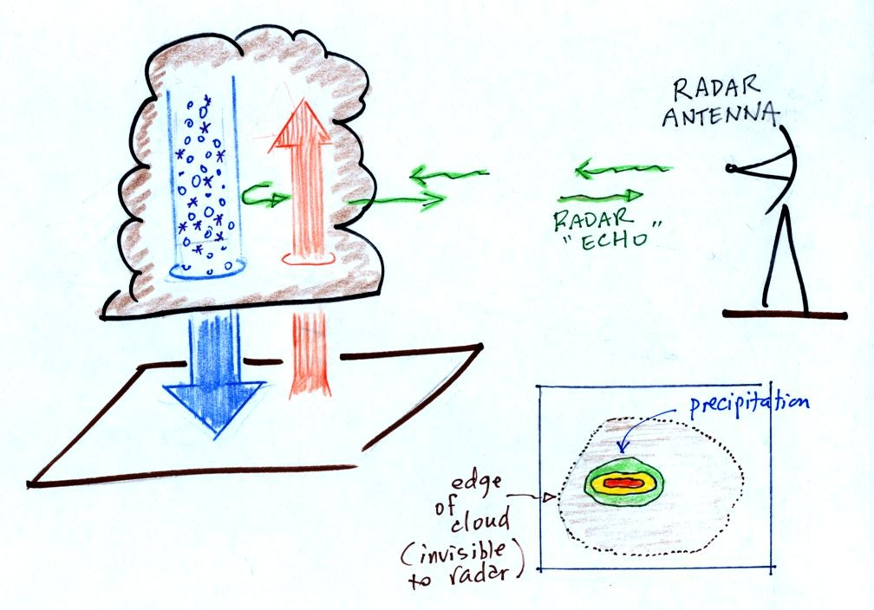
Thunderstorms with rotating updrafts produce a very characteristic hook shaped echo on radar. Here are a couple of examples:
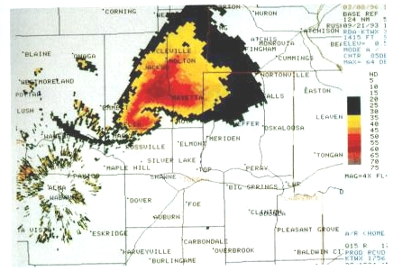
The colors provide an idea of precipitation intensity (red is the heaviest precipitation).
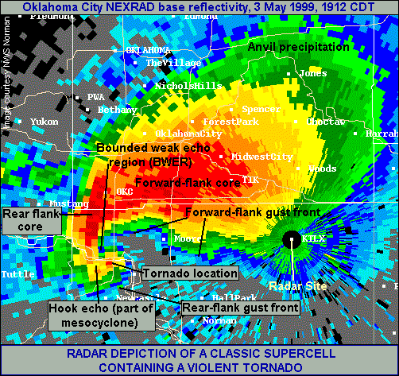
This is the radar image of a very strong tornado that hit Oklahoma City in May 1999
( http://www.spc.noaa.gov/faq/tornado/radscel.htm ) . It is possible that tornado winds of over 300 MPH may have been produced during that storm.
We watched a short video segment at this point. It showed a photograph of a distant supercell thunderstorm with a distinctive dome. The video showed the wall clouds at the bottoms of 2 or 3 other much closer supercells. And finally a computer simulation of the air motions inside a supercell thunderstorm was shown. Researchers understand the development of a supercell pretty well. The exact process that initiates tornado development is still unknown, however.

