Wednesday Apr. 22, 2009
The most recent Optional Assignment was collected today. Because the end of the semester is approaching quickly, any addtional optional assignments will probably be in-class assignments.
Quiz #4 Study Guides Pt. 1 and Pt. 2 are now available.
One of the 1S1P Assignment #3 topics is now available. At least one more topic will be added as soon as I can think of what it will be.
Music today was from Tesoro.

We'll finish up the section on tornadoes today and just begin the section on lightning.
We'll mostly be looking at tornado damage today.
Simplified, Easy-to-Remember version of the Fujita Scale
winds < 100 MPH
F0
F1 | roof damage,  mobile home tipped over
microburst winds can cause this degree of damage
winds 100 to 200 MPH
F2 | roof gone,  outside walls still standing
F3 | outside walls gone,  inside walls intact
winds 200 to 300 MPH
F4 | home destroyed,  debris nearby
F5 | home destroyed,  debris carried away
Here are some photographs of tornado damage
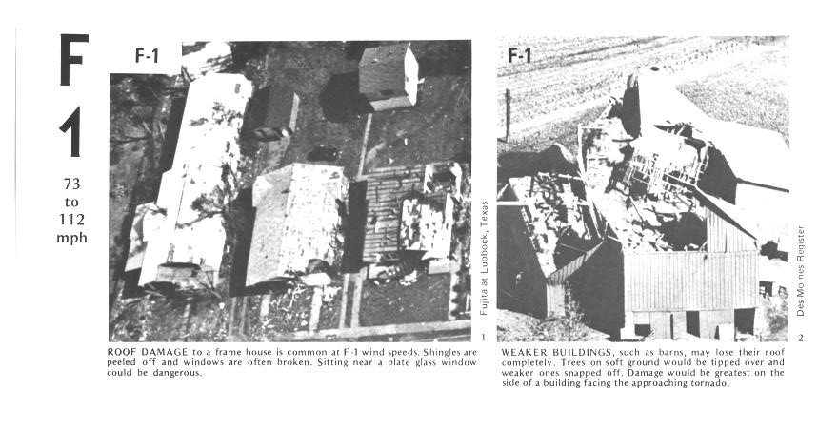
The buildings on the left suffered light roof damage. The barn roof at right was more heavily damaged.
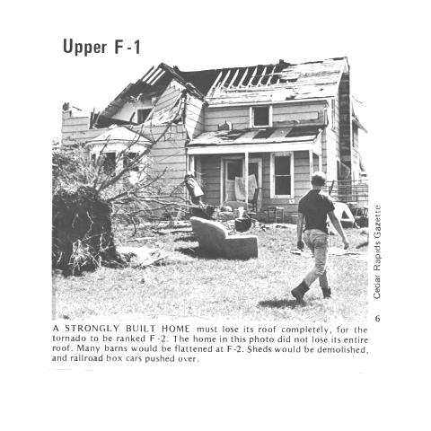
More severe damage to what appears to be a well built house roof.

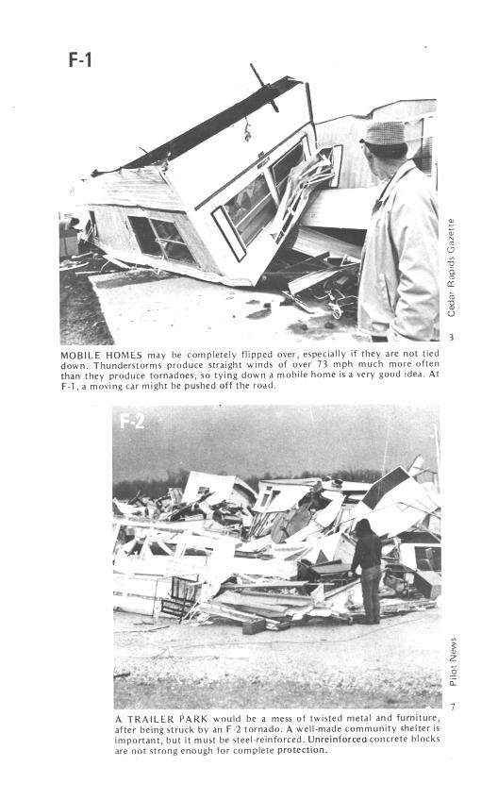
F1 tornado winds can tip over a mobile home if it is not tied down (the caption states that an F1 tornado could blow a moving car off a highway). F2 level winds (bottom photo above) can roll and completely destroy a mobile home.
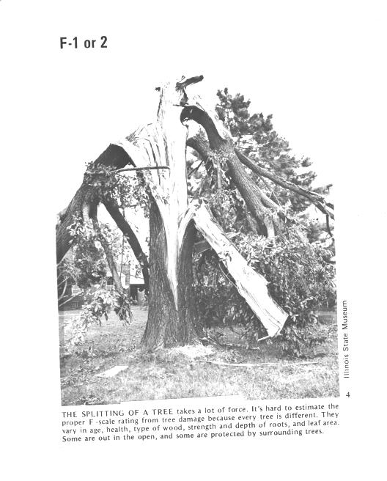
Trees, if not uprooted, can suffer serious damage from F1 or F2 tornado winds.
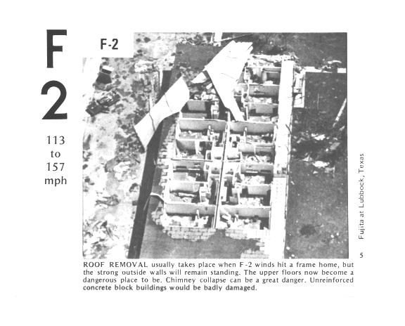
F2 level winds have completely removed the roof from this building. The outside walls of the building are still standing.
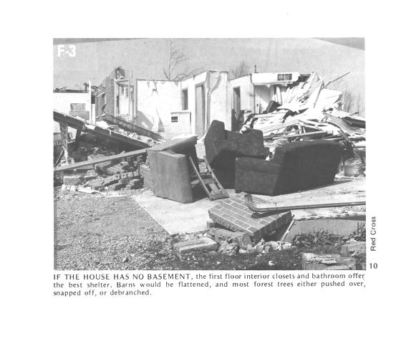
The roof is gone and the outer walls of this house were knocked down. This is characteristic of F3 level damage. In a house without a basement or storm cellar it would be best to seek shelter in an interior closet or bathroom (plumbing might help somewhat to keep the walls intact).
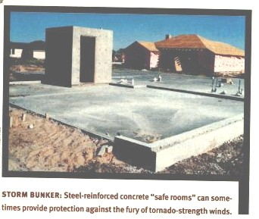
In some tornado prone areas,
people construct a small closet or room inside their home made of reinforced concrete.
A better solution might be to have a storm cellar located underground.
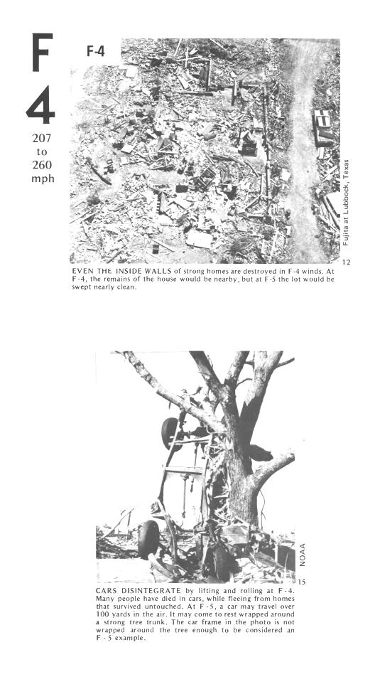
All of the walls were knocked down in the top photo but the debris is left nearby. This is characteristic of F4 level damage. All of the sheet metal in the car body has been removed in the bottom photo and the car chasis has been bent around a tree. The tree has been stripped of all but the largest branches.
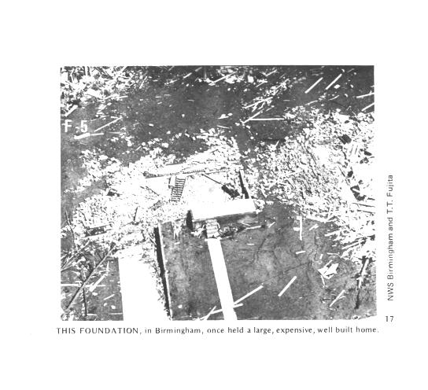
An F5 tornado completely destroyed the home in the photo above and removed most of the debris.
Only bricks and a few pieces of lumber are left.

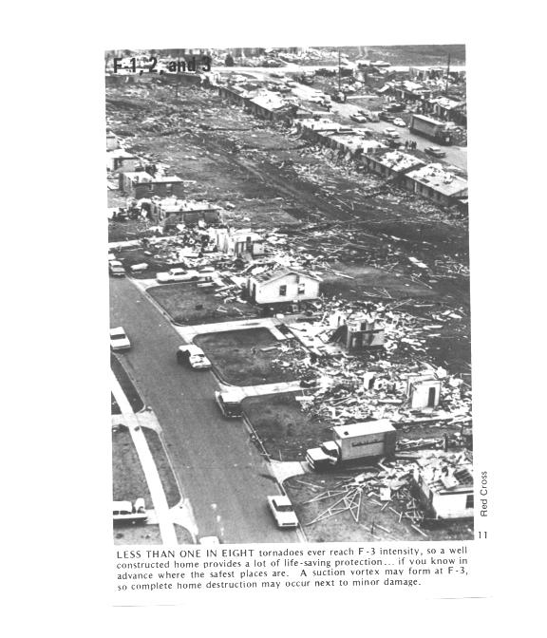
Several levels of damage are visible in the photograph above. It was puzzling initially how some homes could be nearly destroyed while a home nearby or in between was left with only light damage. One possible explanation is shown below
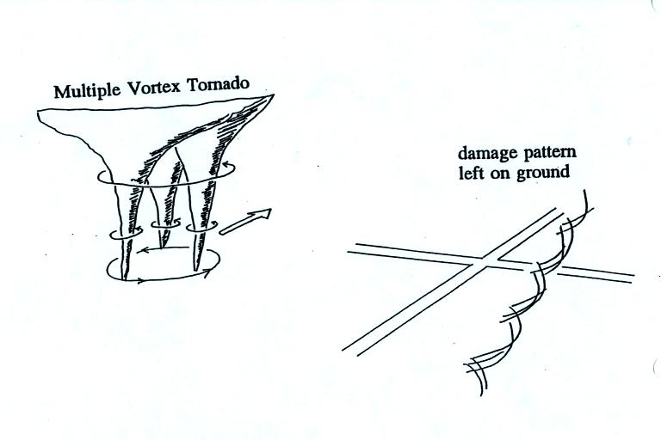
Some big strong tornadoes may have smaller more intense "suction vortices" that spin around the center of the tornado. Tornado researchers have actually seen the scouring pattern shown at right in the figure above that the multiple vortices can leave behind.
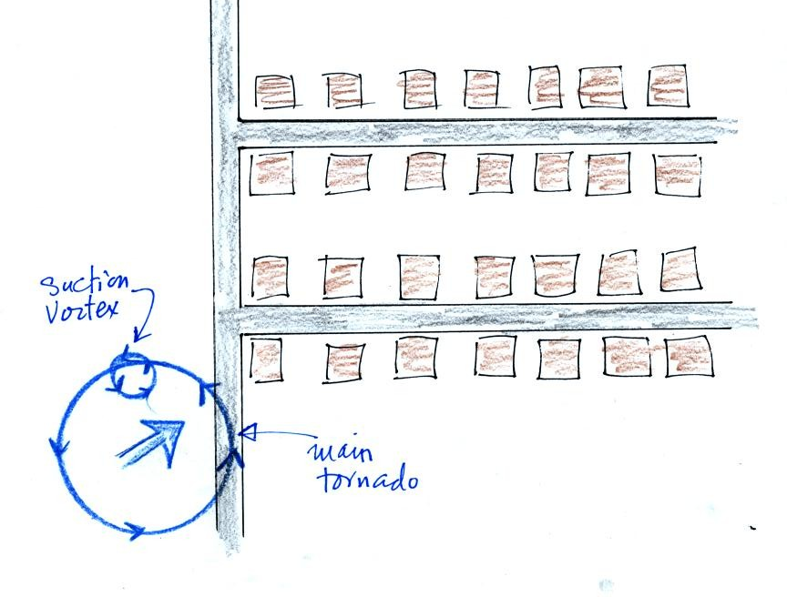
The sketch above shows a tornado located SW of a neighborhood.
As the tornado sweeps through the neighborhood, the suction vortex will rotate around the core of the tornado.
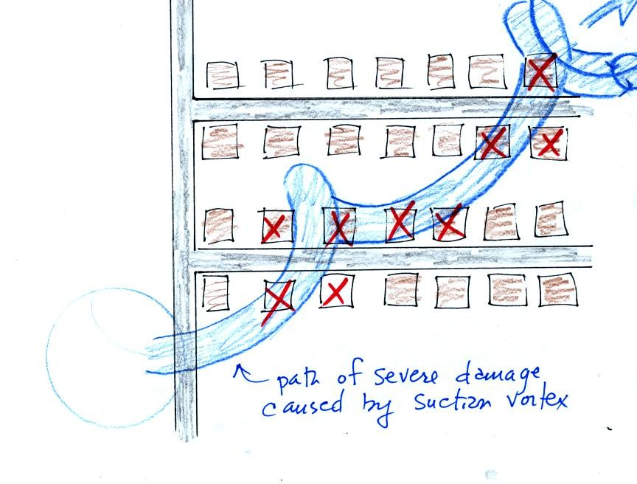
The homes marked in red would be damaged severely. The others would receive less damage (remember, however that there would probably be multiple suction vortices in the tornado).
The following figures, added in response to a question from a student in class, weren't shown in class.
Air motions inside tornadoes are complex and difficult (dangerous) to study. Researchers resort to laboratory simulations ("tornado machines") and computer models.
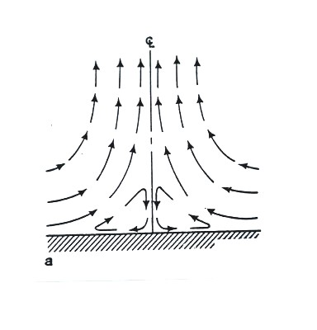
The figure above shows what the winds are thought to be like in a weak tornado.
Friction probably causes the closed circulation loop near the bottom center of the tornado.
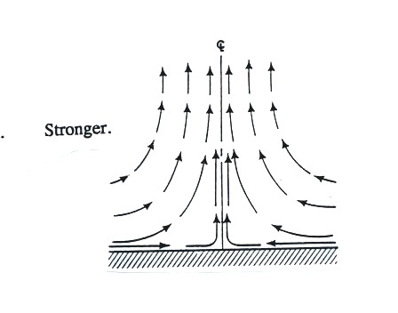
Winds in a somewhat stronger tornado.
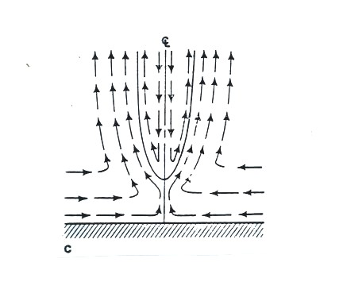
Downward moving air is found in the core of this tornado.
This tornado would also have a larger diameter than the weaker tornadoes above.
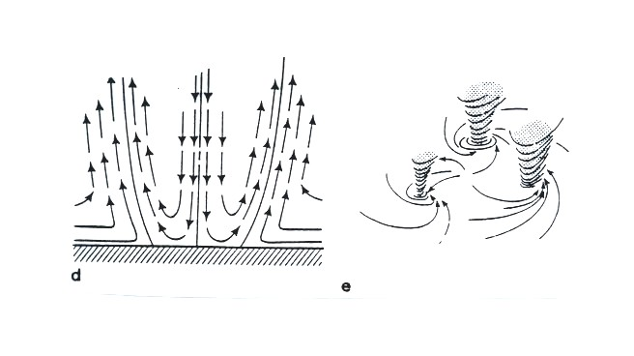
Vortex breakdown has reached the ground. Sinking air would normally result in clear skies. There are a few firsthand reports of people being able to look upward in the center of a tornado and seeing clear skies.
This vortex breakdown is what may lead to the formation of multiple vortices.

At this point we watched the last of the tornado video tapes. It showed a tornado that occurred in Pampa, Texas. Near the end of the segment, video photography showed several vehicles (pick up trucks and a van) that had been lifted 100 feet or so off the ground that were being thrown around at 80 or 90 MPH by the tornado winds. Winds speeds of about 250 MPH were estimated from the video photography.

Click on this link, for a brief introduction to lightning, the next topic we will be covering in this class.
Lightning kills about 100 people every year in the United States (more than tornadoes or hurricanes but less than flooding, summer heat and winter cold) and is the cause of about 30% of all power outages. In the western United States, lightning starts about half of all forest fires. Lightning caused fires are a particular problem at the beginning of the thunderstorm season in Arizona. At this time the air underneath thunderstorms is still relatively dry. Rain falling from a thunderstorm will often evaporate before reaching the ground. Lightning then strikes dry ground, starts a fire, and there isn't any rain to put out or at least slow the spread of the fire. This is so called dry lightning.
Lighning is most commonly produced by thunderstorms (it has also be observed in dust storms and volcanic eruptions).
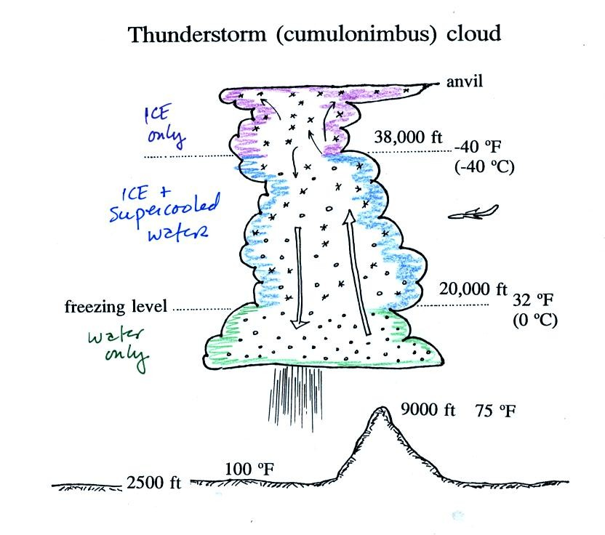
A typical summer thunderstorm in Tucson (found on p. 165 in the photocopied Classnotes). Remember that even in the summer a large part of the middle of the middle of the cloud is found at below freezing temperatures and contains a mixture of super cooled water droplets and ice crystals. This is where the ice crystal process of precipitation formation operatures and is also where electrical charge is created. Doesn't it seem a little unusual that electricity can be created in such a cold and wet environment?
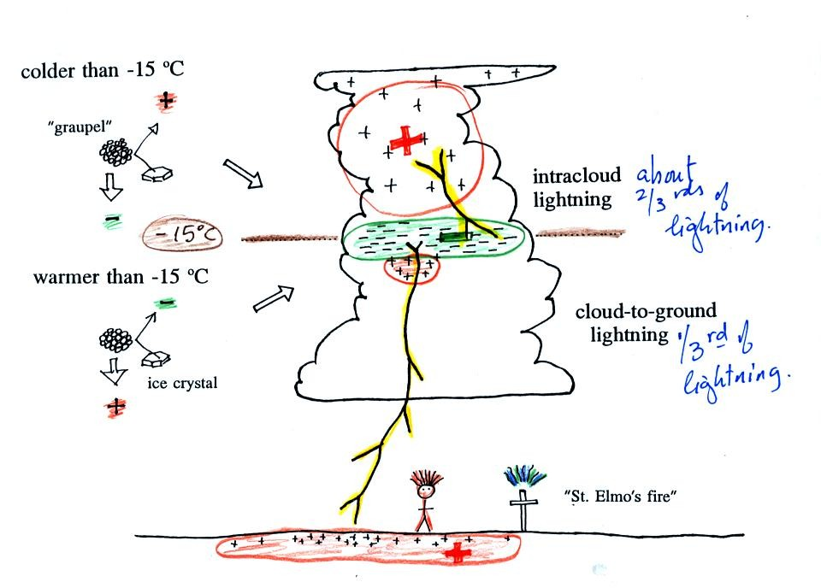
Collisions between precipitation particles produce the electrical charge needed for lightning. When temperatures are colder than -15 C, graupel becomes negatively charged after colliding with a snow crystal. The snow crystal is positively charged and is carried up toward the top of the cloud by the updraft winds. At temperature warmer than -15 (but still below freezing), the polarities are reversed. Large positive and negative charge centers begin to build up inside the cloud. When the electrical attrative forces between these charge centers gets high enough lightning occurs. Most lightning (2/3 rds) stays inside the cloud and travels between the main positive charge center near the top of the cloud and a large layer of negative charge in the middle of the cloud; this is intracloud lightning. About 1/3 rd of all lightning flashes strike the ground. These are called cloud-to-ground discharges (actually negative cloud-to- ground lightning).
A couple of interesting things that can happen at the ground when the electrical forces get high enough. Attraction between positive charge in the ground and the layer of negative charge in the cloud can become strong enough that a person's hair will literally stand on end. This is incidentally a dangerous situation to be in as lightning might be about to strike. St. Elmo's fire is a faint electrical discharge that sometimes develops at the tops of elevated objects during thundestorms. It was first observed coming from the tall masts of sailing ships at sea (St. Elmo is the patron saint of sailors).

