Monday Apr. 27, 2009
I'm not sure I remember but I think the music today came from Alison Krauss.
The Expt. #4 revised reports were collected today.

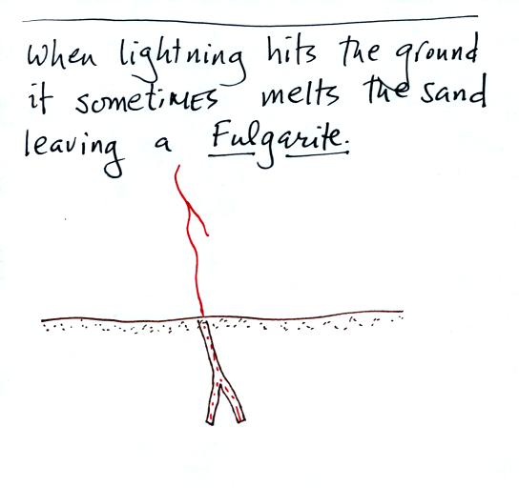

Fulgurites sometimes form when lightning strikes soil. The heat from the lightning channel fuses the sand into a hard tube like or root like formation that remains after the lightning is over. A couple of small pieces of fulgurites were passed around in class.

We will spend the next two classes on Hurricanes.
A good place to begin is to compare hurricanes (tropical cyclones) with middle latitude storms (extratropical cyclones).
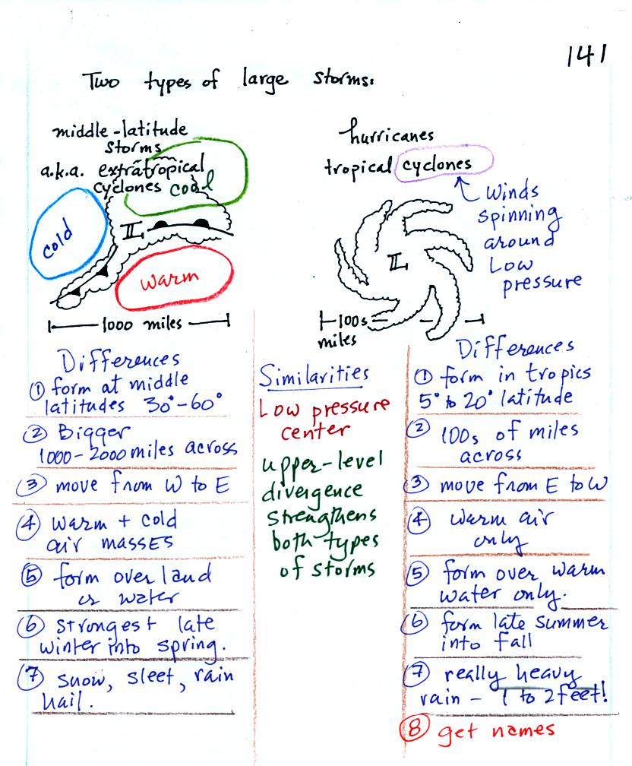
Hurricanes and middle latitude storms have a couple of characteristics in common: a. they both form around surface centers of low pressure (that is why the term cyclone appears in the names of both types of storms). Upper level divergence can lower the surface pressure which then can cause both types of storms to intensify.
1,2. Middle latitude storms (MLS) are form at middle latitude (between 30 and 60 degrees latitude) and are generally bigger than hurricanes. A large middle latitude storm might cover half of the United States. Hurricanes form in the tropics, a big hurricane might fill the Gulf of Mexico.
3. MLS form in the prevailing westerly wind belt and move from west to east. Hurricanes form in the trade winds and move from east to west.
4,5. MLS can form over land or water. Fronts separate warm, cold, and cool air masses. Hurricanes only form over very warm ocean water and are made entirely of warm moist air.
6. The strongest MLS form in the winter and early spring. Peak hurricane activity occurs in the late summer into the fall.
7. MLS can produce a variety of different types of precipitation. Hurricanes mostly just produce very large amounts of rain.
8. Hurricanes receive names (when they reach tropical storm strength). The names now alternate male and female. The names of particularly strong or deadly hurricanes (such as Katrina) are retired, otherwise the names repeat every 6 years.

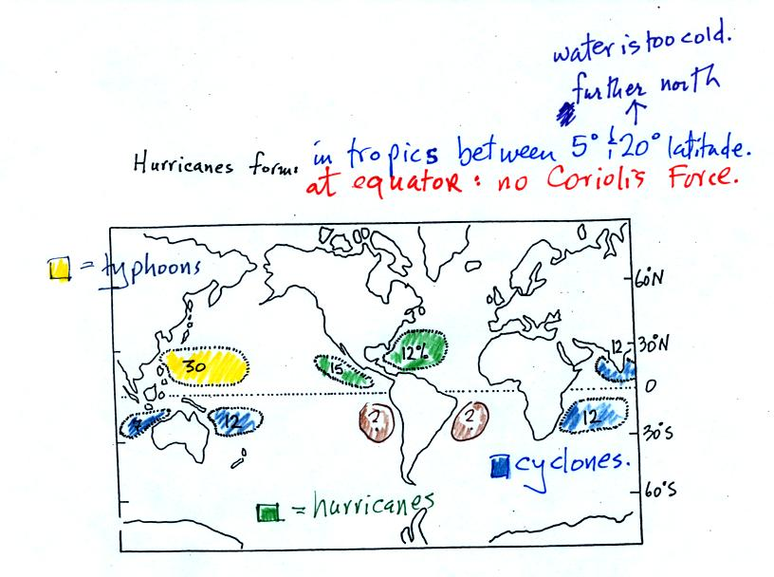
The figure above shows the relative frequency of tropical cyclone development in different parts of the world. The name hurricane, cyclone, and typhoon all refer to the same type of storm (tropical cyclone is a general name that can be used anywhere). In most years the ocean off the coast of SE Asia is the world's most active hurricane zone. Hurricanes are very rare off the east and west coasts of South America.
Hurricanes form between 5 and 20 degrees latitude, over warm ocean water, north and south of the equator. The warm layer of water must be fairly deep to contain enough energy to fuel a hurricane and in order that mixing doesn't bring cold water up to the ocean surface. The atmosphere must be unstable so that thunderstorms can develop. Hurricanes will only form when there is very little or no vertical wind shear (changing wind direction or speed with altitude). Hurricanes don't form at the equator because there is no Coriolis force there (the Coriolis force is what gives hurricanes their spin and it causes hurricanes to spin in opposite directions in the northern and southern hemispheres.
Note that more tropical cyclones form off the west coast of the US than off the east coast. The west coast hurricanes don't generally get much attention, because they move away from the coast and usually don't present a threat to the US (except occasionally to the state of Hawaii). The moisture from these storms will sometimes be pulled up into the southwestern US where it can lead to heavy rain and flooding.
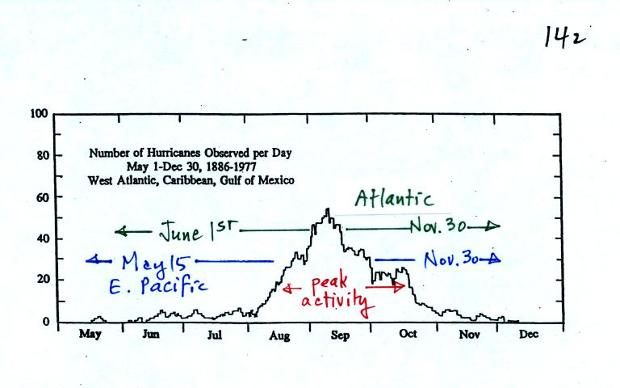
Hurricane season in the Atlantic officially runs from June 1 through to November 30. The peak of hurricane season is in September. In 2005, an unusually active hurricane season in the Atlantic, hurricanes continued through December and even into January 2006. Hurricane season in the Pacific begins two weeks earlier on May 15 and runs through Nov. 30.

Some kind of meteorological process that produces low level convergence is needed to initiate a hurricane. One possibility, and the one that fuels most of the strong N. Atlantic hurricanes, is an "easterly wave." This is just a "wiggle" in the wind flow pattern. Easterly waves often form over Africa or just off the African coast and then travel toward the west across the N. Atlantic. Winds converge as they approach the wave and then diverge once they are past it . The convergence will cause air to rise and thunderstorms to begin to develop.
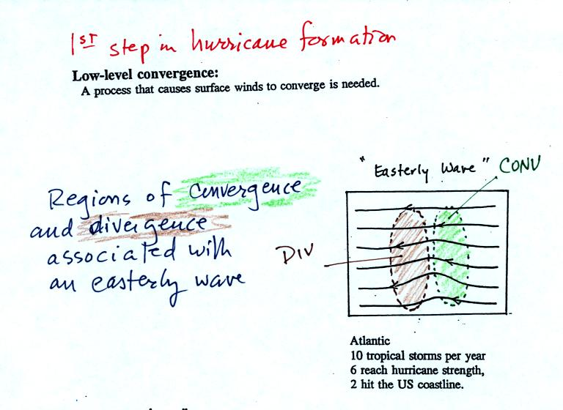
In an average year, in the N. Atlantic, there will be 10 named storms (tropical storms or hurricanes) that develop during hurricane season. 2005 was, if you remember, a very unusual year. There were 28 named storms in the N. Atlantic in 2005. That beat the previous record of 21 names storms that had been set in 1933. Of the 28 named storms, 15 developed into hurricanes.
In some ways winds blowing through an easterly wave resembles traffic on a multi-lane highway. Traffic will back up as it approaches a section of the highway with a closed lane. Once through the "bottleneck" traffic will begin to flow more freely.

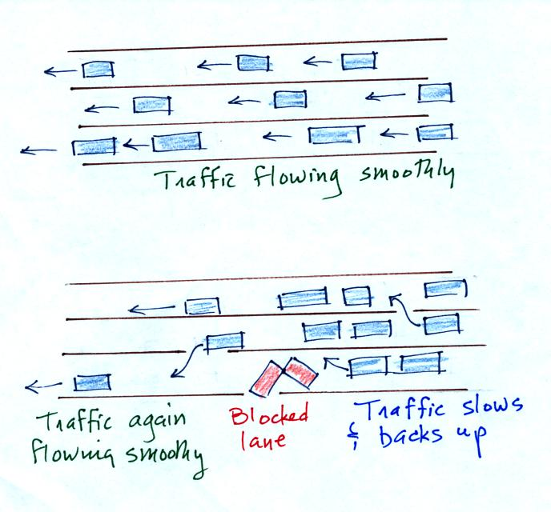
Another process that causes surface winds to converge is a "lee side low."
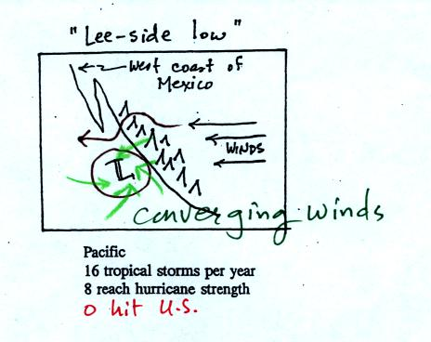
Winds blowing over mountains on the west coast of Mexico will sometimes form a surface low on the downwind side of the mountains. Surface winds will spiral inward toward the center of the low. Note there are generally a few more tropical storms and hurricanes in the E. Pacific than in the N. Atlantic. They generally move away from the US coast, though the Hawaiian Islands are sometimes affected.

That was about all the new material we had time to cover in class because a 20 minute segment from a NOVA program (PBS network) on hurricanes was shown. A film crew was on board a NOAA reconnaissance plane as it flew into the narrow eye of hurricane GILBERT. Gilbert set the record low sea level pressure reading for the Atlantic ocean (888 mb). That record stood until the 2005 hurricane season when WILMA set a new record of 882 mb. The world record low sea level pressure, 870 mb, was set in a SE Asian typhoon in 1979.
Here are some of the comments written down during the video (these were on the back of the handout distributed in class. We will review the Saffir Simpson scale in class on Wednesday and look at the 3-dimensional structure of hurricanes in more detail.

One of the most distinctive features of a hurricane is the clear eye in the center. The eye is produced by sinking air. Once in the eye, the people in the NOAA plane where able to see blue sky when they looked and and saw the ocean surface when they looked down. The eye of a hurricane is something that very few people will ever see. The eye is surrounded by the eye wall, a ring of strong thunderstorms.

The Saffir simpson scale is used to rate hurricane intensity or damage potential. We'll talk more about hurricane damage in class on Friday.

