Monday Feb. 2, 2009
I remember having played something from Rodrigo y Gabriela today, but I'm not sure which song it was. Probably Diablo Rojo.
The 1S1P Bonus Assignment reports were collected today.
The Experiment #1 reports are due next Monday (Feb. 9). Try to bring in your materials this week so that you can pick up the Supplementary Information sheet.
The Practice Quiz is Wednesday this week. Reviews are scheduled for Mon. and Tue. afternoons this week (4 - 5 pm in FCS 225, both days). Practice Quiz Study Guide.

A little review before starting on some new material today. It is sometimes helpful to imagine a pile of bricks (or wood blocks) when trying to understand atmospheric pressure.
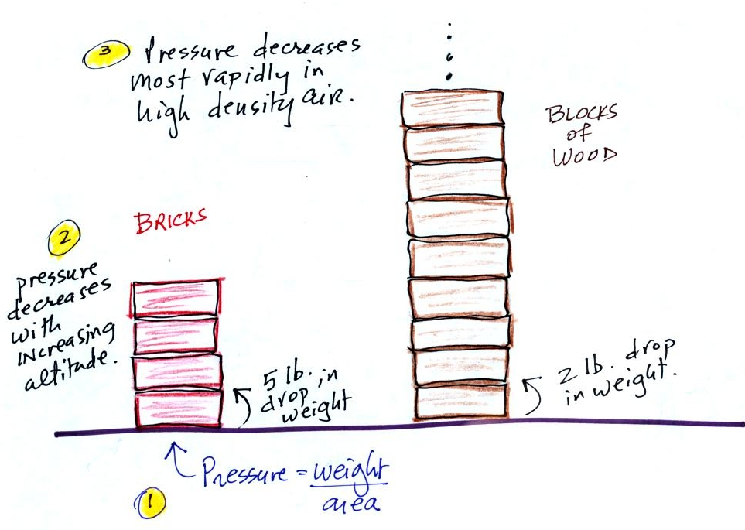

1. The atmospheric pressure at sea level is determined by the weight of the air overhead.
2. As you move upward in the atmosphere, there is less and less air left overhead, less and less weight. Pressure decreases with increasing altitude.
3. You could imagine a pile of bricks and a pile of wood blocks both having the same total weight. It would take a lot more wood blocks to make this true. Then as you move upward a level in each pile, you would find a bigger decrease in weight for the pile of bricks than for the pile of wood blocks (5 lbs per brick, 2 pounds per block). Bricks are denser than wood blocks, pressure decreases most rapidly with increasing altitude in the denser pile of bricks. Pressure decreases more rapidly in dense air than in lower density air.

Newton's Law of Universal Gravitation is an equation that allows you to calculate the gravitational attraction between two objects. We worked through the following two pages in the photocopied ClassNotes fairly quickly. With a little thought you can appreciate and understand why certain variables appear in Newton's Law and why they appear in either the numerator (direct proportionality) or in the denominator (inverse proportionality).
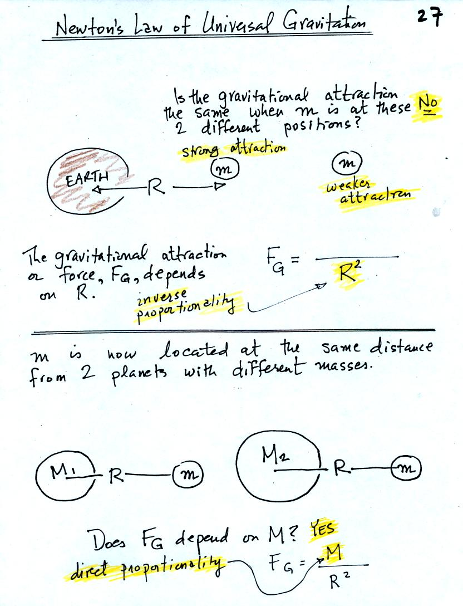
The gravitational attraction between two objects (M and m in the figures) depends first of all on the distance separating the objects. The gravitational force becomes weaker the further away the two objects are from each other. In the bottom picture above and the top figure below we see that the attractive force also depends on the masses of the two objects.
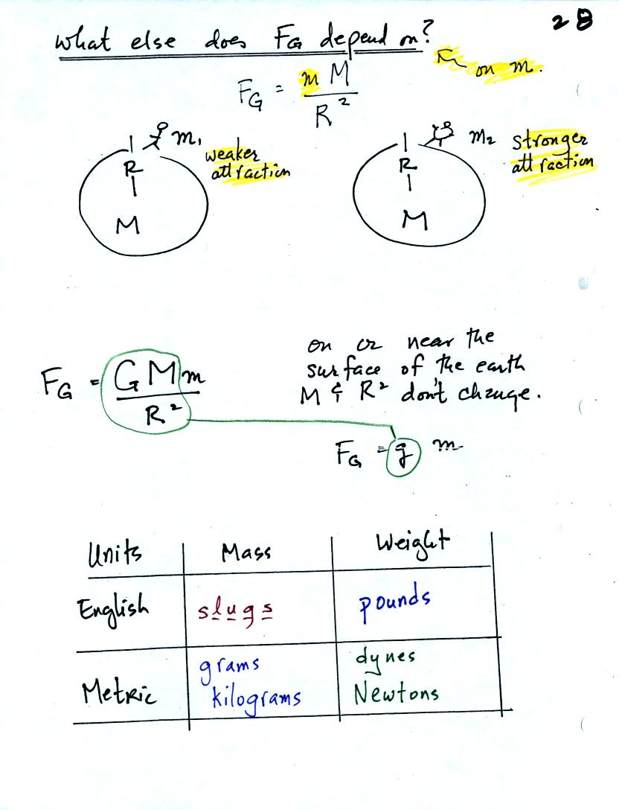
The complete formula is shown in the middle of the page above. G is a constant. On the surface of the earth G, M, and R don't change. The gravitational acceleration, g, is just the quantity [G times M_{earth} divided by ( R_{earth} )² ]. To determine the weight (on the earth's surface) of an object with mass m you simply multiply m x g.
Down at the bottom of the page are the Metric and English units of mass and weight. You have probably heard of pounds, grams, and kilograms. You might not have heard of dynes and Newtons. Most people have never heard of slugs.

Mercury barometers are used to measure atmospheric pressure. A mercury barometer is really just a balance that can be used to weigh the atmosphere. A basic understanding of how a mercury barometer works is something that every college graduate should have. You'll find most of what follows on p. 29 in the photocopied Class Notes.
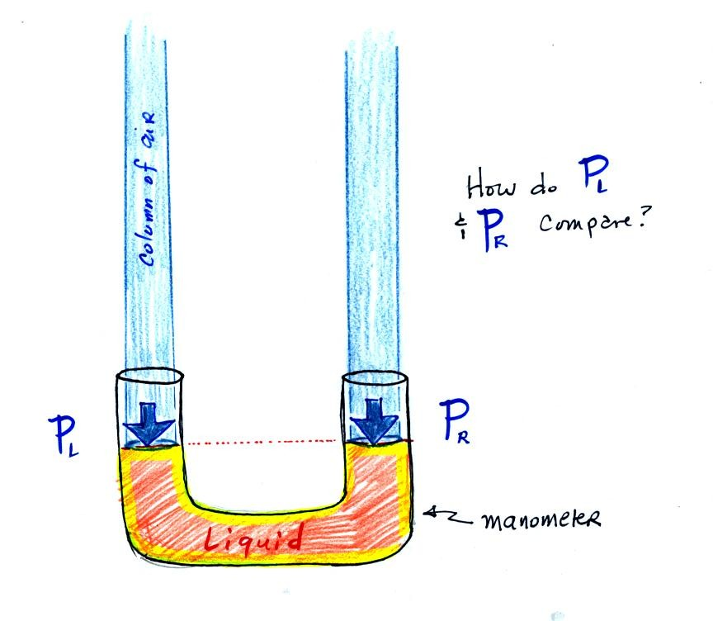
The instrument above ( a u-shaped glass tube filled with a liquid of some kind) is a manometer and can be used to measure pressure difference. The two ends of the tube are open so that air can get inside and air pressure can press on the liquid. Given that the liquid levels on the two sides of the manometer are equal, what could you about P_{L} and P_{R}?
The liquid can slosh back and forth just like the pans on a balance can move up and down. A manometer really behaves just like a pan balance.
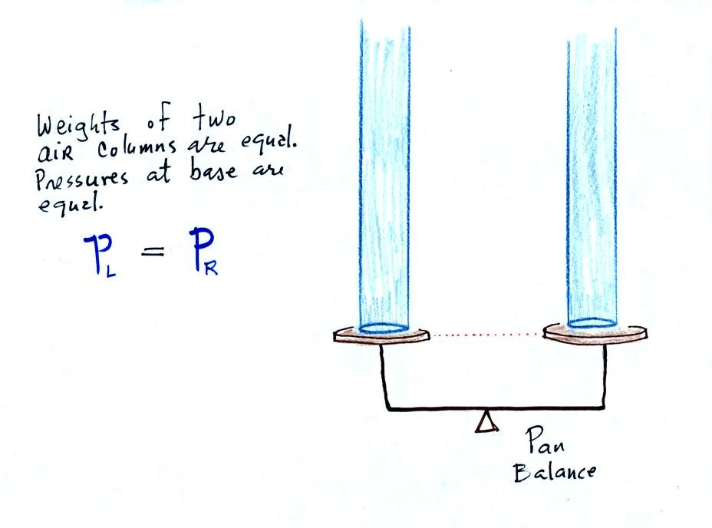
P_{L} and P_{R} are equal (note you don't really know what either pressure is just that they are equal).
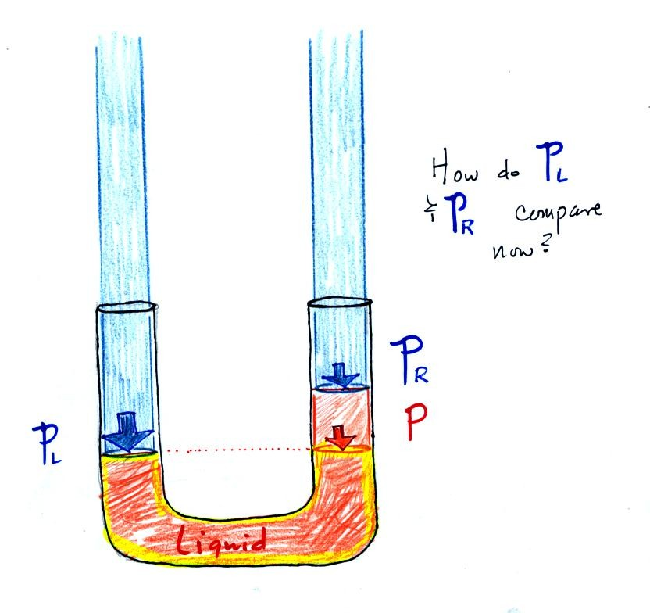
Now the situation is a little different, the liquid levels are no longer equal. You probably realize that the air pressure on the left, P_{L}, is a little higher than the air pressure on the right, P_{R}. P_{L} is now being balanced by P_{R} + P acting together. P is the pressure produced by the weight of the extra fluid on the right hand side of the manometer (the fluid that lies above the dotted line). The height of the column of extra liquid provides a measure of the difference between P_{L} and P_{R}.
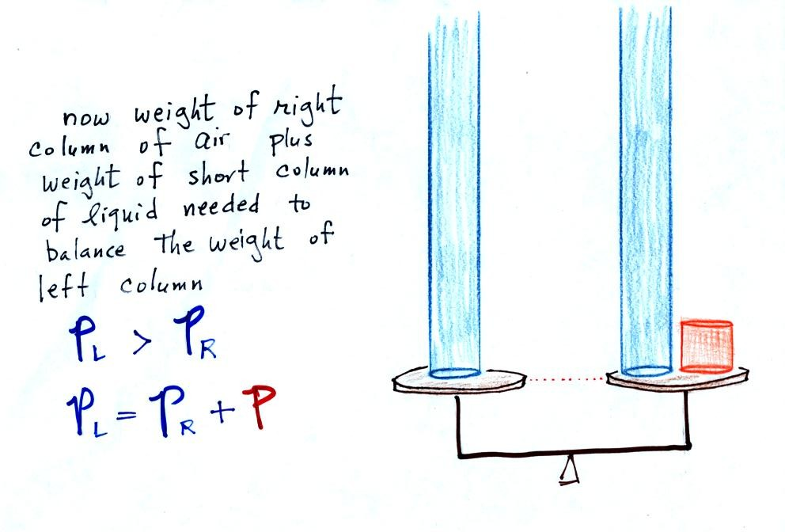
Next we will just go and close off the right hand side of the manometer.
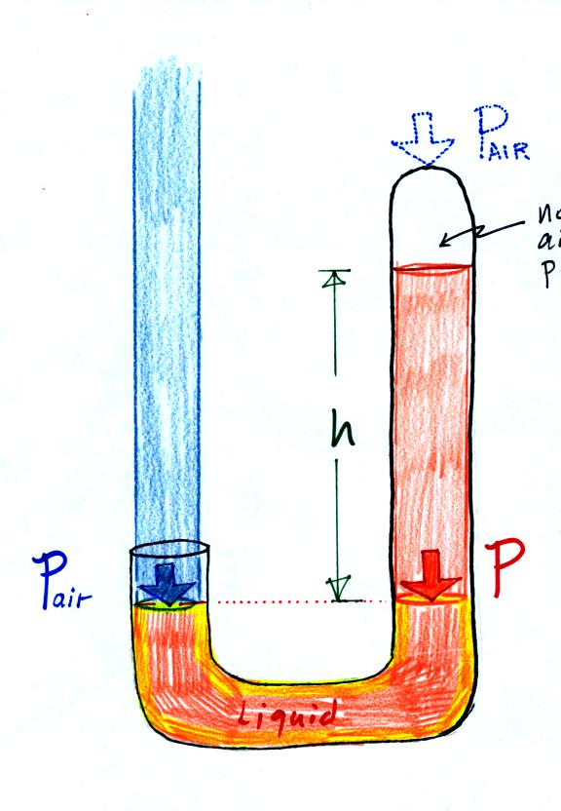
Air pressure can't get into the right tube any more. Now at the level of the dotted line the balance is between P_{air} and P (pressure by the extra liquid on the right). If P_{air} changes, the height of the right column, h, will change. You now have a barometer, an instrument that can measure and monitor the atmospheric pressure. (some of the letters were cut off in the upper right portion of the figure, they should read "no air pressure")
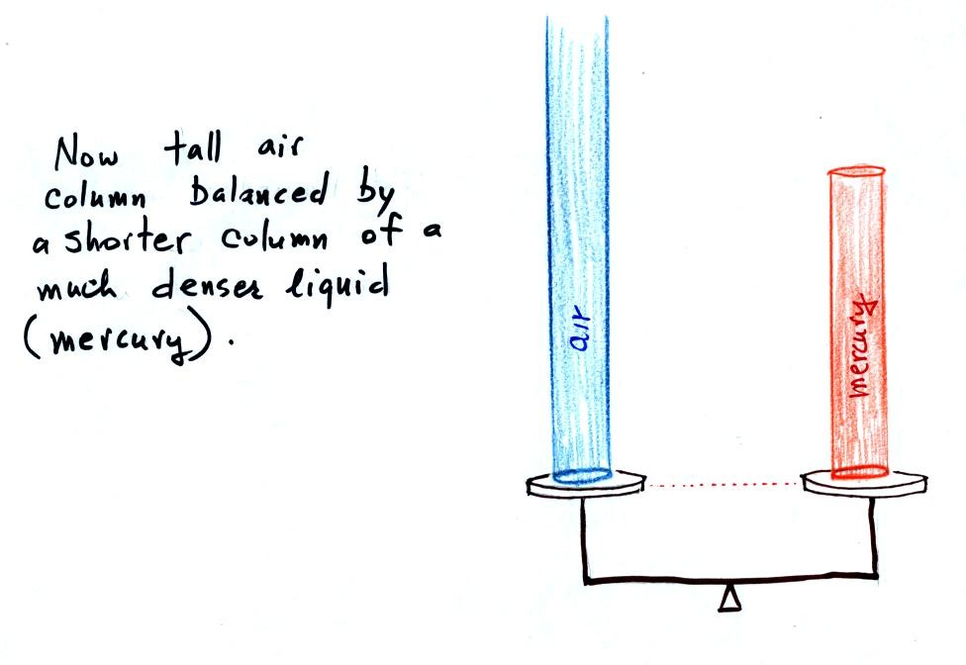
Barometers like this are usually filled with mercury. Mercury is a liquid. You need a liquid that can slosh back and forth in response to changes in air pressure. Mercury is also very dense which means the barometer won't need to be as tall as if you used something like water. A water barometer would need to be over 30 feet tall. With mercury you will need only a 30 inch tall column to balance the weight of the atmosphere at sea level under normal conditions (remember the 30 inches of mercury pressure units mentioned earlier). Mercury also has a low rate of evaporation so you don't have much mercury gas at the top of the right tube (it is the mercury vapor that would make a mercury spill in the classroom dangerous).
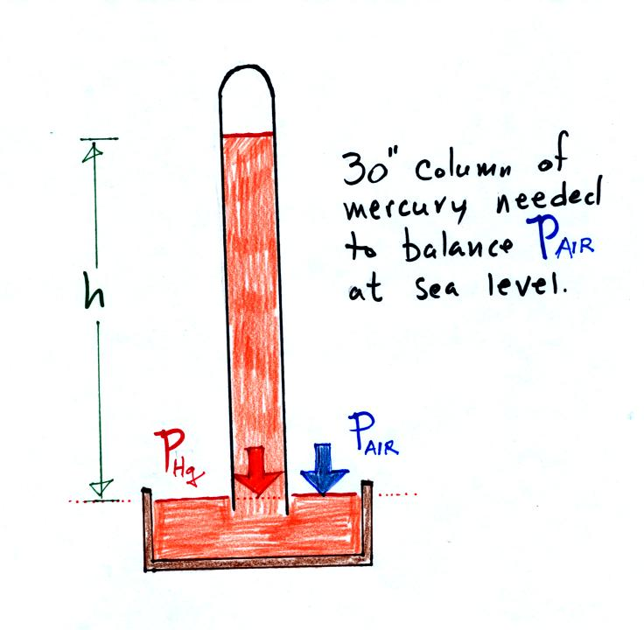
Finally here is a more conventional barometer design. The bowl of mercury is usually covered in such a way that it can sense changes in pressure but not evaporate and fill the room with poisonous mercury vapor.

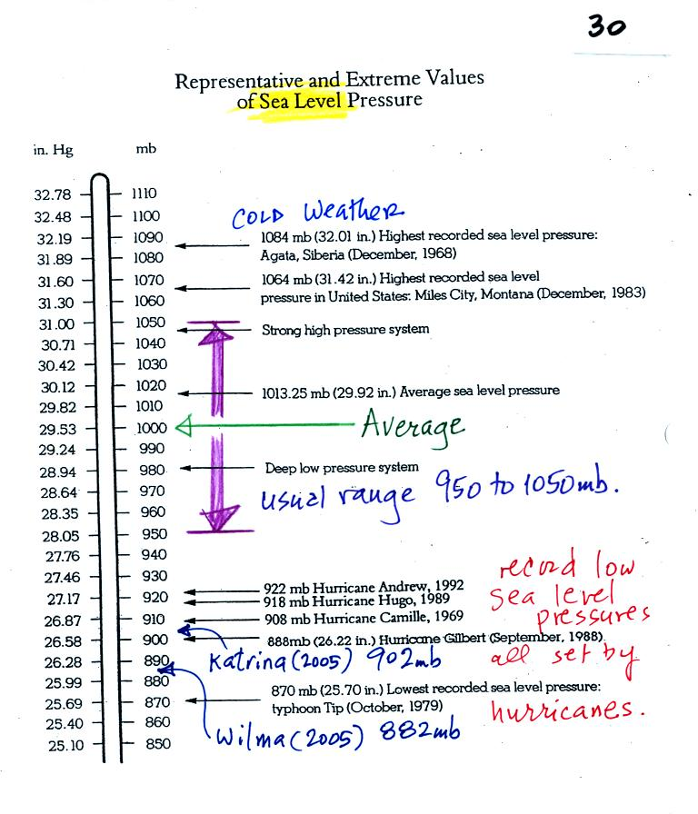
The figure above (p. 30 in the photocopied Class Notes) first shows average sea level pressure values. 1000 mb or 30 inches of mercury are close enough in this class.
Sea level pressures usually fall between 950 mb and 1050 mb.
Record high sea level pressure values occur during cold weather.
Record low pressure values have all been set by intense hurricanes (the record setting low pressure is the reason these storms were so intense). Hurricane Wilma in 2005 set a new record low sea level pressure reading for the Atlantic. Hurricane Katrina had a pressure of 902 mb. You'll find a list of the most intense, destructive, and deadly hurricanes on p. 146a in the photocopied ClassNotes.

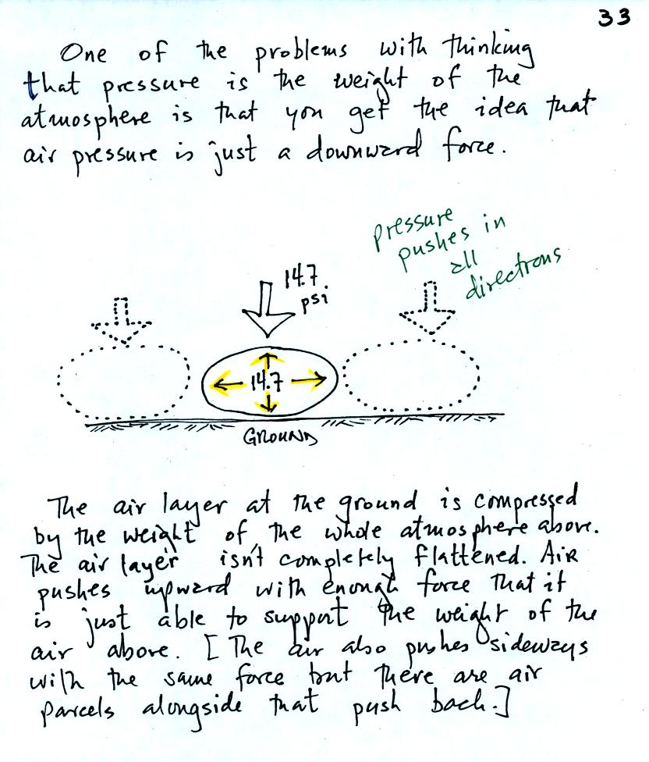

Air pressure is a force that pushes downward, upward, and sideways. If you fill a balloon with air and then push downward on it, you can feel the air in the balloon pushing back (pushing upward). You'd see the air in the balloon pushing sideways as well.
The air pressure in the four tires on your automobile pushes down on the road (that's something you would feel if the car ran over your foot) and pushes upward with enough force to keep the 1000 or 2000 pound vehicle off the road.
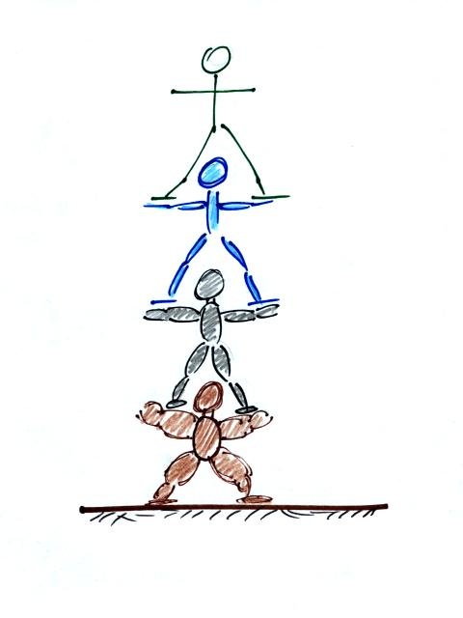
A "people pyramid" might help you to understand what is going on in the atmosphere. If the bottom person in the stack above were standing on a scale, the scale would measure the total weight of all the people in the pile. That's analogous to sea level pressure being determined by the weight of the atmosphere above. The bottom person in the picture above must be strong enough to support the weight of all the people above. That equivalent to the bottom layer of the atmosphere having enough pressure, pressure that points up down and sideways, to support the weight of the air above.
In class on Friday we used a stack of bricks to try to understand that pressure at any level in the atmosphere is determined by the weight of the air overhead. Now we will imagine a stack of matresses to understand why air density decreases with increasing altitude.
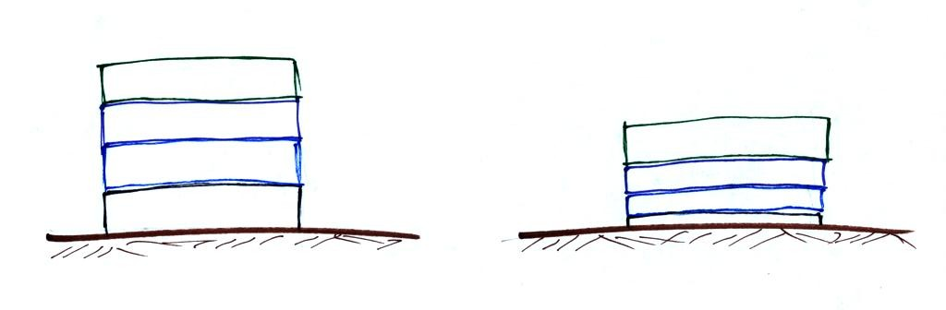
Mattresses are compressible. The mattress at the bottom of the pile is compressed the most by the weight of all the mattresses above. The mattresses higher up aren't squished as much because their is less weight remaining above.
In the case of the atmosphere layers of air behave in just the same way as matresses.
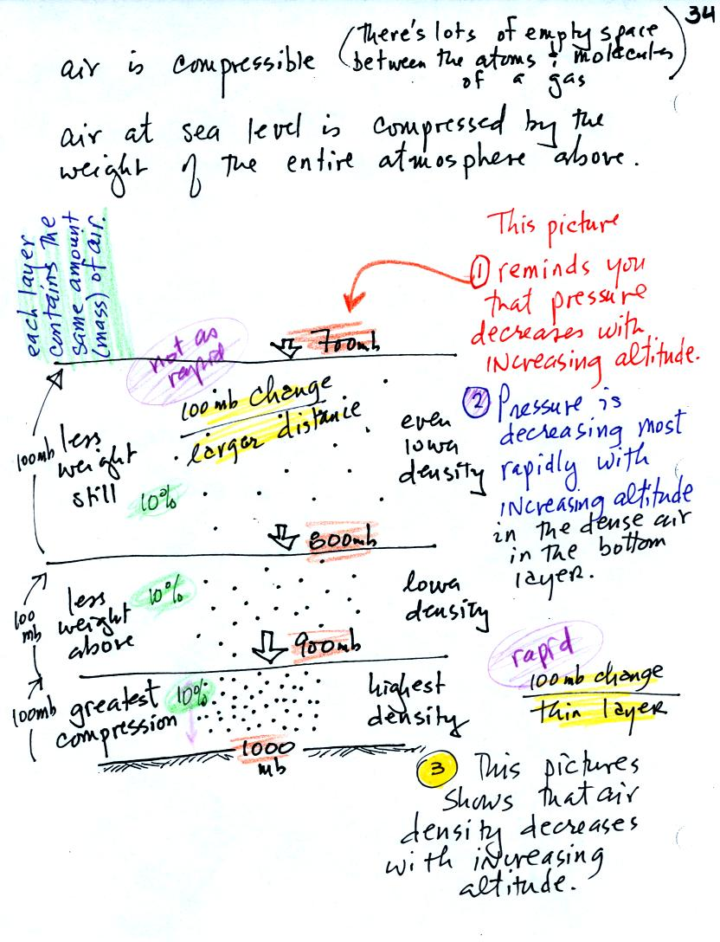
There's a lot of information in this figure. It is worth spending a minute or two looking at it and thinking about it.
1. You can first notice and remember that pressure decreases with increasing altitude. 1000 mb at the bottom decreases to 700 mb at the top of the picture.
Each layer of air contain the same amount (mass) of air. You can tell because the pressure decrease as you move upward through each layer is the same (100 mb). Each layer contains 10% of the air.
2. You again notice something that we covered earlier: the most rapid rate of pressure decrease with increasing altitude is in the densest air in the bottom air layer. It takes almost twice the distance for pressure to decrease from 800 mb to 700 mb in the top most layer.
3. The densest air is found in the bottom layer because the air is squeezed into a smaller volume than the other layers. Air density decreases with increasing altitude.

Class concluded with a demonstration of the upward force caused by air pressure.
The demonstration is summarized on p. 35a in the photocopied Classnotes.
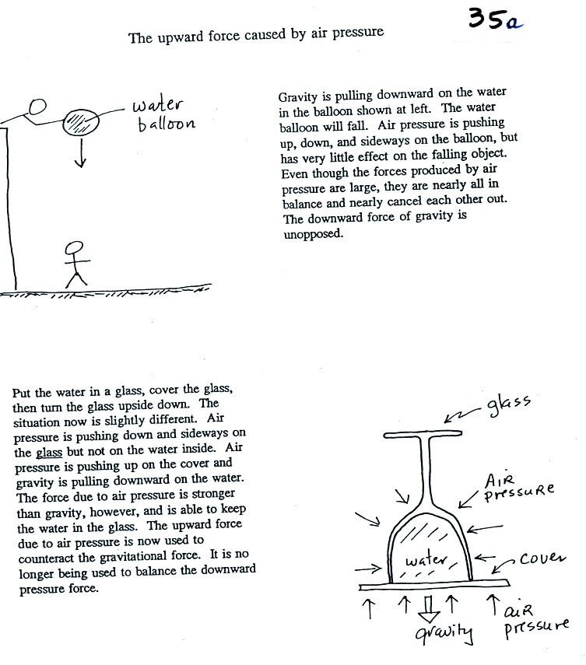
Here's a little bit more detailed and more complete explanation of what is going on. First the case of a water balloon.
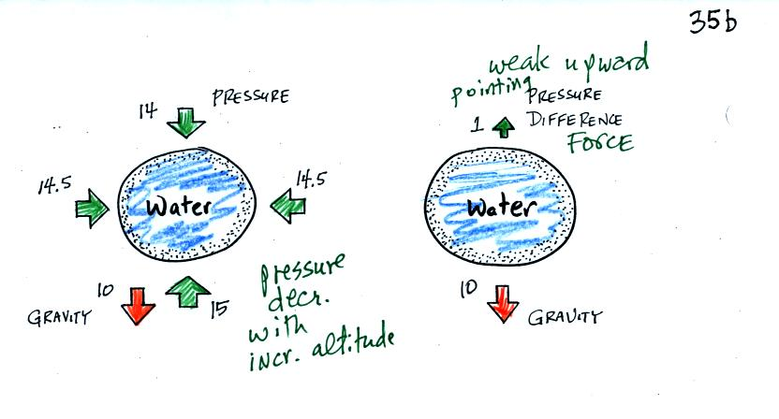
The figure at left shows air pressure (red arrows) pushing on all the sides of the balloon. Because pressure decreases with increasing altitude, the pressure pushing downward on the top of the balloon is a little weaker (strength=14) than the pressure pushing upward at the bottom of the balloon (strength=15). The two sideways forces cancel each other out. The total effect of the pressure is a weak upward force (1 unit of upward force shown at the top of the right figure, you might have heard this called a bouyant force). Gravity exerts a downward force on the water balloon. In the figure at right you can see that the gravity force (strength=10) is stronger than the upward pressure difference force (strength=1). The balloon falls as a result.
In the demonstration a wine glass is filled with water. A small plastic lid is used to cover the wine glass. You can then turn the glass upside down without the water falling out.
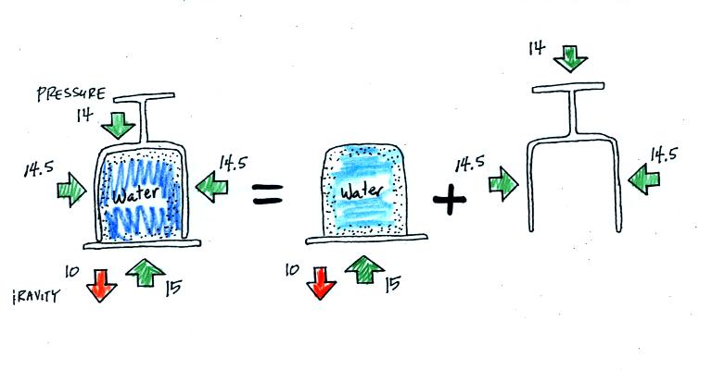
All the same forces are shown again in the left most figure. In the right two figures we separate this into two parts. First the water inside the glass isn't feeling the downward and sideways pressure forces (because they're pushing on the glass). Gravity still pulls downward on the water but the upward pressure force is able to overcome the downward pull of gravity. The upward pointing pressure force is used to overcome gravity not to cancel out the downward pointing pressure force.
The demonstration was repeated using a 4 Liter flash (more than a gallon of water, more than 8 pounds of water). The upward pressure force was still able to keep the water in the flask (much of the weight of the water is pushing against the sides of the flask which the instructor was supporting with his arms).

