Wednesday, Feb. 4, 2009
Mykonos from the Fleet Foxes was featured before class today.
The Experiment #1 reports are due next Monday. Try to get your materials back this week so that you can pick up the supplementary information handout. The graduated cylinders from Expt. #1 also needed for Experiment #2. The Expt. #2 materials should be handed out next week.

If there were a real quiz today you would have the entire class period to work on it. It's just a Practice Quiz today however, so we did cover a little bit of new material first.
So far we have looked at how pressure and air density change with increasing altitude. Now we will look how air temperature changes with altitude. The figure drawn in class has been split into two parts and redrawn for improved clarity (actually I just took the figures from the Fall 2008 semester, which were themselves probably taken from the Spring 2008 class). The numbers were added after class
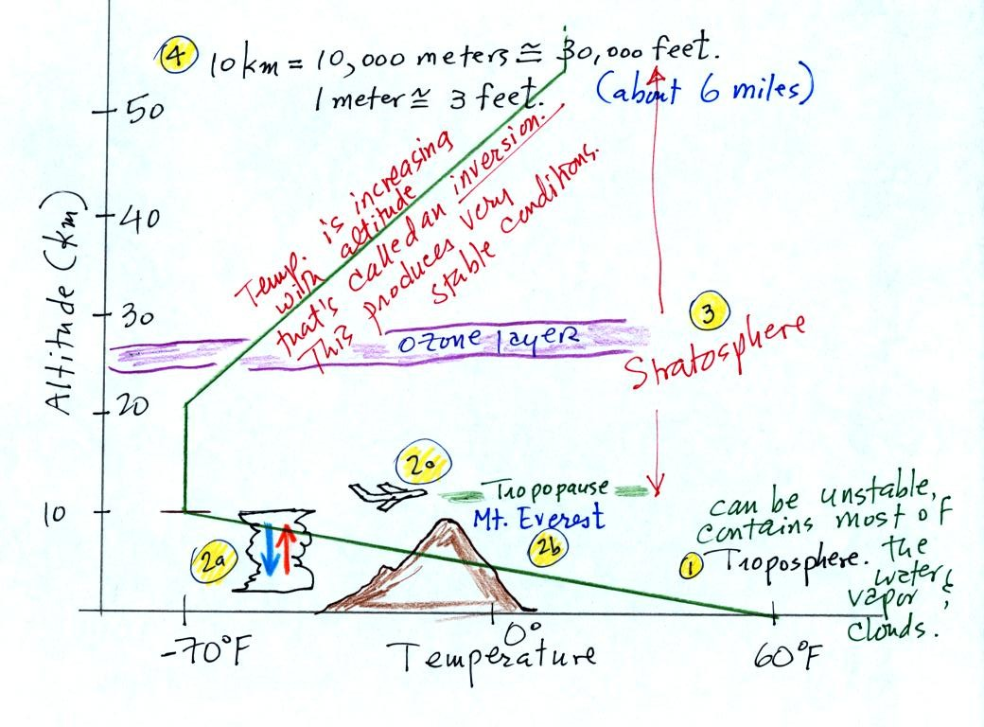
The atmosphere can be split into layers depending on whether temperature is increasing or decreasing with increasing altitude. The two lowest layers are shown in the figure above. There are additional layers (the mesosphere and the thermosphere) above 50 km but we won't worry about them.
1. We live in the troposphere. The troposphere is found, on average, between 0 and about 10 km altitude, and is where temperature usually decreases with increasing altitude. [the troposphere is usually a little higher in the tropics and lower at polar latitudes]
The troposphere contains most of the water vapor in the atmosphere (the water vapor comes from evaporation of ocean water) and is where most of the clouds and weather occurs. The troposphere can be stable or unstable (tropo means to turn over and refers to the fact that air can move up and down in the troposphere).
2a. The thunderstorm shown in the figure indicates unstable conditions, meaning that strong up and down air motions are occurring. When the thunderstorm reaches the top of the troposphere, it runs into the stable stratosphere. The air can't continue to rise into the stable stratosphere so the cloud flattens out and forms an anvil (anvil is the name given to the flat top of the thunderstorm). The flat anvil top is something that you can go outside and see and often marks the top of the troposphere.
2b. The summit of Mt. Everest is a little over 29,000 ft. tall and is close to the top of the troposphere.
2c. Cruising altitude in a passenger jet is usually between 30,000 and 40,000, near or just above the top of the troposphere, and at the bottom of the stratosphere.
3. Temperature remains constant between 10 and 20 km and then increases with increasing altitude between 20 and 50 km. These two sections form the stratosphere. The stratosphere is a very stable air layer. Increasing temperature with increasing altitude is called an inversion. This is what makes the stratosphere so stable.
4. A kilometer is one thousand meters. Since 1 meter is about 3 feet, 10 km is about 30,000 feet. There are 5280 feet in a mile so this is about 6 miles.
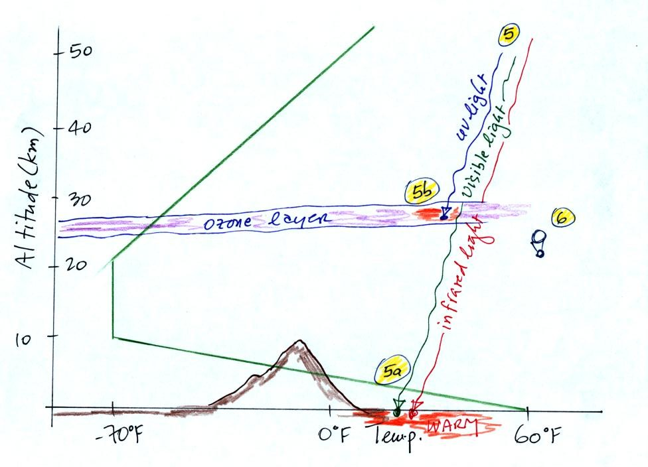
5. Sunlight is a mixture of ultraviolet (7%), visible (44%), and infrared light (49%). We can see the visible light.
5a. Much of the sunlight arriving at the top of the atmosphere passes through the atmosphere and is absorbed at the ground. This warms the ground. The air in contact with the ground is warmer than air just above. As you get further and further from the warm ground, the air is colder and colder. This explains why air temperature decreases with increasing altitude.
5b. How do you explain increasing temperature with increasing altitude in the stratosphere.
The ozone layer is found in the stratosphere (peak concentrations are found near 25 km altitude). Absorption of ultraviolet light by ozone warms the air in the stratosphere and explains why the air can warm. The air in the stratosphere is much less dense (thinner) than in the troposphere. It doesn't take as much energy to warm this thin air as it would to warm denser air closer to the ground.
6. That's a manned balloon (it wasn't shown in class); Auguste Piccard and Paul Kipfer are inside. They were to first men to travel into the stratosphere (see pps 31 & 32 in the photocopied Class Notes). We'll see a short video showing part of their adventure at some point in the next week or so. It really was quite a daring trip at the time, and they very nearly didn't survive it.

