Monday Feb. 9, 2009
Umm, some music today from Pink Martini.
The Experiment #1 reports were collected today. It will probably take at least a week to get the reports graded.
The materials for Expt. #2 should be available in class on Wednesday or Friday this week.

The day has started out well: I successfully got one of my two cats, the wilder of the two, to the vet (for shots) and safely back home this morning.
And what I call a Cosmic Convergence of Events might just be underway.
I was feeling so good that I decided an In-Class Optional Assignment seemed appropriate. Here are the answers to the assignment.
Today is the Full Moon. Did you know that every month's Full Moon has a name? I certainly didn't, one of my NATS 101 students from last semester turned me on to that fact. The January full moon was the "wolf moon." The January full moon was the biggest full moon that we'll have in 2009 and rivaled the Dec., 2008 perigee moon (click here for more details). Here are a couple of (not so good) haiku poems about the Jan. wolf moon:
Cold dark morning sky
Silhouettes on the full moon
Are they trees or wolves?
On the horizon
The wolf moon is running from
The approach of dawn
There was a chance that we might see snow in Tucson early Tuesday morning.
What do you think February's full moon is called? It's called the "snow moon." Doesn't that seem like an odd coincidence? Rather than write another haiku poem I drew a picture of the snow moon:
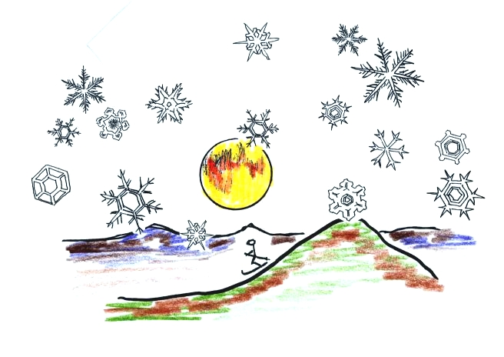
Snow on the ground in Tucson is pretty rare. Here's a picture from the Arizona Daily Star.
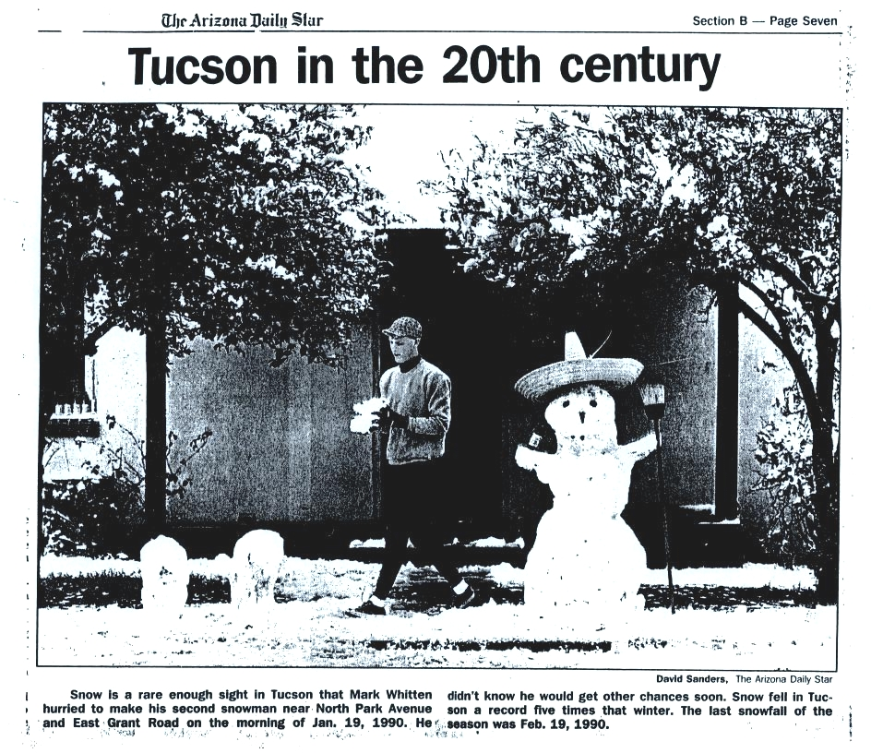

Last Friday we looked at how the relative strengths of the downward graviational force and the upward pressure difference force determine whether a parcel of air will rise or sink. Archimedes Law is another way of trying to understand the situation.
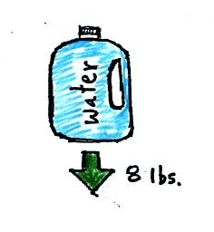
A gallon of water weighs about 8 pounds (lbs).
If you submerge a 1 gallon jug of water in a swimming pool, the jug becomes, for all intents and purposes, weightless. Archimedes' Law (see figure below) explains why this is true.
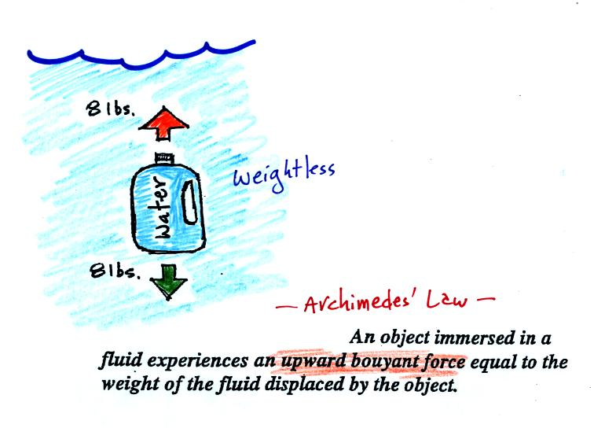
The upward bouyant force is really just another name for the pressure difference force covered on Wednesday (higher pressure pushing up on the bottle and low pressure at the top pushing down, resulting in a net upward force). A 1 gallon bottle will displace 1 gallon of pool water. One gallon of pool water weighs 8 pounds. The upward bouyant force will be 8 pounds, the same as the downward force on the jug due to gravity. The two forces are equal and opposite.
Now we imagine pouring out all the water and filling the 1 gallon jug with air. Air is about 1000 times less dense than water; the jug will weigh practically nothing.
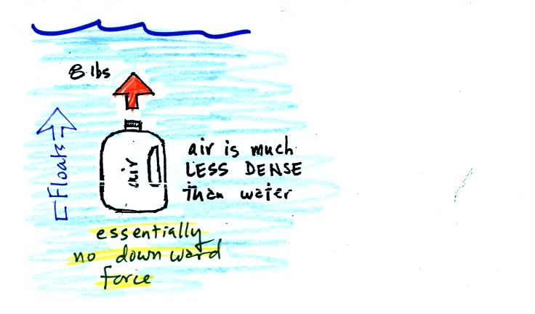
If you submerge the jug in a pool it will displace 1 gallon of water and experience an 8 pound upward bouyant force again. Since there is no downward force the jug will float.
One gallon of sand (which is about 1.5 times denser than water) jug will weigh 12 pounds.
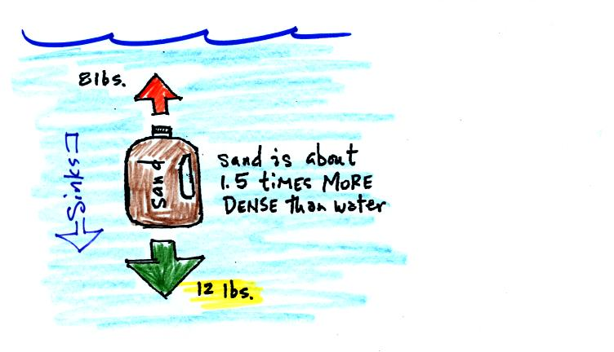
The jug of sand will sink because the downward force is greater than the upward force.
You can sum all of this up by saying anything that is less dense than water will float in water, anything that is more dense than water will float in water.
The same reasoning applies to air in the atmosphere.
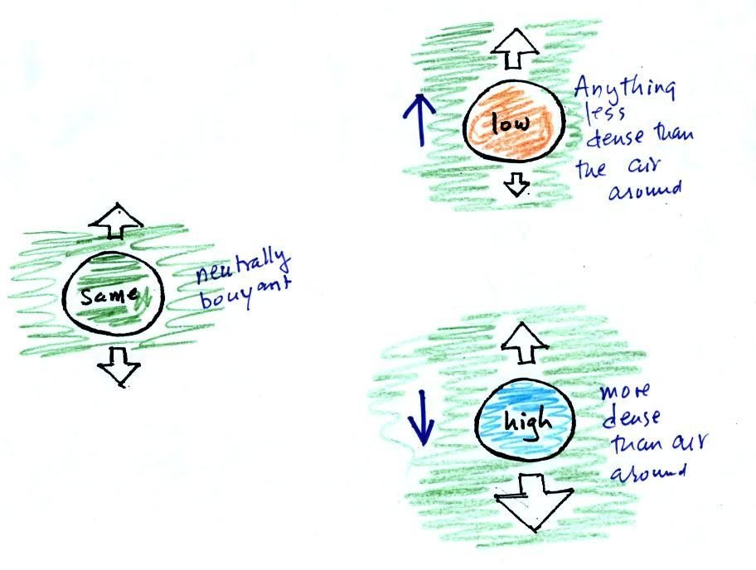
Air that is less dense (warmer) than the air around it will rise. Air that is more dense (colder) than the air around it will sink.
Here's a little more information about Archimedes which wasn't covered in class.

It was time for a colorful demonstration involving water and objects that either float or sink in water.
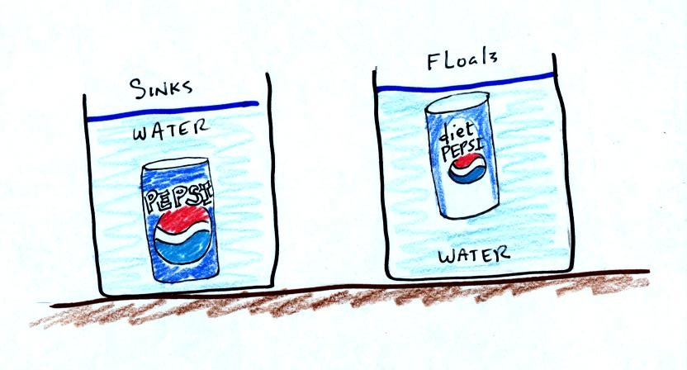
A can of regular Pepsi was placed in a beaker of water. The can sank. We repeated the demonstration with Coke and Diet Coke (Coke now has the exclusive franchise at The University).
Both cans are made of aluminum which has a density almost three times higher than water. The drink itself is largely water. The regular Pepsi also has a lot of high-fructose corn syrup, the diet Pepsi doesn't. The mixture has a density greater than plain water. Both cans contain a little air (or perhaps carbon dioxide gas) or neither one would float. This is much less dense than water.
The average density of the can of regular Pepsi (water&sugar + aluminum + air) ends up being slightly greater than the density of water. The average density of the can of diet Pepsi (water + aluminum + air) is slightly less than the density of water.
In some respects people in swimming pools are like cans of regular and diet Pepsi. Some people float (they're a little less dense than water), other people sink (slightly more dense than water).
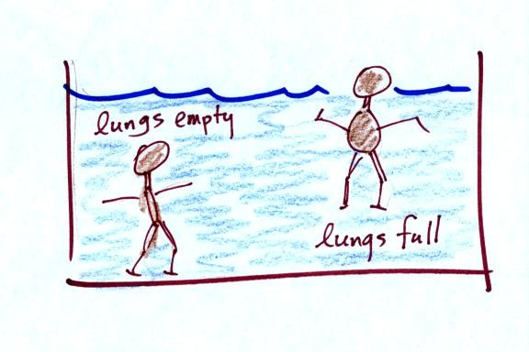
Many people can fill their lungs with air and make themselves float, or they can empty their lungs and make themselves sink.
People must have a density that is about the same as water.

For the next 2 or 3 days we'll be learning how weather data are entered onto surface weather maps and learn about some of the analyses of the data that are done and what they can tell you about the weather. We will also have a brief look at upper level (higher altitude) weather maps.
Much of our weather is produced by relatively large (synoptic scale) weather systems. To be able to identify and characterize these weather systems you must first collect weather data (temperature, pressure, wind direction and speed, dew point, cloud cover, etc) from stations across the country and plot the data on a map. The large amount of data requires that the information be plotted in a clear and compact way. The station model notation is what meterologists use (you'll find the station model notation discussed in Appendix C, pps 525-529, in the textbook).
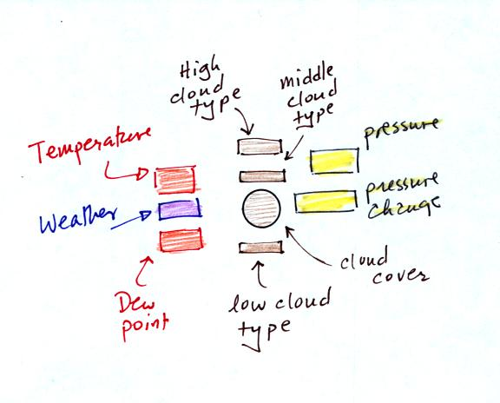
The figure above wasn't shown in class.
A small circle is plotted on the map at the location where the weather measurements were made. The circle can be filled in to indicate the amount of cloud cover. Positions are reserved above and below the center circle for special symbols that represent different types of high, middle, and low altitude clouds. The air temperature and dew point temperature are entered to the upper left and lower left of the circle respectively. A symbol indicating the current weather (if any) is plotted to the left of the circle in between the temperature and the dew point (you can choose from close to 100 different weather symbols included in the textbook ). The pressure is plotted to the upper right of the circle and the pressure change (that has occurred in the past 3 hours) is plotted to the right of the circle.
Here's the actual example we started on in class.
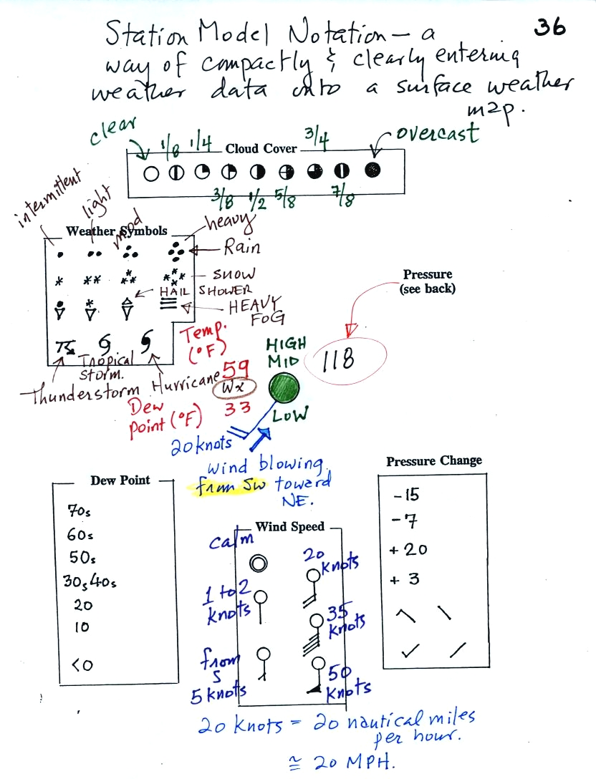
This is frankly a mess and would be very hard to unscramble if you are seeing it for the first time. So we'll work through another example one step at a time.
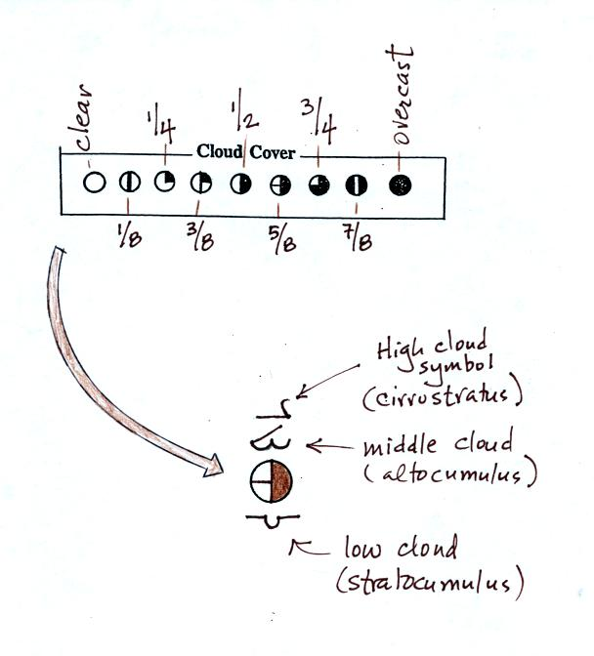
The center circle is filled in to indicate the portion of the sky covered with clouds (estimated to the nearest 1/8th of the sky) using the code at the top of the figure. Then symbols (not drawn in class) are used to identify the actual types of high, middle, and low altitude clouds (the symbols can be found on a handout to be distributed in class).
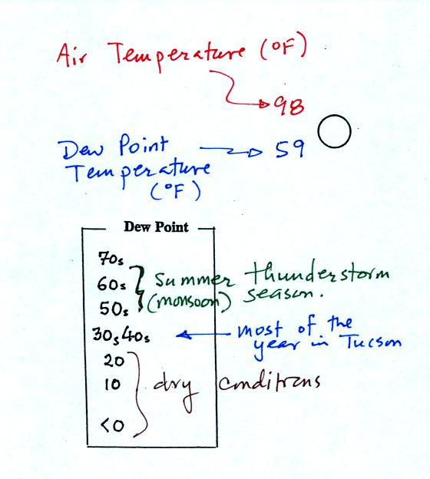
The air temperature in this example was 98º F (this is plotted above and to the left of the center circle). The dew point temperature was 59º F and is plotted below and to the left of the center circle. The box at lower left reminds you that dew points are in the 30s and 40s during much of the year in Tucson. Dew points rise into the upper 50s and 60s during the summer thunderstorm season (dew points are in the 70s in many parts of the country in the summer). Dew points are in the 20s, 10s, and may even drop below 0 during dry periods in Tucson.
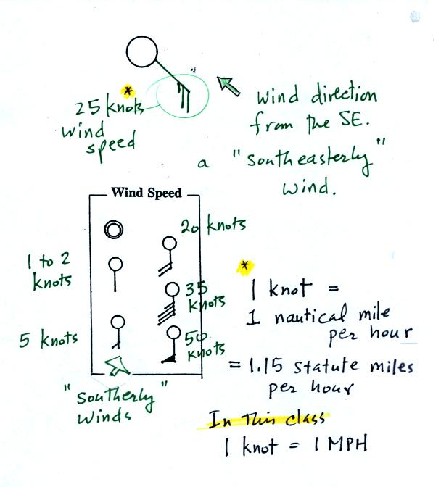
A straight line extending out from the center circle shows the wind direction. Meteorologists always give the direction the wind is coming from. In this example the winds are blowing from the SE toward the NW at a speed of 25 knots. A meteorologist would call these southeasterly winds. Small barbs at the end of the straight line give the wind speed in knots. Each long barb is worth 10 knots, the short barb is 5 knots. Knots are nautical miles per hour. One nautical mile per hour is 1.15 statute miles per hour. We won't worry about the distinction in this class, you can just pretend that one knot is the same as one mile per hour.
Here are some additional wind examples that weren't shown in class:
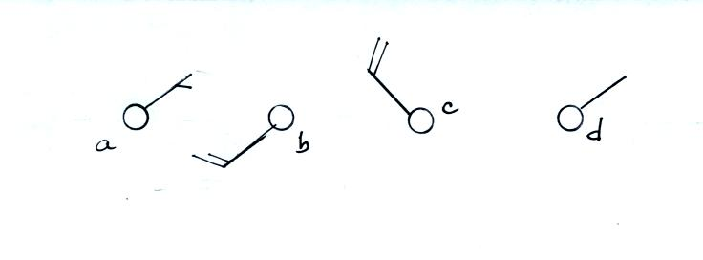
In (a) the winds are from the NE at 5 knots, in (b) from the SW at 15 knots, in (c) from the NW at 20 knots, and in (d) the winds are from the NE at 1 to 2 knots.
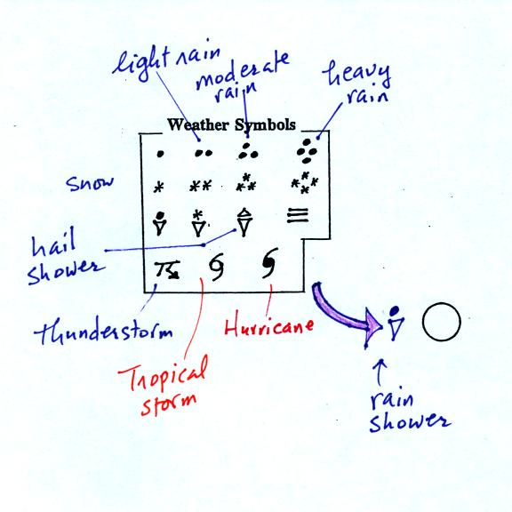
A symbol representing the weather that is currently occurring is plotted to the left of the center circle. Some of the common weather symbols are shown. There are about 100 different weather symbols that you can choose from.
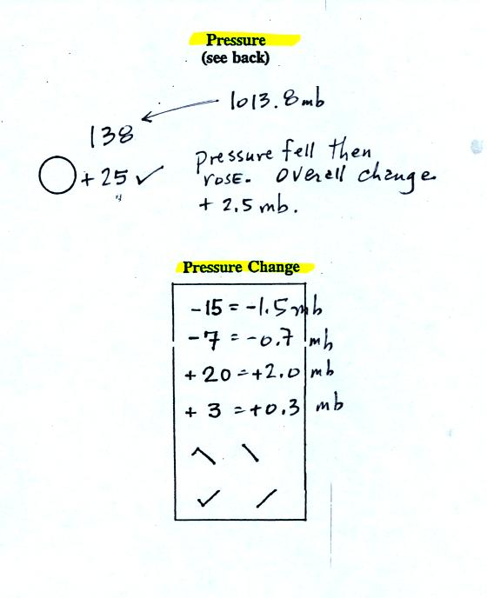
The sea level pressure is shown above and to the right of the center circle. Decoding this data is a little "trickier" because some information is missing. We'll learn about decoding the pressure in class on Friday.
Pressure change data (how the pressure has changed during the preceding 3 hours and not covered in class) is shown to the right of the center circle. You must remember to add a decimal point. Pressure changes are usually pretty small.

Here are some links to surface weather maps with data plotted using the station model notation: UA Atmos. Sci. Dept. Wx page, National Weather Service Hydrometeorological Prediction Center, American Meteorological Society.

We haven't learned how to decode the pressure data yet.
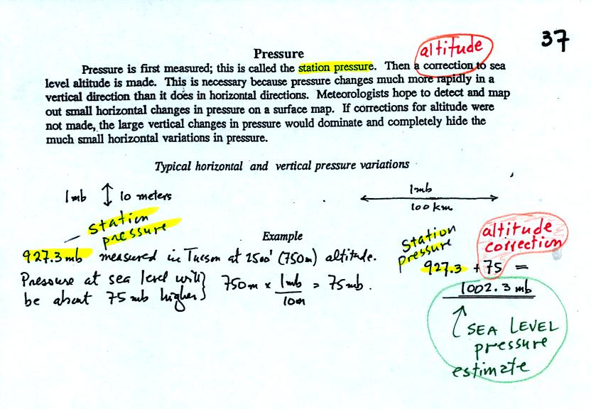
Meteorologists hope to map out small horizontal pressure changes on surface weather maps (that produce wind and storms). Pressure changes much more quickly when moving in a vertical direction. The pressure measurements are all corrected to sea level altitude to remove the effects of altitude. If this were not done large differences in pressure at different cities at different altitudes would completely hide the smaller horizontal changes.
In the example above, a station pressure value of 927.3 mb was measured in Tucson. Since Tucson is about 750 meters above sea level, a 75 mb correction is added to the station pressure (1 mb for every 10 meters of altitude). The sea level pressure estimate for Tucson is 927.3 + 75 = 1002.3 mb. This is also shown on the figure below
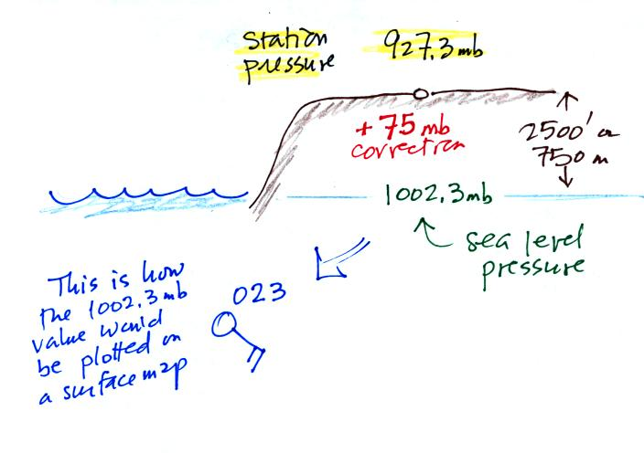

Here's the remainder of p. 37 in the photocopied ClassNotes.
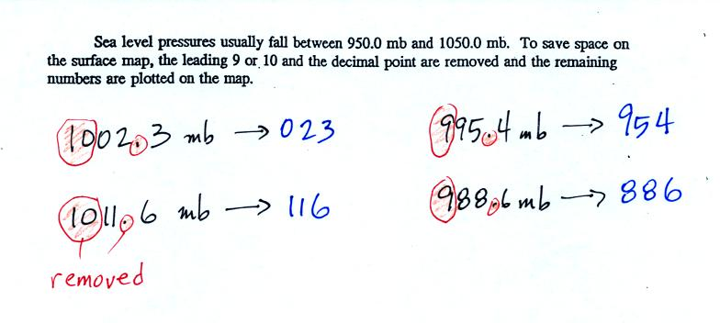
To save room, the leading 9 or 10 on the sea level pressure value and the decimal point are removed before plotting the data on the map. For example the 10 and the . in 1002.3 mb would be removed; 023 would be plotted on the weather map (to the upper right of the center circle). Some additional examples are shown above.
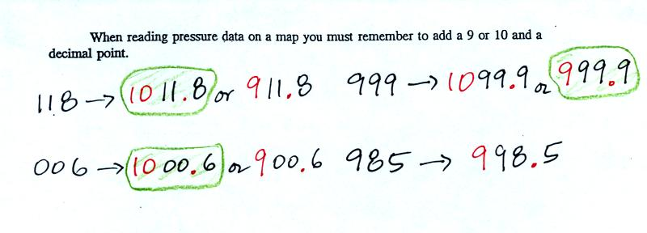
When reading pressure values off a map you must remember to add a 9 or 10 and a decimal point. For example
118 could be either 911.8 or 1011.8 mb. You pick the value that falls between 950.0 mb and 1050.0 mb (so 1011.8 mb would be the correct value, 911.8 mb would be too low).
Another important piece of information that is included on a surface weather map is the time the observations were collected. Time on a surface map is converted to a universally agreed upon time zone called Universal Time (or Greenwich Mean Time, or Zulu time). That is the time at 0 degrees longitude. There is a 7 hour time zone difference between Tucson (Tucson stays on Mountain Standard Time year round) and Universal Time. You must add 7 hours to the time in Tucson to obtain Universal Time.
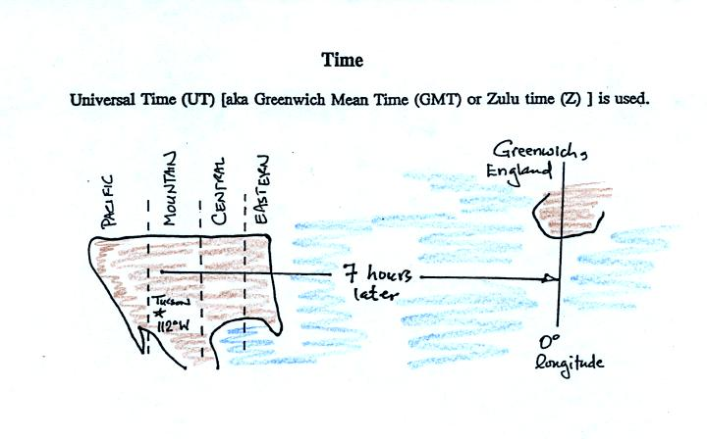
Here are some examples (only the first example was worked in class):
2:45 pm MST:
first convert 2:45 pm to the 24 hour clock format 2:45 + 12:00 = 14:45 MST
then add the 7 hour time zone correction ---> 14:45 + 7:00 = 21:45 UT (9:45 pm in Greenwich)
9:05 am MST:
add the 7 hour time zone correction ---> 9:05 + 7:00 = 16:05 UT (4:05 pm in England)
18Z:
subtract the 7 hour time zone correction ---> 18:00 - 7:00 = 11:00 am MST
02Z:
if we subtract the 7 hour time zone correction we will get a negative number.
We will add 24:00 to 02:00 UT then subtract 7 hours
02:00 + 24:00 = 26:00
26:00 - 7:00 = 19:00 MST on the previous day
2 hours past midnight in Greenwich is 7 pm the previous day in Tucson

