Monday Feb. 16, 2009
Music today was from The Watson Twins. They were playing last Friday night at The Plush.
The first real quiz of the semester is Wednesday this week. A Study Guide is available, and reviews will be held Monday and Tuesday afternoons from 4-5 pm in FCS 225.
Optional Assignment #1 was collected at the beginning of class today. Answers were handed out in class. You can also look at the answers online.
It was a busy weekend, and I didn't get the Expt. #1 reports graded. They'll be done by Wednesday. Some of the Radon 1S1P reports (Last names starting with F - L) have been graded and were returned in class. The others should be done sometime this week.
There are still some Expt. #2 materials available. If you're working on Expt. #2, don't wait until the last minute. Collect your data now, return the materials, and pick up the Supplementary Information sheet.
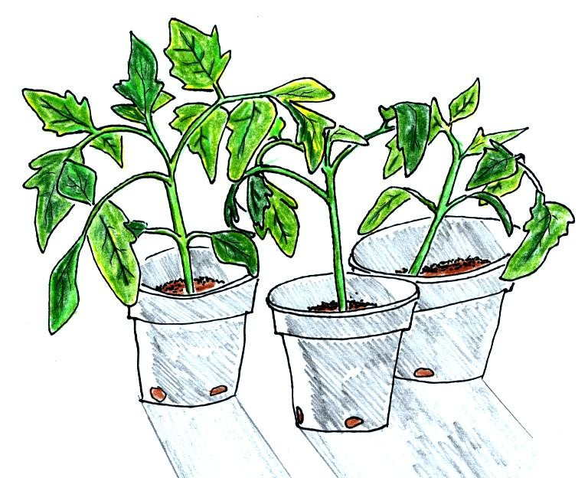

Here's this week's picture: 3 of the 30 odd tomato seedlings growing on my office window sill.

Today we'll learn about some of the weather conditions that precede and follow passage of warm and cold front.
A crossectional view of a cold front is shown below:
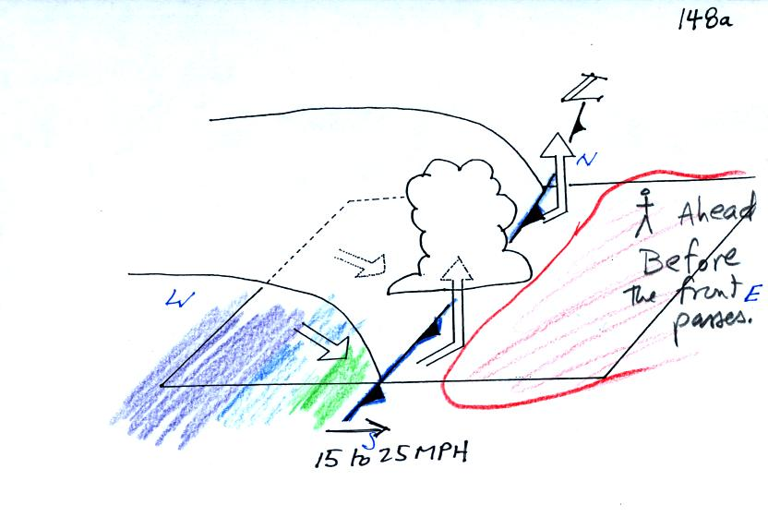
Here are some of the specific weather changes
Weather variable | Behind | Passing | Ahead
Temperature | cool, cold, colder* |  | warm
Dew Point | usually much drier* |  | may be moist (may not be  moist in desert SW)
Winds | northwest | gusty winds | from the southwest
Clouds, Weather | clearing | rain clouds, thunderstorms | might see some high clouds
Pressure | rising | reaches a minimum | falling
* the coldest air might follow passage of a cold front by a day or two. Nighttime temperatures often plummet in the cold dry air behind a cold front.
In the next figure we started with some weather data plotted on a surface map using the station model notation.
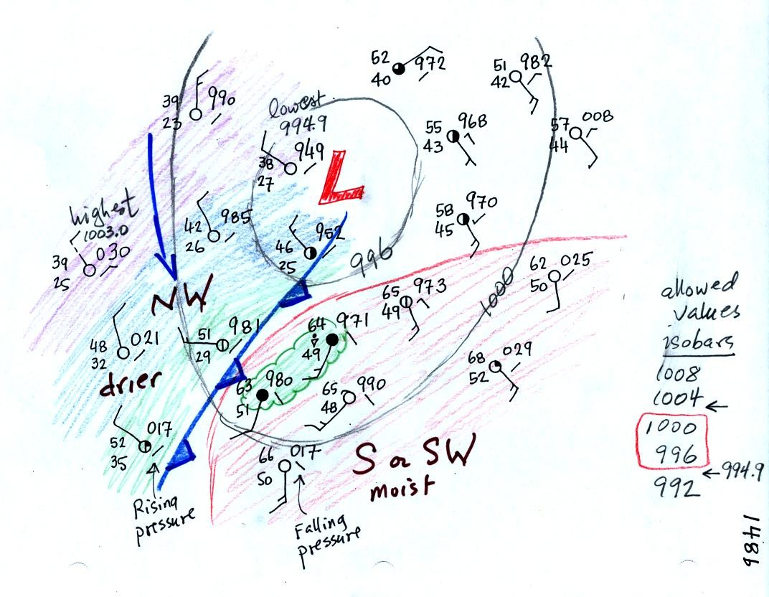
Before trying to locate a cold front, we needed to draw in a few isobars and map out the pressure pattern. In some respects fronts are like spokes on a wheel - they rotate counterclockwise around centers of low pressure. It makes sense to first determine the location of the low pressure center.
Isobars are drawn at 4 mb increments beginning at 1000 mb. Some of the allowed values are shown on the right side of the figure. The highest pressure on the map is 1003.0 mb, the lowest is 994.9 mb. Thus we have drawn in 996 mb and 1000 mb isobars.
The next step was to try to locate the warm air mass in the picture. Temperatures are in the 60s in the lower right portion of the map; this area has been circled in red.
The cold front on the map seems to be properly postioned. The air ahead of the front is warm, moist, has winds blowing from the S or SW, and the pressure is falling. These are all things you would expect to find ahead of a cold front.
The air behind the front is colder, drier, winds are blowing from the NW, and the pressure is falling.

Now we'll go through the same procedure with warm fronts.
Here's the crossectional view
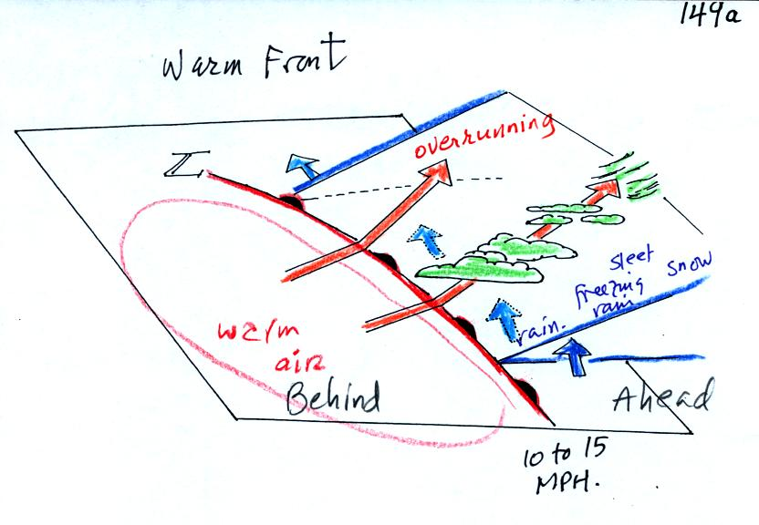
Here ae the weather changes in advance of and following the frontal passage.
Weather Variable | Behind (after) | Passing | Ahead (before)
Temperature | warmer |  | cool
Dew point | moister |  | drier
Winds | from S or SW |  | from E or SE
Clouds, Weather | clearing |  | wide variety of clouds well ahead of the front.  wide variety of types of precipitation also.
Pressure | rising |  | falling
And here is the surface map analysis:
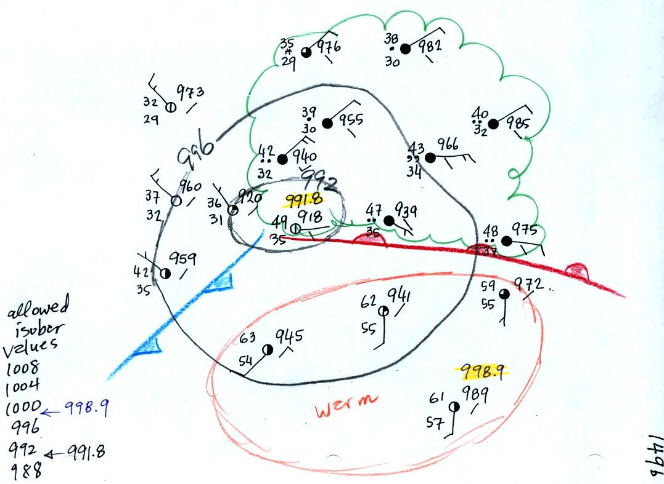
There was also pretty clear evidence of a cold front on this map.

Next we went back to the surface map example from Wed., Feb. 11. We were trying to figure out what was causing the clouds in the NE portion of the map and what was causing the rain shower along the Gulf Coast.
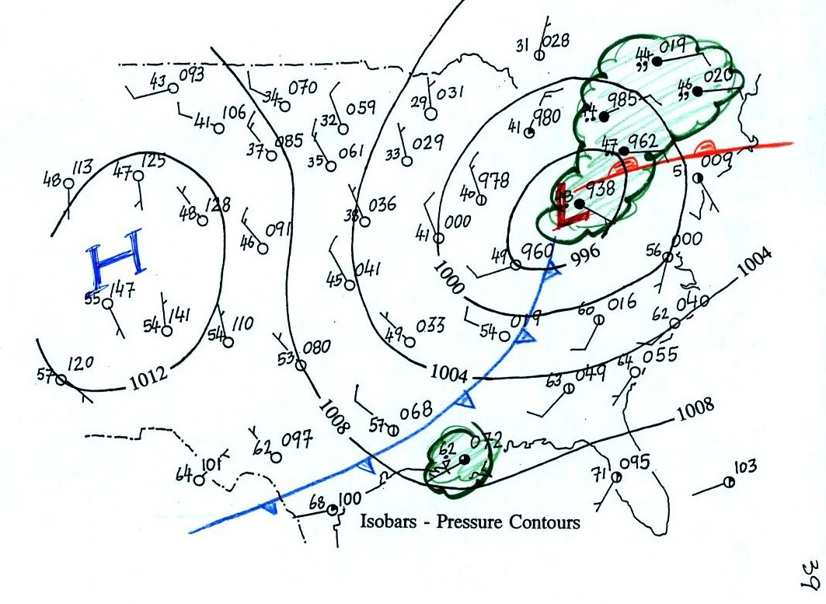
We've added a warm and cold front to the picture. The warm front is probably what is producing most of the widespread cloudiness and precipitation in the NE portion of the map (rising air motions caused by surface winds converging into the low pressure center is also contributing). The cold front is producing the showers along the Gulf Coast.

We spent the rest of the class reviewing a concept that we covered in class last Friday. I.e. how upper level divergence can lower surface pressure and cause a storm to intensity. In class today we looked at hurricanes.
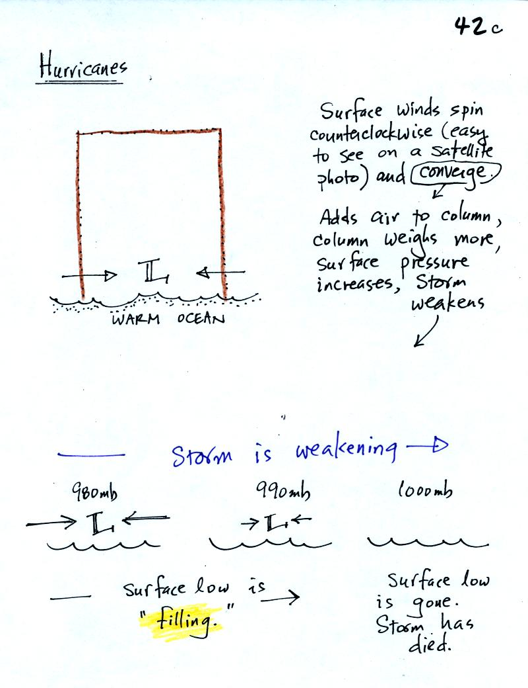
In this first picture we look at the effect of the surface winds converging into the low pressure at the bottom center of the hurricane. These winds add air to the column. Adding air will increase the weight of the column which will act to increase the surface pressure. Surface pressure could increase from 980 mb to 990 mb and then to 1000 mb. At that point the storm would have essentially died.
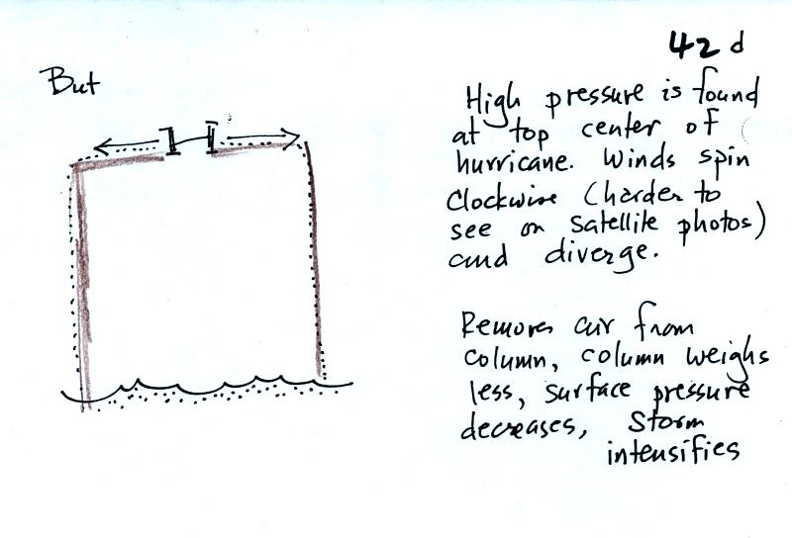
Upper leve divergence would remove air from the column and cause the surface pressure to decrease.
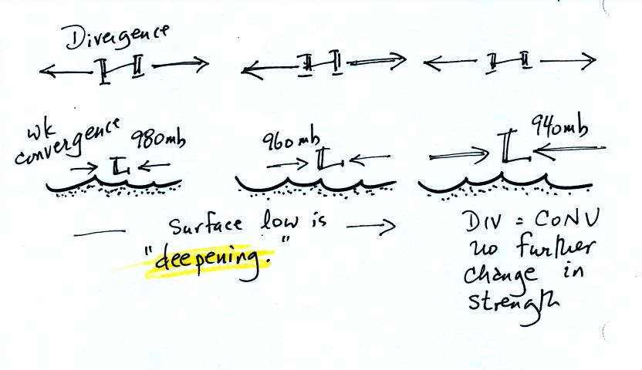
Not what you usually have are both processes occurring at the same time. The question is whether the upper level divergence or the surface convergence is dominant. In the figure above the upper level divergence is at first the larger effect. This lowers the surface pressure (from 980 mb to 960 mb to 940 mb). As the surface pressure drops the surface winds will increase in speed. The amount of convergence will increase until it eventually balances the upper level divergence. Beginning at that point the storm intensity won't change any further.

