Friday Feb. 27, 2009
Today's music was Go Daddy O from Big Bad Voodoo Daddy.
Today was the first of the 1S1P Assignment #1 due dates. At least one of your reports was due today. You can turn in a 2nd report (and the surface weather map analysis) next Wednesday, Mar. 4.
The Experiment #2 reports are due next Monday (Mar. 2). The revised Expt. #1 reports are due next Wednesday (Mar. 4).

There was an In Class Optional Assignment during class today. If you weren't in class but are reading the online notes, you can turn in answers to the questions at the start of class next Monday for partial credit.
In class Optional Assignment Question #1
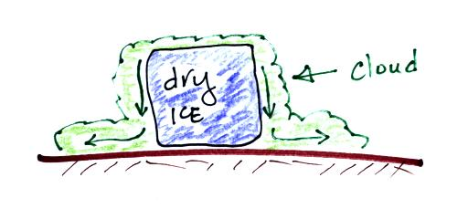
There are at least two phase changes occurring in the picture above. What are they?
Is energy being transported from the air INTO the dry ice or AWAY FROM the dry ice & into the air?
(hint: the visible cloud is not carbon dioxide gas)

We'll finish up the material on latent heat energy transport today and just start the section on electromagnetic radiation, the most important of the energy transport processes.
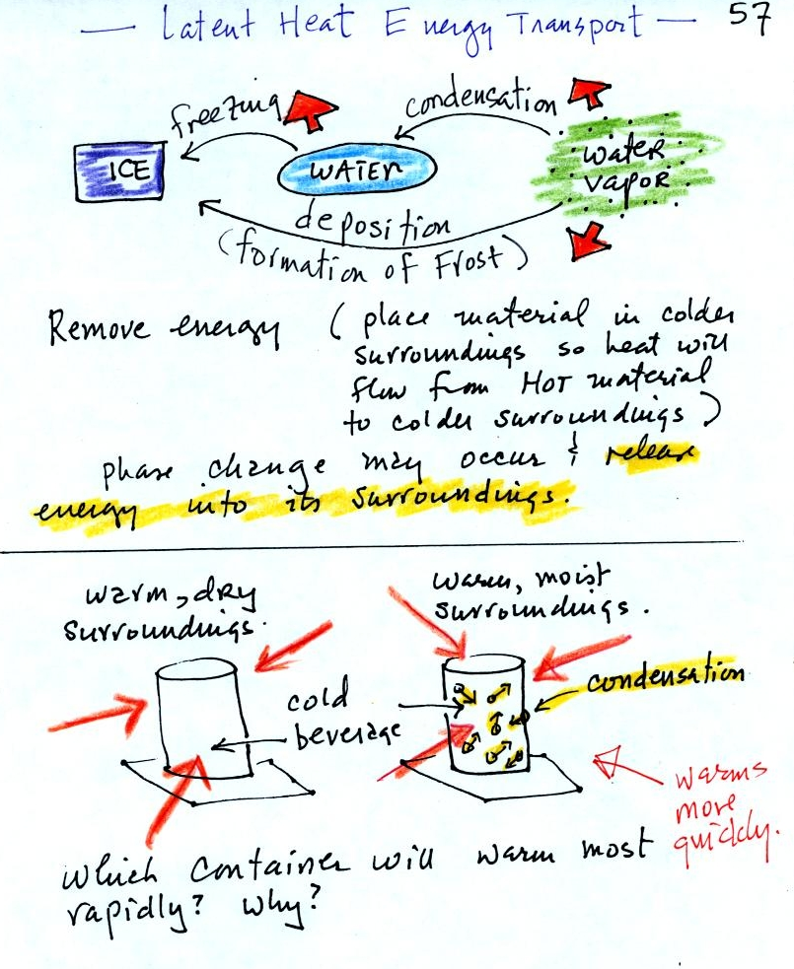

You can consciously remove energy from water vapor to make it condense or from water to cause it to free (you could put water in a freezer; energy would flow from the relatively warm water to the colder surroundings). Or if one of these phase changes occurs energy will be released into the surroundings (causing the surroundings to warm). Note the orange energy arrows have turned around and are pointing from the material toward the surroundings.
A can of cold drink will warm more quickly in warm moist surroundings than in warm dry surroundings. Heat will flow from the warm air into the cold cans in both cases. Condensation of water vapor is an additional source of energy and will warm that can more rapidly. The condensation may actually be the dominant process.
You feel cold when you step out of a shower and water on your body evaporates. The opposite situation, stepping outdoors on a humid day and actually having water vapor condense onto your body (it can happen to your sunglasses but not to you, your body is too warm). If it did happen it would warm you up.
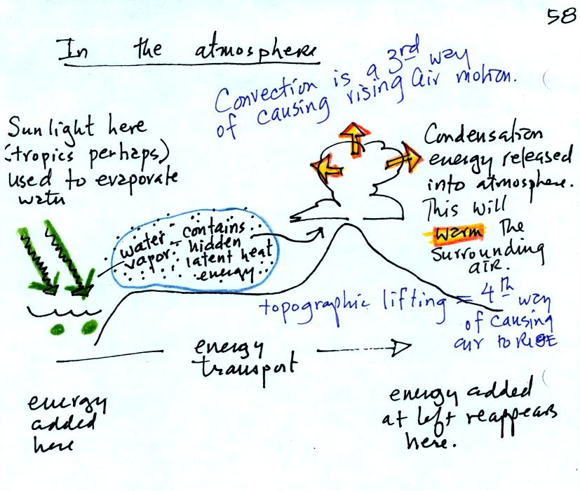
This figure shows how energy can be transported from one location to another in the form of latent heat. The story starts at left in the tropics where there is often an abundance or surplus of sunlight energy. Some of the incoming sunlight evaporates ocean water. The resulting water vapor moves somewhere else and carries hidden latent heat energy with it. This hidden energy reappears when something (air running into a mountain and rising, expanding, and cooling) causes the water vapor to condense. The condensation releases energy into the surrounding atmosphere.
Energy arriving in sunlight in the tropics has effectively been transported to the atmosphere in Tucson.
Note: two additional processes that cause rising air motions are listed in the figure above. The 4 processes are: winds converging into centers of low pressure, fronts, convection, and topographic lifting.
The following figure wasn't shown in class.
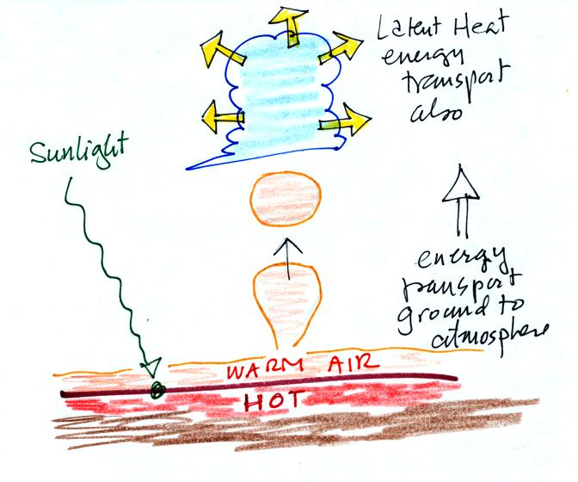
The formation of a cloud means that latent heat is being released into the air. Two energy transport processes are at work in this picture: convection and latent heat (conduction is also present, that is how is energy is transported from the hot ground into the thin layer of air in contact with the ground. In this case energy is being transported vertically in the form of latent heat.

Question #2
The person is trying to cool the hot steaming bowl of soup by blowing on it.

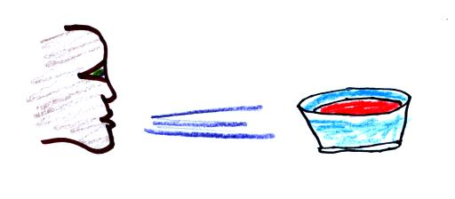

What two energy transport processes are at work here?
(hint: you've seen that head before that should suggest at least one answer)
Question #3
A person is standing outside on a cold windy day in A,
has fallen into cold water in B, and is perspiring heavily in C.
Match each energy transport process below with the most
appropriate situation in the drawing.
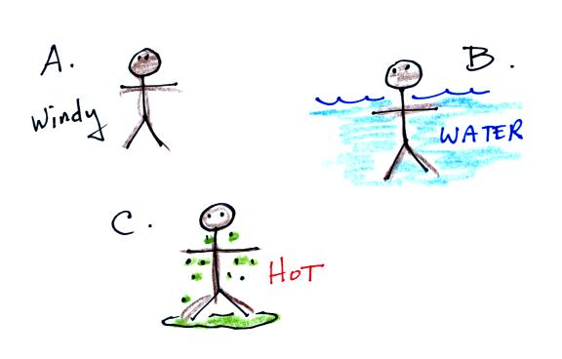

Conduction_______ Convection _______ Latent heat _______

We'll spend the next three or four class periods on electromagnetic (EM) radiation. It is the most important energy transport process because it can travel through empty space.
To really understand EM radiation you need to understand electric fields. To understand electric fields we need to quickly review a basic rule concerning static electricity. Here's a little more detailed version of what we did in class.
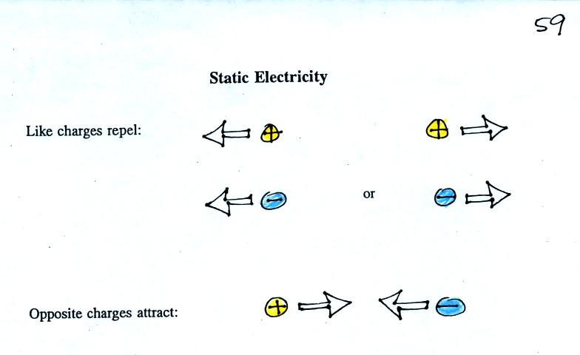
Static electricity was demonstrated (one of the poorer demonstrations of the semester) using a sweater (a gift from my Aunt Ethel and Uncle Nelson made of acrylic fiber and wool) and two balloons.
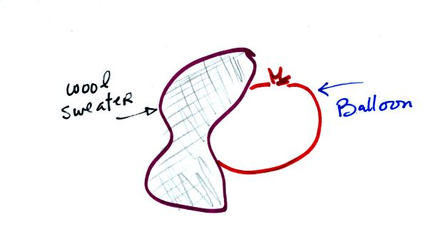
Each balloon was rubbed with the sweater. The balloons (and the sweater) became electrically charged (the balloons had one polarity of charge, the sweater had the other). We didn't know what charge the balloons carried just that they both had the same charge.
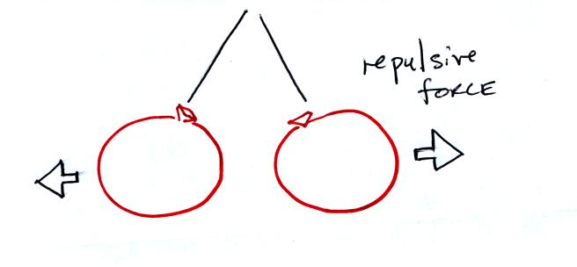
If you bring the balloons close to each other they are pushed apart by a repulsive electrical force.
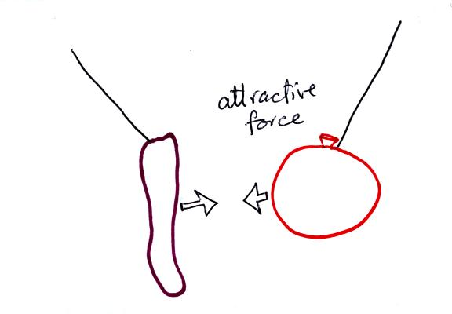
The sweater and the balloon carry opposite charges. IF they are brought together they experience an attractive electrical force.

Question #4
Would the formation of a cloud WARM or COOL the surrounding air?
Does the formation of frost WARM or COOL the air?
Question #5
Who or what do you think showed up at my back door yesterday evening while I was trying to watch American Idol, record Survivor, and talk on the phone?
(hint: click here)

Our next step in understanding EM is to learn something about electric field arrows. Imagine placing a + charge at the three positions shown in the figure below.
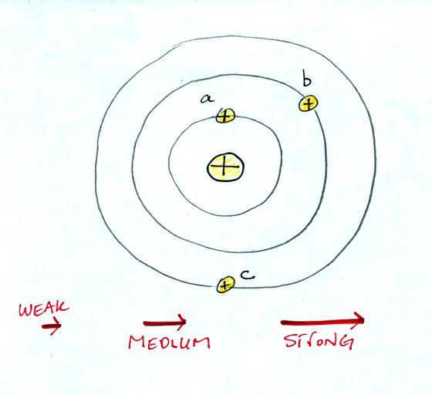
Then choose one of the three arrows at the bottom of the picture to show both the direction and the force that would be exerted on each charge.
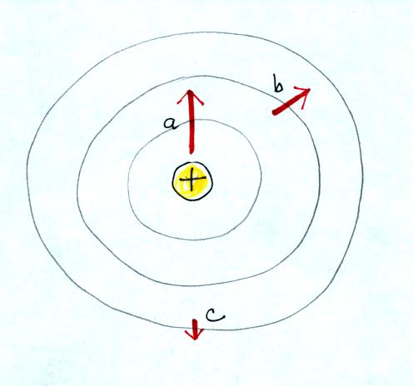

Here's the answer. The closer the charge is to the center, the greater the strength of the outward force. With just a little thought you can see that if you were to place + charges at other positions you would quickly end up with a figure that looks like the pattern at the bottom of p. 59 in the photocopied ClassNotes.
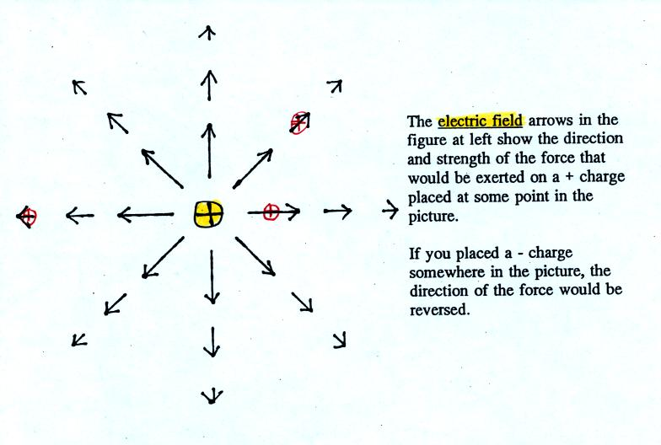
The electric field arrows in this picture show the direction and give an idea of the strength that would be exerted on a positive placed at any position in the figure.

The figures on p. 60 in the photocopied class notes have been redrawn below for clarity.
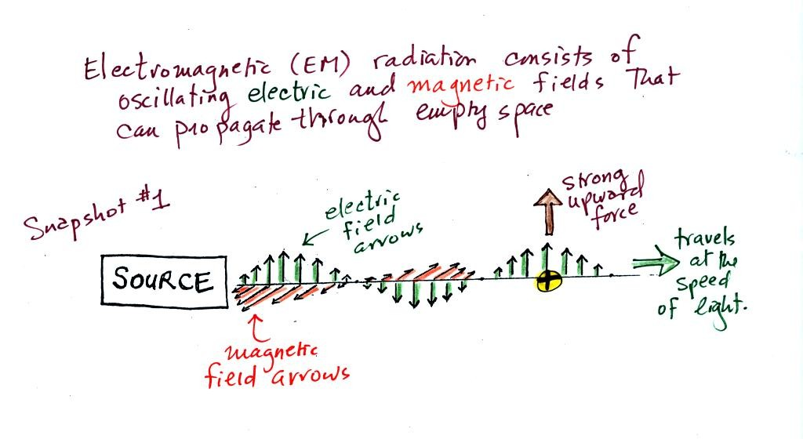
We imagine turning on a source of EM radiation and then a short time later we take a snapshot. The EM radiation is a wavy pattern of electric and magnetic field arrows. We'll ignore the magnetic field lines. The E field lines sometimes point up, sometimes down. The pattern of electric field arrows repeats itself.
Note the + charge near the right side of the picture. At the time this picture was taken the EM radiation exerts a fairly strong upward force on the + charge.
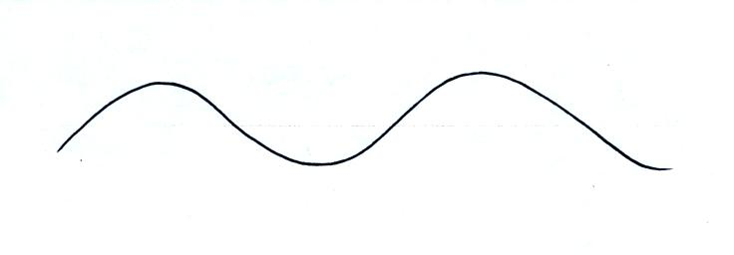
Textbooks often represent EM radiation with a wavy line like shown above. But what does that represent?
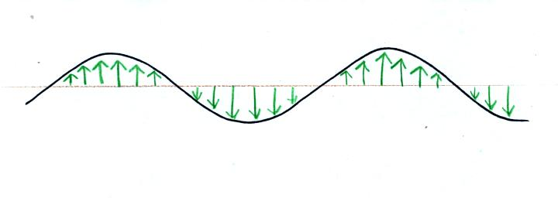
The wavy line just connects the tips of a bunch of electric field arrows.
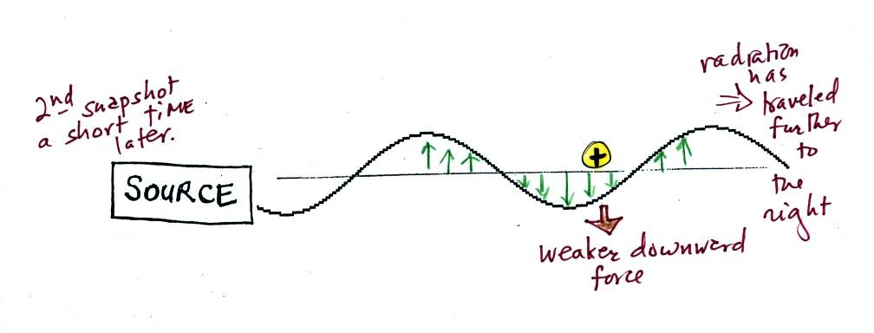
This picture was taken a short time after the first snapshot when the radiation had traveled a little further to the right. The EM radiation now exerts a somewhat weaker downward force on the + charge.
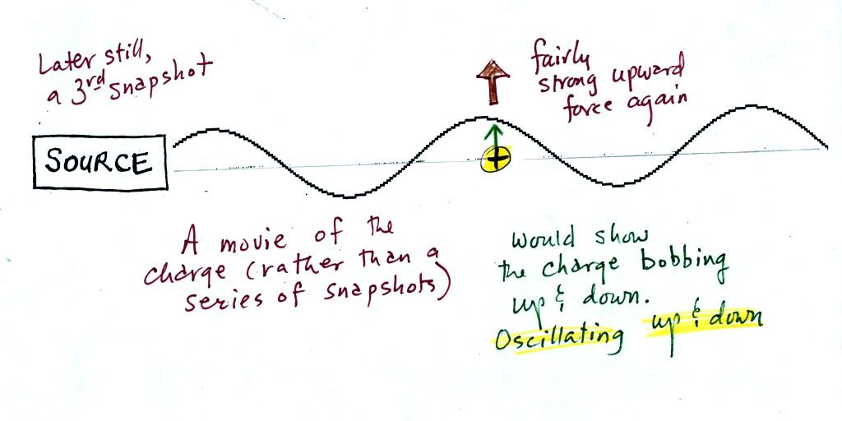
The + charge is now being pushed upward again. A movie of the + charge, rather than just a series of snapshots, would show the charge bobbing up and down much like a swimmer in the ocean would do as waves passed by.
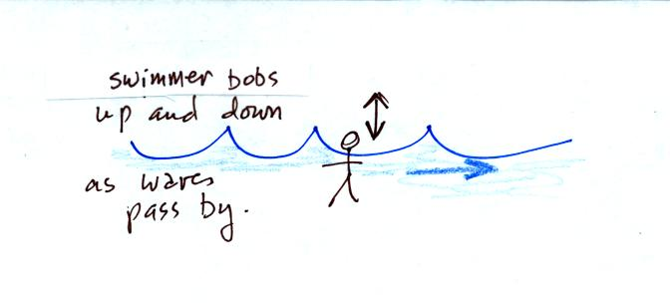
The wavy pattern used to depict EM radiation can be described spatially in terms of its wavelength, the distance between identical points on the pattern. By spatially we mean you look at different parts of the radiation at one particular instant frozen in time.
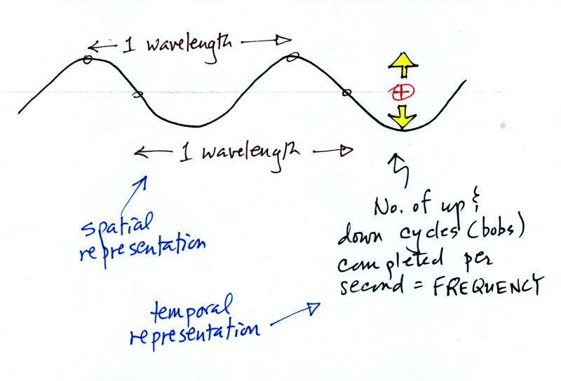
Or you can describe the radiation temporally using the frequency of oscillation (number of up and down cycles completed by an oscillating charge per second). By temporally we mean you at one particular point for a certain period of time.

Question #6
Would the electric field at a point midway between the + and a - charge
point UP DOWN RIGHT LEFT or would the electric field be ZERO?

