Wednesday Jan. 14, 2009
Today's musical selection was Tres Ninas from the San Carlos Spanish Guitar CD by Domingo DeGrazia (the CD is available from cdbaby.com). You can read more about this local artist (the youngest son of artist Ted DeGrazia) here. The plan this semester is to fill the 5 minutes before class with some kind of music (music won't take up any actual class time). Hopefully you'll enjoy at least some of the selections; comments and ideas from students are welcome.
Today was the first day of class. We first briefly discussed the Course Information handout. Read through this carefully on your own. You should try to purchase a copy of the photocopied Classnotes (in the bookstore) right away as we will probably be using some of them in class on Friday (sorry I should thought of a more equitable way of distributing the 6 or 7 free packets that I had from previous semesters). You will not find this section of NATS 101 on D2L.
The textbook is recommended this semester, not required. I would recommend it for people who want to get a more complete picture of the whole subject than we will be able to cover in class (we will only cover perhaps 1/3 of the material in the textbook). That means you'll read things that interest you on your own. Otherwise you should be able to do perfectly well in the class by reading the online notes and other suggested online sources.
You should be aware that there are a couple of topics (daily weather discussion and climate change) that won't receive as much emphasis in this class as they might in the two other sections of NATS 101 Introduction to Weather and Climate (largely due to the interests and background of the instructor). The other two sections (MWF 10-10:50 in ILC 120 and TR 9:30-10:45 in Modern Languages 350) are large, 300 student sections. Don't get the idea I'm encouraging you to change sections, I'm not (the other sections may well be full at this point anyway).
Copies of quizzes, quiz answers, a final exam, and final exam answers from a previous section of the course can be downloaded here.
Next we looked at the Writing Requirements handout. You should be thinking about which of the 4 experiments (or book or scientific paper reports) you would like to do so that you can sign up in class on Friday. There aren't enough materials for everyone to do the same experiment. Distribution of the materials for the first experiment will probably begin in class next Wednesday.

Your grade in this class will depend on your quiz scores, how much extra credit (from optional homework assignments) you earn, your writing grade, and (perhaps) your score on the final exam. A sample grade report from the Fall 2008 MWF Nats 101 class was shown.
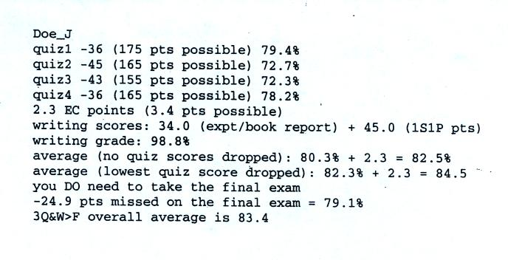
Don't worry about all the details at this point. Note that this student earned Cs on all the quizzes but ended up with a B in the class largely because of the high (98.8%) writing grade and because of the extra credit (EC) points. Be sure to do the writing assignments and try to do most of the optional extra credit assignments.

Most Intro. to Weather and Climate textbooks begin by describing the atmosphere. What is the atmosphere made of, how do air temperature, air density, air pressure change with altitude? That kind of thing. Today we just had enough time to start to look at the composition of the atmosphere.
Quite a few people seemed to know the answer to the following question.
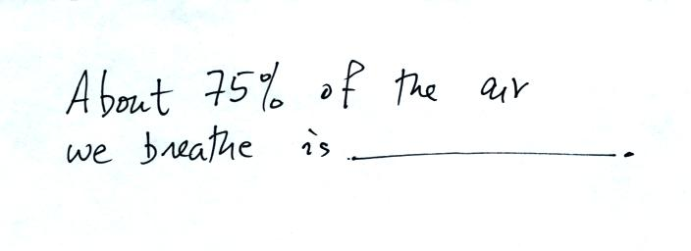
The answer is nitrogen. You can see liquid nitrogen, it is clear and looks like water (though you certainly wouldn't want to drink it, it is very cold). Once it has evaporated and turned into a gas it is invisible. Nitrogen was discovered in 1772 by Daniel Rutherford (a Scottish botanist). Atmospheric nitrogen is relatively unreactive and is sometimes used to replace air in packaged foods to preserve freshness. We'll use liquid nitrogen in several class demonstration this semester.
This next question was also pretty easy.

Oxygen is the second most abundant gas in the atmosphere. Oxygen is the most abundant element (by mass) in the earth's crust, in ocean water, and in the human body. Here's a photograph of liquid oxygen. It has a (very faint) blue color (I was a little disappointed when I saw the picture the first time because I had imagined the liquid oxygen might be a deeper more vivid blue).
When heated (such as in an automobile engine) the oxygen and nitrogen in air react to form compounds such as nitric oxide (NO), nitrogen dioxide (NO₂), and nitrous oxide (N₂O). Together as a group these are called oxides of nitrogen; the first two are air pollutants, the last is a greenhouse gas. More about those in class on Friday.
Here are the 5 most abundant gases in the earth's atmosphere.
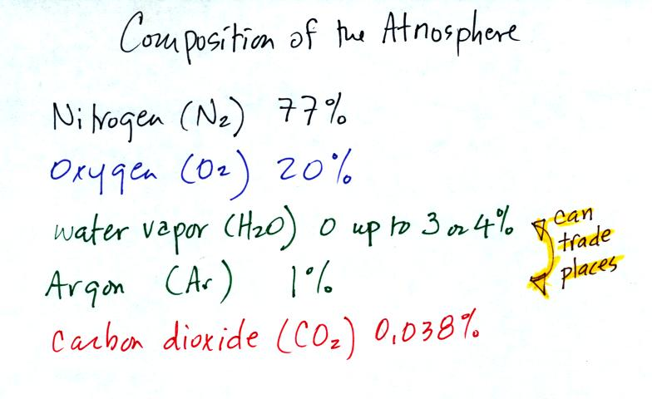
Water vapor and argon are the 3rd and 4th most abundant gases in the atmosphere. The concentration of water vapor can vary from near 0% to as high as 3% or 4%. Water vapor is, in many locations, the 3rd most abundant gas in air. In Tucson, the air is often dry enough that argon is in 3rd position and water vapor is 4th.
Water vapor, a gas, is invisible. Clouds are visible because they are made up of small drops of liquid water or ice crystals. Water is the only compound that exists naturally in solid, liquid, and gaseous phases in the atmosphere.
Argon is an unreactive noble gas (helium, neon, krypton, xenon, and radon are also inert gases). Noble bases are often used in "neon signs.
Here's a little more explanation (from Wikipedia) of why noble gases are so unreactive. Don't worry about all these additional details. The noble gases have full valence electron shells. Valence electrons are the outermost electrons of an atom and are normally the only electrons that participate in chemical bonding. Atoms with full valence electron shells are extremely stable and therefore do not tend to form chemical bonds and have little tendency to gain or lose electrons.

Water plays an important role in the formation of clouds, storms, and weather. Meteorologists are very interested in knowing and keeping track of how much water vapor is in the air at a particular place and time. One of the variables they use is the dew point temperature. The value of the dew point gives you an idea of how much water vapor is actually in the air. The higher the dew point value, the more water vapor the higher the water vapor concentration.
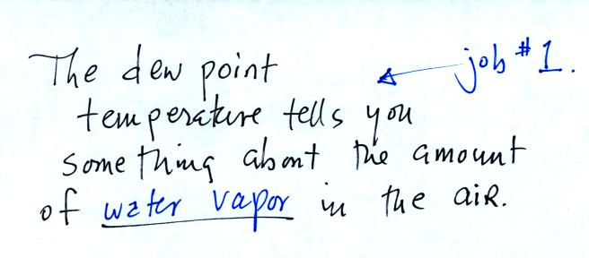
The chart below gives a rough equivalence between dew point temperature and percentage concentration of water vapor in the air.
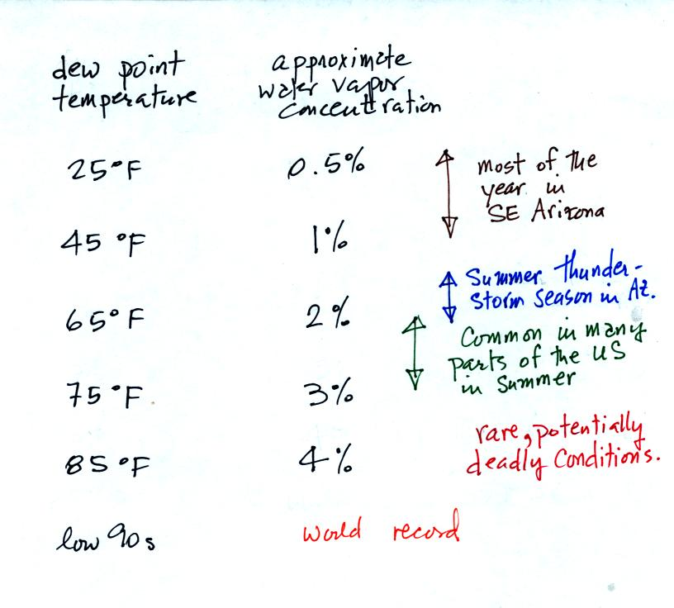
Air temperature will always be equal to or warmer than the dew point temperature. Experiencing 80º dew points would be very unpleasant (and possibly life threatening). Click here to see current dew point temperatures across the U.S.
The second job of the dew point temperature is
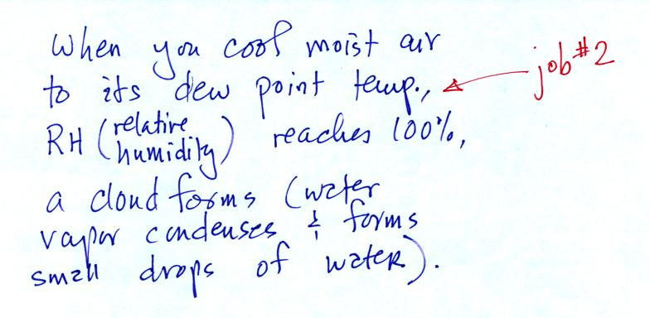
We could use the cup of liquid nitrogen to show this.
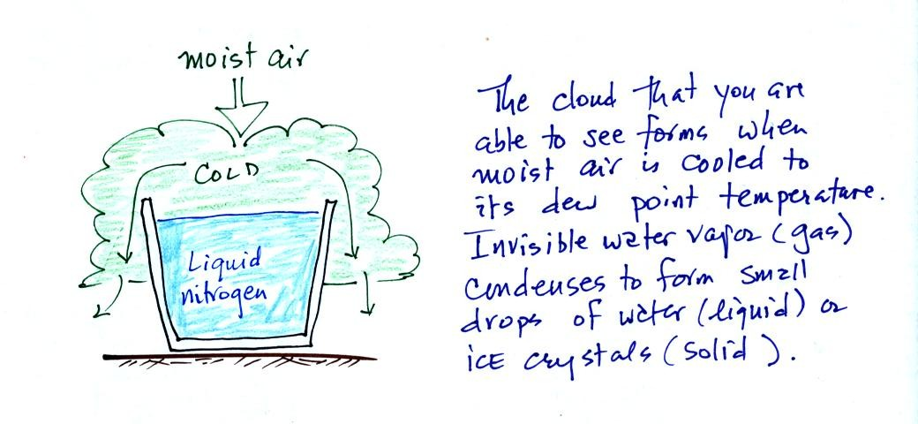
The cloud came from moisture in the air. The cloud was not made of nitrogen gas (which is invisible). Note also that a certain amount of "artistic" license was used in the figure above; liquid nitrogen is not blue and water clouds are not green.

The first optional (extra credit) assignment was made at this point.
The assignment will be due Wed., Jan. 21 and will be worth 0.1 or 0.2 pts.
Your assignment is to write a haiku poem that incorporates some of what you now know about the composition of the atmosphere.
Haiku is a form of Japanese poetry. In English, a haiku poem consists of 3 lines; the lines must contain 5, 7, and 5 syllables.
You'll find an example in the online notes.
Why am I giving you an assignment like this? Well I am often surprised at how creative NATS 101 students often are and am looking forward to seeing what you come up with.

The remaining material was not covered in class. We'll review some of this quickly in class on Friday.
The earth's original atmosphere, which was composed mostly of hydrogen (H) and helium (He), was very different from the atmosphere that we have today. This original atmosphere escaped (the earth was hot and the gases were moving around with enough speed that they could overcome the pull of the earth's gravity) or was swept into space (by the solar wind).
Our present atmosphere is though to have come from volcanic eruptions.
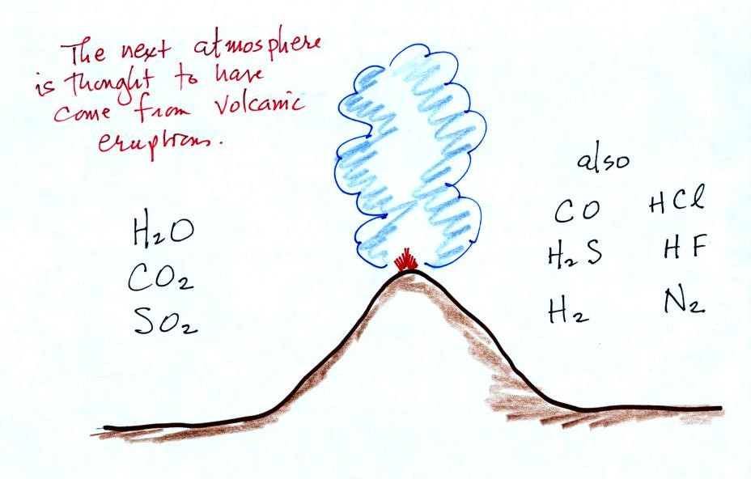
Volcanoes emit a lot of water vapor and carbon dioxide. As the earth began to cool the water vapor condensed and began to create oceans. Carbon dioxide dissolved in the oceans and was slowly turned into rock. Smaller amounts of nitrogen (N2) are emitted by volcanoes. Nitrogen is relatively inert and remained in the air. Nitrogen concentration built up over time.
Volcanoes didn't add any of the oxygen that is the atmosphere. Where did that come from?
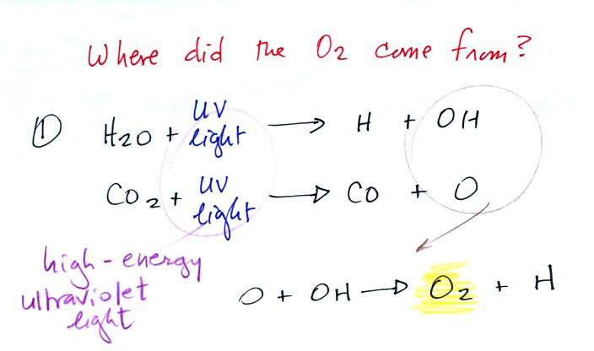
The oxygen is thought to have first come from photodissociation of water vapor and carbon dioxide by ultraviolet light (the high energy radiation splits the H₂0 and CO₂ molecules into pieces). The O and OH react to form O₂ and H.

Once O₂ begins to accumulate in the air it can react with O to form ozone, O₃. The ozone then begins to absorb ultraviolet light and life forms can safely move from the oceans (which would absorb UV light in the absence of ozone) onto land. Eventually plants and photosynthesis would become the main source of atmospheric oxygen.
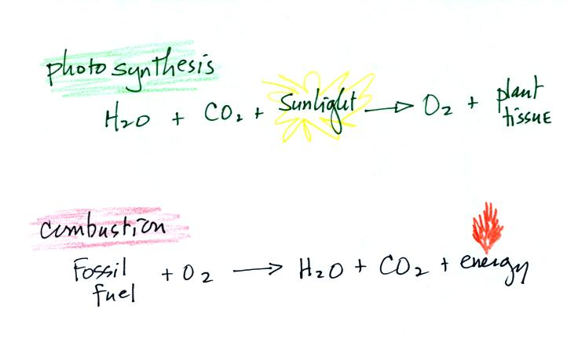
Note that combustion (and respiration) is really just the opposite of photosynthesis. We burn fossil fuels to generate energy. Water vapor and carbon dioxide are by products.
In class on Friday we will see that blue-green algae (cyanobacteria) in the ocean began to produce oxygen by photosynthesis even before plants were able to move from the oceans onto land.

