Monday Mar. 2, 2009
Today's music was The Arsonist performed by Rose's Pawn Shop!
The Experiment #2 reports (most of them) were collected today. It usually takes a week or so to get these graded. If you haven't returned your materials please do so as soon as you can, the thermometers are needed for Expt. #3.
Here are answers to the Feb. 27 In-class Optional Assignment.

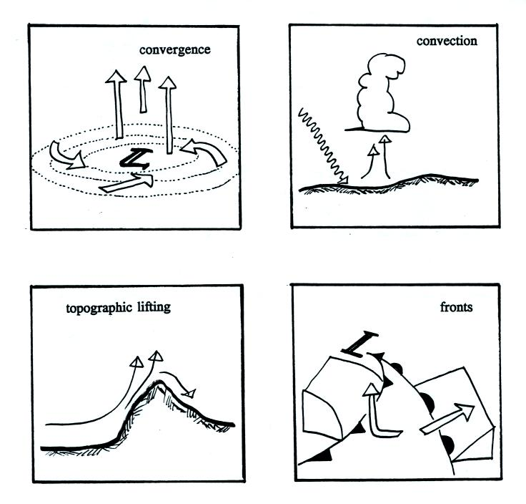

There are 4 processes that can cause air to rise. We've covered two of these, convergence and fronts, already. The last two were snuck into Friday's class. It is worth pointing them out again.
The first is illustrated in the upper right corner above. Sunlight warms the ground which then warms the air in contact with the ground. This warm low density air starts to rise. This is free convection.
Air moving horizontally encounters a mountain in the figure above at lower left. The air is forced to rise in order to get past the mountain. This is topographic (or orographic) lifting.

The following figure wasn't shown in class. It explains how energy can be transported from one place to another (even through empty space) in the form of electromagnetic (EM) radiation.
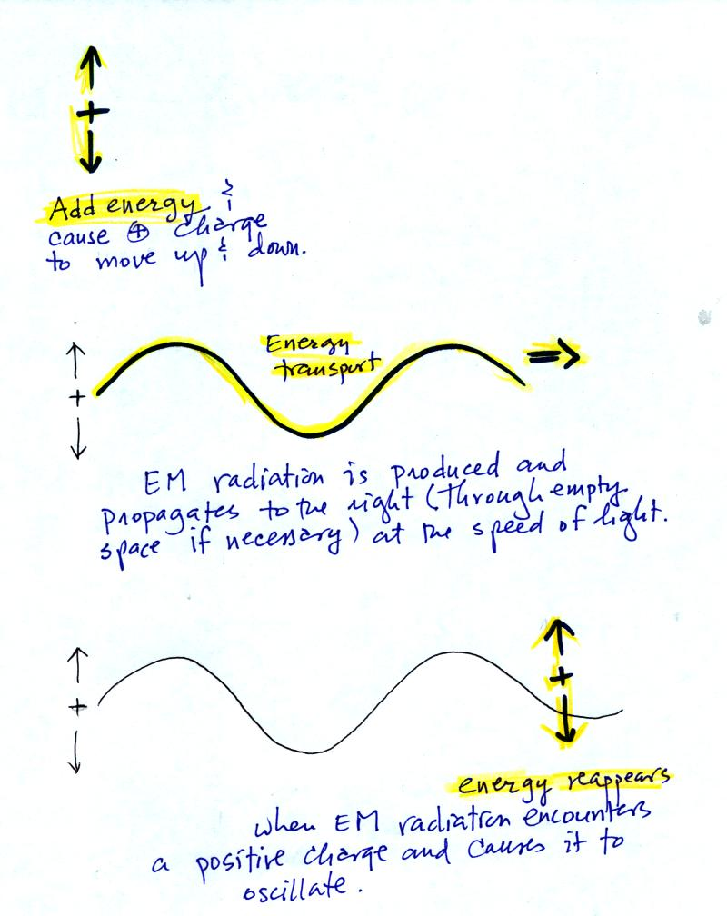

You add energy when you cause an electrical charge to move up and down and create the EM radiation (top left).
In the middle figure, the EM radiation then travels out to the right (it could be through empty space or through something like the atmosphere).

Once the EM radiation encounters an electrical charge at another location (bottom right), the energy reappears as the radiation causes the charge to move. Energy has been transported from left to right.

I'm in a little bit of a rush today putting today the online notes. So many of the remaining figures have been taken from the Fall 2008 notes and may differ slightly from today's notes (mostly just the colors are different)..
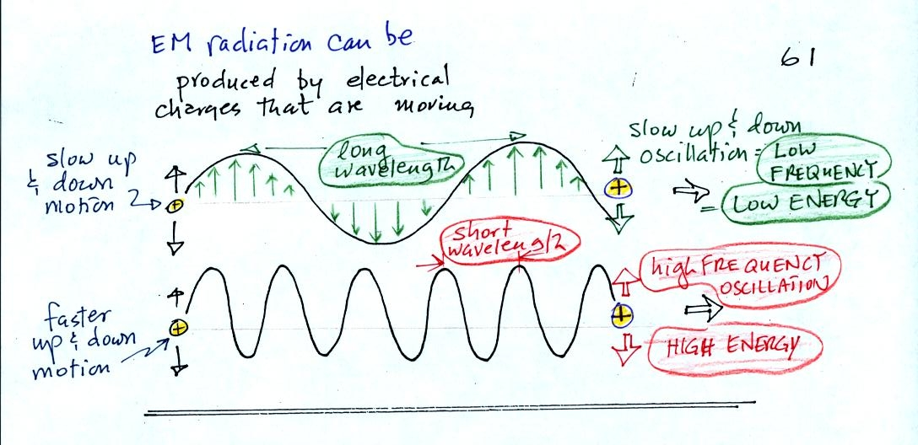
EM radiation can be created when you cause a charge to move up and down. If you move a charge up and down slowly (upper left in the figure above) you would produce long wavelength radiation that would propagate out to the right at the speed of light. If you move the charge up and down more rapidly you produce short wavelength radiation that propagates at the same speed.
Once the EM radiation encounters the charges at the right side of the figure above the EM radiation causes those charges to oscillate up and down. In the case of the long wavelength radiation the charge at right oscillates slowly. This is low frequency and low energy motion. The short wavelength causes the charge at right to oscillate more rapidly - high frequency and high energy.
These three characteristics: long wavelength / low frequency / low energy go together. So do short wavelength / high frequency / high energy. Note that the two different types of radiation both propagate at the same speed.
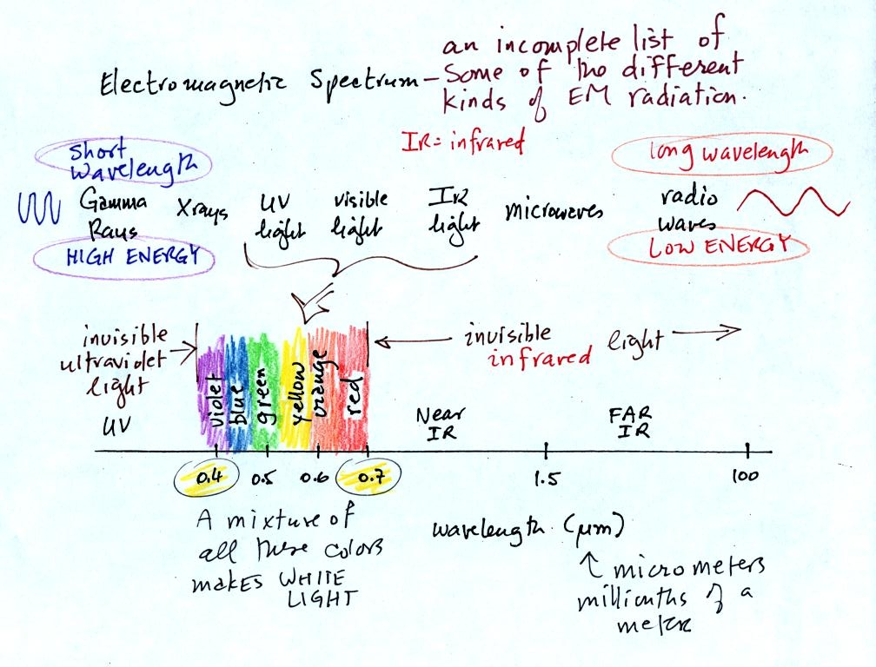
This is really just a partial list of some of the different types of EM radiation. In the top list, shortwave length and high energy forms of EM radiation are on the left (gamma rays and X-rays for example). Microwaves and radiowaves are longer wavelength, lower energy forms of EM radiation.
We will mostly be concerned with just ultraviolet light (UV), visible light (VIS), and infrared light (IR). Note the micrometer (millionths of a meter) units used for wavelength. The visible portion of the spectrum falls between 0.4 and 0.7 micrometers (UV and IR light are both invisible). All of the vivid colors shown above are just EM radiation with slightly different wavelengths. WHen you see all of these colors mixed together, you see white light.

Here are some rules governing the emission of electromagnetic radiation:
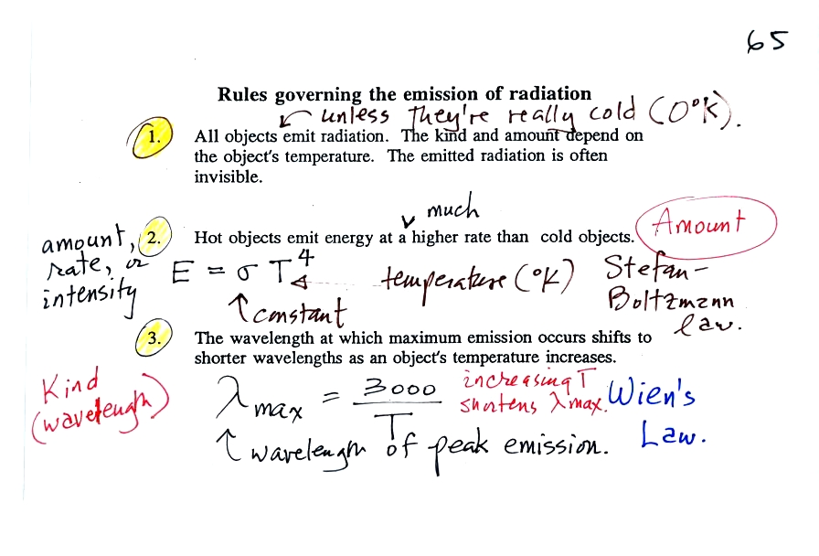
1.
Unless an object is very cold (0 K) it will emit EM radiation. All the people, the furniture, the walls and the floor in the classroom even the air are emitting EM radiation. Often this radiation will be invisible so that we can't see it and weak enough that we can't feel it. Both the amount and kind (wavelength) of the emitted radiation depend on the object's temperature.
2.
The second rule allows you to determine the amount of EM radiation (radiant energy) an object will emit. Don't worry about the units, you can think of this as amount, or rate, or intensity. Don't worry about σ either, it is just a constant. The amount depends on temperature to the fourth power. If the temperature of an object doubles the amount of energy emitted will increase by a factor of 2 to the 4th power (that's 2 x 2 x 2 x 2 = 16). A hot object just doesn't emit a little more energy than a cold object it emits a lot more energy than a cold object. This is illustrated in the following figure:

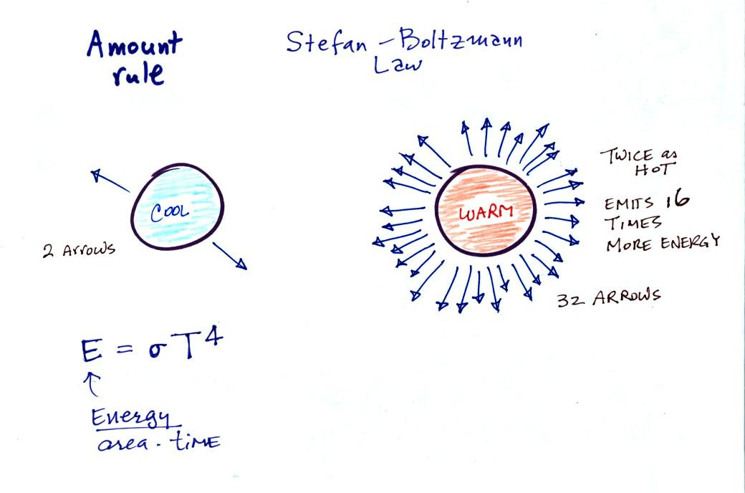
3.
The third rule tells you something about the kind of radiation emitted by an object. We will see that objects usually emit radiation at many different wavelengths. There is one wavelength however at which the object emits more energy than at any other wavelength. This is called lambda max (lambda is the greek character used to represent wavelength) and is called the wavelength of maximum emission. The third rule allows you to calculate "lambda max." This is illustrated below:
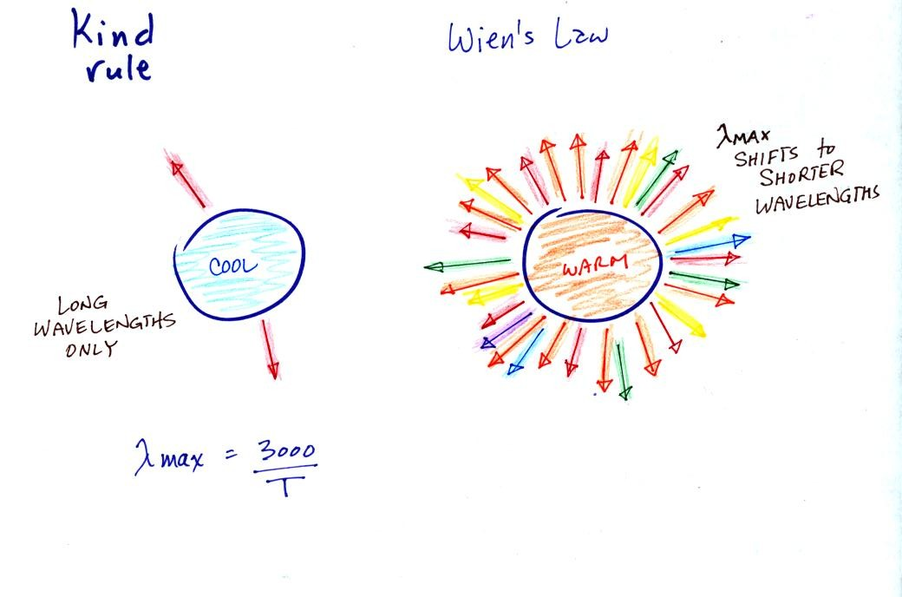

The following graphs (at the bottom of p. 65 in the photocopied Class Notes) also help to illustrate the Stefan-Boltzmann law and Wien's law.
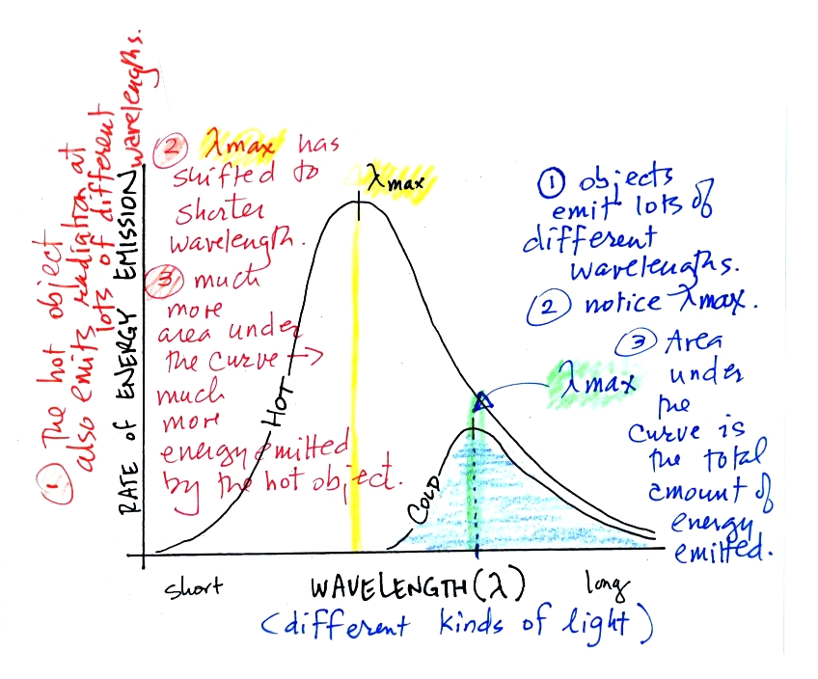
1.
Notice first that both and warm and the cold objects emit radiation over a range of wavelengths (the curves above are like quiz scores, not everyone gets the same score, there is a distribution of grades)
3.
The area under the warm object curve is much bigger than the area under the cold object curve. The area under the curve is a measure of the total radiant energy emitted by the object. This illustrates the fact that the warmer object emits a lot more radiant energy than the colder object.

2.
Lambda max has shifted toward shorter wavelengths for the warmer object. This is Wien's law in action. The warmer object is emitting lots of types of short wavelength radiation that the colder object doesn't emit.

An ordinary 200 W tungsten bulb connected to a dimmer switch can be used to demonstrate these rules (see p. 66 in the photocopied ClassNotes). We'll be seeing the EM radiation emitted by the bulb filament.
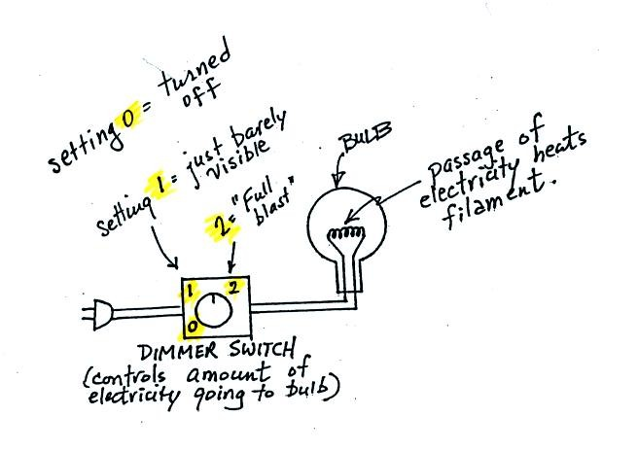
The graph at the bottom of p. 66 has been split up into 3 parts and redrawn for improved clarity.
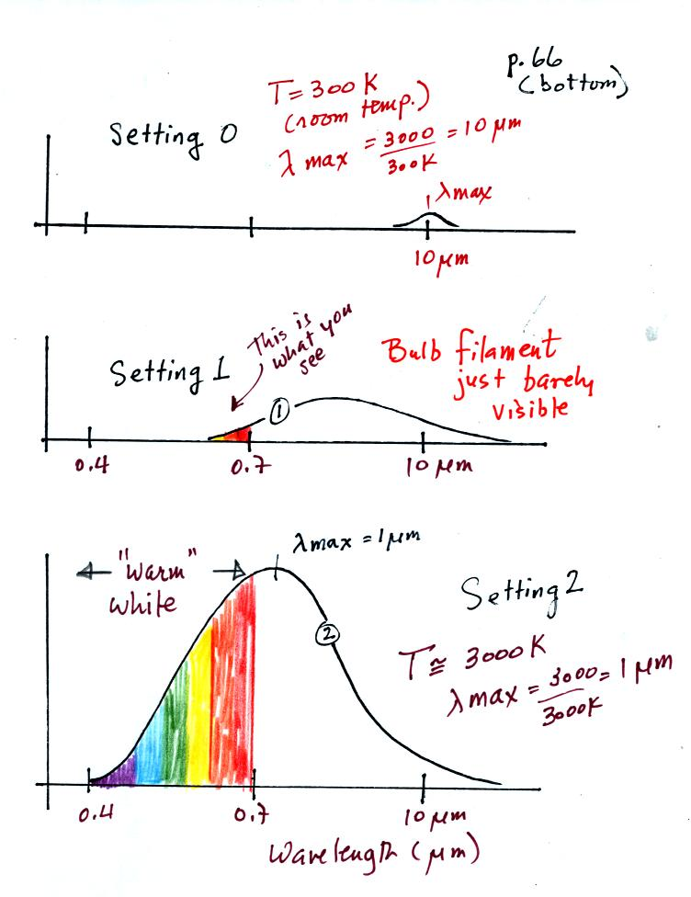
We start with the bulb turned off (Setting 0). The filament will be at room temperature which we will assume is around 300 K (remember that is a reasonable and easy to remember value for the average temperature of the earth's surface). The bulb will be emitting radiation, it's shown on the top graph above. The radiation is very weak so we can't feel it. It is also long wavelength, far IR, radiation so we can't see it. The wavelength of peak emission is 10 micrometers.
Next we use the dimmer switch to just barely turn the bulb on (the temperature of the filament is now about 900 K). The bulb wasn't very bright at all and had an orange color. This is curve 1, the middle figure. Note the far left end of the emission curve has moved left of the 0.7 micrometer mark - into the visible portion of the spectrum. That is what you are able to see, just the small fraction of the radiation emitted by the bulb that is visible light (but just long wavelength red and orange light). Most of the radiation emitted by the bulb is to the right of the 0.7 micrometer mark and is invisible IR radiation (it is strong enough now that you could feel it if you put your hand next to the bulb).
Finally we turn on the bulb completely (it was a 200 Watt bulb so it got pretty bright). The filament temperature is now about 3000K. The bulb is emitting a lot more visible light, all the colors, though not all in equal amounts. The mixture of the colors produces a "warm white" light. It is warm because it is a mixture that contains a lot more red, orange, and yellow than blue, green, and violet light. It is interesting that most of the radiation emitted by the bulb is still in the IR portion of the spectrum (lambda max is 1 micrometer). This is invisible light. A tungsten bulb like this is not especially efficient, at least not as a source of visible light.
You were able to use one of the diffraction gratings to separate the white light produced by the bulb into its separate colors.
When you looked at the bright white bulb filament through one of the diffraction gratings the colors were smeared out to the right and left as shown below (the following two figures weren't shown in class):

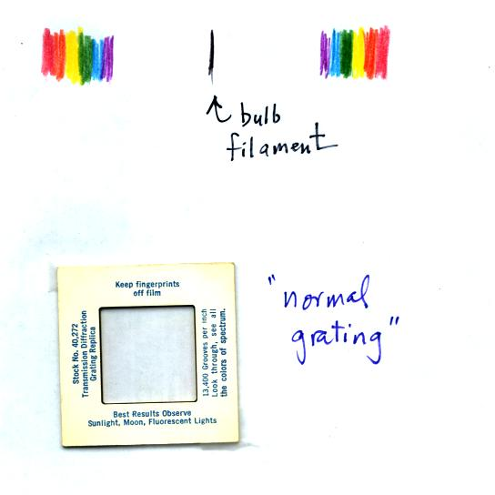
Some of the grating handed out in class behaved a little differently and spread out the colors orizontally, vertically, and diagonally.
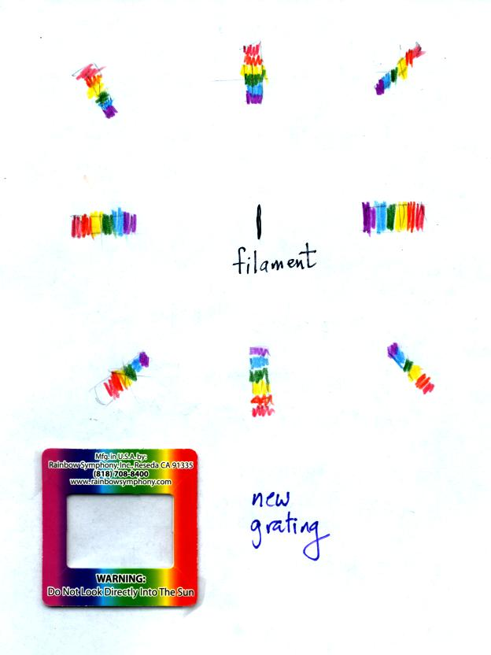

The sun emits electromagnetic radiation. That shouldn't come as a surprise since you can see it and feel it. The earth also emits electromagnetic radiation. It is much weaker and invisible. The kind and amount of EM radiation emitted by the earth and sun depend on their respective temperatures.
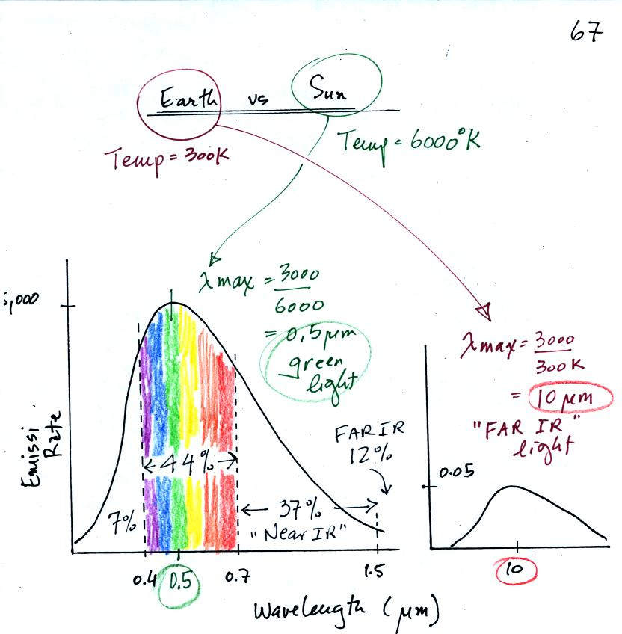
The curve on the left is for the sun. We first used Wien's law and a temperature of 6000 K to calculate lambda max and got 0.5 micrometers. This is green light; the sun emits more green light than any other kind of light. The sun doesn't appear green because it is also emitting lesser amounts of violet, blue, yellow, orange, and red - together this mix of colors appears white. 44% of the radiation emitted by the sun is visible light, 49% is IR light (37% near IR + 12% far IR), and 7% is ultraviolet light. More than half of the light emitted by the sun is invisible.
100% of the light emitted by the earth (temperature = 300 K) is invisible IR light. The wavelength of peak emission for the earth is 10 micrometers.
Because the sun (surface of the sun) is 20 times hotter than the earth a square foot of the sun's surface emits energy at a rate that is 160,000 times higher than a square foot on the earth. Note the vertical scale on the earth curve is different than on the sun graph. If both the earth and sun were plotted with the same vertical scale, the earth curve would be too small to be seen.

