Monday Mar. 23, 2009
Today's music was from Black Tuesday, a local group. They played at The Hut on St. Patrick's Day.
All of the 1S1P Assignment #1 reports have been graded. They were returned in class today.
The Expt. #1 revised reports and the Expt. #2 reports have been graded.
The Expt. #2 revised reports are due this week (I'll give you until Friday). Please return your original report with your revised report.
The Expt. #3 reports are due next Monday (Mar. 30). You should try to return your materials this week so that you can pick up the Supplementary Information sheet.
I'll try to have the midterm grade summaries done sometime this week.
There is a new Optional Assignment due Friday this week.

Today we are going to just jump into the topic of humidity and work 4 example problems. This way you will learn about the 4 humidity variables (mixing ratio, saturation mixing ratio, relative humidity, and dew point temperature). You'll see what they do and what can cause their values to change.
As we worked through these problems we added comments to an 8 item long list. You'll find the complete list at the bottom of today's notes. It is a list of some of the most important characteristics of the four humidity variables.
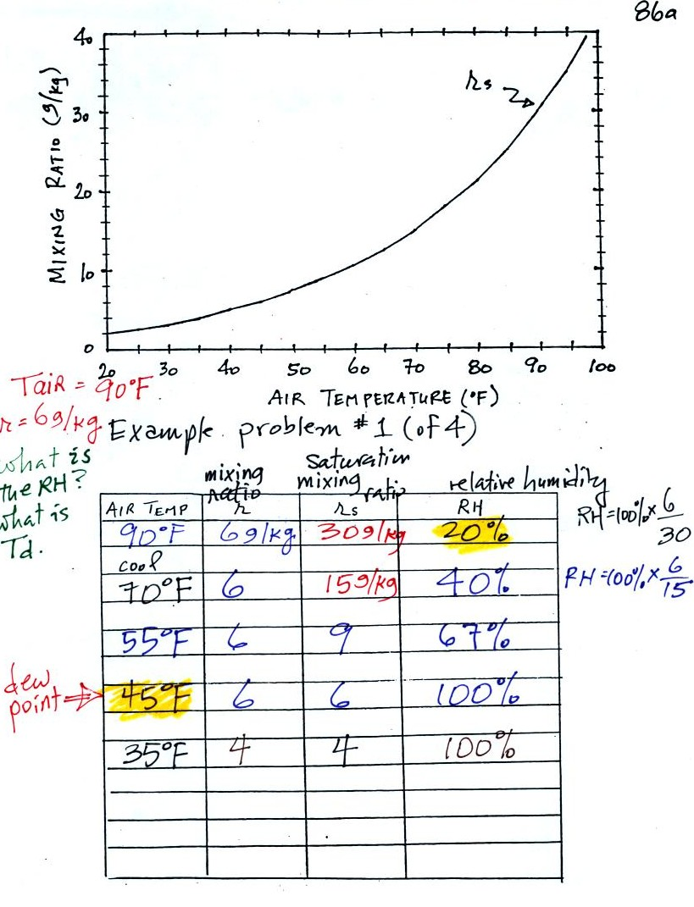
Here is the first sample problem that we worked in class. You might have a hard time unscrambling this if you're seeing it for the first time. The series of steps that we followed are retraced below:
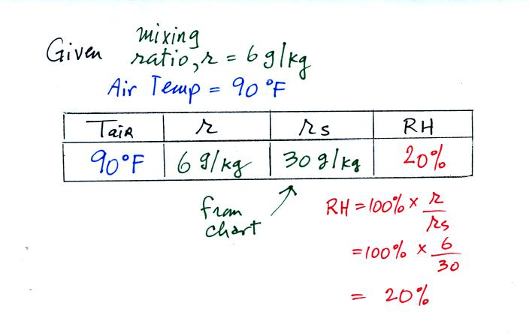
We're given an air temperature of 90 F and a mixing ratio (r) of 6 g/kg (see Item 1 on the list at the end of the notes). We're supposed to find the relative humidity (RH) and the dew point temperature.
We start by entering the data we were given in the table. Once you know the air's temperature you can look up the saturation mixing ratio value; it is 30 g/kg for 90 F air (Items 4 & 3 on the list). 90 F air could potentially hold 30 grams of water vapor per kilogram of dry air (it actually contains 6 grams per kilogram in this example). A table of saturation mixing ratio values can be found on p. 86 in the ClassNotes.
Once you know mixing ratio and saturation mixing ratio you can calculate the relative humidity (you divide the mixing ratio by the saturation mixing ratio, 6/30, and multiply the result by 100%). The RH is 20%. See Item 5 on the list at the bottom of today's notes.
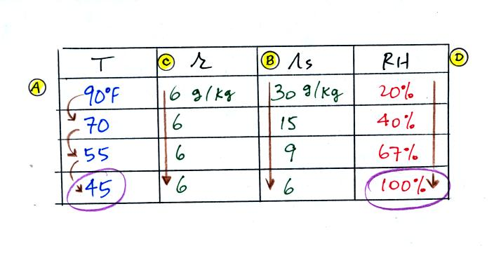
The numbers we just figured out are shown on the top line above.
(A) We imagined cooling the air from 90F to 70F, then to 55F, and finally to 45F.
(B) At each step we looked up the saturation mixing ratio and entered it on the chart. Note that the saturation mixing ratio values decrease as the air is cooling.
(C) The mixing ratio doesn't change as we cool the air. The only thing that changes r is adding or removing water vapor and we aren't doing either. See Item 2.
(D) Note how the relative humidity is increasing as we cool the air (Item 6). The air still contains the same amount of water vapor it is just that the air's capacity is decreasing.
Finally at 45 F the RH becomes 100%. This is kind of a special point. You have cooled the air until it becomes saturated. The dew point temperature in this problem is 45 F. (Item 7)
What would happen if we cooled the air further still, below the dew point temperature?
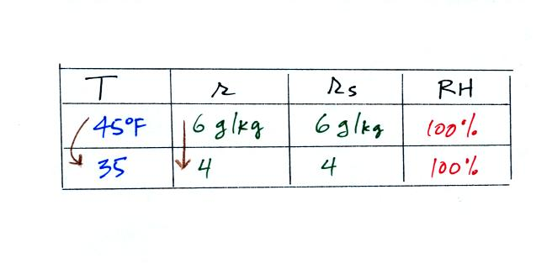
35 F air can't hold the 6 grams of water vapor that 45 F air can. You can only "fit" 4 grams of water vapor into the 35 F air. The remaining 2 grams would condense. If this happened at ground level the ground would get wet with dew. If it happens above the ground, the water vapor condenses onto small particles in the air and forms fog or a cloud. Now because water vapor is being taken out of the air (and being turned into water), the mixing ratio will decrease from 6 to 4.
In many ways cooling moist air is liking squeezing a moist sponge (this figure wasn't shown in class)
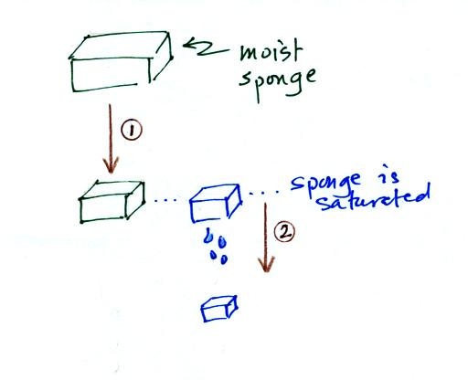
Squeezing the sponge and reducing its volume is like cooling moist air and reducing the saturation mixing ratio. At first when you sqeeze the sponge nothing happens, no water drips out. Eventually you get to a point where the sponge is saturated. This is like reaching the dew point. If you squeeze the sponge any further (or cool air below the dew point) water will begin to drip out of the sponge (water vapor will condense from the air).

Here's the 2nd problem we worked:
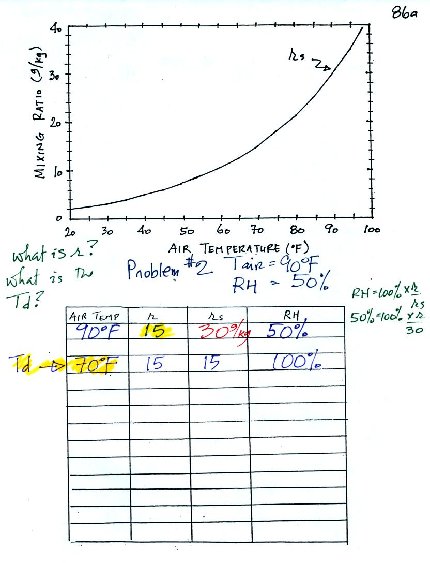
The work that we did in class is shown above. Given an air temperature of 90 F and a relative humidity of 50% you are supposed to figure out the mixing ratio (15 g/kg) and the dew point temperature (70 F). The problem is worked out in detail below:
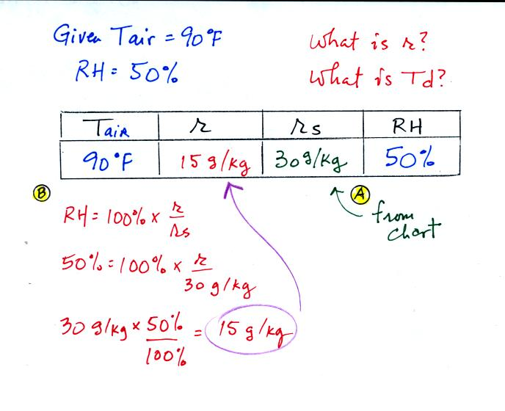
First you fill in the air temperature and the RH data that you are given.
(A) since you know the air's temperature you can look up the saturation mixing ratio (30 g/kg).
(B) Then you can substitute into the relative humidity formula and solve for the mixing ratio (15 g/kg).
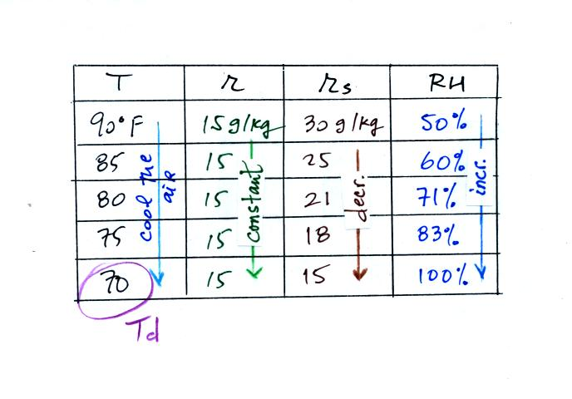
Finally you imagine cooling the air. Cooling causes the saturation mixing ratio to decrease, the mixing ratio stays constant, and the relative humidity increases. In this example the RH reached 100% when the air had cooled to 70 F. That is the dew point temperature.

We can use results from humidity problems #1 and #2 worked in class on Monday to learn a useful rule.
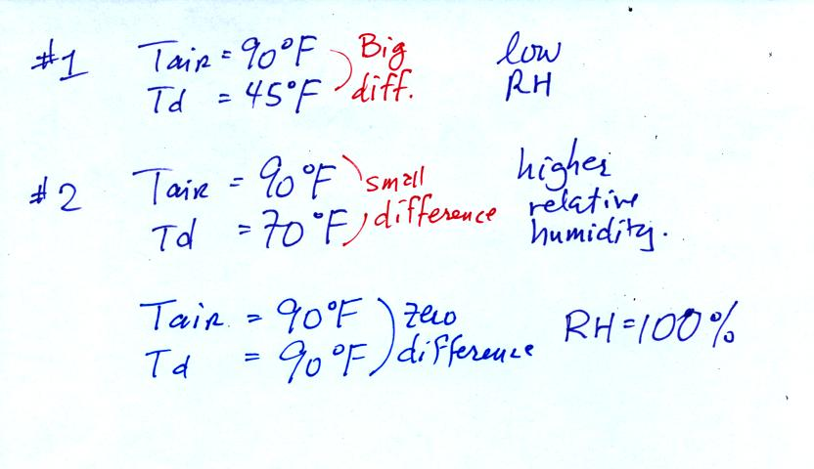
In the first example the difference between the air and dew point temperatures was large (45 F) and the RH was low. In the 2nd problem the difference between the air and dew point temperatures was smaller (20 F) and the RH was higher. The easiest way to remember this rule is to remember the case where there is no difference between the air and dew point temperatures. The RH then would be 100%.

Here's the 3rd example problem. Once you've worked a couple of problems they go much faster.
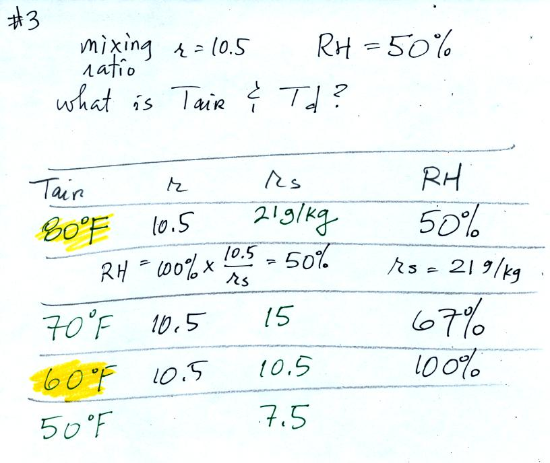
Here's the play by play solution to the question
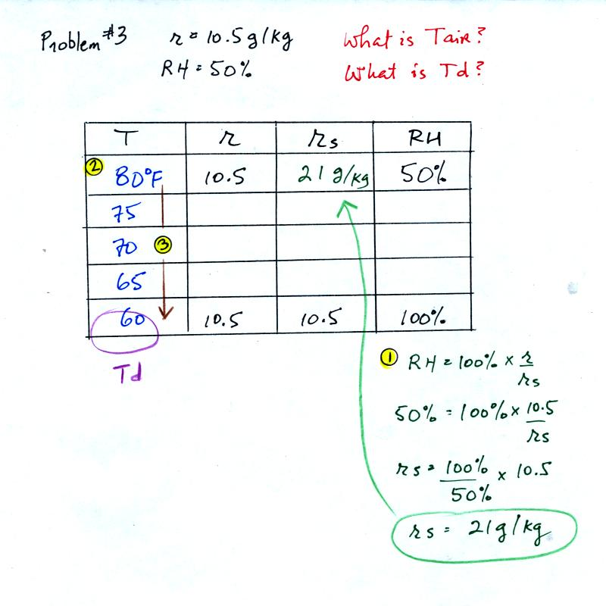
You are given a mixing ratio of 10.5 g/kg and a relative humidity of 50%. You need to figure out the air temperature and the dew point temperature.
(1) The air contains 10.5 g/kg of water vapor, this is 50%, half, of what the air could potentially hold. So the air's capacity, the saturation mixing ratio must be 21 g/kg (you can either do this in your head or use the RH equation following the steps shown).
(2) Once you know the saturation mixing ratio you can look up the air temperature in a table.
(3) Then you imagine cooling the air until the RH becomes 100%. This occurs at 60 F. The dew point is 60 F.

Problem #4 is probably the most difficult of the bunch.
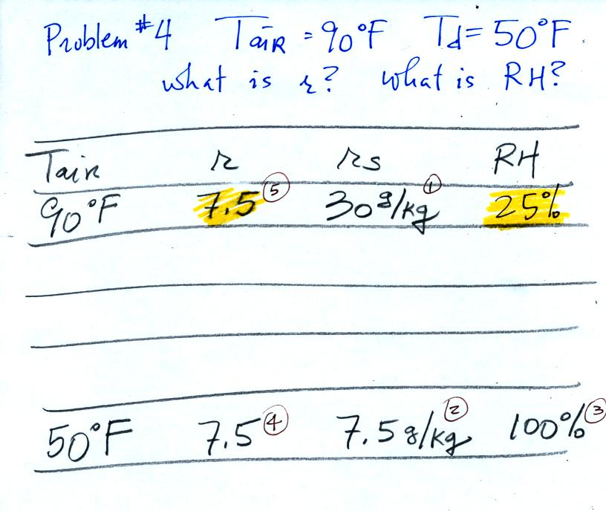
Here's what we did in class, we were given the air temperature and the dew point temperature. We were supposed to figure out the mixing ratio and the relative humidity.
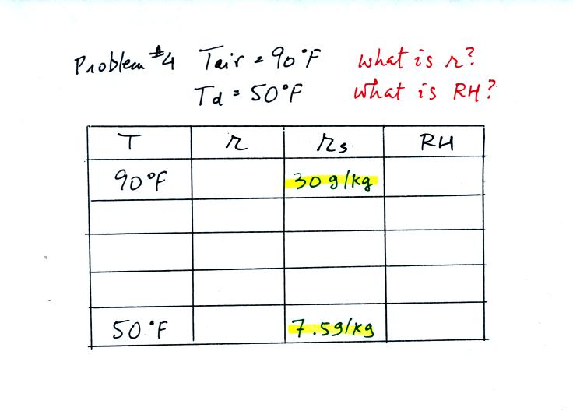
We enter the two temperatures onto a chart and look up the saturation mixing ratio for each.
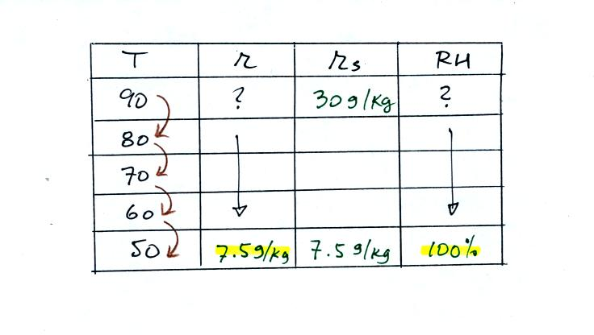
We ignore the fact that we don't know the mixing ratio. We do know that if we cool the 90 F air to 50 F the RH will become 100%. We can set the mixing ratio equal to the value of the saturation mixing ratio at 50 F, 7.5 g/kg.
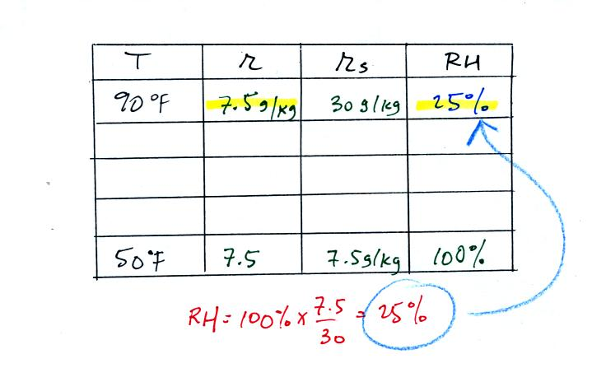
Remember back to the three earlier examples. When we cooled air to the the dew point, the mixing ratio didn't change. So the mixing ratio must have been 7.5 all along. Once we know the mixing ratio in the 90 F air it is a simple matter to calculate the relative humidity, 25%.

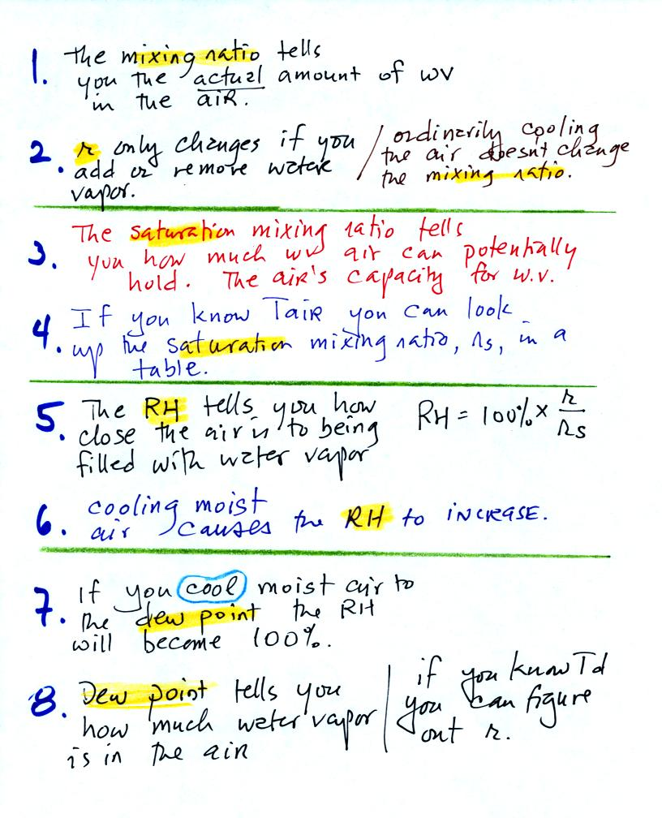
Listed above are some of the most important properties of the 4 humidity variables.

