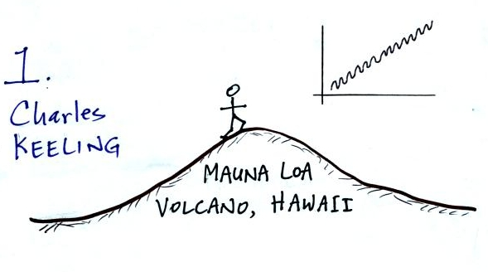
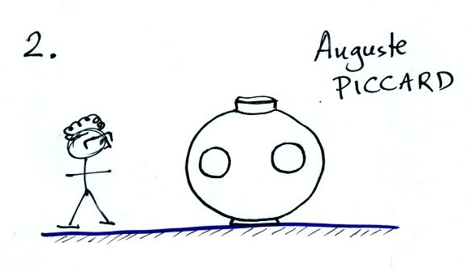
At the Mauna Loa Observatory in Hawaii. Professor Piccard standing next to the
What is that in the upper right corner, a graph aluminum sphere he designed and had built
of some kind? by a Belgian beer keg manufacturer

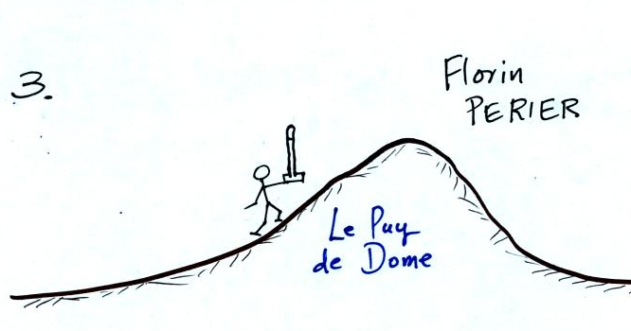
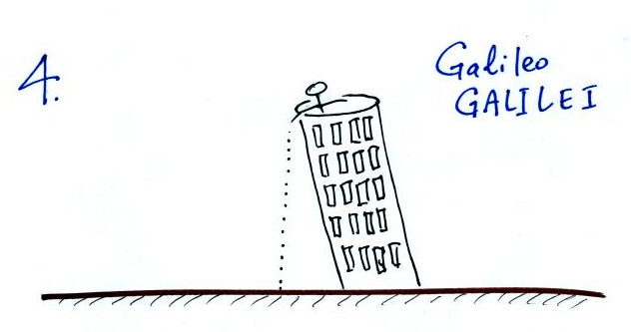

Carefully carrying a mercury barometer up the Galileo standing on top of a tower in Italy.
side of a mountain. The tower seems to be tilted a little bit to
one side.
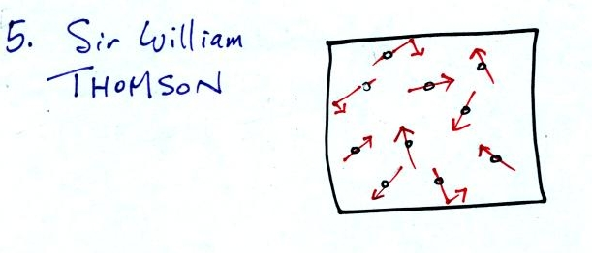
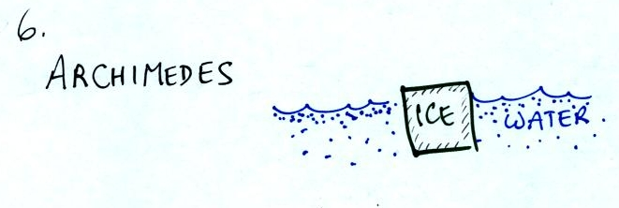

Gas molecules zipping around at hundreds Ice is less dense than water; it floats in
of miles per hour inside a sealed container. water.
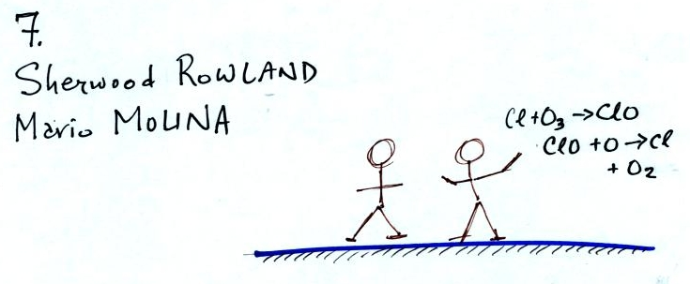
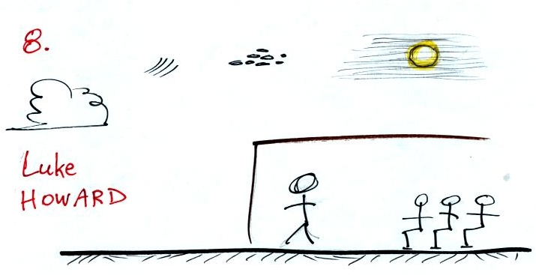

Nobel Prize winners at work in their chemistry An amateur scientist, his address at the
laboratory. Askesian Society astounded his colleagues.
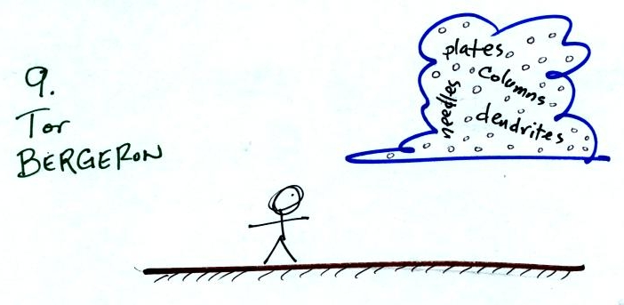
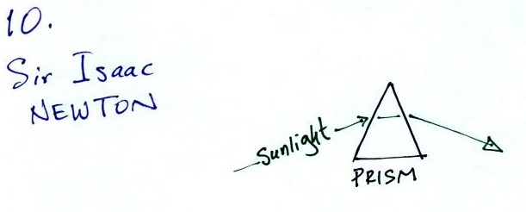

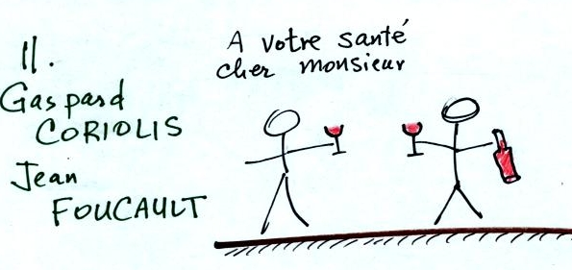
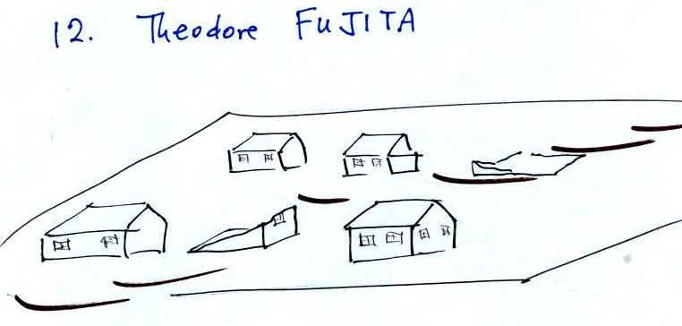
A swedish meteorologist. The bending of light is known as refraction.
The amount of bending is dependent on the
wavelength of light.

Avec deux verres et une bouteille de vin,
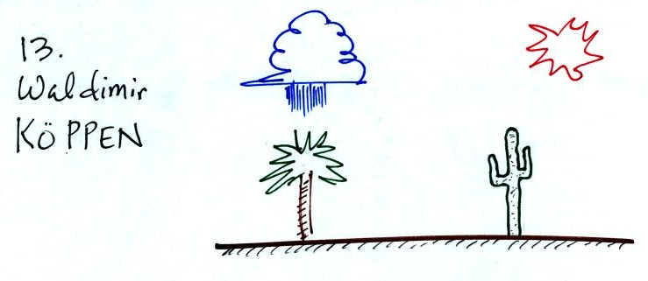
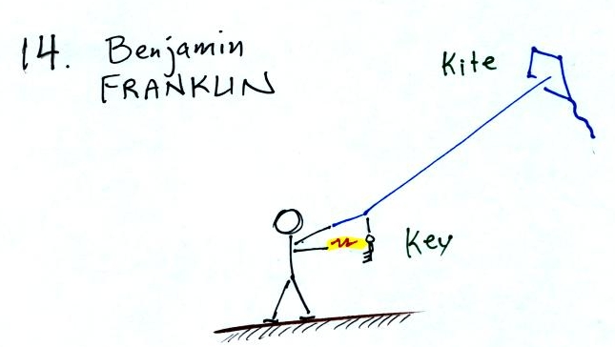
ces deux hommes font la fete. Two houses are destroyed while the others
nearby are left relatively undamaged.
Tropical rainforest and subtropical desert scenes. Flying a kite in 1752.

Now try to match each of the 14 people above with the appropriate description below:
(A) Devised a system for identifying & classifying clouds that is still used, with small changes, today.
(B) His climate classification system is based on monthly average temperature and precipitation data or types of native vegetation
(C) This experiment, which proved that air pressure decreases with increasing altitude, was carried out in France in 1648.
(D) If gravity were the only force present (and it usually isn't) a feather and a bowling ball dropped from some height above the ground would fall at the same speed and reach the ground at the same time.
(E) Proved that white light is actually a mixture of violet, blue, green, yellow, orange, and red.
(F) Using a pressurized gondola, Auguste Piccard and Paul Kipfer made a somewhat calamitous trip up into the stratosphere and back.
(G) An object immersed in a fluid experiences an upward bouyant force equal to the weight of the fluid displaced.
(H) Understood that it wasn't the fine French wind that made their heads spin.
(I) Measurements he started in 1958 have continued to the present day and show about a 15% increase in the atmospheric CO2 concentration
(J) Believed that in clouds with water droplets and ice crystals, all precipitation, liquid or solid, began as ice crystals.
(K) First to warn that stable chlorofluorocarbon molecules would diffuse upward to the stratosphere where they could react with and destroy ozone.
(L) Aka Lord Kelvin. Temperature on the scale named after this Scottish physicist never goes below zero and is a measure of the average kinetic energy of the atoms or molecules in a gas.
(M) Investigating the electricity in thunderstorms which he believed was the same positive and negative charges he studied in his laboratory.
(N) Probably the most recognized name in tornado research, devised a tornado intensity scale, and suggested the existence of multiple vortices inside some tornadoes.

