NATS 101 Sect. 1 & 5 Name___________Answers_____________________
Practice Quiz Feb. 3 & 4, 2010 (please also put your name on the back)

1. (5 pts) The air is healthiest when the Air Quality Index is HIGH LOW.
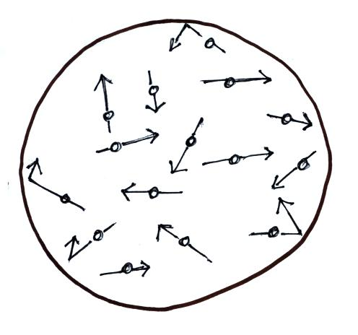
2. (10 pts) The pressure produced by the gas in the balloon at right
does not depend on the ___b___. The pressure in the balloon is
inversely proportional to the ___e____. (fill in the blanks)
a. gas density b. masses of the gas molecules c. number of gas molecules
d. gas temperature e. balloon volume
In a question like this the order of the answers is important and you must put the answers in the blanks. I usually mention that in the question, but I sometimes forget.

3. (10 pts) Are oxygenated fuels used in Tucson in the WINTER or SUMMER months? Are they used to reduce OZONE(O₃) or CARBON MONOXIDE(CO) concentrations? The idea in questions like this is to circle one of the words in each pair.

4. (5 pts) An increase in the atmospheric concentration of __c____ might change the color of the sky from a deep blue to bluish-white.
a. ozone b. carbon monoxide c. particulate matter d. sulfur dioxide e. water vapor

5. (10 pts) Chlorofluorocarbons in the air are of concern because they __b___ and __c___.
a. are a key ingredient in photochemical smog b. destroy stratospheric ozone
c. are greenhouse gases d. react with water in clouds to form acid rain
In this case the order of the answers doesn’t matter. You can either fill in the blanks with your answer or circle the letter of the correct answers in the list.

6. (15 pts) Air pressure at any level in the atmosphere is determined by the weight of the air ABOVE BELOW that level. Air density INCREASES DECREASES with increasing altitude. Decreasing pressure with increasing altitude produces an UPWARD DOWNWARD pointing pressure difference force.

7. (10 pts) Photochemical smog can form when which two of the following react?
a. water vapor (H₂O) b. hydrocarbons c. oxygen (O₂)
d. sulfur dioxide (SO₂) e. ozone (O₃) f. carbon dioxide (CO₂)

8. (5 pts) People might not be aware of a buildup of ____carbon monoxide_____________ in their home because this toxic gas is colorless and odorless. I also accepted radon, but not carbon dioxide (CO₂ levels don’t build up to deadly levels in a home. If your paper was graded by one of the TAs they might have counted that answer wrong. If this were a real quiz you could tell me and I would give you credit.

9. (5 pts) In the acid rain demonstration done in class, ___d___ gas (from dry ice) was bubbled through Tucson tap water. There is concern that increasing atmospheric concentrations of this gas might acidify the world’s oceans and be detrimental to certain kinds of sea life.
a. ozone b. sulfur dioxide c. nitrogen dioxide d. carbon dioxide
10. (5 pts) Average atmospheric pressure at sea level is about 1000 ___d___.
a. inches of mercury b. kilograms c. pounds per square inch d. millibars

11. (10 pts) Is there more OXYGEN or NITROGEN in the earth’s atmosphere? Is there more ARGON or CARBON DIOXIDE in the air we breathe?

12. (5 pts) What is the name of the instrument, invented in the 1600s, that is used to measure atmospheric pressure? Mercury barometer (just barometer is also acceptable)

13. (10 pts) __SO₂__ is found in London-type smog. __SO₂__ can react with water in clouds to form acid rain. [fill in each blank with O₃ (ozone), SO₂ (sulfur dioxide) or CO (carbon monoxide); answers can be used more than once].

14. (10 pts) Which two of the following are true?
a. the earth’s original atmosphere was composed mainly of hydrogen and helium
b. the earth is thought to be 4.5 million years old
c. comets are thought to be the source of most of the oxygen in the atmosphere
d. the nitrogen, water vapor, and carbon dioxide in today’s air probably came from volcanoes
the earth is about 4.5 billion years old, plants and photosynthesis are the source of most the atmosphere’s oxygen.

15. (5 pts) On summer afternoons the concentration of ___c____ in Tucson air sometimes approaches 70% or 80% of the National Ambient Air Quality Standard which might be an unhealthy level.
a. carbon monoxide b. sulfur dioxide c. ozone d. carbon dioxide e. radon

16. (5 pts) The lowest layer in the atmosphere is called the _____troposphere____________________ and is found, on average, between 0 and about 10 km altitude.

17. (5 pts) The buildup of ___a___ in the earth’s atmosphere made it possible for plant life to move from the oceans and begin to safely live on land.
a. ozone b. carbon dioxide c. water vapor d. argon

18. (5 pts) Photodissociation of oxygen (O₂) by ultraviolet
(UV) light is the first step in the production of ________ozone_____________ in the stratosphere.

19. (10 pts) An INCREASE DECREASE of air DENSITY PRESSURE TEMPERATURE with increasing altitude is called an inversion and produces stable atmospheric conditions.

20. (5 pts) On the earth two objects that have the same weight must also have the same ___c___.
a. volume b. composition c. mass d. density

Extra Credit (up to 10 pts - you can only earn 10 pts, even if you get all the questions correct)
1. (5 pts) If the strength of the earth’s gravitational force were to increase, which one of the following would not change?
a. sea level atmospheric pressure b. the weight of the atmosphere
c. sea level air density d. the mass of the atmosphere

2. (5 pts) The dew point temperature tells you whether the air is ___a___.
a. dry or moist b. stable or unstable c. clean or polluted d. hot or cold

3. (5 pts) Air ___a____ with increasing altitude in the atmosphere.
a. pressure & density both decrease b. pressure decreases & air density increases
c. pressure increases & air density decreases d. pressure & density both increase

This practice quiz is pretty representative of the real quizzes that you will take during the remainder of the semester. It gives you a pretty good idea of the level of difficulty that you can expect on the quizzes. There are a variety of question formats. And, there is almost always some kind of a mistake (like leaving off the “fill in the blanks” instructions) or a typo on the quizzes. If you find a question confusing or don’t know how to answer a question on one of the “real” quizzes be sure to ask me about it during the quiz.

If you did some serious studying for the Practice Quiz and didn’t do as well as you thought you would, come see me during my office hours. Generally it isn’t a case of not having studied enough but rather not having studied in the right kind of way. I can suggest some strategies that sometimes produce a dramatic improvement in quiz scores.

