NATS 101 Sect. 17 Name_______________________________
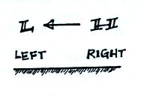
Quiz #5 Nov. 29, 2000

1. Would warm air be needed on the LEFT or RIGHT side
of the picture at right to produce the upper-level
pressure pattern shown? At the surface would you find
low pressure on the LEFT or RIGHT side of the picture?

2. (5 pts) When two air masses collide at a front, one air mass rises because it has lower
a. pressure b. temperature c. humidity d. density e. speed

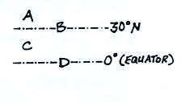
3. (15 pts) Use the letters in the figure at right to show where
the following 3-cell model surface features would be found.
(letter answers can be used more than once or not at all)
horse south
latitudes _____ doldrums_____ westerly winds_____

low pressure belt_____ trade winds _____

4. (5 pts) The Coriolis force is caused by
a. the fact that temperature decreases as one moves from the equator toward the poles
b. topographical features such as mountains on the earth's surface
c. the elliptical orbit of the earth around the sun
d. the rotation of the earth on its axis
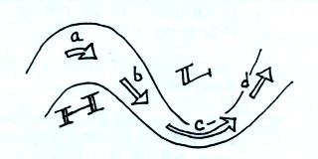
5. On the northern hemisphere, upper-level chart at
right, the strength of the pressure gradient force
(PGF) at Point C is GREATER LESS EQUAL
than(to) the strength of the PGF at Point A.
At Point C, the strength of the PGF is
GREATER LESS EQUAL than(to) the strength
of the Coriolis force (CF).

6. The polar front is often shown on weather maps as a(n) STATIONARY OCCLUDED front. A(n) STATIONARY OCCLUDED front forms when a cold front overtakes a warm front.
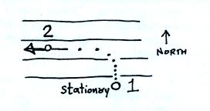
7. In the figure at right, the net force is zero at _____,
the pressure gradient force (PGF) points toward the
north at _____, and the Coriolis force (CF) points
toward the north at _____.
a. point 1 b. points 1 and 2
c. point 2 d. neither point 1 or point 2

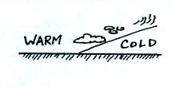
8. The figure at right is a crossectional view of a WARM COLD
front. The cold air mass is moving toward the LEFT RIGHT
and the warm air mass is moving toward the LEFT RIGHT
Name_____________________________________

9. (5 pts) Cities will usually remain warmer than the surrounding countryside at night. Would
you expect to see a COUNTRY breeze (blowing from the country toward the city) or a CITY breeze (blowing from the city toward the country) develop at night?
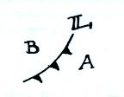
10. (15 pts) Use the letters in the figure at right to show where
the following weather conditions would most likely be found.

southwesterly winds _____ rising pressure _____
warmest air _____ driest air _____

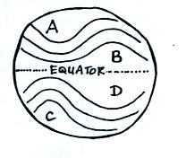

11. You would expect to find a high (H) on the upper-level
chart at right at points _____ and _____. The upper-
level winds blow parallel to the contours and from east to west in
a. the southern hemisphere b. the northern hemisphere
c. neither hemisphere d. both hemispheres

12. Wind speed determines the strength of which two of the following?
a. gravity b. Coriolis force c. pressure gradient force d. frictional force
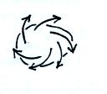
13. (15 pts) The figure at right shows the SURFACE UPPER-LEVEL
winds that would blow around a LOW HIGH pressure center in
the NORTHERN SOUTHERN hemisphere. The winds are
DIVERGING CONVERGING which will cause the air in the center
of the picture to RISE SINK.

14. The P in mP and cP air masses stands for _______________ and tells you that these air
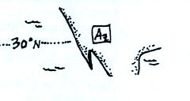
masses are _____________________.

15. During the summer monsoon in Arizona, winds become
EASTERLY WESTERLY when the Pacific LOW HIGH
moves NORTH SOUTH of its normal position at
about 30º latitude.

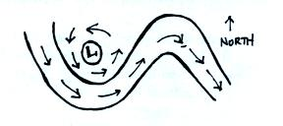
Extra Credit (up to 10 pts)
1. Which two of the following types of motion are
shown on the upper-level chart at right?
a. zonal b. anticyclonic c. geostrophic
d. cyclonic e. meridional

2. The frictional force plays a role in determining
a. upper level winds only b. surface winds only
c. neither surface or upper level winds d. both surface and upper level winds
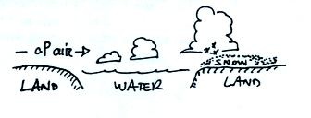
3. Name one of the two processes that cause rising air
motions in the "lake effect."

