Answers to the Feb. 9 In-class Optional Assignment
Question #1
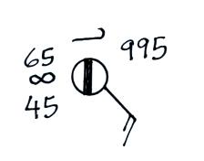
Decode the station model data plotted and fill in the blanks below
Temperature ____65º F___ present weather conditions__haze___
wind direction _from the SE_ dew point temperature ___45º F ___
cloud cover ___1/8 th___ wind speed __15 knots__
cloud type(s) __cirrus__ pressure__999.5 mb__
Question #2
How would the following conditions be plotted on a surface weather map using the station model notation
temperature = 75 F wind from the SE at 15 knots
1/4 of the sky is covered with Fc and/or Fs clouds of bad weather (scud)
intermittent rain dew point temperature = 49 F
