Answers to the Upper Level Winds Examples

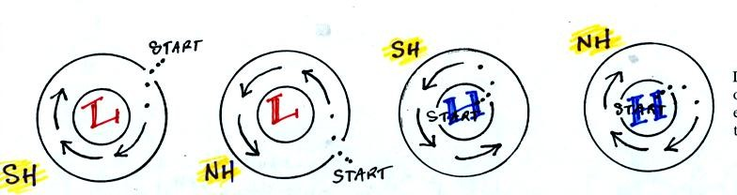
If the direction of initial motion (the dotted line) is toward the center of the circle it is a low. If the initial motion is outward it is a high. Once the air starts to move look in the direction the wind is blowing and see whether the wind takes a turn to the right (Northern hemisphere) or a turn to the left (Southern hemisphere).
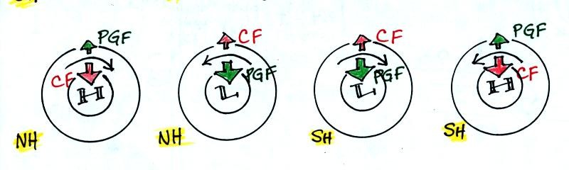
The PGF always points toward low (it is the inward pointing force in the middle two figures and the outward force in the figures on the ends). Once you know which force is the PGF the other force must be the CF. Look to see if the CF is perpendicular and to the right of the wind (Northern hemisphere) or to the left of the wind (Southern hemisphere).
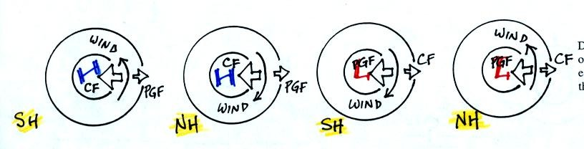
The PGF always points toward low. Look to see if the CF is to the right (Northern hemisphere) or to the left (Southern hemisphere) of the wind.

