Upper Level Winds Examples
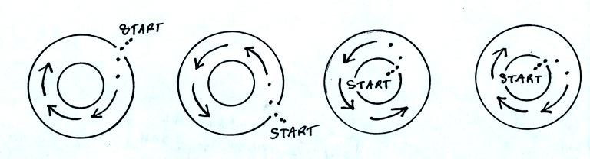
The air is initially stationary. The dots show the direction of the initial motion. Determine whether each is a center of High or Low pressure. Does each show winds in the Northern or Southern hemisphere?
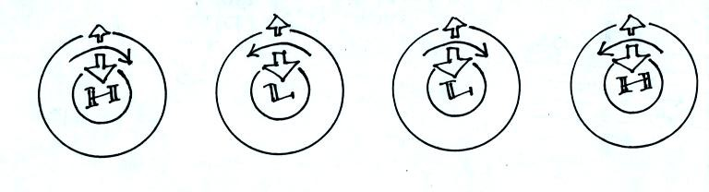
Identify the forces and determine the hemisphere.
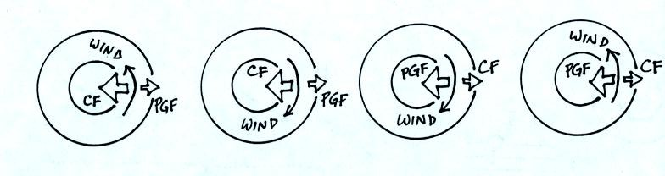
Determine whether each is a center of High or Low pressure. Does each show winds in the Northern or Southern hemisphere?
You can download the answers from the online study guide.

