ATMO/ECE 489/589 Spring 2011
Homework #6 (due Tue., Apr. 12)

1. (8 pts) The figure below shows the electric radiation field waveform radiated by the first return stroke in a CG flash. The signal amplitude has been range normalized to 100 km (using a 1/distance relationship). The dots are from a recording of E field, the fine solid line is an integration of a dE/dt signal measurement that was made with faster time resolution.
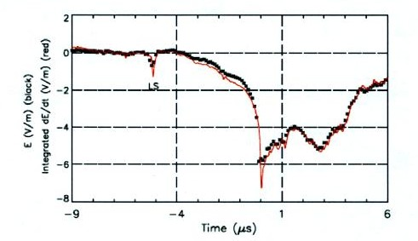

.
Use the transmission line model expression to estimate the peak current in this stroke. You will need to choose an appropriate value for the return stroke velocity. You may neglect any propagation effects.

2. (15 pts) Using the nearest neighbor probability distribution function derived in class (Eqn. [2] in the conference publication on the back of this page), verify the expressions for
(a) the most probable nearest-neighbor distance, r_{mp} and
(b) the mean nearest-neighbor distance, < r > then
(c) use the average CG flash area strike density value, Ng, derived in class (6.6
strikes/(km² yr), calculate numerical values for r_{mp} and < r >.
(d) use the same area strike density value to compute the probability that the closest strike
per year in central Tucson will be within 100 m of a randomly chosen point.
