ATMO/ECE 489/589 Topics Summary for the Midterm Exam

Jan. 13 Overview of global electric circuit, typical fair weather conductivity, λ, and electric field, Ez, values at the ground. Typical fair weather current density, Jz.

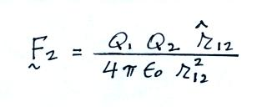
Jan. 18 Historical overview. Contributions of Benjamin Franklin: power of points, sentry box & kite experiment, lightning rods. Franklin chimes, Volta hailstorm.

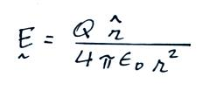
Jan. 20 Start review of electrostatics
Coulomb's law
Electric Field

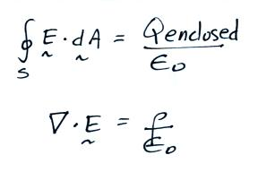

Gauss' Law (integral form)
Gauss' Law (differential form)

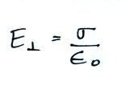
E field inside a conductor = 0
E field at the surface of a conductor
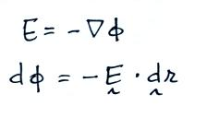
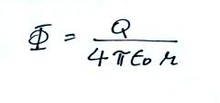
Jan. 25 Electrostatic potential

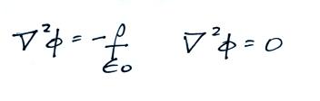
Poisson's Eqn.
Laplace's Eqn.

Electric field mills
Flat plate E field (change) antennas
Passive integrators

Jan. 27 Active integrators for E field (change) antennas
"Fast" and "slow" E field antennas
Point charge above a conducting plane – method of images (brief mention)
Conducting sphere in a uniform E field
Feynman - electric field enhancement near a sharp point, Atlas/Centaur incident
Balloon borne field mill
Estimates of volume space charge density from Ez profiles

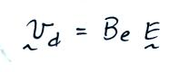
Feb. 1 Currents in the atmosphere

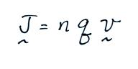
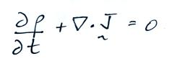
Electrical mobility, Be

Current density

Continuity equation (steady state → Jz constant with altitude)
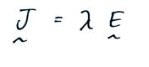
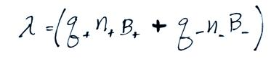
Ohm's law

Conductivity
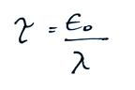
Resistivity and resistance

Discharge time or relaxation time

Screening layers created by a conductivity discontinuity at the edge of a cloud
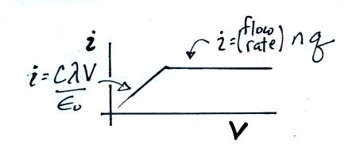

Feb. 3 Ion counters and conductivity meters

Feb. 8 Origin of atmospheric conductivity
alpha, beta, gamma radiation from radioactive materials in the ground
alpha particles from Radon gas that diffuses from the soil

Decay series
Th²³² (thoron series)
X Np²³⁷ (has all decayed away)
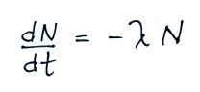
U²³⁸ (radon series)
U²³⁵ (actinon series)

Radioactive decay

Feb. 10 Example estimate of ionization rate from radon
Cosmic radiation
dominant over the oceans at all altitudes
dominant over land above 1 km altitude

Formation of small ions
ionization of air molecules (N₂⁺ and O₂⁺)
e⁻ attaches to O₂ but not to N₂
water vapor molecules (and other gases) cluster around O₂⁻ , N₂⁺ , and O₂⁺
positive small ions have slightly lower mobility than negative small ions

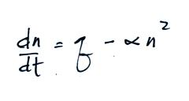
Ion balance equations
steady state solutions

Feb. 15 Summary of electrical parameters vs altitude handout
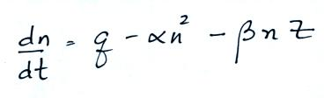
Ion-particle attachment – “large ions”

Microphysical structure of a cold cloud
cloud droplet and ice crystal nucleation
riming and graupel
Typical distribution of electrical charge in a thunderstorm

Feb. 17 Cloud electrification
Convective theory
Inductive process of electrification - depends on an existing electric field
Non-inductive process (Reynolds, Gourley, Brook mechanism)
charge reversal temperature

Feb. 22 Inverted polarity charge distribution in thunderstorms
KSC field mill network & E field mill records from small and large storms

E field change measurements
Chi-squared function used to determine location (x,y,z) and magnitude of the
charge (ΔQ) neutralized by lightning flashes.

single charge and 2 arbitrary charge models
Typical ΔQ, charge heights and temperatures

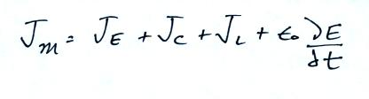
Feb. 24 Thunderstorm as a current source
Maxwell current

