Monday Apr. 4, 2011
3 selections from Cloud Cult this morning ("When Water Comes to Life", "Unexplainable Stories", and "No One Said It Would be Easy")
The Experiment #3 reports have been graded and were returned in class today. You now have the opportunity to revise your report (you don't have to if you're happy with the grade you received). Revised reports are due in two weeks - by Monday Apr. 18. Please return your original report with your revised report. You only need to redo sections where you want to earn additional credit.
The 1S1P reports about Fog in Tucson that were turned in last Friday have been graded also. They were returned in class together with green cards.

In the next two or three classes we will be looking at how and why surface and upper level winds blow the way they do.
Some real world examples of where this occurs are shown in the figure below. The two largest types of storm systems, middle latitude storms (extratropical cyclones) and hurricanes (tropical cyclones), develop around surface centers of low pressure. Winds spin counterclockwise around cyclones (centers of low pressure) in the northern hemisphere and clockwise in the southern hemisphere. Winds spin clockwise around "anticyclones" (high pressure) in the northern hemisphere and counterclockwise in the southern hemisphere.

Storm systems in the tropics (0 to 30 degrees latitude) generally move from east to west. At middle latitudes (30 to 60 degrees), storms move in the other direction, from west to east. To understand why this is true we need to learn something about the earth's global scale pressure and wind patterns. This is a topic we will be getting into next week.

I've borrowed some more carefully drawn figures below from the Spring 2009 online notes. Steps 1-8 below were on a 4 page handout distributed in class.

Upper level winds spinning around high and low pressure in the northern and southern hemispheres are shown in the first set of four pictures. The first thing to notice is that upper level winds blow parallel to the contours. We will see that 2 forces, the pressure gradient force (PGF) and the Coriolis force (CF), cause the winds to blow this way. Eventually you will be able to draw the directions of the forces for each of the four upper level winds examples. Here is an example of what you will be able to do.
The four drawings at the bottom of the page show surface winds blowing around high and low pressure in the southern hemisphere. These winds blow across the contour lines slightly, always toward low pressure. The frictional force is what causes this to occur. He is an example of what you will be able to say about surface winds blowing around low pressure in the southern hemisphere.

The main point to take from Step #2 is that a net inward force is needed anytime an object is moving in a circular path. It doesn't matter what direction the object is moving. The net force is inward anytime something moves in a circular path.
Quite a few people would say there is an outward force being exerted in the bottom picture, but the force is inward in each of the cases below.

It's just not the same amount of inward force. The amount of force is just right in the top figure, a little "too strong" in the middle figure, and "not quite strong enough" in the bottom figure.

Now we'll start to look at the forces that cause the wind to blow.

The pressure gradient force always points toward low pressure. The PGF will cause stationary air to begin to move (it will always move toward low pressure).

The Coriolis force is caused by the rotation of the earth and points perpendicular to the wind. It can only change the wind's direction, it can't cause the wind to speed up or slow down. The direction of the CF depends on whether you're in the northern or southern hemisphere. We'll look at the cause of the Coriolis force in class on Friday.

Now we start to put everything together. The PGF at Point 1 starts stationary air moving toward the center of low pressure (just like a rock would start to roll downhill). Once the air starts to move, the CF causes it to turn to the right (because this is a northern hemisphere chart). The wind eventually ends up blowing parallel to the contour lines and spinning in a counterclockwise direction. Note that the inward PGF is stronger than the outward CF. This results in a net inward force, something that is needed anytime wind blows in a circular path.

See if you can figure out what to do with this figure. You’ll find the answer at the end of today’s notes (the next to the last page).

With high pressure the air starts moving outward. In this example the wind takes a right turn and ends up blowing in a clockwise direction around the high. Note there is a net inward force here just as there was with the two previous examples involving low pressure.

Try this one on your own.You’ll find the answer on the last page of today’s notes.
This is as far as we got in class on Monday. We have a quiz on Wednesday so we'll look at surface winds next Friday.

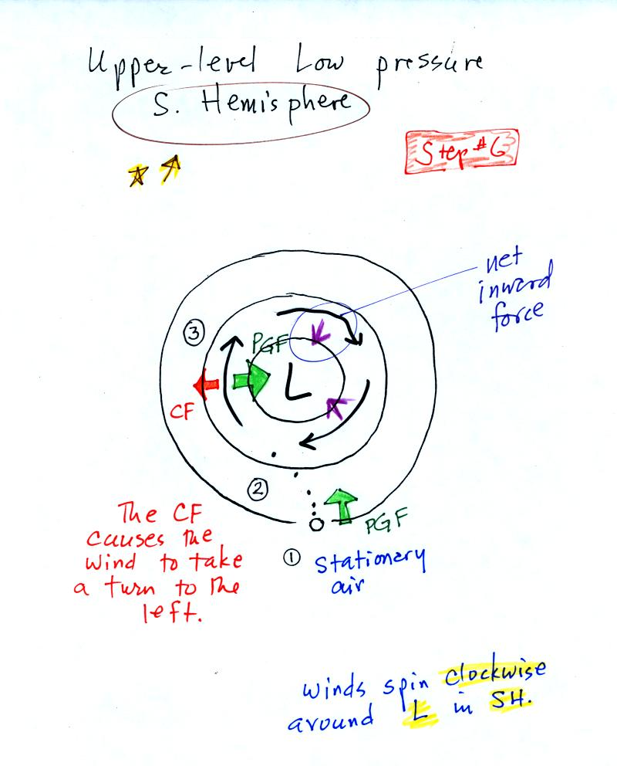
Upper level winds blowing around low pressure in the southern hemisphere. This is the first of two situations you were supposed to figure out.

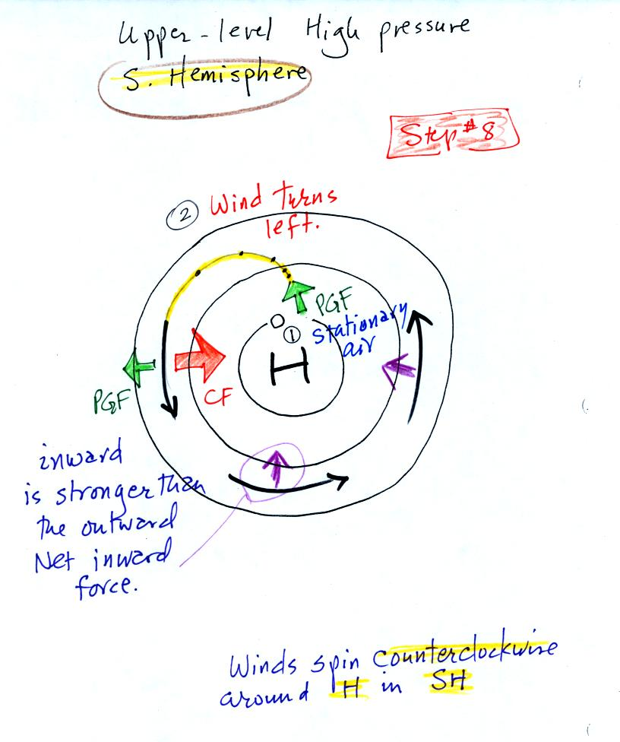
Upper level winds blowing around high pressure in the southern hemisphere. This is the second of the two analyses you were supposed to do.

