Monday Feb. 7, 2011
Patty Griffin got the new week started in NATS 101 this morning ("You'll Remember", "Stay on the Ride", and "Getting Ready"). She was in Tucson not too long ago.
The Experiment #1 reports were collected in class today. It generally takes at least one week to get these graded. The materials for Experiment #2 will be handed out this week (if not Wednesday, then Friday for sure).
The first take home Optional Assignment was handed out in class today. It is due next Monday, Feb. 14. I'll have extra copies in class on Wednesday or you can download a copy of the assignment here. You should finish the assignment before coming to class next Monday (you can also turn in the assignment early).
The in-class assignment from last week was returned today.

We spent the majority of today's class on a new topic - Surface Weather Maps. We began by learning how weather data are entered onto surface weather maps.
Much of our weather is produced by relatively large (synoptic scale) weather systems - systems that might cover a significant fraction of the continental US. To be able to identify and characterize these weather systems you must first collect weather data (temperature, pressure, wind direction and speed, dew point, cloud cover, etc) from stations across the country and plot the data on a map. The large amount of data requires that the information be plotted in a clear and compact way. The station model notation is what meterologists use.

A small circle is plotted on the map at the location where the weather measurements were made. The circle can be filled in to indicate the amount of cloud cover. Positions are reserved above and below the center circle for special symbols that represent different types of high, middle, and low altitude clouds. The air temperature and dew point temperature are entered to the upper left and lower left of the circle respectively. A symbol indicating the current weather (if any) is plotted to the left of the circle in between the temperature and the dew point; you can choose from close to 100 different weather symbols (on a handout distributed in class). The pressure is plotted to the upper right of the circle and the pressure change (that has occurred in the past 3 hours) is plotted to the right of the circle.
We worked through this material one step at a time (refer to p. 36 in the photocopied ClassNotes). Some of the figures below were borrowed from a previous semester or were redrawn and may differ somewhat from what was drawn in class.

The center circle is filled in to indicate the portion of the sky covered with clouds (estimated to the nearest 1/8th of the sky) using the code at the top of the figure. 3/8ths of the sky is covered with clouds in the example above.

Then symbols are used to identify the actual types of high, middle, and low altitude clouds observed in the sky. Later in the semester we will learn the names of the 10 basic cloud types. Six of them are sketched above and symbols for them are shown.
A complete list of cloud symbols was on a handout distributed in class (a copy can be found here ) You do not, of course, need to remember all of the cloud symbols.

A straight line extending out from the center circle shows the wind direction. Meteorologists always give the direction the wind is coming from. In this example the winds are blowing from the NW toward the SE at a speed of 5 knots. A meteorologist would call these northwesterly winds.
Small barbs at the end of the straight line give the wind speed in knots. Each long barb is worth 10 knots, the short barb is 5 knots. Knots are nautical miles per hour. One nautical mile per hour is 1.15 statute miles per hour. We won't worry about the distinction in this class, we will just consider one knot to be the same as one mile per hour.

Here are four more examples. What is the wind direction and wind speed in each case. The answers are at the end of today’s lecture notes.
The air temperature and the dew point temperature are probably the easiest data to decode.

The air temperature in this example was 64º F (this is plotted above and to the left of the center circle). The dew point temperature was 39º F and is plotted below and to the left of the center circle. The box at lower left reminds you that dew points range from the mid 20s to the mid 40s during much of the year in Tucson. Dew points rise into the upper 50s and 60s during the summer thunderstorm season (dew points are in the 70s in many parts of the country in the summer). Dew points are in the 20s, 10s, and may even drop below 0 during dry periods in Tucson (that has been the case here recently).

A symbol representing the weather that is currently occurring is plotted to the left of the center circle (in between the temperature and the dew point). Some of the common weather symbols are shown. There are about 100 different weather symbols that you can choose from (click here if you didn't get a copy of the handout distributed in class today). There's no way I could expect you to remember all of these weather symbols.

The pressure data is usually the most confusing and most difficult data to decode.

The sea level pressure is shown above and to the right of the center circle. Decoding this data is a little "trickier" because some information is missing. We'll look at this in more detail momentarily.
Pressure change data (how the pressure has changed during the preceding 3 hours) is shown to the right of the center circle. You must remember to add a decimal point. Pressure changes are usually pretty small. The pressure change data wasn't mentioned in class.
Here's what you need to know about the pressure data.

Meteorologists hope to map out small horizontal pressure changes on surface weather maps (that produce wind and storms). Pressure changes much more quickly when moving in a vertical direction. The pressure measurements are all corrected to sea level altitude to remove the effects of altitude. If this were not done large differences in pressure at different cities at different altitudes would completely hide the smaller horizontal changes.
In the example above, a station pressure value of 927.3 mb was measured in Tucson. Since Tucson is about 750 meters above sea level, a 75 mb correction is added to the station pressure (1 mb for every 10 meters of altitude). The sea level pressure estimate for Tucson is 927.3 + 75 = 1002.3 mb. This sea level pressure estimate is the number that gets plotted on the surface weather map.
The calculation above is shown in a picture below

Here are some examples of coding and decoding the pressure data. We kind of rushed through this and will come back to it again on Wednesday.
First of all we'll take some sea level pressure values and show what needs to be done before the data is plotted on the surface weather map.

To save room, the leading 9 or 10 on the sea level pressure value and the decimal point are removed before plotting the data on the map. For example the 10 and the . in 1002.3 mb would be removed; 023 would be plotted on the weather map (to the upper right of the center circle). Some additional examples are shown above.

When reading pressure values off a map you must remember to add a 9 or 10 and a decimal point. For example
118 could be either 911.8 or 1011.8 mb. You pick the value that falls between 950.0 mb and 1050.0 mb (so 1011.8 mb would be the correct value, 911.8 mb would be too low).

I rushed through the pressure material so that we could finish up with a little information about Archimedes Law. Last Friday we saw that the relative strengths of the downward graviational force and the upward pressure difference force determine whether a parcel of air will rise or sink. Archimedes Law is another, somewhat simpler, way of trying to understand this topic.

A gallon of water weighs about 8 pounds (lbs).
If you submerge the gallon jug of water in a swimming pool, the jug becomes, for all intents and purposes, weightless. Archimedes' Law (see figure below, from p. 53a in the photocopied ClassNotes) explains why this is true.

Archimedes first of all tells you that the surrounding fluid will exert an upward pointing bouyant force on the submerged water bottle. That's why the submerged jug can become weightless. Archimedes law also tells you how to figure out how strong the bouyant force will be. In this case the 1 gallon bottle will displace 1 gallon of pool water. One gallon of pool water weighs 8 pounds. The upward bouyant force will be 8 pounds, the same as the downward force. The two forces are equal and opposite.
Archimedes law doesn't really tell you what causes the upward bouyant force. If you're really on top of this material you will recognize that it is really just another name for the pressure difference force that we covered last Friday (higher pressure pushing up on the bottle and low pressure at the top pushing down, resulting in a net upward force).
Now we imagine pouring out all the water and filling the 1 gallon jug with air. Air is about 1000 times less dense than water;compared to water, the jug will weigh practically nothing.

If you submerge the jug of air in a pool it will displace 1 gallon of water and experience an 8 pound upward bouyant force again. Since there is no downward force the jug will float.
One gallon of sand (which is about 1.5 times denser than water) jug weighs 12 pounds (being a detail kind of person I actually checked this out).

The jug of sand will sink because the downward force is greater than the upward force.
You can sum all of this up by saying anything that is less dense than water will float in water, anything that is more dense than water will float in water.
The same reasoning applies to air in the atmosphere.

Air that is less dense (warmer) than the air around it will rise. Air that is more dense (colder) than the air around it will sink.
Here's a little more information about Archimedes.
There's a colorful demonstration that shows how small differences in density can determine whether an object floats or sinks.

A can of regular Coca Cola was placed in a beaker of water. The can sank. A can of Diet Coke on the other hand floated. (Coke was used instead of Pepsi because Coke now has the exclusive franchise on the U. of A. campus)
Both cans are made of aluminum which has a density almost three times higher than water. The drink itself is largely water. The regular Coke also has a lot of high-fructose corn syrup, the diet Coke doesn't. The mixture of water and corn syrup has a density greater than plain water. There is also a little air (or perhaps carbon dioxide gas) in each can.
The average density of the can of regular Coke (water & corn syrup + aluminum + air) ends up being slightly greater than the density of water. The average density of the can of diet Coke (water + aluminum + air) is slightly less than the density of water.
We repeated the demonstration with a can of Pabst Blue Ribbon beer. That also floated, the beer doesn't contain any corn syrup (I don't think).
In some respects people in swimming pools are like cans of regular and diet soda. Some people float (they're a little less dense than water), other people sink (slightly more dense than water).

Many people can fill their lungs with air and make themselves float, or they can empty their lungs and make themselves sink. People have an average density that is about the same as water. That makes sense because we are largely made up of water (water makes up about 60% of human males and 55% of human females according to this source)

Here are the answers to the questions about winds:
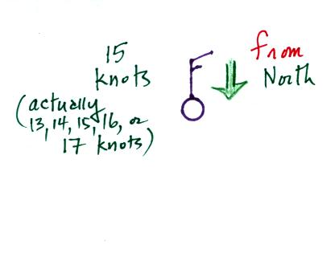 | 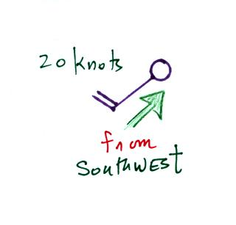
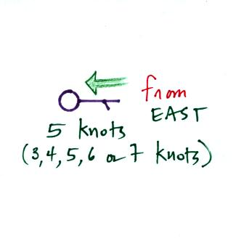 | 