NATS 101 Sect. 17 Name_______________________________
Quiz #2 Oct. 4, 2000

1. (5 pts) Hurricanes develop in the tropics when the surface winds converge, the upper level winds are light, and the atmosphere is unstable. What other important requirement is there?

2. (5 pts) The earth's surface is warm enough that it emits more radiation than it receives from the sun. Which of the following supplies most of the energy needed to bring the surface into energy balance?
a. absorption of ultraviolet radiation by the ozone layer
b. emission of infrared radiation by the earth's atmosphere
c. heat stored in the earth's oceans
d. heat from the hot molten core of the earth

3. (5 pts) The term ____________________ generally refers to the winds blowing around an area of low pressure. In some parts of the world, the same word is the name given to the storms that we call hurricanes.

4. (10 pts) The Saffir-Simpson scale is used to rate hurricane severity. In addition to sustained wind speeds, what other two hurricane characteristics does the scale include?

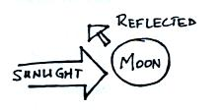
5. (5 pts) Ten percent (10 out of 100 incoming units) of the sunlight
reaching the moon in the figure at right is being reflected. To be
in radiative equilibrium, the moon would need to emit _______ units
of radiation back into space. (fill in the blank with 0 10 20 80 90
100 110 or 120)

6. (5 pts) An average hurricane has an eye about 50 km (30 miles) across. Would a smaller diameter eye indicate a STRONGER or WEAKER than average hurricane?

7. (5 pts) Water vapor is a gas that plays an important role in the earth/atmosphere energy balance. Is this because water vapor selectively absorbs ULTRAVIOLET, VISIBLE, or INFRARED light?
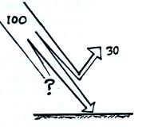
8. (10 pts) About 30% of the sunlight reaching the top of the
earth's atmosphere is reflected. What percentage makes it
to the ground? What happens to the remaining sunlight?

9. (10 pts) In a strengthening hurricane the sea-level pressure in the center of the hurricane will INCREASE DECREASE because of strong DIVERGENCE CONVERGENCE of the upper-level winds.
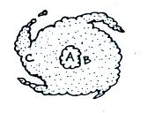
10. (20 pts) Use the letters in the figure at right, a top view
of a mature hurricane, to indicate where the following
are found.
a. lowest surface pressure _______ b. sinking air _______
c. strongest surface winds _______ d. eye wall _______

11. (5 pts) If measurements revealed that the wavelength of peak emission from the sun was slowly shifting to longer wavelengths, you could probably conclude the sun was getting
a. bigger b. closer to the earth c. warmer
d. smaller e. further from the earth f. colder

12. (15 pts) Fill in the blanks below withe VIS (visible), UV (ultraviolet), or IR (infrared)
The atmosphere is essentially completely transparent to _______ light.
Greenhouse gases selectively absorb _______ light
Oxygen (O₂) and ozone (O₃) strongly absorb _______ light
The wavelength of peak emission from the sun is in the _______ part of the spectrum
The atmospheric window (8-12 μm) is in the _______ part of the spectrum
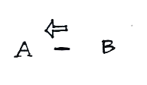
13. (10 pts) Opposite charges are positioned at Points A and B
in the figure at right. A negative charge placed in between
the two points will move toward the left. Would you expect
to find a POSITIVE or NEGATIVE charge at Point A?
Would the electric field between Points A and B point
toward the RIGHT or the LEFT?

14. (5 pts) Does the STEFAN-BOLTZMANN law (E=σT⁴) or WIEN'S law (λ_{MAX}=3000/T)
tell you something about the amount of energy emitted by an object?
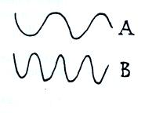
15. (20 pts) Two examples of electromagnetic radiation are shown at
right. Does A have LONGER, SHORTER, or the SAME
wavelength as B? Does B have HIGHER, LOWER, or the SAME
frequency as A? Is A a MORE or LESS energetic form of
radiation than B? Does A propagate at a HIGHER, a LOWER, or
the SAME speed as B?

Extra Credit (up to 10 pts)
1. For every increase of 1 on the Saffir-Simpson scale, a hurricane's winds increase by about _______ miles per hour. (fill in the blank with 5, 10, 20, 50, or 100)

2. In most years there are more hurricanes _______ than in any other location in the world.
Hurricane formation is noticeably absent _______.
a. in the Gulf of Mexico b. in the Indian Ocean c. off the coast of SE Asia
d. off the E and W coasts of South America e. off the E coast of the US in the Atlantic

3. IR radiation acounts for about 80% of the energy transported from the earth's surface to the atmosphere. What is the next most important process?

