NATS 101 In-class Optional Assignment Name_____________________________________
due at the end of class

1. The highest temperature ever recorded in the US is
a. 124º F b. 134º F c. 144º F d. 154º F

2. The coldest location on earth is
a. Alaska b. the North Pole c. Siberia d. the South Pole

3. The Gulf Stream is a warm ocean current that flows northward along the east coast of the US. The Gulf stream is an example of energy transport by
a. conduction b. convection c. electromagnetic radiation d. latent heat

4. One _________________________ is the energy needed to warm 1 gram of water 1º C.

5. _______ and _______ could occur during cloud formation. You would need to add energy to a material in order for _______ and _______ to occur. (fill in the blanks, each answer should be used once)
a. condensation b. deposition c. evaporation d. sublimation
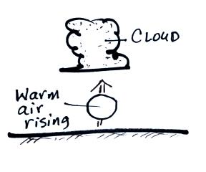

6. The figure at right shows warm air rising and the formation
of a cloud. What two energy transport processes are best
illustrated in this figure?

7. A room temperature object that feels cold to the touch probably has
a. high specific heat b. high thermal conductivity c. high latent heat
d. low specific heat e. low thermal conductivity f. low latent heat
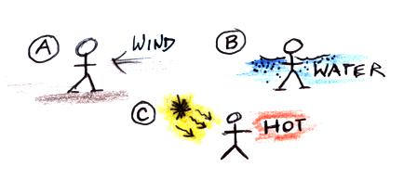
8. A person is standing outside on a cold windy day in
Fig. A at right. The person has fallen into cold water in
Fig. B. In Fig. C the person is perspiring heavily on a
hot dry summer day. Match each of the energy transport
processes below with the situation at right that best
illustrates each process.
latent heat_______ conduction_______ convection_______

9. Frost sometimes forms on cold mornings. Would frost release energy into and WARM the surrounding air or take energy from and COOL the surrounding air?

10. Why is electromagnetic radiation the most important of the 4 energy transport processes?

